OKPESEYI SIMILOLUWA BLOSSOM
16/SCI01/033
CSC 408
- Suppose a company is interested in purchasing a call center software package to improve its customer service.

- Describe the project management processes that would be needed to support the first 2 phases of the project methodology.

Project Initiation
Project initiation is the starting point of any project. In this process, all the activities related to winning a project takes place. Usually, the main activity of this phase is the pre-sale. During the pre-sale period, the service provider proves the eligibility and ability of completing the project to the client and eventually wins the business. Then, it is the detailed requirements gathering which comes next. During the requirements gathering activity, all the client requirements are gathered and analyzed for implementation. In this activity, negotiations may take place to change certain requirements or remove certain requirements altogether. Usually, project initiation process ends with requirements sign-off.
Project Planning
Project planning is one of the main project management processes. If the project management team gets this step wrong, there could be heavy negative consequences during the next phases of the project. Therefore, the project management team will have to pay detailed attention to this process of the project. In this process, the project plan is derived in order to address the project requirements such as, requirements scope, budget and timelines. Once the project plan is derived, then the project schedule is developed. Depending on the budget and the schedule, the resources are then allocated to the project. This phase is the most important phase when it comes to project cost and effort.
Project Execution
After all paperwork is done, in this phase, the project management executes the project in order to achieve project objectives. When it comes to execution, each member of the team carries out their own assignments within the given deadline for each activity. The detailed project schedule will be used for tracking the project progress. During the project execution, there are many reporting activities to be done. The senior management of the company will require daily or weekly status updates on the project progress. In addition to that, the client may also want to track the progress of the project. During the project execution, it is a must to track the effort and cost of the project in order to determine whether the project is progressing in the right direction or not. In addition to reporting, there are multiple deliveries to be made during the project execution. Usually, project deliveries are not onetime deliveries made at the end of the project. Instead, the deliveries are scattered throughout the project execution period and delivered upon agreed timelines.
Control and Validation
During the project life cycle, the project activities should be thoroughly controlled and validated. The controlling can be mainly done by adhering to the initial protocols such as project plan, quality assurance test plan and communication plan for the project. Sometimes, there can be instances that are not covered by such protocols. In such cases, the project manager should use adequate and necessary measurements in order to control such situations. Validation is a supporting activity that runs from first day to the last day of a project. Each and every activity and delivery should have its own validation criteria in order to verify the successful outcome or the successful completion. When it comes to project deliveries and requirements, a separate team called 'quality assurance team' will assist the project team for validation and verification functions.
Closeout and Evaluation
Once all the project requirements are achieved, it is time to hand over the implemented system and closeout the project. If the project deliveries are in par with the acceptance criteria defined by the client, the project will be duly accepted and paid by the customer. Once the project closeout takes place, it is time to evaluate the entire project. In this evaluation, the mistakes made by the project team will be identified and will take necessary steps to avoid them in the future projects. During the project evaluation process, the service provider may notice that they haven't gained the expected margins for the project and may have exceeded the timelines planned at the beginning. In such cases, the project is not a 100% success to the service provider. Therefore, such instances should be studied carefully and should take necessary actions to avoid in the future.

- Describe an IT project management methodology that can be adopted for the project.
The PRINCE2 process contains the steps that lead to the project objective.
Start up the Project
This is where it’s determined whether the project is viable. Once confirmed, it must be approved by the project board. This includes a project brief which contains the business case, the best way to do the project, the name of the person chosen to execute it and a detailed stage plan, which indicates the work that needs to be done by the initiation stage. Activities of this process include the trigger, which is a high-level document stating the project’s mandate. Also, it’s important to do the due diligence before the project is executed to save time and money once the project has started.
Initiate the Project
During this process, several questions need to be addressed: What work must be done in the project? What are the reasons for the project, including risks and benefits and how they’ll be identified and resolved? To answer, define the project scope, including when the products can be delivered without compromising quality. Define how to monitor the project’s progress and who needs to know and how they’ll be informed. The activities associated with this process include constructing risk, configuration, quality and communications management strategies. Also, set up project controls, along with project plan and project initiation documentation.
Direct the Project
This process is to help the project board be accountable to the project through their decision-making. They have authority on initiating the project, delivering its product and closing the project. They also offer direction and control during the project. Additionally, they work with the corporate entities or program management and review post-project benefits. Activities related to this process include authorizing the initiation, the project itself and the stages of the project. Other direction is offered as needed until project closure is authorized.
Control Stages
This is where the project manager assigns tasks, monitors that work, deals with whatever issues arise and reports on its progress to the project board. Activities in this process include authorizing a work package with the team, reviewing its status and progress, and checking on its quality when complete. One must also review and compare progress to the project plan, capture any issues and risks and act to resolve them.
Manage Product Delivery
This process manages the delivery of the project product, controlling the work between the project manager and the team. Activities associated with this process include accepting the work package, executing the work package and delivering the work package to make sure it’s complete.
Manage Stage Boundary
There are two parts to this process: firstly, the project manager provides the project board with an overview of performance, updates the project plan and business case, and creates a plan for the next stage. Secondly, the information provided by the project manager will help the project board review the current stage, approve the next and review the updated plan. Activities include planning the next stage and reporting on the stage end.
Close the Project
This process is about making sure the project achieved its goals and objectives by the deadline. Sometimes project managers prepare the planned closure and the premature closure, but that’s not required. Mandatory activities include handing over the product, evaluating the project and recommending its closure to the project board to officially close it out.

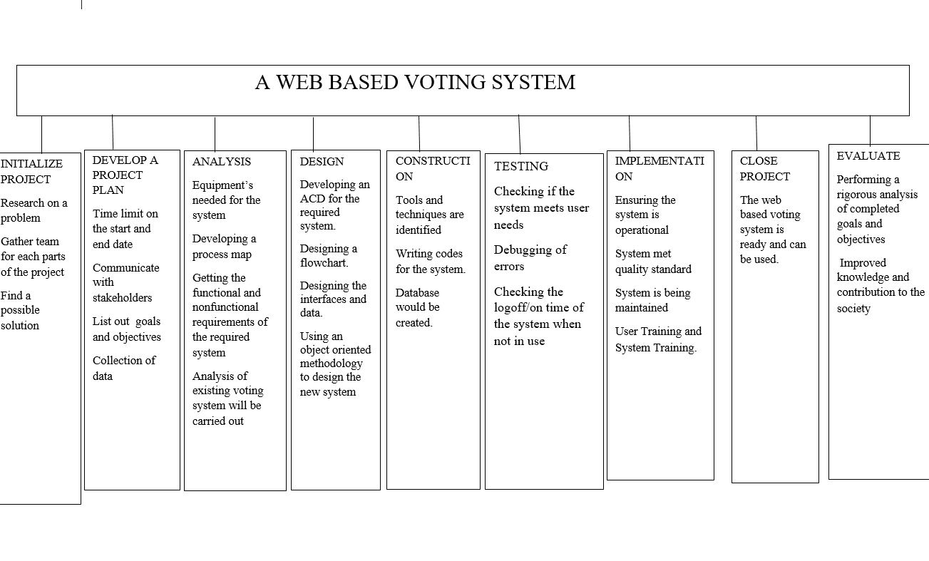
b.
i. I will define the estimate purpose.
ii. Develop an estimate plan.
- Define a work breakdown structure.
- Clearly define identify the rules and assumptions of the project
- Create a data collection
- Learning how to manage risks and uncertainty.

- Why is the study of Project management important for computing and information technology students?
Strategic Alignment
Project management is important because it ensures what is being delivered, is right, and will deliver real value against the business opportunity.
Leadership
Project management is important because it brings leadership and direction to projects. Without project management, a team can be like a ship without a rudder; moving but without direction, control or purpose. Leadership allows and enables a team to do their best work. Project management provides leadership and vision, motivation, removing roadblocks, coaching and inspiring the team to do their best work.
Clear Focus & Objectives
Project management is important because it ensures there’s a proper plan for executing on strategic goals. Where project management is left to the team to work out by themselves, you’ll find teams work without proper briefs, projects lack focus, can have vague or nebulous objectives, and leave the team not quite sure what they’re supposed to be doing, or why.
Realistic Project Planning
Project management is important because it ensures proper expectations are set around what can be delivered, by when, and for how much. Without proper project management, budget estimates and project delivery timelines can be set that are over-ambitious or lacking in analogous estimating insight from similar projects. Ultimately this means without good project management, projects get delivered late, and over budget.
Quality Control
Projects management is important because it ensures the quality of whatever is being delivered, consistently hits the mark. Projects are also usually under enormous pressure to be completed. Without a dedicated project manager, who has the support and buy-in of executive management, tasks are underestimated, schedules tightened and processes rushed. The result is bad quality output. Dedicated project management ensures that not only does a project have the time and resources to deliver, but also that the output is quality tested at every stage.
Risk Management
Project management is important because it ensures risks are properly managed and mitigated against to avoid becoming issues. Risk management is critical to project success. The temptation is just to sweep them under the carpet, never talk about them to the client and hope for the best. But having a robust process around the identification, management and mitigation of risk is what helps prevent risks from becoming issues.
Orderly Process
Project management is important because it ensures the right people do the right things, at the right time it ensures proper project process is followed throughout the project lifecycle. Surprisingly, many large and well-known companies have reactive planning processes. But reactivity as opposed to proactivity can often cause projects to go into survival mode. This is a when teams fracture, tasks duplicate, and planning becomes reactive creating inefficiency and frustration in the team.
Continuous Oversight
Project management is important because it ensures a project’s progress is tracked and reported properly.
Status reporting might sound boring and unnecessary and if everything’s going to plan, it can just feel like documentation for documentation’s sake. But continuous project oversight, ensuring that a project is tracking properly against the original plan, is critical to ensuring that a project stays on track.
Subject Matter Expertise
Project management is important because someone needs to be able to understand if everyone’s doing what they should. With a few year experience under their belt, project managers will know a little about a lot of aspects of delivering the projects they manage. They’ll know everything about the work that their teams execute; the platforms and systems they use, and the possibilities and limitations, and the kinds of issues that typically occur.
Managing and Learning from Success and Failure
Project management is important because it learns from the successes and failures of the past. Project management can break bad habits and when you’re delivering projects, it’s important to not make the same mistakes twice. Project managers use retrospectives or post project reviews to consider what went well, what didn’t go so well and what should be done differently for the next project.

