NAME: AGWANIRU RPSEMARY ONYINYECHI
MATRIC NO: 17/ENG01/003
COURDE CODE: ENG 382
COURSE TITLE: ENGINEERING MATHEMATICS IV

SOLUTION TO ASSIGNMENT IV
Using MatLAB
Function File
- function dydt = mathsassignfour(t,y)

dydt(1) = -0.03*y(1)+0.005*y(2)+1;
dydt(2) = 0.03*y(1)-0.018*y(2)+0.0075*y(3);
dydt(3) = 0.013*y(2)-0.0325*y(3);
dydt=dydt';
- end

SIMULATION FILE
commandwindow
clearvars
clc
close all
[t,Q] = ode45('mathsassignfour', [0:40:1200], [0 0 0]);

figure(1)
subplot(3,1,1)
plot(t,Q(:,1),'o-green')
xlabel('Time (min)')
ylabel('Volume (Litre)')
grid on
grid minor
axis tight

subplot(3,1,2)
plot(t,Q(:,2),'*-blue')
xlabel('Time (min)')
ylabel('Volume (Litre)')
grid on
grid minor
axis tight

subplot(3,1,3)
plot(t,Q(:,3),'+-red')
xlabel('Time (min)')
ylabel('Volume (Litre)')
grid on
grid minor
axis tight
figure(2)
plot(t,Q)
xlabel('Time (min)')
ylabel('Volume (Litres)')
legend('Tank 1', 'Tank 2', 'Tank 3')
grid on
grid minor
axis tight

GRAPH (FIGURE 1)
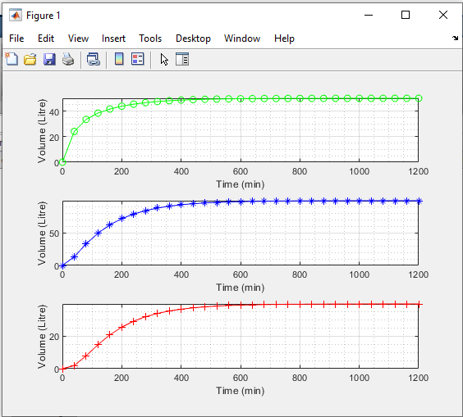
DYNAMIC RESPONSES OF TANK

