NAME: ORAFU PRECIOUS

MATRIC NO: 17/SCI01/087

COURSE CODE: CSC 408 ASSIGNMENT

ANSWERS

1a) Project Initiation
Initiation is the first phase of the project lifecycle. This is where the project’s value and feasibility are measured. Project managers typically use two evaluation tools to decide whether or not to pursue a project:

Business Case Document – This document justifies the need for the project, and it includes an estimate of potential financial benefits.
Feasibility Study – This is an evaluation of the project’s goals, timeline and costs to determine if the project should be executed. It balances the requirements of the project with available resources to see if pursuing the project makes sense.
Teams abandon proposed projects that are labeled unprofitable and/or unfeasible. However, projects that pass these two tests can be assigned to a project team or designated project office.

Project Planning
Once the project receives the green light, it needs a solid plan to guide the team, as well as keep them on time and on budget. A well-written project plan gives guidance for obtaining resources, acquiring financing and procuring required materials. The project plan gives the team direction for producing quality outputs, handling risk, creating acceptance, communicating benefits to stakeholders and managing suppliers.

The project plan also prepares teams for the obstacles they might encounter over the course of the project, and helps them understand the cost, scope and timeframe of the project.
1b) The Waterfall Methodology
One of the more traditional project management methodologies, Waterfall is a linear, sequential design approach where progress flows downwards in one direction — like a waterfall. Originating in the manufacturing and construction industries, its lack of flexibility in design changes in the earlier stages of the development process is due to it becoming exuberantly more expensive because of its structured physical environments.

The methodology was first introduced in an article written in 1970 by Winston W. Royce (although the term ‘Waterfall’ wasn’t used), and emphasizes that you’re only able to move onto the next phase of development once the current phase has been completed. The phases are followed in the following order:

System and software requirements
Analysis: resulting in models, schema, and business rules
Design: resulting in the software architecture
Coding: the development, proving, and integration of software
Testing: the systematic discovery and debugging of defects
Operations: the installation, migration, support, and maintenance of complete systems
Waterfall is a project management methodology that stresses the importance of documentation. The idea is that if a worker was to leave during the development process, their replacement can start where they left off by familiarizing themselves with the information provided on the documents.

Pre-Agile saw the Waterfall methodology being used for software development, but there were many issues due to its non-adaptive design constraints, the lack of customer feedback available during the development process, and a delayed testing period.

Best suited for: Larger projects that require maintaining stringent stages and deadlines, or projects that have been done various times over where chances of surprises during the development process are relatively low.

2a). Work Break Structure Of Building a Solar Vehicle

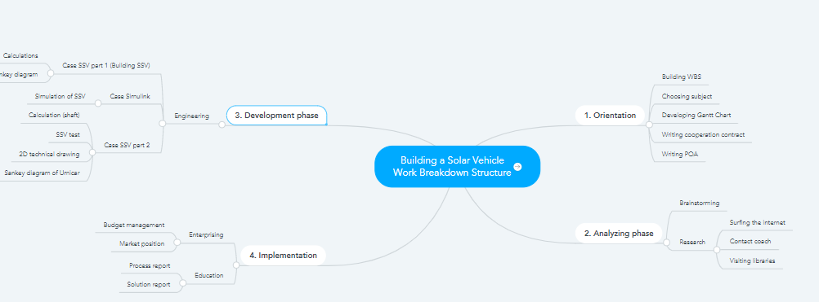

2b.) Strategy To Create Focused Differentiation Through a Customer Relationship Management (CRM) system.

Choosing a standalone CRM system
Standalone CRM is considered the superset of a basic CRM system.
This will involve the implementation of more complex processes including custom reporting, custom views, customized workflows and add-ons. Some of the benefits include the following:

i.) Send automated emails or notifications
ii.) Gather and accurately maintain customer information
iii.) Analyze data and uncover various trends
iv.) Improve your customer service
It’s important to note that the data migration sometimes involves multiple sources which can require the need for data cleansing.

For a company that decides to use a standalone CRM, employee training will be required. CRM training for administrators will also be required if the business plans to self-maintain this kind of CRM application. This training will help those using the system gain greater efficiency and enable your company to better understand and meet the needs of your customers.

3.) Project management for information systems provides practitioners who have current information technology skills with an understanding of the theory and practice of project management through an integrated view of the concepts, skills, tools, and techniques involved in the management of information technology projects. Much of the knowledge needed to manage projects is unique to the discipline of project management. Project managers must also have knowledge and experience in general management and must understand the applicability of the project in order to work effectively with specific industry groups and technologies.
Project management for information systems focuses on information technology projects. While IT project managers are generally selected because of their expertise in information technology, they generally spend more time becoming better project managers, and less time being information technology experts.

