Name: Najeebat Ahmed opeyemi
Matric no:16/sci03/001
Course code:csc 408

The project management processes needed to support the first two phases are:
1a.Project Initiation
Project initiation is the starting point of any project. In this process, all the activities related to winning a project takes place. Usually, the main activity of this phase is the pre-sale.
During the pre-sale period, the service provider proves the eligibility and ability of completing the project to the client and eventually wins the business. Then, it is the detailed requirements gathering which comes next.
During the requirements gathering activity, all the client requirements are gathered and analysed for implementation. In this activity, negotiations may take place to change certain requirements or remove certain requirements altogether.
Usually, project initiation process ends with requirements sign-off.

1b.Project Planning
Project planning is one of the main project management processes. If the project management team gets this step wrong, there could be heavy negative consequences during the next phases of the project.
Therefore, the project management team will have to pay detailed attention to this process of the project.
In this process, the project plan is derived in order to address the project requirements such as, requirements scope, budget and timelines. Once the project plan is derived, then the project schedule is developed.
Depending on the budget and the schedule, the resources are then allocated to the project. This phase is the most important phase when it comes to project cost and effort.

1c. Agile model

One of the more recognizable project management methodologies, Agile is best suited for projects that are iterative and incremental. It’s a type of process where demands and solutions evolve through the collaborative effort of self-organizing and cross-functional teams and their customers. A new model is emerging that is based on agile software development. It promotes adaptive planning and learning, continuous iteration and improvement, and rapid, flexible responses to change through shortened development cycles. The agile approach unlocks the ability to experiment and learn as you go.

In the classic contact center model, inflexible and proprietary platforms leave you unable to address disruptive changes in consumer behavior. But with the agile contact center approach, you use simple APIs to rapidly integrate with new platforms and channels of communication, and to change the way communications are used by your agents and consumers. Originally created for software development, it was established as a response to the inadequacies of the Waterfall method (info on it later below), the processes of which did not meet the demands of the highly competitive and constant movement of the software industry.

Agile project management stems from the values and principles of the Agile Manifesto. A declaration cemented in 2001 by 13 industry leaders, its purpose is to uncover better ways of developing software
by providing a clear and measurable structure that fosters iterative development, team collaboration, and change recognition.

Values
1. Individuals and interactions over processes and tools
2. Working software over comprehensive documentation
3. Customer collaboration over contract negotiation
4. Responding to change over following a plan
Principles
1. Customer satisfaction through early and continuous software delivery
2. Accommodate changing requirements throughout the development process
3. Frequent delivery of working software
4. Collaboration between the business stakeholders and developers throughout the project
5. Support, trust, and motivate the people involved
6. Enable face-to-face interactions
7. Working software is the primary measure of progress
8. Agile processes to support a consistent development pace
9. Attention to technical detail and design enhances agility
10. Simplicity
11. Self-organizing teams encourage great architectures, requirements, and designs
12. Regular reflections on how to become more effective

Because of its adaptiveness, Agile methodology is commonly used to deliver more complex projects. It uses six main deliverables to track progress and create the product which are the product vision statement, product roadmap, product backlog, release plan, Sprint backlog, and increment. With these features, it establishes itself as a methodology that places an emphasis on collaboration, flexibility, continuous improvement, and high quality results.

2a.

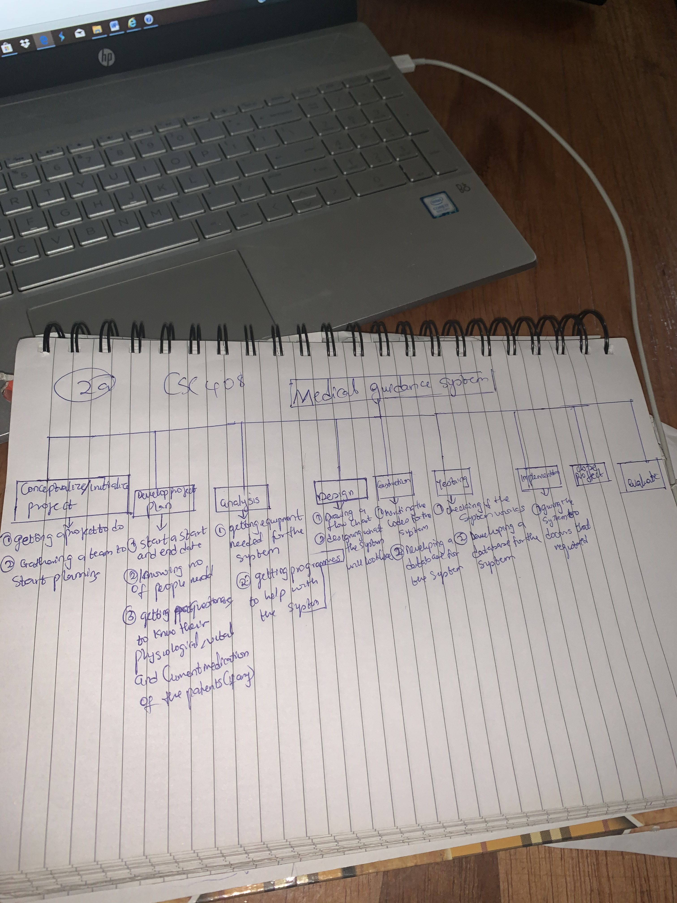

3. IT project management is the process of planning, organizing and delineating responsibility for the completion of an organizations' specific information technology (IT) goals.

IT project management includes overseeing projects for software development, hardware installations, network upgrades, cloud computing and virtualization rollouts, business analytics and data management projects and implementing IT services.

In addition to the normal problems that can cause a project to fail, factors that can negatively affect the success of an IT project include advances in technology during the project's execution, infrastructure changes that impact security and data management and unknown dependent relationships among hardware, software, network infrastructure and data. IT projects may also succumb to the first-time, first-use penalty which represents the total risk an organization assumes when implementing a new technology for the first time. Because the technology hasn’t been implemented or used before in the organization, there are likely to be complications that will affect the project’s likelihood of success.
Project management is important because it ensures there’s a proper plan for executing on strategic goals.

As project managers, we position ourselves to prevent such a situation and drive the timely accomplishment of tasks, by breaking up a project into tasks for our teams. Oftentimes, the foresight to take such an approach is what differentiates good project management from bad. Breaking up into smaller chunks of work enables teams to remain focused on clear objectives, gear their efforts towards achieving the ultimate goal through the completion of smaller steps and to quickly identify risks, since risk management is important in project management.

