NAME: AKUH OjoAjogu Joseph Yusuf
MATRIC NUMBER: 17/ENG06/008
DEPARTMENT: Mechanical Engineering
COURSE TITLE: Electrical Machines II
COURSE CODE: EEE326
LECTURERS IN CHARGE: Professor S.T. Wara and Engr. Ayamolowo
ASSIGNMENT 2

ANSWERS
Question1
1a) - A single phase induction motor does not have a self-starting torque
- During light load conditions, the power factor of the load drops to a very low value
- The speed control of an induction motor is very hard to attain.
- Due to poor starting torque the motor cannot be used for applications which requires high starting torque.
1b) According to double field revolving theory, we can resolve any alternating quantity into two components. Each component has a magnitude equal to the half of the maximum magnitude of the alternating quantity, and both these components rotate in the opposite direction to each other. For example – a flux, φ can be resolved into two components
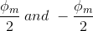
each of these components rotates in the opposite direction i. e if one φ_{m}/2 is rotating in a clockwise direction then the other φ_{m} / 2 rotates in an anticlockwise direction.
When we apply a single phase AC supply to the stator winding of single phase induction motor, it produces its flux of magnitude, φ_{m}. According to the double field revolving theory, this alternating flux, φ_{m} is divided into two components of magnitude φ_{m}/2. Each of these components will rotate in the opposite direction, with the synchronous speed, N_{s}.
Let us call these two components of flux as forwarding component of flux, φ_{f} and the backward component of flux, φ_{b}. The resultant of these two components of flux at any instant of time gives the value of instantaneous stator flux at that particular instant.
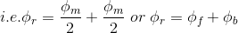
Now at starting condition, both the forward and backward components of flux are exactly opposite to each other. Also, both of these components of flux are equal in magnitude. So, they cancel each other and hence the net torque experienced by the rotor at the starting condition is zero. So, the single phase induction motors are not self-starting motors.

1c) Constructional features of a single phase IM
All the single phase induction motor have one construction feature in common, viz, the auxiliary starting winding. The starting winding is provided so that, together with the main or working winding, the motor can stimulate a two phase motor to develop torque at start. In the case of the permanent capacitor the auxiliary winding remains in the circuit after starting and thus closely approximates a two-phase motor also when it is operating under load. Hence the term ‘split phase’ may rightly be applied to all the single phase induction motors
Principle of operation single phase induction motor
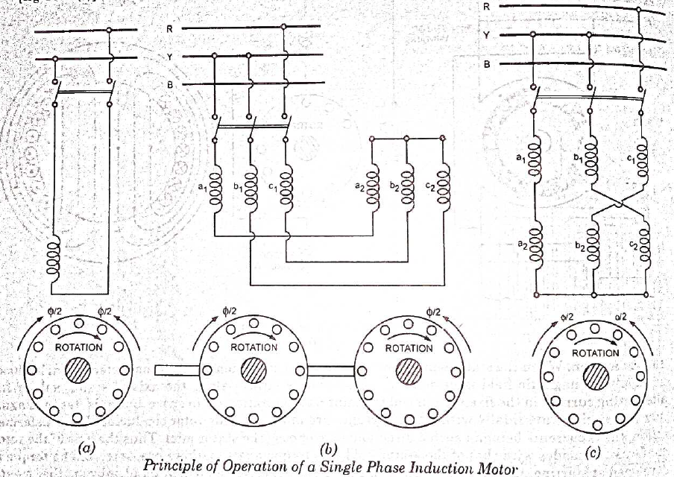
Under stationary rotor conditions (i.e, when speed N = 0 or slip s = 1), the two rotating fields slip pass the rotor at the same slip, s = 1 and inducing equal currents in the squirrel cage rotor. The two rotating fields are of the same strength and develop equal and opposite electro-magnetic torques resulting in net torque of zero value. Thus the starting torque is zero and the single phase induction motor is non- self-starting. Further, the two rotating fields induce a resultant EMF in the stator which balances the applied voltage assuming low leakage impedance of the stator winding.

1d) Torque Slip Characteristics of Single Phase Induction Motor
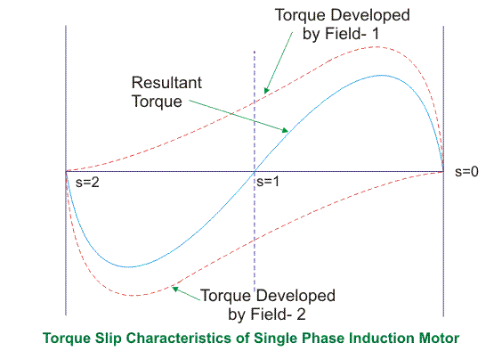
From the figure, we see that at a slip of unity, both forward and backward field develops equal torque but the direction of which are opposite to each other so the net torque produced is zero hence the motor fails to start. From here we can say that these motors are not self-starting unlike the case of three phase induction motor. There must be some means to provide the starting torque. If by some means, we can increase the forward speed of the machine due to which the forward slip decreases the forward torque will increase and the reverse torque will decrease as a result of which motor will start.
From here we can conclude that for starting of single phase induction motor, there should be a production of difference of torque between the forward and backward field. If the forward field torque is larger than the backward field than the motor rotates in forward or anti clockwise direction. If the torque due to backward field is larger compared to other, then the motor rotates in backward or clockwise direction. They are not self-starting because in induction machine a rotating magnetic field is required to produce torque. A rotating magnetic field can produced if we have balanced three phase supply and each phase is electrically spaced 120 to each other OR we have required minimum two phase but in single phase induction motor there is single phase supply to the stator of motor. A single phase supply cannot produce a rotating magnetic field but it produce a pulsating magnetic field which does not rotate. Due to this pulsating magnetic field torque cannot produce so motor is not self-start.
1e) - Split phase induction motor.
- Capacitor start induction motor
- Capacitor start capacitor run induction motor
- Permanent split capacitor motor
- Shaded pole induction motor

Shaded Pole Single Phase Induction Motors
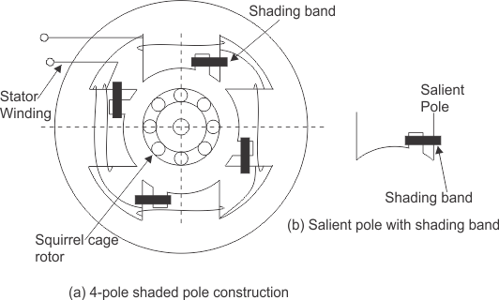
The stator of the shaded pole single phase induction motor has salient or projected poles. These poles are shaded by copper band or ring which is inductive in nature. The poles are divided into two unequal halves. The smaller portion carries the copper band and is called as shaded portion of the pole.
ACTION: When a single phase supply is given to the stator of shaded pole induction motor an alternating flux is produced. This change of flux induces emf in the shaded coil. Since this shaded portion is short circuited, the current is produced in it in such a direction to oppose the main flux. The flux in shaded pole lags behind the flux in the unshaded pole. The phase difference between these two fluxes produces resultant rotating flux.
We know that the stator winding current is alternating in nature and so is the flux produced by the stator current. In order to clearly understand the working of shaded pole induction motor consider three regions-
    - When the flux changes its value from zero to nearly maximum positive value.
    - When the flux remains almost constant at its maximum value.
    - When the flux decreases from maximum positive value to zero.
REGION 1:
When the flux changes its value from zero to nearly maximum positive value – In this region the rate of rise of flux and hence current is very high. According to Faraday’s law whenever there is change in flux emf gets induced. Since the copper band is short circuit the current starts flowing in the copper band due to this induced emf. This current in copper band produces its own flux. Now according to Lenz’s law the direction of this current in copper band is such that it opposes its own cause i.e rise in current. So the shaded ring flux opposes the main flux, which leads to the crowding of flux in non shaded part of stator and the flux weaken in shaded part. This non uniform distribution of flux causes magnetic axis to shift in the middle of the non shaded part.
REGION 2:
When the flux remains almost constant at its maximum value- In this region the rate of rise of current and hence flux remains almost constant. Hence there is very little induced emf in the shaded portion. The flux produced by this induced emf has no effect on the main flux and hence distribution of flux remains uniform and the magnetic axis lies at the center of the pole.
REGION 3:
When the flux decreases from maximum positive value to zero – In this region the rate of decrease in the flux and hence current is very high. According to Faraday’s law whenever there is change in flux emf gets induced. Since the copper band is short circuit the current starts flowing in the copper band due to this induced emf. This current in copper band produces its own flux. Now according to Lenz’s law the direction of the current in copper band is such that it opposes its own cause i.e decrease in current. So the shaded ring flux aids the main flux, which leads to the crowding of flux in shaded part of stator and the flux weaken in non shaded part. This non uniform distribution of flux causes magnetic axis to shift in the middle of the shaded part of the pole.
This shifting of magnetic axis continues for negative cycle also and leads to the production of rotating magnetic field. The direction of this field is from non shaded part of the pole to the shaded part of the pole.

Split Phase Induction Motor
In addition to the main winding or running winding, the stator of single phase induction motor carries another winding called auxiliary winding or starting winding. A centrifugal switch is connected in series with auxiliary winding. The purpose of this switch is to disconnect the auxiliary winding from the main circuit when the motor attains a speed up to 75 to 80% of the synchronous speed. We know that the running winding is inductive in nature. Our aim is to create the phase difference between the two winding and this is possible if the starting winding carries high resistance. Let us say
I_{run} is the current flowing through the main or running winding,
I_{start} is the current flowing in starting winding,
and V_{T} is the supply voltage.
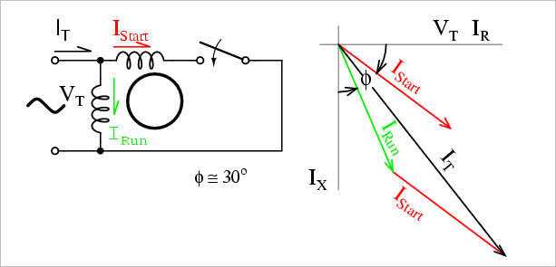
We know that for highly resistive winding the current is almost in phase with the voltageand for highly inductive winding the current lag behind the voltage by large angle. The starting winding is highly resistive so, the current flowing in the starting winding lags behind the applied voltage by very small angle and the running winding is highly inductive in nature so, the current flowing in running winding lags behind applied voltage by large angle. The resultant of these two current is I_{T}. The resultant of these two current produce rotating magnetic field which rotates in one direction. In split phase induction motor the starting and main current get splitted from each other by some angle so this motor got its name as split phase induction motor.

Applications of Split Phase Induction Motor
Split phase induction motors have low starting current and moderate starting torque. So these motors are used in fans, blowers, centrifugal pumps, washing machine, grinder, lathes, air conditioning fans, etc. These motors are available in the size ranging from 1/20 to 1/2 KW.
1f)
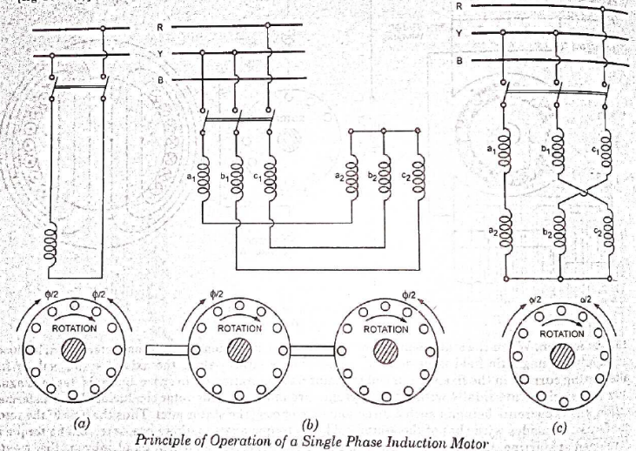
Under stationary rotor conditions (i.e, when speed N = 0 or slip s = 1), the two rotating fields slip pass the rotor at the same slip, s = 1 and inducing equal currents in the squirrel cage rotor. The two rotating fields are of the same strength and develop equal and opposite electro-magnetic torques resulting in net torque of zero value. Thus the starting torque is zero and the single phase induction motor is non- self-starting. Further, the two rotating fields induce a resultant EMF in the stator which balances the applied voltage assuming low leakage impedance of the stator winding.
QUESTION 2
2a) The universal motor is a type of electric motor that can operate on either AC or DC power and uses a electromagnet as the stator to create its magnetic field. The applications includes
- Blenders
- Vacuum cleaners
- Hair dryers
- Wind trimmer
- Drills

2b) Construction of Universal Motor:
Construction of a universal motor is very similar to the construction of a DC machine. It consists of a stator on which field poles are mounted. Field coils are wound on the field poles.

Non-Compensated Universal Motor:
The Non-compensated motor has two salient poles and it is laminated as shown in figure below.
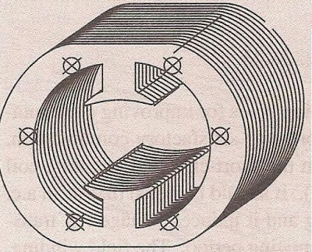
The armature is of wound type and the laminated core is either straight or skewed slots. The leads of the armature winding are connected to the commutator. High resistance brushes are used along with this type of motor to help better commutation. An equivalent Non-compensated type Universal Motor is shown in figure below.
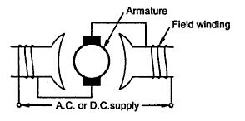

Compensated Type with Distributed Field:
The compensated type Universal Motor consists of distributed field winding and the stator core is similar to that of split-phase motor. We know that split phase motors consist of an auxiliary winding in addition to main winding. Similar to the split phase motors, the compensated type also consists of an additional winding. The compensating winding helps in reducing the reactance voltage which is caused due to alternating flux, when the motor runs with the AC supply.
An equivalent Compensated type Universal Motor is shown in figure below.
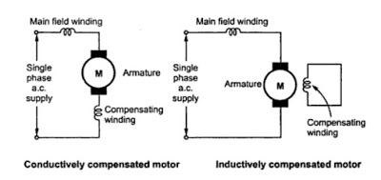
2c) there is no difference. A universal motor has its rotor and stator windings connected in series, and it can run on both AC and DC that is why it’s called universal, or sometimes a DC series motor. It is mostly used in home appliances, electric tools and so on. Because it has a high speed.

QUESTION 3

3a) Principle of Operation of 3-Phase Induction Motor
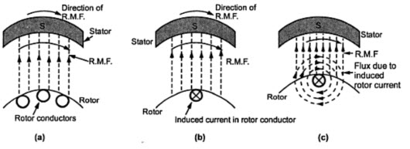Principle of Operation of 3-Phase Induction Motor
- When the motor is excited with three-phase supply,three-phase stator winding produce a rotating magnetic field with 120 displacements at constant magnitude which rotates at synchronous speed. This changing magnetic field cuts the rotor conductors and induces a current in them according to the principle of Faraday’s laws of electromagnetic induction. As these rotor conductors are shorted, the current starts to flow through these conductors.
- In the presence of magnetic field of stator, rotor conductors are placed, and therefore, according to the Lorenz force principle, a mechanical force acts on the rotor conductor. Thus, all the rotor conductors force, i.e., the sum of the mechanical forces produces torque in the rotor which tends to move it in the same direction of rotating magnetic field.
- This rotor conductor’s rotation can also be explained by Lenz’s law which tells that the induced currents in the rotor oppose the cause for its production, here this opposition is rotating magnetic field. This result the rotor starts rotating in the same direction of the stator rotating magnetic field. If the rotor speed more than stator speed,then no current will induce in the rotor because the reason for rotor rotation is the relative speed of the rotor and stator magnetic fields. This stator and the rotor fields difference is called as slip. This how 3-phase motor is called as asynchronous machine due to this relative speed difference between the stator and the rotors.
- As we discussed above, the relative speed between the stator field and the rotor conductors causes to rotate the rotor in a particular direction. Hence, for producing the rotation, the rotor speed Nr must always be less than the stator field speed Ns, and the difference between these two parameters depends on the load on the motor.

3b) Advantages

- They have very simple and rugged (almost unbreakable) construction
- they are very reliable and having low cost
- they have high efficiency and good power factor
- minimum maintenance required
- 3 phase induction motor is self starting hence extra starting motor or any special starting arrangement is not required
- 3 phase induction motors will have self starting torque unlike synchronous motors, hence no starting methods are employed unlike synchronous motor. However, single-phase induction motors does not have self starting torque, and are made to rotate using some auxiliaries.

Disadvantages
- Unbalanced loading ( can cause voltage fluctuations )
- Complex System (requires symmetrical components for analysis and operation )
- Phase Sequence needed to be kept in mind while making connections

3c) The equivalent motor resistance referred to stator =
R₀₁= $R_{1}+\frac{R_{2}}{X_{2}}$ = 0.06+0.06 = 0.12Ω.
The equivalent motor reactance referred to stator,
X₀₁ = $X_{1}+\frac{X_{2}}{k^{2}}$ = 0.2+0.22 = 0.42Ω
Motor impedance
Z₀₁ = $\sqrt{\left(R_{01}^{2}\right)+\left(X_{01}^{2}\right)}$ = $\sqrt{{(0.12)}^{2}+{(0.42)}^{2}}$ = 0.437Ω.
s =
$$\frac{\frac{R_{2}}{K^{2}}}{\frac{R_{2}}{K^{2}}+Z_{01}}$$=
$$\frac{0.06}{0.06+0.437}$$= 0.12
Maximum gross power output
=
$$\frac{3V^{2}}{2(R_{01}+Z_{01}}$$=
$$\frac{3×\left(\frac{400}{\sqrt{3}}\right)\underset{←}{2}}{2(0.12+0.437)}$$
= 143,626w or 143.63kw

3d)
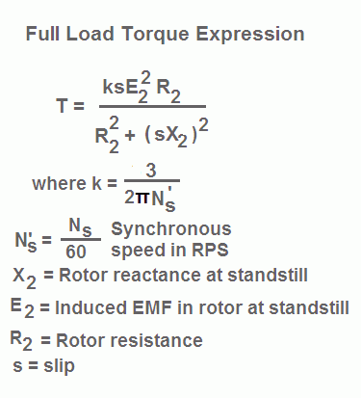
Thus, at low values of slip, torque is approximately proportional to slip s and the torque slip characteristics of induction motor is a straight line as shown in the figure. The region (from s = 0 to s = sm) is called the stable region of operation and operating point of the motor should be in this region. In the stable region, the value of slip is small. Hence this region is also called as the low slip region.

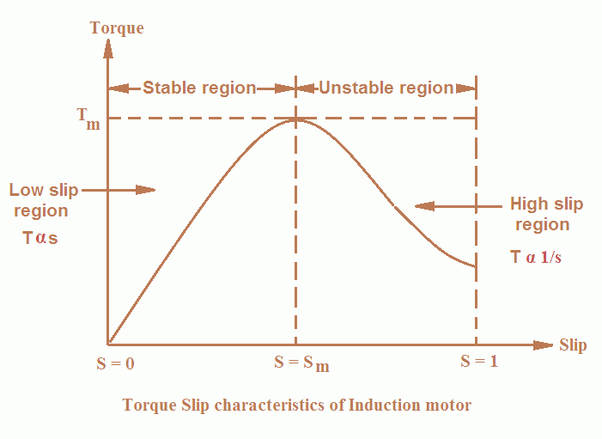
As the slip increases torque increases and attains its maximum value when s = R2/X2. This maximum value of torque is also known as break down or pull out torque. When a further increase in slip occurs due to increase in load beyond the point maximum torque
Thus at higher values of slip (i.e. the slip beyond that corresponding to maximum torque) torque is approximately inversely proportional to slip, s and the torque slip characteristics of induction motor is rectangular hyperbola as shown in the figure. The region (extending from s = sm to s = 1) is called unstable region. In this region with the increase in load, slip increases but torque decreases. The result is that the motor could not pick up the load and slows down and eventually stops. In the unstable region, the value of slip is large so this region is also called as the high-slip region.
3e)
20 Rps = rpm = 20 x 60 = 1200rpm
15rps = rpm = 15 x 60 = 900 rpm
Ns =
$$\frac{120f}{p}$$
$$\frac{120 ×60}{1200}=6poles$$
$$\% slip= \left\lfloor \frac{Ns-Nr}{Ns}\right\rfloor ×100$$
=
$$\left\lfloor \frac{1200-900}{1200}\right\rfloor ×100=25\%$$
F’= sf
F’= 0.25 x 60 = 15Hz
Ns-Nr = 1200 -900 = 300
F’= SF
0.1 X 60 = 6Hz

Question 4
4a) – changing the applied voltage
- Changing the applied frequency
- Changing the number of stator poles
- Constant v/f control of induction motor
- By injecting emf in rotor circuit
4b) - Direct On-Line Starter (DOL)
- Star-Delta Starter
- Auto Transformer Starter
- Rotor Impedance Starter
4c) Direct On-Line Starter (DOL): The Direct On-Line (DOL) starter is the simplest and the most inexpensive of all starting methods and is usually used for squirrel cage induction motors. It directly connects the contacts of the motor to the full supply voltage. The starting current is very large, normally 6 to 8 times the rated current. The starting torque is likely to be 0.75 to 2 times the full load torque. In order to avoid excessive voltage drops in the supply line due to high starting currents, the DOL starter is used only for motors with a rating of less than 5KW. There are safety mechanisms inside the DOL starter which provides protection to the motor as well as the operator of the motor. The power and control circuits of induction motor with DOL starter are shown in figure1.
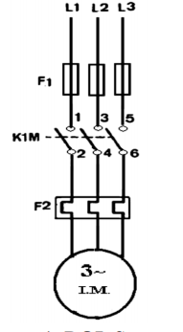
Star-Delta Starter: The star delta starting is a very common type of starter and extensively used, compared to the other types of the starters. This method used reduced supply voltage in starting. Figure 2 shows the connection of a 3phase induction motor with a star – delta starter. The method achieved low starting current by first connecting the stator winding in star configuration, and then after the motor reaches a certain speed, throw switch changes the winding arrangements from star to delta configuration. By connecting the stator windings, first in star and then in delta, the line current drawn by the motor at starting is reduced to one-third as compared to starting current with the windings connected in delta. At the time of starting when the stator windings are start connected, each stator phase gets voltage VL/√3 , where VL is the line voltage. Since the torque developed by an induction motor is proportional to the square of the applied voltage, star- delta starting reduced the starting torque to one – third that obtainable by direct delta starting.
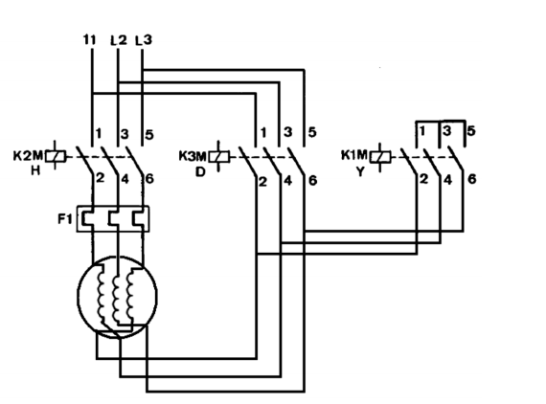

QUESTION 5
5a) There could be many reasons to test an induction motor.
- The simplest would be to find out if it works.
- You could test it to see if it performs in accordance with its specifications.
- You could test it to determine the machine parameters necessary for modeling and vector controlling the machine.
- You could test it for reliability and lifetime.
- You could test it to failure to see how much performance margin it has.
5b) SIMILARITIES
- the shaft of the motor is locked so that it cannot move and the rotor winding is short circuited.
- In the slip ring motor, the rotor winding is short circuited through the slip rings
DIFFERENCES
- in a blocked rotor test the rotor is blocked so that it cannot move, a voltage is applied to the motor, and the resulting voltage, current and power are measured while in a short circuit test the test is performed at a rated frequency and with balanced polyphase voltages applied to the stator terminal
- in a short circuit test as the motor is no load the power factor is very low whch is less than 0.5 while the block rotor test is conducted at low voltage because if the applied voltage was normal voltage then the current flowing through the stator windings were high enough to overheat the windings and damage them
5c) SIMILARITIES
- Open circuit test or no load test on a transformer is performed to determine 'no load loss (core loss)' and 'no load current
- The open circuit and no load test are performed for determining the parameter of the transformer like their efficiency, voltage regulation, circuit constant
DIFFERENCES
- The purpose of the open circuit test is to determine the no-load current and losses of the transformer because of which their no-load parameter are determined. While the no load test determines the copper loss occur on the full load. The copper loss is used for finding the efficiency of the transformer.

- A open circuit test is conducted when the secondary of the transformer is kept in open condition without connecting any load with it. Thus there will not be any current in the secondary coil. While A no load test is conducted shorting the secondary terminals. Thus there will be huge current flow in the secondary coil when voltage is applied in the primary.

5d) – power supply test
- Ac motor winding continuity test
- Ac motor winding resistance test
- Insulation resistance test
Power Supply Test
For three phase motors, the expected voltage for a 230/400V system is 230V phase to neutral and 400V between each of the three phase supply lines. Check that the correct voltage is applied to the motor using a multimeter. Ensure the terminal for power supply is in good condition. Check the connection bar for terminal (U, V, and W). three phase motors, connection type is either Star (Y) or Delta.
5d)

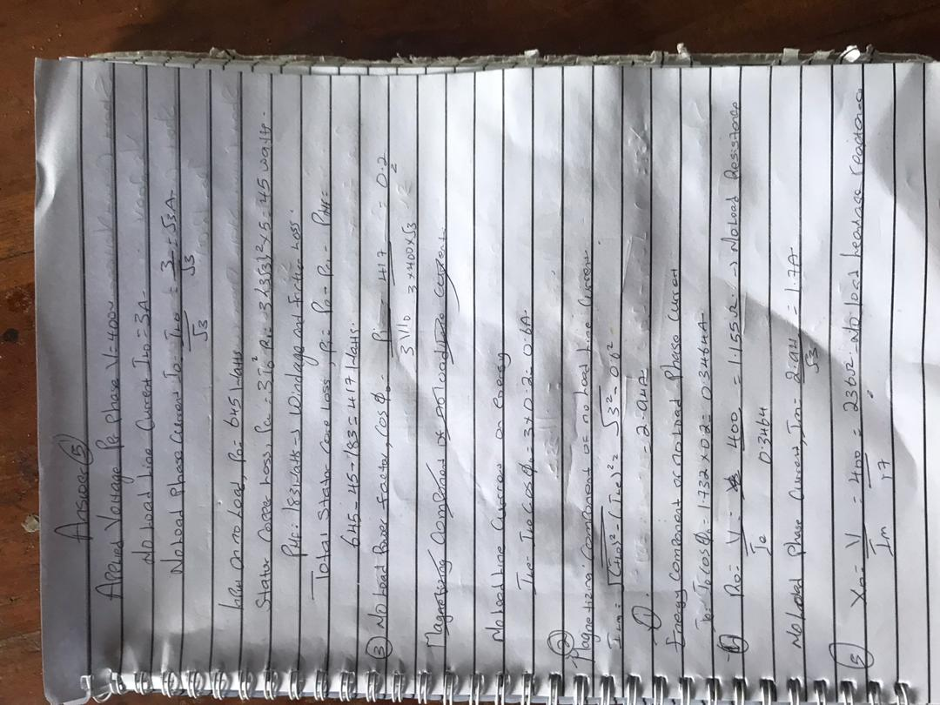
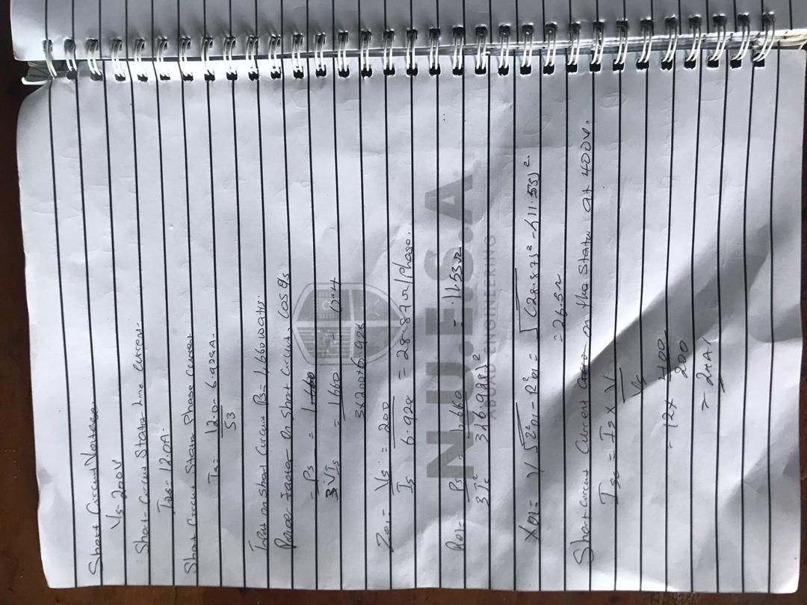

Question 6
6a) synchronous generator converts mechanical energy to Electrical energy. The source of which creates the mechanical energy may be a steam engine, water falling through a waterwheel, a wind turbine, a hand crank or via compressed air.
A synchronous generator has 2 main parts:
1) Stator
2) Rotor
The Rotor is the rotating part whereas the Stator is the stationary part, hence where they get their names from.
- Rotor has north and south poles protruded on it, in the case of salient poles, on which Laminations are used to reduce Eddy losses. The north and south poles of the rotor are wrapped with windings, the number of poles will always be even and dependent on the speed of the generator.
- A separate DC supply is provided to the rotor with the help of slip rings and brushes and the current is passed to windings on the rotor. The rotor is attached to the shaft which makes the rotor rotate. As winding carrying current is under permanent magnet poles of rotor it will itself creates its own magnetic field
- Stator is the stationary part . it is the section made of steel plates combined together with windings on it at 120 degree intervals to balance it out.
- Now as the rotor rotates its magnetic field will cut the windings of the Stator and this in turn will cause an AC voltage to be induced in the Stator windings and an AC current is drawn.
A synchronous generator operates on the amount of poles wound within its stator. The more poles in the stator equates to a smaller rev/min. For example a 2 pole generator would run at maximum of 3000r/min whereas a 4 pole generator would only run at 1500r/min. This is done with the equation F=NsP to find the speed at which the motor runs at. The rotation of the shaft is synchronized with the frequency of the supply current, which means the rotation period is exactly equal to the number of AC cycles.
I would also use Faradays law to help explain the principle of operation with calculations. Faradays law means that the amount of voltage created is equal to the change in magnetic flux divided by the change in time. The bigger the change you have in the magnetic field, the greater amount of voltage.
Fleming's right hand rule (for generators) shows the direction of induced current when a conductor moves in a magnetic field. No current is induced if the motion of the conductor is in line with the field, going either direction, and the same can be said if it runs parallel to current.
The right hand is held with the thumb, first finger and second finger mutually perpendicular to each other (at right angles), as shown in the diagram .
- The Thumb represents the direction of Motion of the conductor.
- The First finger represents the direction of the Field. (north to south)
The Second finger represents the direction of the induced or generated Current (the direction of the induced current will be the direction of conventional current, from positive to negative.
6b)
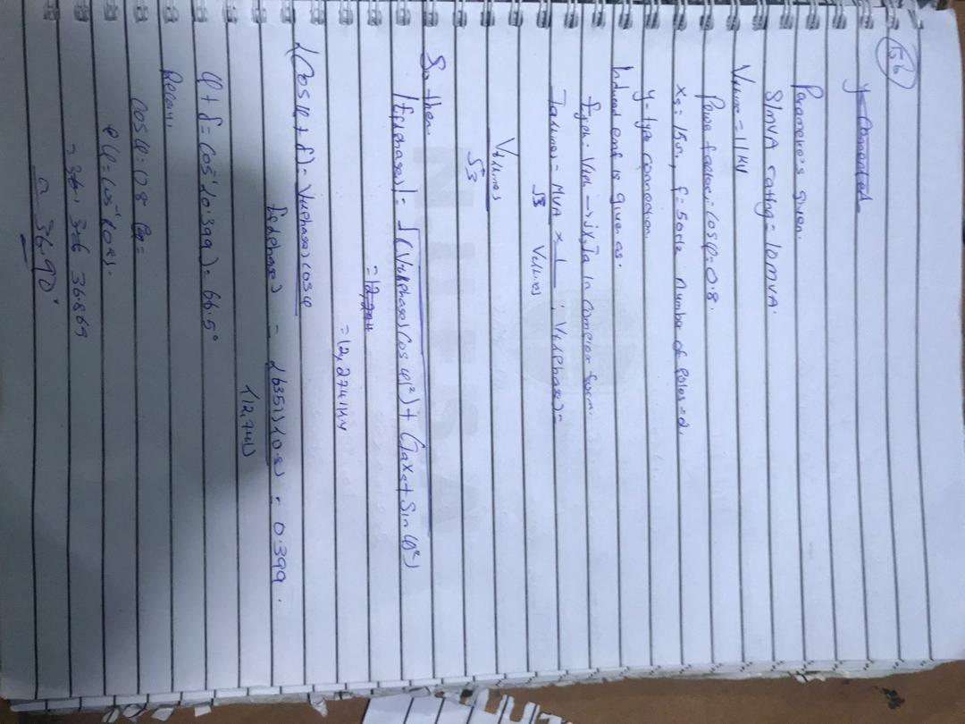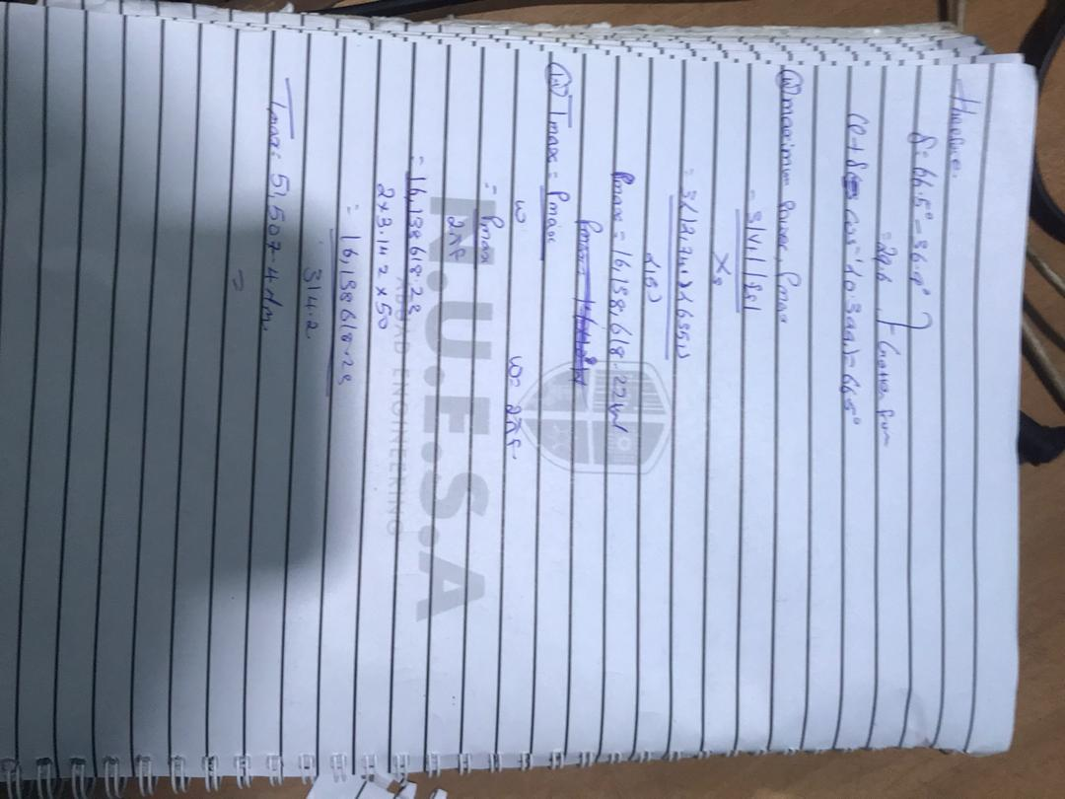
6c)
Parallel operation of generators is by far the most common form of operation. Generators may be operated in parallel on a small scale, e.g. two or three generators operating in parallel to provide power to a remote community, or large scale, e.g. the north american power grid
Benefits of parallel operation include
- Redundancy: failure of one unit does not affect the integrity of the power supply, generators may be taken out of service for preventative maintenance
- Scaling: many units can combine to provide a power demand, rather than requiring fewer very large generators
- Resource management: generators can be located and operated to best meet the generating conditions, instead of having to be located and operated to meet the requirements of a local load. An example of this may be a nuclear power plant, which may take many weeks to bring up to full operating conditions. Using a nuclear generating station at full power to meet a "base load" with smaller more rapid response generators is one way to supply fluctuating load requirements.
- Efficiency: Generators operating at full load are more efficient than those operating at low loads. It is more efficient to meet a changing load by adding or removing smaller generators than having a single large generator operating inefficiently.
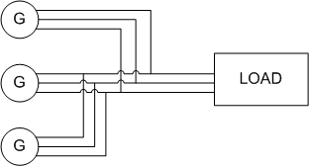FIG. 1. EXAMPLE CIRCUIT OF THREE GENERATORS OPERATING IN PARALLEL TO SUPPLY A LOAD

Voltage and Frequency Variation

V-Q Relationship
When considering synchronous generators operating alone it becomes clear that the terminal voltage of the machine is dependent on the reactive power being supplied to the load. When supplying more reactive power, the termial voltage falls. In general, the effect of changes to terminal voltage with reactive load can be plotted as shown. Increasing the inductive load on the generator reduces the terminal voltage, adding capacitance increases the terminal voltage. Reductions to the terminal voltage can be compensated by increasing the no load voltage EE
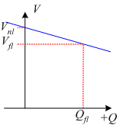FIG. 2. GENERATOR VOLTAGE VARIATION WITH REACTIVE POWER

f-P Relationship
The output power of a generator is largely independent of the actual generator control. The ouput power closely matches in the input power from the prime mover. The speed of rotation of the generator is also set by the prime mover, with the frequency of the open circuit induced voltage directly determined by rotational speed:
f=p120nsf=p120ns
In order to understand the frequency-power relationship, it is important to try to understand the mechanical system that drives the generator. At no-load, the mechanical system is rotating at the no-load speed, nnlnnl and results in the generation of voltages at no load frequency nflnfl.
When the generator is loaded, power is drawn from the mechanical system and the generator applies a torque which opposes the direction of motion of the mechanical system. As a result, the generator tends to slow down the mechanical system. (In the same way that when you are driving on a flat road and then start to go up a hill, the car slows down).
In a synchronous generator, changing mechanical speed is undesirable, as it results in a change in the frequency of the induced voltages. For this reason, a "governor" is applied to the mechanical system to make the change in speed predictable with power changes. The mechanical governor sets the no-load speed and controls the reduction in speed so that the speed-power relationship is linear. This relationship is shown in Fig. 3. It is important to stress that this is not a function of the generator, but of how the mechanical system is controlled.
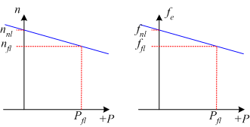FIG. 3. GENERATOR FREQUENCY VARIATION WITH POWER OUTPUT
If the frequency of the generated voltages is too low, the frequency can be increased by increasing the no-load speed of the mechanical governor (equivalent to a cruise control in a car increasing the gas fed to the engine when the car goes up hill).
Mathematically, the changes in frequency with load are described using two quantities, the Speed Droop SDSD and the slope of the power-frequency plot, SpSp .
Speed Droop, SDSD is defined as
SD=nnl−nflnfl×100%=fnl−fflffl×100%SD=nnl−nflnfl×100%=fnl−fflffl×100%
Typical values for speed droop are in the range 2% - 4%
The power from the generator can be found using
P=Sp(fnl−fsys)P=Sp(fnl−fsys)
where
Sp=ΔPΔf=Pflfnl−fnlSp=ΔPΔf=Pflfnl−fnl
The slope SpSp is often quoted in kW/Hz or MW/Hz.
In the above equations, subscripts nl,flnl,fl refer to no-load and full-load operation respectively and syssys refers to the operating system frequency.

Infinite Bus
The infinite bus is a useful concept that summarizes how most people already view the power grid. It can be applied when the power grid is sufficiently large that the action of any one user or generator will not affect the operation of the power grid.
In an infinite bus:
- System frequency is constant, independent of power flow
- System voltage is constant, independent of reactive power consumed or supplied
An infinite bus assumed in many small electrical applications. As an example, we take for granted that the voltage supply to a residential outlet will be 120V and 60Hz: the voltage and frequency are not changed when you turn the TV on.
Frequency-power and voltage-reactive power plots for an infinite bus are shown in Fig. 4.
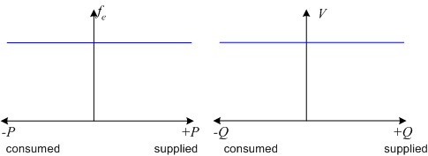FIG. 4. F-P AND V-Q PLOTS FOR AN INFINITE BUS

