NAME; DADA MOYINOLUWA GRACE
MATRIC NO; 17/MHS02/104

QUALITATIVE DATA COLLECTION METHODS
Unlike quantitative data, which deals with numbers and figures, qualitative data is descriptive in nature rather than numerical. Qualitative data is usually not easily measurable as quantitative and can be gained through observation or open-ended survey or interview questions.
Qualitative research is most likely to provide answers to questions such as “why?” and “how?”
As mentioned, qualitative data collection methods are most likely to consist of open-ended questions and descriptive answers and little or no numerical value. Qualitative data is an excellent way to gain insight into your audience’s thoughts and behavior (maybe the ones you identified using quantitative research, but wasn’t able to analyze in greater detail).
Qualitative data collection methods include
1. Open-Ended Surveys and Questionnaires
Opposite to closed-ended are open-ended surveys and questionnaires. The main difference between the two is the fact that closed-ended surveys offer predefined answer options the respondent must choose from, whereas open-ended surveys allow the respondents much more freedom and flexibility when providing their answers.
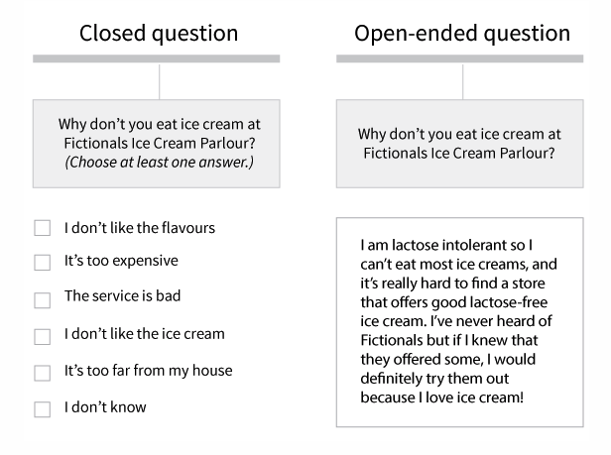
Here’s an example that best illustrates the difference
2. 1 on 1 Interview
One-on-one (or face-to-face) interviews are one of the most common types of data collection methods in qualitative research. Here, the interviewer collects data directly from the interviewee. Due to it being a very personal approach, this data collection technique is perfect when you need to gather highly-personalized data.
Depending on your specific needs, the interview can be informal, unstructured, conversational, and even spontaneous (as if you were talking to your friend) – in which case it’s more difficult and time-consuming to process the obtained data – or it can be semi-structured and standardized to a certain extent (if you, for example, ask the same series of open-ended questions).

3. Focus groups
The focus groups data collection method is essentially an interview method, but instead of being done 1-on-1, here we have a group discussion.
Whenever the resources for 1-on-1 interviews are limited (whether in terms of people, money, or time) or you need to recreate a particular social situation in order to gather data on people’s attitudes and behaviors, focus groups can come in very handy.
Ideally, a focus group should have 3-10 people, plus a moderator. Of course, depending on the research goal and what the data obtained is to be used for, there should be some common denominators for all the members of the focus group.
For example, if you’re doing a study on the rehabilitation of teenage female drug users, all the members of your focus group have to be girls recovering from drug addiction. Other parameters, such as age, education, employment, marital status do not have to be similar.

4. Direct observation
Direct observation is one of the most passive qualitative data collection methods. Here, the data collector takes a participatory stance, observing the setting in which the subjects of their observation are while taking down notes, video/audio recordings, photos, and so on.
Due to its participatory nature, direct observation can lead to bias in research, as the participation may influence the attitudes and opinions of the researcher, making it challenging for them to remain objective. Plus, the fact that the researcher is a participant too can affect the naturalness of the actions and behaviors of subjects who know they’re being observed.

