NAME: OMOLADE BRIGHT AYOMIDE
MATRIC NO: 19/SCI01/078
DEPARTMENT: COMPUTER SCIENCE
Number 1

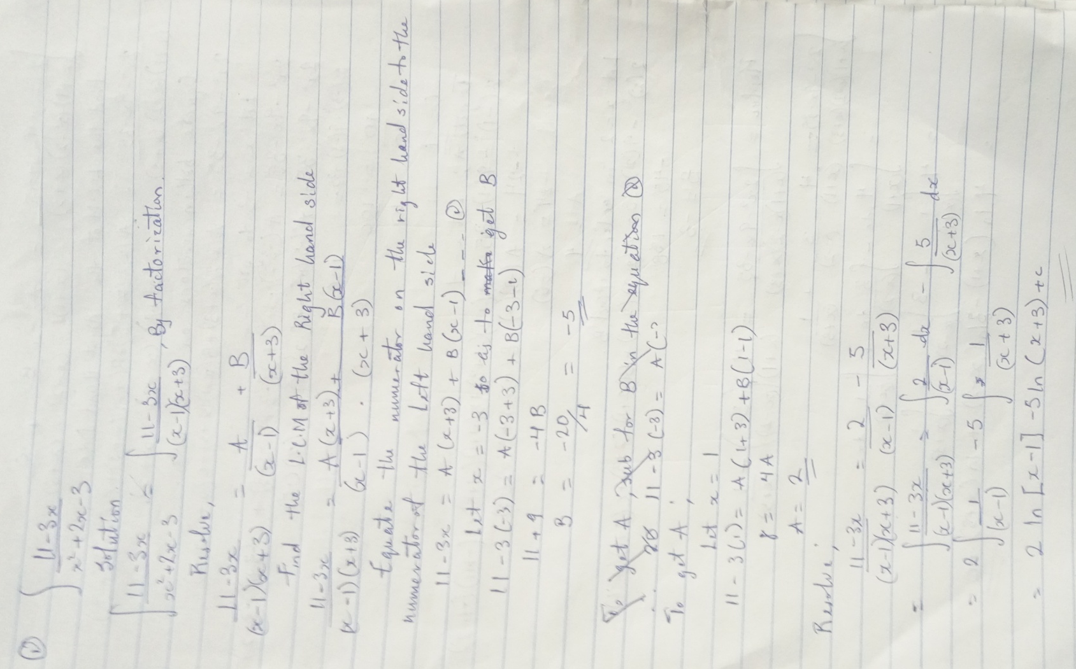

Number 2
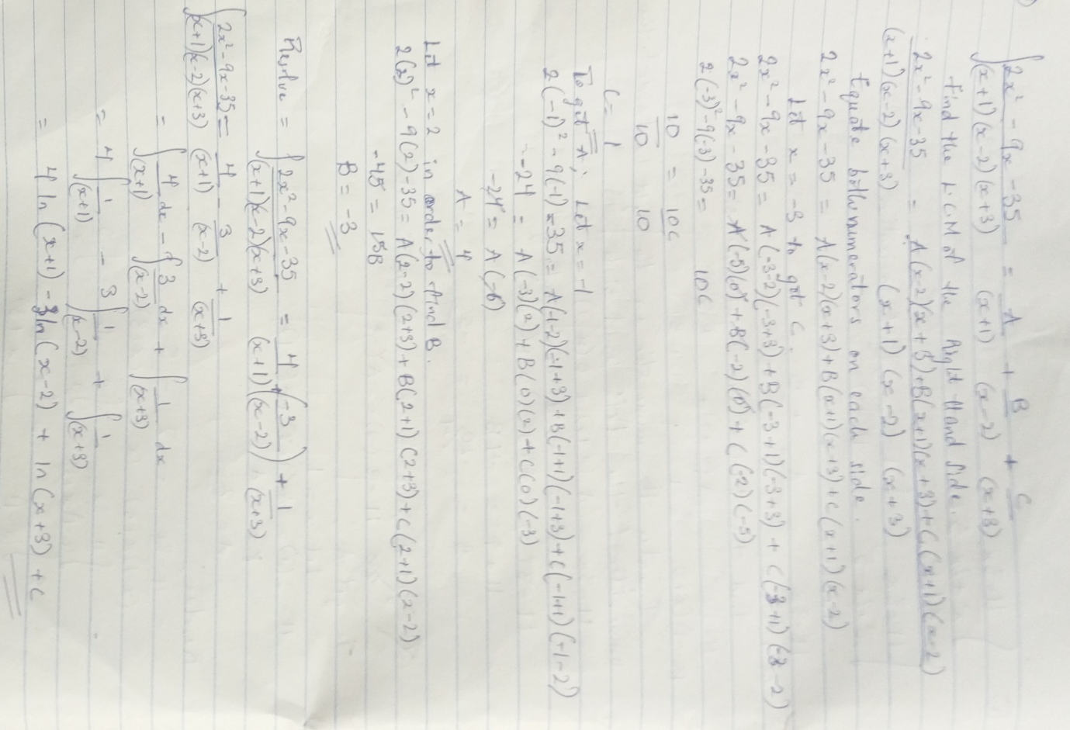

Number 3

