NAME:DUNMOYE AKEEM O.
CIVIL ENGINEERING
17/ENG03/016
- You have been appointed as the civil engr by Mr. Lawrence to construct a building . Highlight ten out of your copious responsibilities from the beginning to the end of the project that will ensure timely completion of the project . Assuming that the client has not appointed any architect .
SOLUTION
- To bring to notice if any discrepancies in drawings, quantities and rates as well as make necessary changes if any.
- Liaising (coordinating) with consultants, subcontractors, supervisors, planners, quantity surveyors and labourers involved in the project.
- To keep an eye on surveying works (i.e. to confirm the boundaries correctly) and setting out (i.e. plotting or marking of the plan on field/site as per plan on the sheet).
- To save on material and labour cost along with adding a valve to the structure.
- Agreeing a price for materials, and making cost-effective solutions.
- Checking of materials at the time of delivery.
- Setting up the sequence of work in accordance with the drawings and specifications.
- To check on safety measures taken by people working on site.
- Resolving technical issues arising, if any, during execution of work.
- Keeping record of drawings, technical reports and site diary.
- Counselling and Supervising junior or trainee engineers and give them health and safety training.

- Differentiate between any 4
- Architectural and civil engr drawing:
Architect drawings or as we call it preliminary design drawing, is a set of drawing that does not represent structural design, but only as general layout and planning for civil engineers (structural and geotechnical) to build on
civil engineering drawing sets are divided into several sub category:
- FEED Drawings (Front-End Engineering Design Drawing), this sets of drawing are usually produced by structual engineer using general estimation and quick calculation. this drawing is guideline for estimators to calculate how much money, material, machinery, manpower and time required for bidding process. this drawings also does not represent structural properties.
- Detailed Engineering Design Drawings, the first “real” output from structural and geotechnical engineering that are produced for structural and geotechnical “trial”/judging by government-appointed independent experts. the final revision (after the judging process) is the drawing that will be used for construction and does represent the structural properties. this drawing usually made into 3 legalized copies and stored in City Archive, the structural and geotechnical engineers themselves and the client(s).
- shop drawing, shop drawings are sets of drawing that provides very detailed instructions by structural and geotechnical engineers (i.e the details of foundation and base slab joint, Column A-1 joint with Beam A, rebar position for pile foundation, etc), so that the contractor (a.k.a project engineer) can build it.
- As-Built drawing, this drawings are provided by Project Engineer as proof that he/she has carried out the instruction (from structural and geotechnical engineers) with exact precision or with several changes due to one or two technical difficulties encountered. this drawings are also made in several legalized copies and then stored in City Archive, Consultant Firm, Contractor Firm and sometimes the client.

- WORKING DRAWINGS AND PRESENTATION DRAWINGS : A Working drawing is a drawing or blueprint based on explanations. It is completed with a thorough plan and views (details, notes, and dimensions) to ensure the product construction or replication without any additional information. it is a scale drawing of an object to be made or structure to be built intended for direct use by the workman, WHILE A Presentation drawing is any of a set of design drawings made to articulate and communicate a design concept or proposal such as for an exhibition, review, or publication intended to explain a scheme and to promote its merits.

- BEME AND BOQ : A Bill of Engineering Measurements and Evaluation (BEME). A BEME review is a description and evaluation of evidence pertinent to a clearly formulated concept that uses explicit scientific methodologies and methods to systematically identify, assemble, critically analyse and synthesise information relevant to the review topic, WHILE The Bill of Quantities (sometimes referred to as 'BOQ' or 'BQ') is a document prepared by the cost consultant that provides project specific measured quantities of the items of work identified by the drawings and specifications in the tender documentation.

- SECTION AND ELEVATION : A Section of an element or a structure is cut through that shows the interior details of how an element/structure/material is made in the inside which reveals more details whereas the elevation is the exterior appearance of the same, WHILE the term 'Elevation' refers to an orthographic projection of the exterior (or sometimes the interior) faces of a building, that is a two-dimensional drawing of the building's façades.

- Types of Staircase
The various types of staircase include;
- Straight Stairs:
Straight stairs are stairs without any changes in direction.

- L Shaped Stairs:
The L shaped stair is a variation of the straight stair with a bend in some portion of the stair. This bend is usually achieved by adding a landing at the transition point.

- U Shaped Stairs:
U shaped stairs are essentially two parallel flights of straight stairs joined by a landing that creates a 180-degree turn in the walk line.
- Spiral Stairs:
Spiral stairs follow a helical arc. They usually have a very compact design and the treads radiate around a central pole.

- Curved Stairs:
Like spiral stairs, curved stairs follow a helical arc. However, they tend to have a much larger radius and typically do not make a full circle.

- Winder Stairs:
Winder stairs are a variation of an L shaped stair but instead of a flat landing, they have pie-shaped or triangular steps at the corner transition.

- Types of Doors and Types of Windows
Types of Doors;
- Based on Location
- Exterior doors.
- Interior doors.
- Based on Materials
- Wooden or Timber doors.
- Glass doors.
- Steel doors.
- PVC doors.
- FRP doors.
- Based on Operation of Door Shutter
- Swinging doors.
- Folding doors.
- Sliding doors.
- Revolving doors.
- Pivot doors.
- Based on Method of Construction
- Panel doors.
- Flush doors.
- Louvered doors.
- Wire gauzed doors.
Types of Windows
- Awning Windows:

Awning windows open out by pivoting from the top of the window sash, operated by a crank.

- Casement Windows:

Casement windows also open out (like awning windows) and usually pivot from side hinges. Many casements have fairly large glass panes to provide ample light that is uninterrupted by muntin bars or other framing.

- Double-Hung and Single-Hung Windows:

Single-hung has a movable lower sash and a fixed upper sash, while double-hung has two movable sashes; the upper sash slides down.

- Picture Windows:

They are often large glass expanses occupying the center portion of a wall to provide broad views and ample sunlight.

- Slider Windows:

Slider windows slide open sideways. Like casements, they can offer clear views and ample ventilation, but they cannot be sealed as tightly as casements.

- Types of Paper Size;

Most printer users are probably already aware of ‘A size’ paper. These are the most widely used, and easily distinguishable paper sizes. These paper sizes are simple to understand, as they increase and decrease in successive order, with A1 being the biggest paper size and A10 the smallest.

Paper Size | Width x Height (mm) | Width x height (inches)
A1 | 594 x 841 mm | 23.4 x 33.1 in
A2 | 420 x 594 mm | 16.5 x 23.4 in
A3 | 297 x 420 mm | 11.7 x 16.5 in
A4 | 210 x 297 mm | 8.3 x 11.7 in
A5 | 148 x 210 mm | 5.8 x 8.3 in

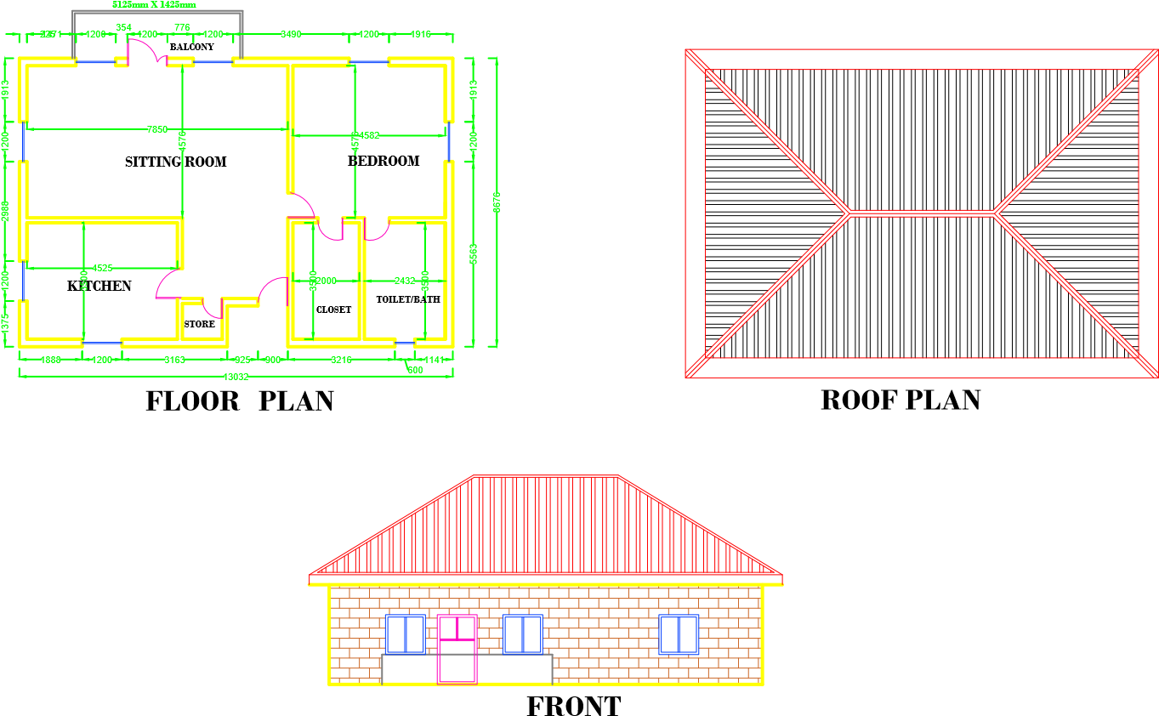
ELEVATION

