NAME: OGBU EMMANUELA KELECHI
MATRIC NO: 17/MHS07/019
COURSE CODE: PHA312
COUSRE TITLE: CHEMOTHERAPY OF PARASITIC DISEASE ANTISEPTICS AND DISENFECANT
- Draw and explain the life cycle of the malaria parasite.
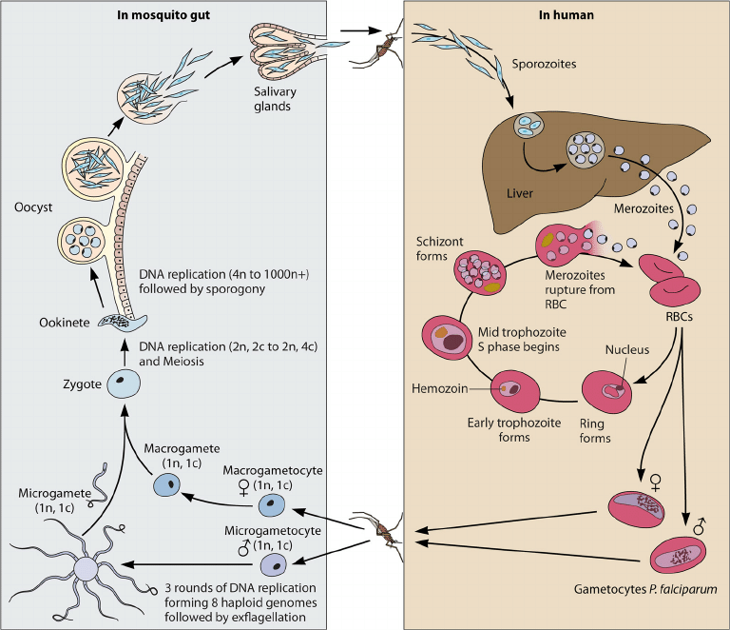
The malaria parasite develops both in humans and in the female anopheles’ mosquitoes.
- Malaria infection begins when an infected female anopheles mosquito bites a person injecting plasmodium parasite, in the form of sporozoites, into the blood stream.
- The sporozoites pass quickly into the human liver.
- The sporozoites multiply asexually in the liver cells over the next 7 to 10days, causing no symptoms.
- In an animal model, the parasites, in the form of merozoites, are released from the liver cells in vesicle, journey through the heart, and arrive in the lungs, where they settle within lung capillaries. The vesicles eventually disintegrate, freeing the merozoites to enter the blood phase of their development.
- In the bloodstream, the merozoites invade red blood cell [erythrocyte] and multiply again until the cells burst. Then they invade more erythrocytes. This cycle is repeated, causing fever each time parasites break free and invade blood cells.
- Some of the infected blood cells leave the cycle of asexual replicating, the merozoites in these cells develop into sexual forms of the parasite, called gametocyte, that circulate in the blood stream.
- When a mosquito bites an infected human, it ingests the gametocyte, which develop further into mature sex cells called gametes.
- The fertilized female gametes develop into actively moving ookinetes that burrow through the mosquito’s midgut wall and form oocyst on the exterior surface.
- Inside the oocyst, thousands of active sporozoites develop. The oocyst eventually bursts, releasing sporozoites into the body cavity that travel to the mosquito’s salivary gland.
- The cycle begins again when the mosquito bites another person.

- Mention two major classification of anti-amoebic drugs
ANSWER
- Tissue amoebiasis [both intestinal and extra intestinal].
- Luminal amoebiasis

- Highlight the name of the drugs used under each group and give appropriate examples
Answer
- Tissue amoebiasis
- Both intestinal and extra intestinal
- Nitroimidazoles: metronidazole, tinidazole, ornidazole, secniazole
- Alkaloids: emetine, hydro emetine.
- Extra intestinal amoebiasis only: chloroquine
- Luminal amoebiasis
- Amide: diloxanide furoate
- 8-hydroxy quinolones: quindochlor
- Antibiotics: tetracycline, paromomycin
- Explain vividly the mechanism of action of metronidazole
Answer
MECHANISM OF ACTION OF METRONIDAZOLE
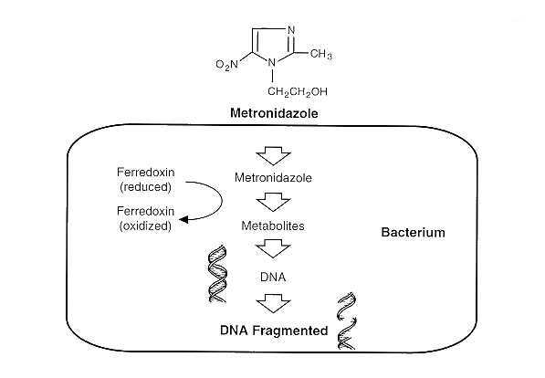
Metronidazole, a synthetic antibacterial and antiprotozoal agent of the nitroimidazole class, is used against protozoa such as trichomonas vaginalis, amebiasis and giardiasis.
Metronidazole is a pro drug it requires reductive activation of nitro group by susceptible organism. Its pathogens such as E.hisolytica , G. lambia etc. these organism contains electron transport components such as ferredoxin, small fe-s proteins that have sufficiently .
The single electron transfer forms a highly reactive nitro radical anion that kills susceptible organism by radical medicated mechanism that target DNA resulting in cell death.

