NAME:Willson Favour Uwem
MATRIC NO: 17/sci05/011
COURSE: PHA312[Chemotherapy of parasitic disease,antiseptic and disinfectant]
ASSIGNMENT
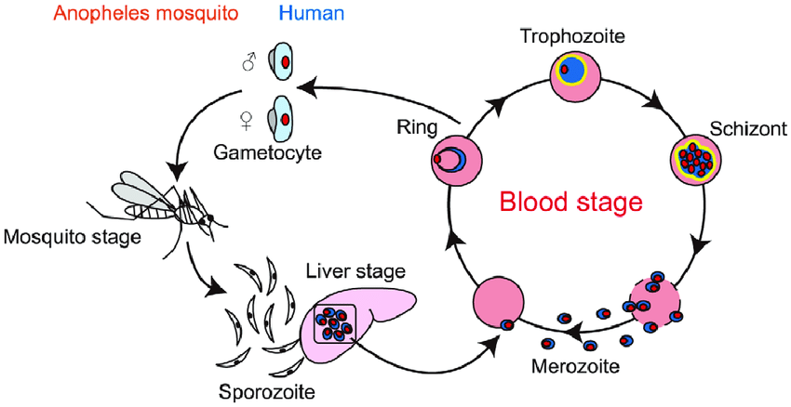
1 The malaria parasite life cycle involves two hosts. During a blood meal, a malaria-infected female Anopheles mosquito inoculates sporozoites into the human host.Sporozoites infect liver cells and mature into schizonts , which rupture and release merozoites . (Of note, in P. vivax and P. ovale a dormant stage [hypnozoites] can persist in the liver (if untreated) and cause relapses by invading the bloodstream weeks, or even years later.) After this initial replication in the liver (exo-erythrocytic schizogony ), the parasites undergo asexual multiplication in the erythrocytes (erythrocytic schizogony ). Merozoites infect red blood cells . The ring stage trophozoites mature into schizonts, which rupture releasing merozoites . Some parasites differentiate into sexual erythrocytic stages (gametocytes) . Blood stage parasites are responsible for the clinical manifestations of the disease. The gametocytes,male (microgametocytes) and female (macrogametocytes), are ingested by an Anopheles mosquito during a blood meal . The parasites’ multiplication in the mosquito is known as the sporogonic cycle . While in the mosquito’s stomach, the microgametes penetrate the macrogametes generating zygotes . The zygotes in turn become motile and elongated (ookinetes) which invade the midgut wall of the mosquito where they develop into oocysts . The oocysts grow, rupture, and release sporozoites, which make their way to the mosquito’s salivary glands. Inoculation of the sporozoites into a new human host perpetuates the malaria life cycle.

2 CLASSIFICATON OF ANTIAMOEBIC DRUGS
Aminoquinoline
Thiazole derivative

3 Aminoquinoline
Chloroquine
THIAZOLE DERIVATIVE
Niridazole

4 Mechanism of action of Metronidazole
Metronidazole is a prodrug. It requires reductive activation of nitro group by susceptible organism. Its selective toxicity towards anaerobic and microaerophilic pathogens such as E. histolytica, G. lamblia, etc. These organisms contain electron transport components such as ferridoxin, small Fe-S proteins that have sufficiently negative redox potential to donate electrons to metronidazole. The single electron transfer forms a highly reactive nitro radical anion that kills susceptible organisms by radical-mediated mechanisms that target DNA, resulting in cell death.

