Abubakar Badamasi
18/mhs07/053
Pharmacology
PHA312
Assignment
1). Malaria infection begins when an infected female Anopheles mosquito bites a person, injecting Plasmodium parasites, in the form of sporozoites, into the bloodstream.
The sporozoites pass quickly into the human liver.
In an animal model, the parasites, in the form of merozoites, are released from the liver cells in vesicles, journey through the heart, and arrive in the lungs, where they settle within lung capillaries. The vesicles eventually disintegrate, freeing the merozoites to enter the blood phase of their development.*
In the bloodstream, the merozoites invade red blood cells (erythrocytes) and multiply again until the cells burst. Then they invade more erythrocytes. This cycle is repeated, causing fever each time parasites break free and invade blood cells.
Some of the infected blood cells leave the cycle of asexual multiplication. Instead of replicating, the merozoites in these cells develop into sexual forms of the parasite, called gametocytes, that circulate in the blood stream.
When a mosquito bites an infected human, it ingests the gametocytes, which develop further into mature sex cells called gametes.
The fertilized female gametes develop into actively moving ookinetes that burrow through the mosquito's midgut wall and form oocysts on the exterior surface.
Inside the oocyst, thousands of active sporozoites develop. The oocyst eventually bursts, releasing sporozoites into the body cavity that travel to the mosquito's salivary glands.
The cycle of human infection begins again when the mosquito bites another person

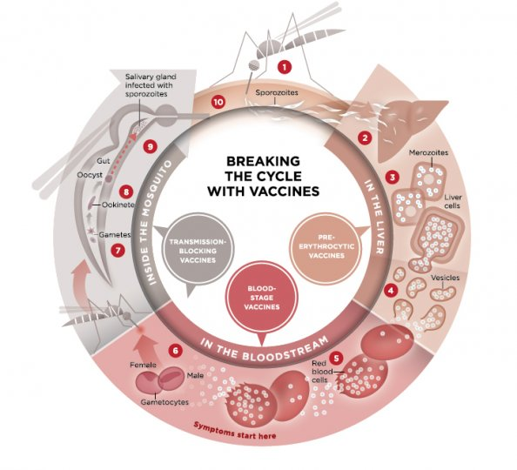

2. A) luminal amoebicide
B) Tissue amoebicide

3. (A) Luminal amoebicide
- Amide:- diloxanide furate, nitazoxanide
- 8-hydroxylquinolols:- di-iodohydroxyl , quinidochlor
- Antibiotics:- tetracycline, paronomycin (B). Tissue amoebicide
- Nitroimidazole:- metronidazole, timidazole
- Alkaloids:- imitine, dihydroimitine. ,,,................................................................ .. .. 4). Metronidazole:- it is the prototype of nitroimidazole and highly active amoebicide it has broad spectrum sidal activity against anaerobic protozoa.
- MOA:- it inhibits nucleic acid synthesis by disrupting the DNA of microbial cells. This function only occurs when metronidazole is partially reduced, and because this reduction usually happens only in anaerobic bacteria and protozoans, it has relatively little effect upon human cells or aerobic bacteria.
- After entering cell by diffusion. It's nitro group is reduced by certain redox proteins operative only in anaerobic microbes to a highly reactive nitro radical which exact cytotoxicity the nitro radical for metronidazole act as an electron sink which compete with the biological electron as receptor of anaerobic organism for the electrons generated by the pyruvate ferredoxine oxidoreductase enzyme. (PFOR) enzyme.

