NAME: AKUMA SUNNY
DEPARTMENT: ELECTRICAL/ELECTRONICS ENGINEERING
MATRIC NO: 17/ENG04/009
COURSE CODE: ENG 384
COURSE TITLE: ENGINEERING LAW AND MANAGERIAL ECONOMICS
ASSIGNMENT II
QUESTION
Briefly discuss the following intellectual property protection methods.
- Patent
- Copyright
- Trademark
- Trade secret
ANSWERS
PATENT
A patent is a form of intellectual property that gives the owner the legal right to exclude others from making, using, selling and importing an invention for a limited period of years, in exchange for publishing an enabling public disclosure of the invention. In most countries patent rights fall under civil law and the patent holder needs to sue someone infringing the patent in order to enforce his or her rights. In some industries patents are an essential form of competitive advantage; in others they are irrelevant.
The procedure for granting patents, requirements placed on the patentee, and the extent of the exclusive rights vary widely between countries according to national laws and international agreements. Typically, however, a patent application must include one or more claims that define the invention. A patent may include many claims, each of which defines a specific property right. These claims must meet relevant patentability requirements, such as novelty, usefulness, and non-obviousness
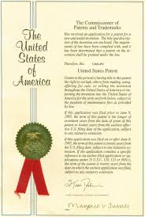

COPYRIGHT
Copyright is the exclusive right given to the creator of a creative work to reproduce the work, usually for a limited time. The creative work may be in a literary, artistic, educational, or musical form. Copyright is intended to protect the original expression of an idea in the form of a creative work, but not the idea itself. Some jurisdictions require "fixing" copyrighted works in a tangible form. It is often shared among multiple authors, each of whom holds a set of rights to use or license the work, and who are commonly referred to as rights holder. These rights frequently include reproduction, control over derivative works, distribution, public performance, and moral rights such as attribution.
Copyrights can be granted by public law and are in that case considered "territorial rights". This means that copyrights granted by the law of a certain state, do not extend beyond the territory of that specific jurisdiction. Copyrights of this type vary by country; many countries, and sometimes a large group of countries, have made agreements with other countries on procedures applicable when works "cross" national borders or national rights are inconsistent
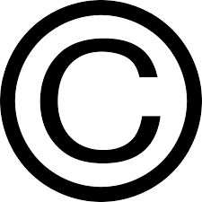

TRADEMARK
A trademark (also written trade mark or trade-mark) is a type of intellectual property consisting of a recognizable sign, design, or expression which identifies products or services of a particular source from those of others, although trademarks used to identify services are usually called service marks. The trademark owner can be an individual, business organization, or any legal entity. A trademark may be located on a package, a label, a voucher, or on the product itself. For the sake of corporate identity, trademarks are often displayed on company buildings. It is legally recognized as a type of intellectual property.
The first legislative act concerning trademarks was passed in 1266 under the reign of Henry III, requiring all bakers to use a distinctive mark for the bread they sold. The first modern trademark laws emerged in the late 19th century. In France the first comprehensive trademark system in the world was passed into law in 1857. The Trade Marks Act 1938 of the United Kingdom changed the system, permitting registration based on "intent-to-use”, creating an examination based process, and creating an application publication system. The 1938 Act, which served as a model for similar legislation elsewhere, contained other novel concepts such as "associated trademarks", a consent to use system, a defensive mark system, and non claiming right system.
The symbols ™ (the trademark symbol) and ® (the registered trademark symbol) can be used to indicate trademarks; the latter is only for use by the owner of a trademark that has been registered.
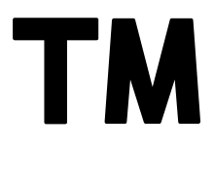

TRADE SECRET
Trade secrets are a type of intellectual property that comprise formulas, practices, processes, designs, instruments, patterns, or compilations of information that have inherent economic value because they are not generally known or readily ascertainable by others, and which the owner takes reasonable measures to keep secret. In some jurisdictions, such secrets are referred to as confidential information.
