ENGINEERING STRATEGIES FOR HANDLING COVID-19 FOR ENVIRONMENTAL HEALTH AND ECONOMIC SUSTAINABILITY
BY
UKPAI CHINENYE SHALOM
17/ENG01/028
SUBMITTED TO
DEPARTMENT OF CHEMICAL ENGINEERING
COLLEGE OF ENGINEERING
AFE BABALOLA UNIVERSITY, ADO-EKITI, EKITI STATE.
APRIL, 2020.

ABSTRACT
A very specialized research laboratory that deals with infectious agents is the biosafety lab. Whether performing research or production activities, when working with infectious materials, organisms or perhaps even laboratory animals, the proper degree of protection is of utmost importance. Protection for laboratory personnel, the environment and the local community must be considered and ensured. The protections required by these types of activities are defined as biosafety levels. Biological safety levels are ranked from one to four and are selected based on the agents or organisms on which the research or work is being conducted. Each level up builds on the previous level, adding constraints and barriers.
On what individual process engineers could do, it is noted that the high margins on pharmaceuticals, along with regulations that effectively prevent manufacturers from changing process design have stalled the sorts of operational improvements that process engineers typically carry out in other sectors. Engineers should carry out a full assessment of medical equipment that might be required in similar situations, to ensure that designs can be open-sourced and shared with manufacturers when needed.

TABLE OF CONTENT
ABSTRACT………………………………………………………………………………...……ii
LIST OF FIGURES…………………………………………………………………………….v

CHAPTER 1……………………………………………………………………………………...1
1.0 Introduction……………………………………………………………………………………1
1.1 What is Chemical Engineering ………………..…………………………………………..….1
1.2 What do Chemical Engineers do ……………………….…………………………………..1-2
1.3 Is a Chemical Engineers curriculum similar to that of a chemist…...………………………...3

CHAPTER 2……………………………………………………………………………………...4
2.0 Literature review………………………………………………………………………………4
2.1 Covid-19 Pandemic……………………………………………………………......…………..4
2.2 How does the COVID-19 virus spread?……………..……………………………………...4-5
2.3 What are the symptoms of coronavirus?……………………………..………………………..5

CHAPTER 3……………………………………………………………………………………...6
3.0 Methodology…………………………………………………………………………………..6
3.1 Ways to help in the prevention and cure of Covid-19……..………………….………………6
3.2 How do Engineers lend a helping hand?………………………………………………………6
3.3 Biosafety Hazards Level-4 ………………………………………………………………..7-11

CHAPTER 4…………………………………………………………………………….………12
4.0 Analysis of result…………………….…………………………………………………...12-13

CHAPTER 5……………………………………………………….……………………………14
5.0 Recommendation and conclusion..………..……...………………………………………….14
5.1 Recommendation…………………………..………………………………………………...14
5.2 Conclusion…………………………………………………………………………………...14

REFERECES…………………………………………………………………………………...15

LIST OF FIGURES
Figure 1: Chemical engineering and sustainability
Figure 2: Chemical engineers can also work in the laboratory.
Figure 3: Corona Virus (Covid-19)
Figure 4: Symptoms of Covid-19
Figure 5: Picture of a Ventilator and a Nose mask.
Figure 6: Signs of Biosafety levels.
Figure 7: BSL-4 Concepts.
Figure 8: Summary on Bio-safety levels.

CHAPTER 1
- INTRODUCTION
1.1 What is Chemical Engineering?
Chemical engineering is a branch of engineering that uses principles of chemistry, physics, mathematics, biology, and economics to efficiently use, produce, design, transport and transform energy and materials. The work of chemical engineers can range from the utilisation of nano-technology and nano-materials in the laboratory to large-scale industrial processes that convert chemicals, raw materials, living cells, microorganisms, and energy into useful forms and products.
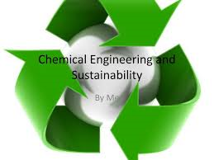
Figure 1: Chemical engineering and sustainability
1.2 What do Chemical Engineers do?
Chemical engineers are involved in many aspects of plant design and operation, including safety and hazard assessments, process design and analysis, modeling, control engineering, chemical reaction engineering, nuclear engineering, biological engineering, construction specification, and operating instructions. Chemical engineers design, construct and operate process plants (fractionating columns pictured).
Chemical engineers also translate processes developed in the lab into practical applications for the commercial production of products and then work to maintain and improve those processes. They rely on the main foundations of engineering: math, physics, and chemistry (though biology is playing an increasing role). The main role of chemical engineers is to design and troubleshoot processes for the production of chemicals, fuels, foods, pharmaceuticals, and biologicals, just to name a few. They are most often employed by large-scale manufacturing plants to maximize productivity and product quality while minimizing costs.
Chemical engineers typically hold a degree in Chemical Engineering or Process Engineering. Practising engineers may have professional certification and be accredited members of a professional body. Such bodies include the Institution of Chemical Engineers (IChemE) or the American Institute of Chemical Engineers (AIChE). A degree in chemical engineering is directly linked with all of the other engineering disciplines, to various extents.
The aerospace, automotive, biomedical, electronic, environmental, medical, and military industries seek the skills of chemical engineers in order to help develop and improve their technical products, such as: Ultra strong fibers, fabrics, and adhesives for vehicles biocompatible materials for implants and prosthetics Films for optoelectronic devices.
Chemical engineers work in almost every industry and affect the production of almost every article manufactured on an industrial scale. Some typical tasks include: Ensuring compliance with health, safety, and environmental regulations Conducting research into improved manufacturing processes Designing and planning equipment layout Incorporating safety procedures for working with dangerous chemicals Monitoring and optimizing the performance of production processes Estimating production costs.
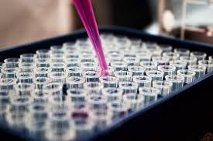
Figure 2: Chemical engineers can also work in the laboratory.
1.3 Is a Chemical Engineers curriculum similar to that of a chemist?
A chemical engineer’s curriculum is similar to that of a chemist but also includes coursework in engineering-related areas such as heat and mass transfer, thermodynamics, fluid dynamics, process design and control, and electronics. Economics, psychology, and political science help chemical engineers to understand the impact of technology on society. Although they learn a lot of theory in the classroom, most of a chemical engineer’s knowledge of real-world applications is derived from on-the-job training, so internships and practical experience are essential.

CHAPTER 2
- LITERATURE REVIEW
2.1 Covid-19 Pandemic
The disease caused by the novel coronavirus first identified in Wuhan, China, has been named coronavirus disease 2019 (COVID-19) – ‘CO’ stands for corona, ‘VI’ for virus, and ‘D’ for disease. Formerly, this disease was referred to as ‘2019 novel coronavirus’ or ‘2019-nCoV.’
The COVID-19 virus is a new virus linked to the same family of viruses as Severe Acute Respiratory Syndrome (SARS) and some types of common cold. COVID-19 has been described as a pandemic by the World Health Organization.
What does that mean? Characterizing COVID-19 as a pandemic is not an indication that the virus has become deadlier. Rather, it’s an acknowledgement of the disease’s geographical spread. UNICEF has been preparing and responding to the epidemic of COVID-19 around the world, knowing that the virus could spread to children and families in any country or community. UNICEF will continue working with governments and our partners to stop transmission of the virus, and to keep children and their families safe.
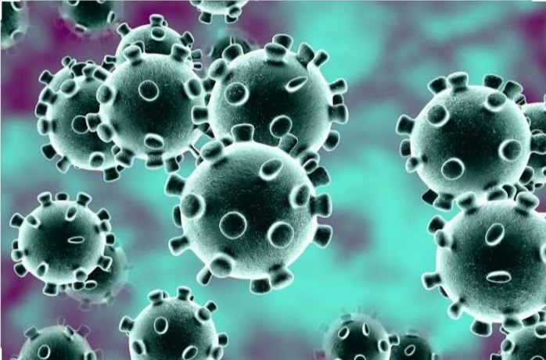
Figure 3: Corona Virus (Covid-19)
2.2 How does the COVID-19 virus spread?
The virus is transmitted through direct contact with respiratory droplets of an infected person (generated through coughing and sneezing), and touching surfaces contaminated with the virus. The COVID-19 virus may survive on surfaces for a few hours to several days, but simple disinfectants can kill it. Studies to date suggest that the virus that causes COVID-19 is mainly transmitted through contact with respiratory droplets, rather than through the air.

2.3 What are the symptoms of coronavirus?
Symptoms can include fever, cough and shortness of breath. In more severe cases, infection can cause pneumonia or breathing difficulties. More rarely, the disease can be fatal.
These symptoms are similar to the flu (influenza) or the common cold, which are a lot more common than COVID-19. This is why testing is required to confirm if someone has COVID-19. It’s important to remember that key prevention measures are the same – frequent hand washing, and respiratory hygiene (cover your cough or sneeze with a flexed elbow or tissue, then throw away the tissue into a closed bin). Also, there is a vaccine for the flu – so remember to keep yourself and your child up to date with vaccinations.
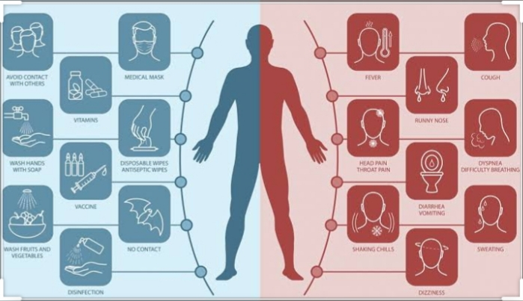
Figure 4: Symptoms of Covid-19

CHAPTER 3
- METHODOLOGY
3.1 Ways to help in the prevention and cure of Covid-19
3.2 How do Engineers lend a helping hand?
On what individual process engineers could do, it is noted that the high margins on pharmaceuticals, along with regulations that effectively prevent manufacturers from changing process design have stalled the sorts of operational improvements that process engineers typically carry out in other sectors.
“By the time process engineers have got involved the process is fixed. So when you say ‘Let’s not do batch tangential flow filtration’ or ‘let’s not do a batch chromatography – let’s make it continuous because that’s what the kit is designed for’ it’s always too late”.
1) I think the big influence process engineers can make in vaccines production is from within the equipment suppliers because they are developing the equipment and thinking how it’s joined up.
2) Process engineers can help with that integration of equipment supply. We will then have cheaper capital cost of facilities, cheaper operational costs, and less supplier interfaces.
3) Other cutting-edge engineering could help lower infection rates. Cleaning solutions and material development with inbuilt anti-bacterial properties being developed into our design solutions would be positive.
4) Engineers should carry out a full assessment of medical equipment that might be required in similar situations, to ensure that designs can be open-sourced and shared with manufacturers when needed.
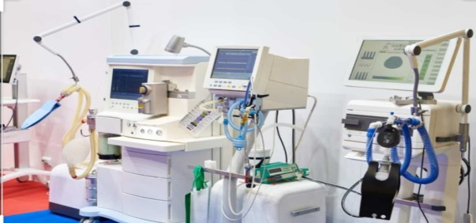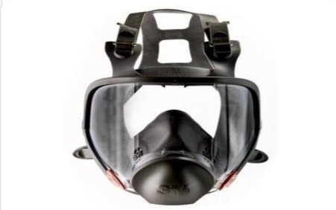
Figure 5: Picture of a Ventilator and a Nose mask.
3.3 Biosafety Hazards Level-4
A biosafety level (BSL) is a set of bio-containment precautions required to isolate dangerous biological agents in an enclosed laboratory facility. The levels of containment range from the lowest biosafety level 1 (BSL-1) to the highest at level 4 (BSL-4). In the United States, the Centres for Disease Control and Prevention (CDC) have specified these levels. In the European Union, the same biosafety levels are defined in a directive. In Canada the four levels are known as Containment Levels. Facilities with these designations are also sometimes given as P1 through P4 (for Pathogen or Protection level), as in the term P3 laboratory.
At the lowest level of biosafety, precautions may consist of regular hand-washing and minimal protective equipment. At higher biosafety levels, precautions may include airflow systems, multiple containment rooms, sealed containers, positive pressure personnel suits, established protocols for all procedures, extensive personnel training, and high levels of security to control access to the facility. The reason biosafety levels are so important is because they dictate the type of work practices that are allowed to take place in a lab setting. They also heavily influence the overall design of the facility in question, as well as the type of specialized safety equipment used within it.
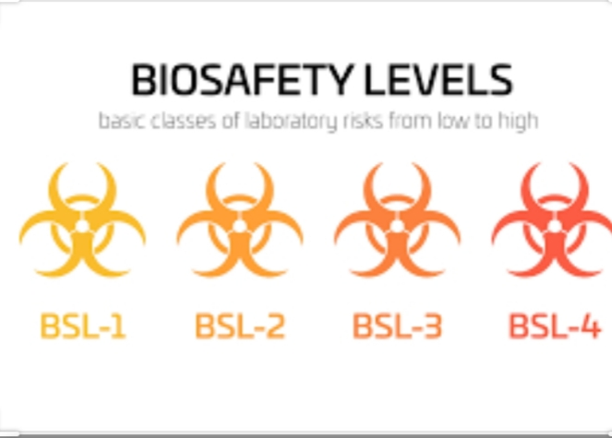
Figure 6: Signs of Biosafety levels.

BSL–1
As the lowest of the four, biosafety level 1 applies to laboratory settings in which personnel work with low-risk microbes that pose little to no threat of infection in healthy adults. An example of a microbe that is typically worked with at a BSL-1 is a non-pathogenic strain of E. coli.
This laboratory setting typically consists of research taking place on benches without the use of special contaminant equipment. A BSL-1 lab, which is not required to be isolated from surrounding facilities, houses activities that require only standard microbial practices, such as:
Mechanical pipetting only (no mouth pipetting allowed)
Safe sharps handling
Avoidance of splashes or aerosols
Daily decontamination of all work surfaces when work is complete
Hand washing etc.
BSL-1 labs also require immediate decontamination after spills. Infection materials are also decontaminated prior to disposal, generally through the use of an autoclave.

BSL–2
This biosafety level covers laboratories that work with agents associated with human diseases (i.e. pathogenic or infections organisms) that pose a moderate health hazard. Examples of agents typically worked with in a BSL-2 include equine encephalitis viruses and HIV, as well as Staphylococcus aureus (staph infections). BSL-2 laboratories maintain the same standard microbial practices as BSL-1 labs, but also include enhanced measures due to the potential risk of the aforementioned microbes. Personnel working in BSL-2 labs are expected to take even greater care to prevent injuries such as cuts and other breaches of the skin, as well as ingestion and mucous membrane exposures. In addition to BSL 1 expectation, the following practices are required in a BSL 2 lab setting:
Appropriate personal protective equipment (PPE) must be worn, including lab coats and gloves. Eye protection and face shields can also be worn, as needed.
All procedures that can cause infection from aerosols or splashes are performed within a biological safety cabinet (BSC).
An autoclave or an alternative method of decontamination is available for proper disposals.
The laboratory has self-closing, lockable doors.
A sink and eyewash station should be readily available.
Biohazard warning signs
Access to a BSL-2 lab is far more restrictive than a BSL-1 lab. Outside personnel, or those with an increased risk of contamination, are often restricted from entering when work is being conducted.

BSL-3
Again building upon the two prior biosafety levels, a BSL-3 laboratory typically includes work on microbes that are either indigenous or exotic, and can cause serious or potentially lethal disease through inhalation. Examples of microbes worked with in a BSL-3 include; yellow fever, West Nile virus, and the bacteria that causes tuberculosis.
The microbes are so serious that the work is often strictly controlled and registered with the appropriate government agencies. Laboratory personnel are also under medical surveillance and could receive immunizations for microbes they work with. Common requirements in a BSL-3 laboratory include:
Standard personal protective equipment must be worn, and respirators might be required.
Solid-front wraparound gowns, scrub suits or coveralls are often required.
All work with microbes must be performed within an appropriate BSC.
Access hands-free sink and eyewash are available near the exit.
Sustained directional airflow to draw air into the laboratory from clean areas towards potentially contaminated areas (Exhaust air cannot be re-circulated).
A self-closing set of locking doors with access away from general building corridors.
Access to a BSL-3 laboratory is restricted and controlled at all times.

BSL-4
BSL-4 labs are rare. However some do exist in a small number of places in the US and around the world. As the highest level of biological safety, a BSL-4 lab consists of work with highly dangerous and exotic microbes. Infections caused by these types of microbes are frequently fatal, and come without treatment or vaccines. Two examples of such microbes include Ebola and Marburg viruses.
In addition to BSL-3 considerations, BSL-4 laboratories have the following containment requirements:
Personnel are required to change clothing before entering, shower upon exiting
Decontamination of all materials before exiting
Personnel must wear appropriate personal protective equipment from prior BSL levels, as well as a full body, air-supplied, positive pressure suit
A Class III biological safety cabinet
A BSL-4 laboratory is extremely isolated—often located in a separate building or in an isolated and restricted zone of the building. The laboratory also features a dedicated supply and exhaust air, as well as vacuum lines and decontamination systems.
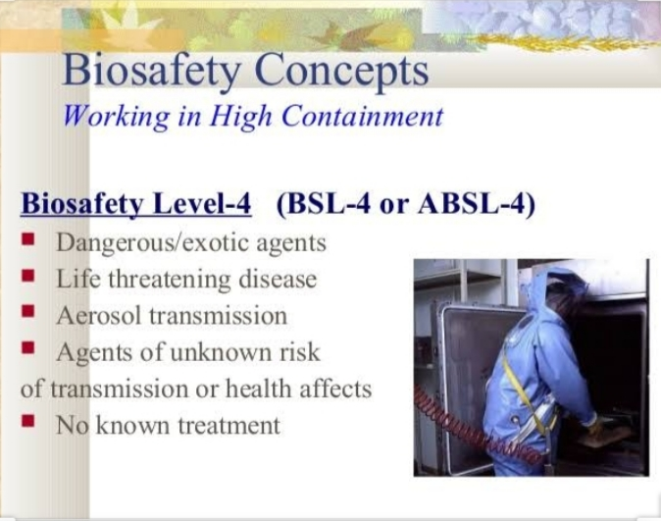
Figure 7: BSL-4 Concepts.

CHAPTER 4
- ANALYSIS OF RESULT
In Summary, A very specialized research laboratory that deals with infectious agents is the biosafety lab. Whether performing research or production activities, when working with infectious materials, organisms or perhaps even laboratory animals, the proper degree of protection is of utmost importance. Protection for laboratory personnel, the environment and the local community must be considered and ensured. The protections required by these types of activities are defined as biosafety levels. Biological safety levels are ranked from one to four and are selected based on the agents or organisms on which the research or work is being conducted. Each level up builds on the previous level, adding constraints and barriers. The Centres for Disease Control and Prevention (CDC) and the National Institutes of Health (NIH) are the main sources for biological safety information for infectious agents. The four biosafety levels were developed to protect against a world of select agents. These agents include bacteria, fungi, parasites, prions, rickettsial agents and viruses, the latter being probably the largest and most important group. In many instances the work or research involves vertebrate animals, everything from mice to cattle. When vertebrates are involved, additional precautions and safety requirements are necessary. Using the most infectious agents also means extensive security measures are in place, not only because of their virulence but also because of their potential for use in bioterrorism.
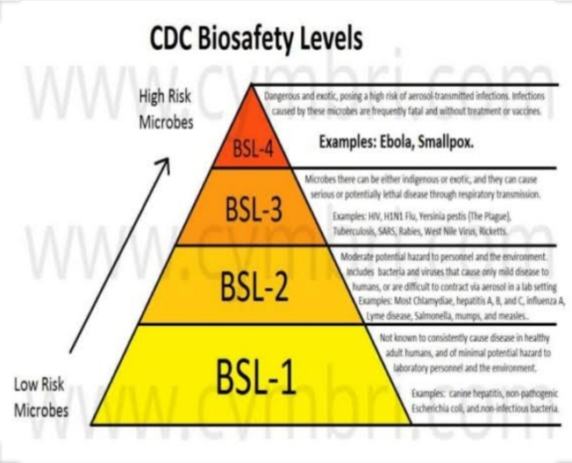
Figure 8: Summary on Bio-safety levels.

Engineering solutions would have been especially effective early on during the outbreak of Covid-19, before measures like lockdown were introduced. But even during lockdown, they could help minimise the spread of the virus in the parts of society that are still open, such as banks and supermarkets. When you look at the potential that engineering can bring to this in a public health (preventive) rather than a medical (restorative) setting, it shows how much we’re actually missing. It may be that these particular (disinfectant) solutions are not workable at scale, but the point is that engineers could probably come up with other design solutions that would work. It’s their job.
The problem is, often social scientists just don’t speak to or mix with engineers very much. It’s a deep-rooted problem, like two parts of a family that fell out years ago over some obscure argument that nobody remembers, but everyone repeats.
It should be seen as part of our mission to bring scientists and engineers together so everyone can benefit. The coronavirus case study shows now more than ever how much we need that kind of collaboration.

CHAPTER 5
- RECOMMENDATION AND CONCLUSION
5.1 Conclusion
In conclusion it can be read from the material written that engineers play an important role in the covid-19 pandemic both in its prevention and its cure.

5.2 Recommendation
Students should also have a vast knowledge on Bio-safety levels, their importance and their use.

REFERENCES
Biosafety in Microbiological and Biomedical Laboratories, 5th edition, Centres for Disease Control and Prevention and National Institutes of Health, February 2007. http://www.cdc.gov/biosafety.
The Biennial Review of the Lists of Select Agents and Toxins, National Select Agent Registry, CDC. Atlanta, GA. 2010. http://www.selectagents.gov.
Coelho AC, García Díez J. Biological Risks and Laboratory-Acquired Infections: A Reality That Cannot be Ignored in Health Biotechnology. Front Bioeng Biotechnol. 2015;3:56. [PMC free article] [PubMed].
Mourya DT, Yadav PD, Majumdar TD, Chauhan DS, Katoch VM. Establishment of Biosafety Level-3 (BSL-3) laboratory: important criteria to consider while designing, constructing, commissioning & operating the facility in Indian setting. Indian J. Med. Res. 2014 Aug;140(2):171-83. [PMC free article] [PubMed].
Callaway E. Biosafety concerns for labs in the developing world. Nature. 2012 May 22;485(7399):425. [PubMed].
Gallandat K, Lantagne D. Selection of a Biosafety Level 1 (BSL-1) surrogate to evaluate surface disinfection efficacy in Ebola outbreaks: Comparison of four bacteriophages. PLoS ONE. 2017;12(5):e0177943. [PMC free article] [PubMed].
https://www.aljazeera.com
https://www.openwho.com
https://www.who.int

