CONCEPT OF SEDIMENT TRANSPORT AND HOW IT AFFECTS COASTAL AREAS

BY
AGBEDE GOODNESS YERINMINI
MATRIC NO: 15/ENG03/003

SUBMITTED IN PARTIAL FULFILMENT
OF THE REQUIREMENT FOR THE AWARD OF THE
BACHELOR OF ENGINEEERING (B.ENG) DEGREE IN CIVIL ENGINEERING
TO
DR. OLOWE K.
DEPARTMENT OF CIVIL ENGINEERING, COLLEGE OF ENGINEERING, AFE BABALOLA UNIVERSITY, ADO-EKITI,
NIGERIA
APRIL, 2020

Sediment transport is the movement of solid particles (sediment), typically due to a combination of gravity acting on the sediment, and /or the movement of the fluid in which the sediment is entrained. Sediment transport occurs in natural systems where the particles are clastic rocks (sand, gravel, boulders, etc.), mud, or clay; the fluid is air, water, or ice; and the force of gravity acts to move the particles along the sloping surface on which they are resting. Sediment transport due to fluid motion occurs in rivers, oceans, lakes, seas, and other bodies of water due to currents and tides. Transport is also caused by glaciers as they flow, and on terrestrial surfaces under the influence of wind. Sediment transport due to only gravity can occur on sloping surfaces in general, including hillslopes, scarps, cliffs, and the continental shelf-continental slope boundary.
Sediment transport is important in the fields of sedimentary geology, geomorphology, civil engineering and environmental engineering .Knowledge of sediment transport is most often used to determine whether erosion or deposition will occur, the magnitude of this erosion or deposition, and the time and distance over which it will occur.
Coastal sediment transport a subset of sediment transport is the interaction of coastal land forms to various complex interactions of physical processes. The primary agent in coastal sediment transport is wave activity, followed by tides and storm surge, and near shore currents. Wind-generated waves play a key role in the transfer of energy from the open ocean to the coastlines. In addition to the physical processes acting upon the shore, the size distribution of the sediment is a critical determination for how the beach will change. These various interactions generate a wide variety of beaches. Other than the interactions between coastal land forms and physical processes there is also the addition of modification of these landforms through anthropogenic sources. Some of the anthropogenic sources of modification have been put in place to halt erosion or prevent harbours from filling up with sediment. In order to assist community planners, local governments, and national governments a variety of models have been developed to predict the changes of beach sediment transport at coastal locations. Typically, during large wave events, the sediment gets transported off the beach face a deposited offshore generating a sandbar. Once the significant wave event has diminished, the sediment then gets slowly transported back onshore.
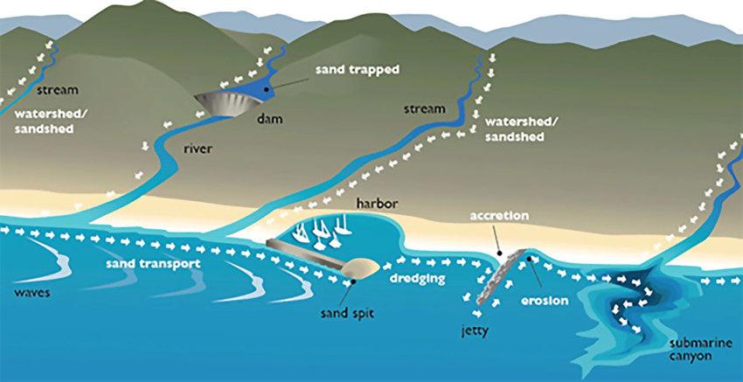
Figure 1.0 Sediment Transport Along the Coastal Areas
Coastal Processes
Processes called erosion, mass movement and weathering break down and remove material from the coast. The material is moved along the coastline by the sea and deposited when there is energy loss.

Transportation
Beach material can be moved in four different ways. These are:
- Solution - when minerals in rocks like chalk and limestone are dissolved in sea water and then carried in solution. The load is not visible.
- Suspension - small particles such as silts and clays are suspended in the flow of the water.
- Saltation – where small pieces of shingle or large sand grains are bounced along the sea bed.
- Traction – where pebbles and larger material are rolled along the sea bed.
Sediment is carried by the waves along the coastline. The movement of the material is known as longshore drift. Waves approach the coast at an angle because of the direction of prevailing wind. The swash will carry the material towards the beach at an angle. The backwash then flows back to the sea, down the slope of the beach. The process repeats itself along the coast in the zigzag movement.

Deposition
When the sea loses energy, it drops the material it has been carrying. This is known as deposition. Deposition can occur on coastlines that have constructive waves.
Factors leading to deposition include:
- waves starting to slow down and lose energy
- shallow water
- sheltered areas, e.g. bays
- little or no wind

Effects of Sediment Transport and Deposition
While sediment is needed to build aquatic habitats and reintroduce nutrients for submerged vegetation, too much or too little sediment can easily cause ecosystem and safety issues. Whether the concerns are caused by scour, erosion, build up, or simply excessive turbidity, the sediment transport rate is an important environmental factor. In addition to the problems cause by load quantity, sediment can easily introduce pollution and other contaminants into a waterway, spreading the pollutants downstream.

Too Much Sediment
Large sediment loads are the most common issue seen with sediment transport rates. Too much sediment can cause poor water quality, algal blooms, and deposition build-up. For aquatic life, excessive suspended sediment can disrupt natural aquatic migrations, as well damage gills and other organs.
Diminished water quality occurs with unusually high sediment transport rates. Turbidity can cause water temperatures to rise (sediment absorbs more solar heat than water does). Rising water temperatures will cause dissolved oxygen levels to drop, as warm water cannot hold as much oxygen as cold water. Suspended sediment can block sunlight from reaching submerged plants, decreasing photosynthesis rates and lowering dissolved oxygen levels still further. If the increase in the sediment load is due to agricultural and urban runoff, algal blooms can occur from the increased nutrient load carried into the water body.
Regular sediment deposition can build bars for aquatic habitats, but increased sedimentation can destroy more habitats than it creates. Siltation, the name for fine sediment deposition, occurs when water flow rates decrease dramatically. This fine sediment can then smother insect larvae, fish eggs and other benthic organisms as it settles out of the water column. Deposition can also alter a waterway’s banks and direction as an unusually high sediment load settles out. Sediment deposition is responsible for creating alluvial fans and deltas, but excessive accumulation of sediment can build up channel plugs and levees. These deposits then block the river from reaching other stream threads or floodplains. Increased sedimentation is considered one of the primary causes of habitat degradation. Depending on the local geology and terrain, sediment build-up can damage aquatic ecosystems not only in downstream sites, but in upstream headwaters as the deposits grow.
Sediment deposition is considered extreme when it exceeds the recommended or established total maximum daily load (TMDL). A TMDL establishes a limit for measurable pollutants and parameters for a body of water. That means that TMDLs can be created for several different elements of the sediment load, including total suspended solids, nutrient impairment, pathogens and siltation. When developing a TMDL report, it is important to consider whether or not the waterway itself is generating the sediment load naturally, as an unstable stream channel.

Too Little Sediment
Coastline erosion can be tied to sediment starvation – when rivers do not bring enough sediment to be deposited on the beach.
Though too much sediment is the more common concern, a lack of sediment transport will also cause environmental issues. Sediment starvation is often caused by man-made structures such as dams, though natural barriers can also limit sediment transport. Without sediment transport and deposition, new habitats cannot be formed, and without some nutrient enrichment (carried with sediment into the water), submerged vegetation could not grow. Too little sediment can alter an ecosystem to the point that native species cannot survive.

Contaminated Sediment
Contaminated sediments are the accumulated riverbed materials that contain toxic or hazardous substances that are detrimental to aquatic, human or environmental health. These contaminants often come from point-source pollution (such as industrial wastewater or other effluent sources), though they can also enter the water through runoff over contaminated soils (mine waste, landfills and urban areas), chemical spills, or deposits from air pollution. As contaminants do not degrade (or degrade very slowly), they can be a source of environmental issues for long periods of time, even if they are not frequently suspended. The most problematic contaminants in both bedded and suspended sediment are metals and persistent bio accumulative toxics (PBTs), such as pesticides and methyl mercury.
Sediment remediation may involve dredging to remove the contaminated sediment from the waterway.
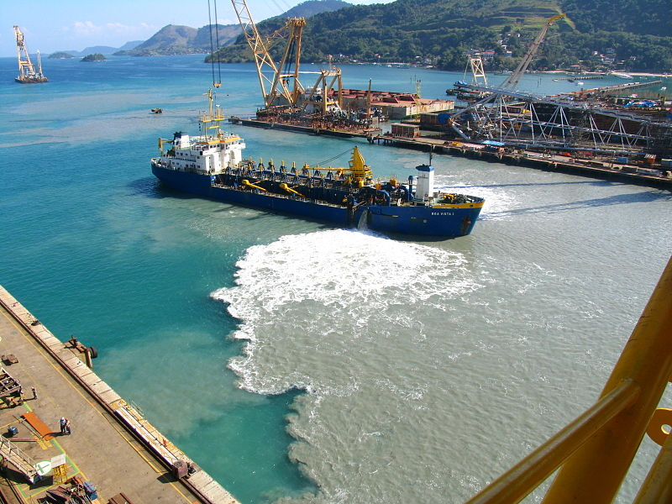
Figure 2.0 Shipyards and other point sources can pollute a body of water. These contaminants may settle to the bottom and be released slowly over time, or be carried away with other sediment.

Scour
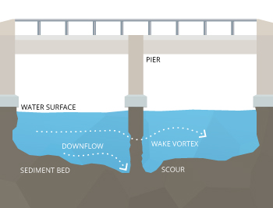
Figure 3.0 Local scour occurs when water flow erodes sediment away from a structure such as a bridge pier, potentially causing structure failure.
When sediment transport removes material from a streambed or bank, the erosion process is called scour. Scour can occur anywhere that there is water flow and erodible material. Local scour is the engineering term for the isolated removal of sediment at one location, such as the base of underwater structures, including bridge piers and abutments. This localized erosion can cause structural failure, as bridges and overwater constructions rely on the bed sediment to support them.
While scour can occur anywhere, it is more likely to occur in alluvial waterways (erodible bed and banks), as opposed to a bedrock-based (non-alluvial) channel. As water flow is responsible for conducting sediment transport, scour can occur even during low flow conditions. However, critical bridge scour conditions typically occur during periods of high flow, such as during a flood event. The higher flow rate can pick up more sediment, and turbulence often occurs at the base of a pier as it interrupts and accelerates the flow.

