ENGINEERING STRATEGIES FOR HANDLING COVID-19 F0R ENVIRONMENTAL HEALTH AND ECONOMIC SUSTAINABILITY IN ELECTRICAL ENGINEERING
PREPARED BY

EZEOBIDI CLEMENTINA ONYINYECHUKWU
17/ENG04/027

SUBMITTED TO
THE DEPARTMENT OF ELECTRICAL AND ELECTRONICS ENGINEERING

COLLEGE OF ENGINEERING

AFE BABALOLA UNIVERSITY , ADO-EKITI EKITI STATE .

IN PARTIAL FULFILLMENT OF THE REQUIREMENTS OF

ENG384: ENGINEERING LAW & MANAGERIAL ECOMONICS.

APRIL,2020.

ABTRACT
Mankind has observed various pandemics through out the history where some of were more disastrous than the others to humans, we are observing a very tough time once again fighting an invisible enemy; the novel COVID-19 coronavirus. Novel coronavirus disease (COVID-19) was first identified in china, which eventually became a major global health concern due to its pathogenicity and widespread distribution around the world. The first confirmed case of the pandemic of coronavirus disease 2019 in Nigeria was declared on 27TH February 2020, when an Italian citizen in Lagos, Nigeria tested positive for the virus , caused by severe acute respiratory syndrome coronavirus 2 (SARS-COV-2). Despite a growing interest in COVID-19 across population there’s need for electrical engineering personnel around are given a duty to find remedy to the deadly viral disease.
The major main of this term paper is the engineering strategy for handling novel coronavirus disease (covid-19) for environmental health and economic sustainability relating to Electrical and electronics engineering, we can come play during this pandemic through the manufacturing of ventilators, the construction and manufacture of medical robots which aid in treating infected patients and the manufacturing of robots with the ability to distribute ultraviolet light to disinfect hospital room, the generation of consistent electricity especially in third generation countries e.t.c.
The novel coronavirus disease has no cure at this point in time but through proper observation of personal hygiene and consistent hand washing, social distancing and awareness. It reduces the wide spread of the virus.

INTRODUCTION
A coronavirus is a virus that is found in animals and rarely can be transmitted from animals to humans and then spread person to person. In addition to COVID-19, other human coronavirus have included; The MERS virus, or middle East respiratory syndrome. The SARS virus or severe acute respiratory syndrome, which was first discovered in Guangdong province in southern china .
COVID-19 symptoms range from mild to severe. It takes 2-14 days after exposure for symptoms to develop. Symptoms may include; fever, cough, shortness of breath other symptoms can include tiredness, aches, runny nose, sore throat, some people have experienced the loss of smell or taste . It is discovered that those with weakened immune systems i.e. existing chronic medical conditions such as lung disease heart disease or diabetes may develop more serious symptoms, like pneumonia or bronchitis. One may never develop symptoms after being exposed to COVID-19 and as such most confirmed cases are in adults but some children have been infected. There is no evidence that children are at greater risk for getting the virus.
The first confirmed case of the pandemic of corona virus disease 2019 in Nigeria was announced on the 27th February 2020, when an Italian citizen in Lagos tested positive for the virus, caused by SARS-CoV-2. On 9th march 2020, a second case of the virus was reported in
Ewekoro, Ogun state, Nigeria, a Nigerian citizen who had contact with the Italian citizen. On the 30th January 2020, following the development of C0VID-19 pandemic in mainland china and other countries worldwide, the federal government of Nigeria set up a coronavirus preparedness group to mitigate the impact of the virus if it eventually spreads to the country. On the same day, the world health organization (WHO) listed Nigeria among the 13 African countries identified as high-risk for the spread of the virus.
Electrical and Electronics Engineering covers everything related to electricity. Electric power engineers concentrate on making electrical energy available and properly utilized. Electrical and electronics engineers focus with systems, circuits and devices used in communication, computer health care instruments and automated control systems. A great number of electrical and electronic engineers go directly into the design and production.
Electrical and electronics engineers play a crucial role during this pandemic as they are task to research, design and manufacture equipment ,devices that will be used to reduce the health risk faced by health personnel and those who are not infected which can be done through the manufacturing of ventilators, the steady production of electricity in the health centers especially in third generation countries, production of robots with the ability to sterilize the medical environment with the use of ultraviolet light etc.
The coronavirus disease has also disrupted the economy of the world and there’s need to sustained the economy plan to a sustainable level as the pandemic affects the profit percentage of shareholders and this human crisis demands coordinated, decisive, inclusive and innovative policy action from world’s leading economies and maximize financial and technical support for the poorest and most vulnerable people and countries.

Literature review
The outbreak of the coronavirus disease (COVID-19) has great impact on so many activities that keeps the human race balanced and such includes; environmental health and the economic sector and there’s great need for sustainability of these sectors while the pandemic is on going as the this viral disease is now fastly spreading around the world.
As at 20th March, 2020, there are 270,069 coronavirus cases, with 11,271 death while 90,603 has been discovered. In total coronavirus patient belongs to Italy i.e. 4,032 deaths, the death toll is followed by china (3,248), Iran (1,433) and Spain (1,044)
As at 11:15 am 31st March, there are 135 confirmed coronavirus cases in Nigeria
And 2 deaths and the breakdown of the cases by state currently: Lagos-81, FCT- 25,Ogun-4, Enugu-2,Ekiti-1,Oyo-8, Edo-2, Bauchi-2,Osun-5, Rivers-1,Benue-1, kaduna-3.
The spread coronavirus has created a life-or-death crisis not just for individuals and for health care systems and as such there is an upending on everything from aviation to the economy and it’s also having a big impact on the environment, it is difficult to make predictions, because much will depend on the spread of the disease, especially in Africa, Latin,
America, Asia and middle east, and the measures various governments will take in the coming weeks and months. The economic impact and what actions may be required to minimize disruptions on the poor and vulnerable. The first part looks at short term actions, whereas the second will look at possible medium to longer term developments. In short term there is likely to be a sharp drop in domestic consumer demand in most developing countries. The demand for food, medical assistance and other essential items may rise, but this would be more than offset by lower demand for non-essential goods such as apparel and various services. Demand would also fall due to other factors such as foreign buyers delaying or withdrawing orders; tourists, both local and foreign, cancelling trips; and deadlines in the stock exchange market which erodes peoples’ wealth and their willingness to spread.

Methodology
In response to the outbreak, the Electrical and Electronic engineering field of study has and is coming up numerous strategies to put in play to curb the deadly coronavirus. The ways at which the Electrical and electronic engineering could aid in tackling the coronavirus disease pandemic it’s through the following among a others

- The development of medical robots
- The generation of steady electricity in medical centers especially in third generation countries.
- The manufacturing of ventilators
- The manufacturing and the distribution of 3D-printed respirators
- The manufacturing of robot with the ability of disinfecting using ultraviolet light.

Table of Contents
ABTRACT i
INTRODUCTION ii
Literature review iv
Methodology v
Chapter one 1
1.0 Electrical and electronics engineering stratregy for handling novel coronavirus (covid-19 ) 1
1. The manufacturing of robots with the ability of disinfecting using ultraviolet light(uv disinfecting technology): 1
2. The manufacturing and distribution of 3D-printed respirators: 3
3. Generation of constant electricity in medical centers espcially third generation countries: 4
4. The manufacturing of ventilators: 5
5. The development of a medical robot: 7
Chapter two 9
2.0 impact of COVID 19 to the economy and how electrical engineers can be a major contributor to the solution ( economic sustainability) 9
2.1 The impact of Covid-19 on the Nigerian economy 9
2.2 What are the policy response by the Nigerian government 9
Chapter three 11
3.0. conclusion and recommendation 11
3.1 conclusion 11
3.2 recommendation 11
References 12

Chapter one

Electrical and electronics engineering stratregy for handling novel coronavirus (covid-19 )
The Global battle against coronavirus pandemic calls for the intervention of Electrical and Electronics practitioners to develops and manufacture devices, equipment which be put into great use for the curbing of this deadly virus outbreak. The various ways Electrical engineering come to play during the pandemic includes the following;
- The development of medical robots
- The generation of steady electricity in medical centers especially in third generation countries.
- The manufacturing of ventilators
- The manufacturing and the distribution of 3D-printed respirators
- The manufacturing of robot with the ability of disinfecting using ultraviolet light.

- The manufacturing of robots with the ability of disinfecting using ultraviolet light(uv disinfecting technology):
the development started in 2014, when a group of Danish hospital started a hospital disinfection pre-commercial procurement, demanding a far more effective way of reducing infection rates in hospitals. The fruitful collaboration between bacteriologists, virologists and hospital staff from hospitals, and robot developers, designers, engineers, investors the production of such robots are made possible. It is observed human exposure to ultraviolet light is highly dangerous as it is associated with numerous negative effects such as premature aging of the skin, signs of sun damages(liver spots, wrinkles, leathery skin e.t.c), eye problems etc
Solution consist of a self- driving robot platform that is equipped with a ultraviolet (UV) light system. With ultraviolet light, the robot can disinfect and kill disease, viruses, bacteria and other types of harmful organic Microorganisms in the environment by breaking down their DNA-structure. The robot disinfect 99, 99% of bacteria and viruses. The invention increase the safety of both staff, patients and their relatives by reducing the risk of contact with virus, bacteria and other harmful microorganisms. This can effectively prevent and reduce the spread of infectious disease, virus and bacteria. The systems automatically pays attention to “infection hotspots”, such as washbasin, patients bed, handles etc.
The UVD robot is user-friendly, safe and reliable, saves operational costs and eliminates human error. Once the cleaning staff orders the robot to start its cleaning route via an app, the robot moves autonomously from room to room, it can take the elevator and open doors automatically. It therefore has a minimal impact on hospital staff workflow. In addition, the robot supports an optional add-on module that can detect fluorescent bacteria and biological fluids his can for example be used as a learning tool for cleaning staff, for data collection regarding hospital hygiene, e.t.c.

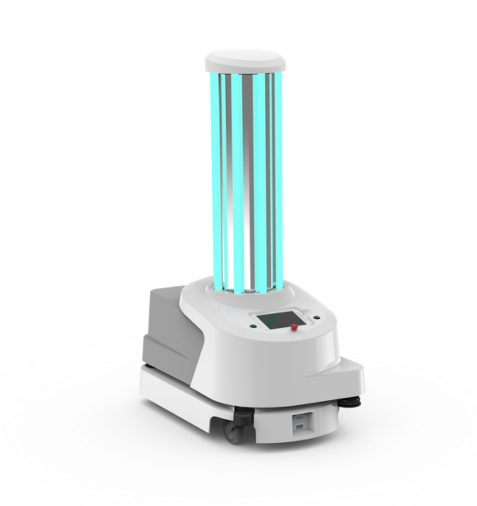
Figure 1: A diagram of UV disinfection robot

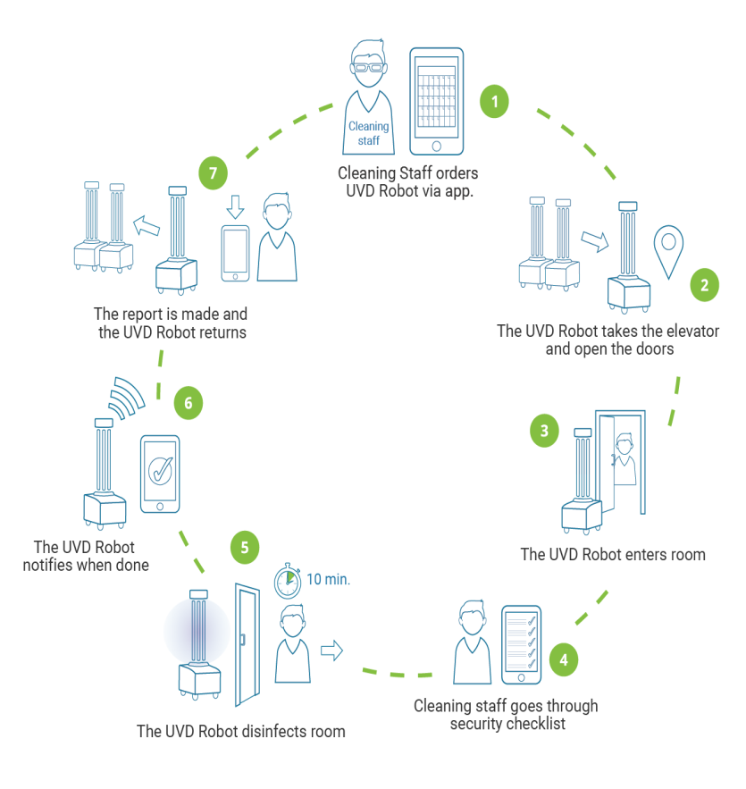

Figure 2: A Diagram of an improved cleaning routine

The manufacturing and distribution of 3D-printed respirators:
As more hospitals see an influx of COVID-19 patients, equipment to treat symptoms is in short supply. Hospitals in hard hit such as Italy have been overwhelmed and are running out of space and equipment, including crucial valves for respiratory machines, which helps people breathe mechanically by ventilating their lungs. And as such a 3D printed respirator was manufactured to fight against the shortage of equipment.
The 3D splitter allows a single ventilator to treat multiple patients . this device is for emergency as it aids breathing of patients.

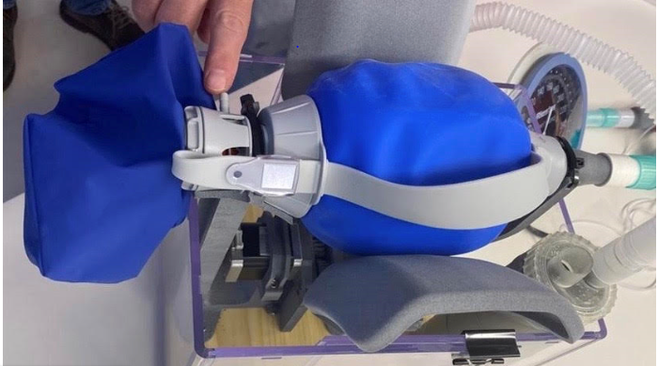
Figure 3: A diagram of 3D printed respirator

Generation of constant electricity in medical centers espcially third generation countries:
COVID-19 has affected the sourcing and supply chains across the power industry. Most of the Asian suppliers of renewable sector equipment are operating with a reduced load, and the developers in India, south Korea, central Europe and others are witnessing logistical delays. However, the industry is not able to predict the long-term impact of Covid-19 and as such electrical engineers are task to sustain the electrical power especially in medical centers as the equipment in use are powered by electricity.
Economic contractions reduce power demand, because every form of economic activity requires electricity, directly or indirectly. Going back to the 2008-9 recession reduced power demand in the united states by about 10 years’ worth of growth. The U.S. electricity use on March 27th ,2020 was 3% lower than on March 27th , 2019. That difference represents a loss of about three years of sales growth. Electricity use is a necessity, and essential services and households will continue to use power. Some, like health care, will use much more,
In Nigeria power distribution companies currently manage the allocation of their daily energy quota from the central power grid. This involves energy rationing to a multi-sector that includes the commercial, industrial, education, residential, health and more. Responding to changes in residential consumption patterns could adversely affect the health sector’s energy access duration. Health care facilities are particularly vulnerable to limited energy access. A dip in power quality or reduced supply hours would affect the normal day-to-day operation of cooling systems( fridges and air-conditioners), ventilators, oxygen masks and other sensitive medical devices and equipment.

The manufacturing of ventilators:
A ventilator (also known as a mechanical ventilator, respirator or breathing machine) is a life support treatment that helps people breathe when they can’t breathe on their own. The machine gets oxygen into the lungs and the body and helps to get rid of carbon dioxide through the lungs. The ventilator is connected to the patients through a tube placed into their mouth or nose and inserted into the windpipe (a process known as intubation).

- MODELS OF VENTILATOR-PATIENT INTERACTION
Ventilators are powered with energy in the form of either electricity or compressed gas. That energy is transmitted(by the ventilator’s control circuit) to assist or replace the patient’s muscular effort in performing the work of breathing(the desired output). And as such, to understand ventilators there should be proper understanding of the mechanical characteristics:
- Input power
- Power conversion and transmission
- Control system
- Output (pressure, volume sand flow waveforms)

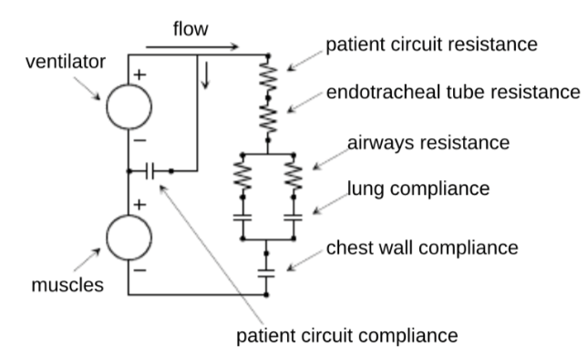
Figure 4: An electrical model of a ventilator patient system.

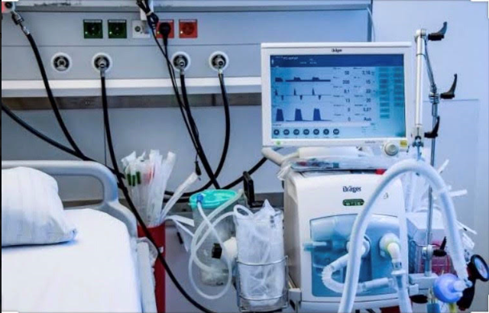
Figure 5: A diagram of a mechanical ventilator

The development of a medical robot:
Since the virus (COVID-19) is highly contagious either through cough droplets and in the health centers, health workers are struggling to keep themselves healthy and the rest of us (hopefully) continue to maintain our distance. And in such Dearing times with the help of electrical engineers, programmers as well as health workers the manufacturing , design and development of mobile robots can be made available. These mobile robots in particular are robot systems that moves in to disinfect facilities, provide surveillances, material handling, and help with deliveries and as such they (mobile robot) are in high demand for these purpose.
- There are Merits of the production of medical robots and a few include;
- Improved communication: telemedicine after approving the intervention of medical robots, supported by robots makes it possible for medical professionals to communicate with patients remotely, saving time and allowing possibly contagious patients to stay confined. Not only can robots communicate with individuals quarantined due to coronavirus, but they can also acquire vital patient information and help doctors treat patients.
- Minimization of human-to-human contact: Due to the contagiousness of COVID-19, it’s safer if human-to-human contact is minimized. Since robots are immune to infection, tech companies such as JD.com and others have stepped up to the challenge of distributing more medical robots.

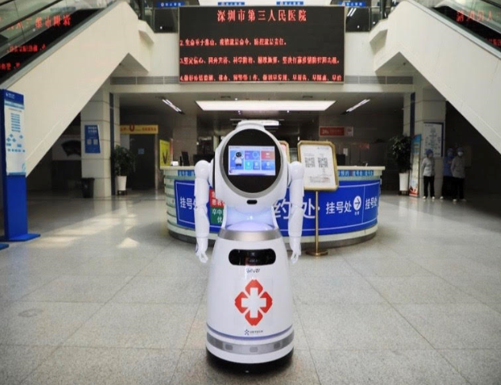
Figure 6: A diagram of a medical robot

Chapter two

2.0 impact of COVID 19 to the economy and how electrical engineers can be a major contributor to the solution ( economic sustainability)

2.1 The impact of Covid-19 on the Nigerian economy
Before the pandemic, the Nigerian government had been grappling with weak recovery from the 2014 oil price shock, with GDP growth tapering around 2.3 percent in 2019. In February, the IMF revised the 2020 GDP growth rate from 2.5 percent to 2 percent, as a result a of relatively low oil prices and limited fiscal space. Relatedly, the country’s debt profile has been source of concern for policymakers and development practitioners as the most recent estimate puts the debt service-to-revenue ratio at 60 percent, which is likely to worsen amid the step decline in revenue associated with failing oil prices. These constraining factors will aggravate the economic impact of the covid-19 outbreak and make it more difficult for the government to weather the crisis.

2.2 What are the policy response by the Nigerian government
Already, the central bank of Nigeria (CBN) has arranged a fiscal stimulus package, including a 50 billion Naira ($138.89 million) credit facility to households and small and medium enterprises most affected by the pandemic a 100 billion naira($277.78 million) loan to the health sector, and a 1 trillion naira($2.78 billion) to the manufacturing sector.

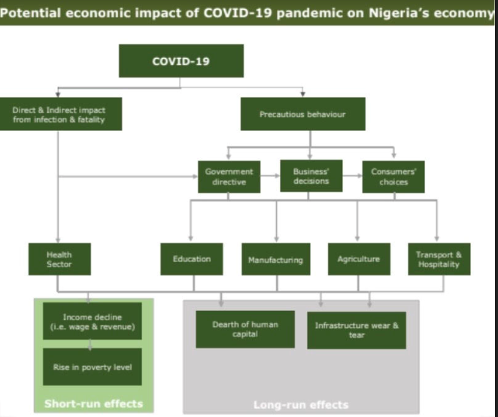
Figure 7: Economic impact of Covid-19 on the Nigerian economy

Chapter three

3.0. conclusion and recommendation

3.1 conclusion
Coronavirus are a large family of viruses that are known to cause illnesses ranging from common cold to more severe diseases such as middle East Respiratory syndrome (MERS) and severe acute respiratory syndrome (SARS) and as such Covid-19 is a global threat facing the world today and engineers are at the forefront of developing the new technologies, infrastructure and solutions that will best help us respond.
Although no vaccine has been completed clinical trials, there are multiple attempts in progress to develop such a vaccine and as such the public is advice is take every necessary safety measure to minimize and prevent the infection of the corona virus.

3.2 recommendation
A People can help protect themselves from respiratory illness with everyday preventive action such as;
- Avoid close contact with people who are sick
- Avoid touching your eyes, nose, mouth with unwashed hands
- Wash your hands often with soap and water for at least 20 seconds.
B The government should engineering personnel in the manufacture of ventilators and other medical essential which are short supply in order to over come the pandemics

References
- Adu, F. D.(2011): Virus and their methods of identification. United state, Trafford.
- Chatburn RL. Classification of mechanical ventilators. Respire care 1992;37(10):1009-1025
- “FIRST CASE OF CORONA VIRUS DISEASE CONFIRMED IN NIGERIA”. Nigeria center for disease control. 28 February 2020. Retrieved 10 March 2020.
- J.P. Fitch and B. sokhansanji.(2000, Dec.). Genomic engineering: moving beyond DNA sequence to function. Proc. IEEE.[online]. 88(12), pp. 1949-1971. Available: http://ieeexplore.ieee.org/stamp/stamp.jsp?arnumber=899061
- “Nigeria center for disease control” ncdc.gov.ng. archived from the original on March 2020. Retrieved 8 March 2020.
- Zhang, L, (2020). “$α$- Ketoamides as broad-spectrum Inhibitors of coronavirus and Enterovirus replication: structure-based design, synthesis, and activity assessment”, journal of medical chemistry,0,0-0

