AFE BABALOLA UNIVERSITY ADO-EKITI (ABUAD)

A TERM PAPER
ON
DEVELOPMENT OF ENVIRONMENTAL HEALTH ENGINEERING FACILITIES, EQUIPMENT, SENSORS AND PUBLIC HEALTH SYSTEMS FOR TACKLING COVID-19 PANDEMIC.

PREPARED BY
NWAGWUAGWU TOCHUKWU DAISY
17 / ENG04 / 043

SUBMITTED TO

ENGR. OYEBODE OLUWADARE JOSHUA

DEPARTMENT OF CIVIL ENGINEERING
COLLEGE OF ENGINEERING

DATE: 11th APRIL 2020

ABSTRACT
Health facilities and equipment are prerequisite to a Nations development and overall workforce. In the prevailing health circumstances the world faces, where funds and workforce availability is currently dwindling, due to the pandemic known as COVID-19. Africa is backward in technological development. The effect of this pandemic would be greatly felt in Africa. The Virus possesses the ability to be highly transmittable through very common everyday gestures such as handshakes, hugs and every other form of body-to-body or fluid contact with infected person. The effect of this Pandemic would be felt greatly in Nigeria due to her large population. As a result of Lack of Technology and Health facilities, Nigeria’s Economy and the overall standard of living of her people would be in grave danger due to this outbreak. The technological development process remains a high silhouette topic for an articulate and politically sophisticated society such as Nigeria. Creative and Innovative are required by professionals to top address the COVID-19 pandemic before it becomes uncontrollable.

Key words: COVID-19, Corona Virus, Ventilators
INTRODUCTION
The Corona virus belongs to a family of viruses that may cause varying symptoms such as pneumonia, fever, breathing difficulty and lung infection. The World Health Organization (WHO) used the term 2019 novel corona virus to refer to a corona virus that affected the lower respiratory tract in Wuhan China on 29th December 2019. The name COVID 19 is the official name of the disease.

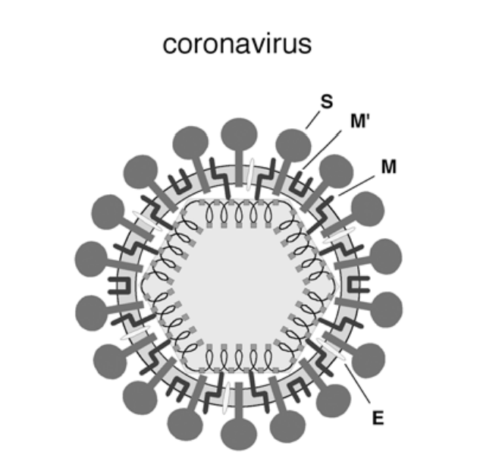
Fig 1. Corona virus Specimen (photo)

The Corona virus has automatically shut down globalization and it is of great importance measures are taken to stop this pandemic before it leads the whole world into a recession.
  - Environmental Health
Environmental Health is concerned with the biological, chemical, and physical influences on human health. This course introduces major terms and concepts used in environmental health practice, focusing on environmental exposures, resulting health effects, and appropriate controls for the Corona Virus. We discuss basic tools for addressing a variety of current problems on the micro, regional, national, and global scale at which the virus has affected. The major application areas are: food safety, pests and pesticides, air quality, global climate change, the built environment, water quality, waste water, solid and hazardous wastes, industrial hygiene. Macroeconomic factors such as trade globalization, market liberalization, debt burdens and structural adjustment policies are among the most powerful drivers of national political agendas and, indirectly, environment and health policies.

Ad earth of institutional resources, human capacity and "enabling" legal frameworks impedes adequate assessment of the complex links between health, environment, poverty and development options. For instance, irrigation schemes may yield benefits in terms of Food security and health. But when irrigation and dam design is not sensitive to the Surrounding ecosystem, the scheme may enhance the conditions necessary for disease vectors to thrive and thereby create new health impacts. Agricultural chemicals can be used constructively to increase yields, but they also can kill or maim farm workers and children,and infiltrate water sources, when chemical regulation and education is inadequate.

  - Health Facilities and Equipment
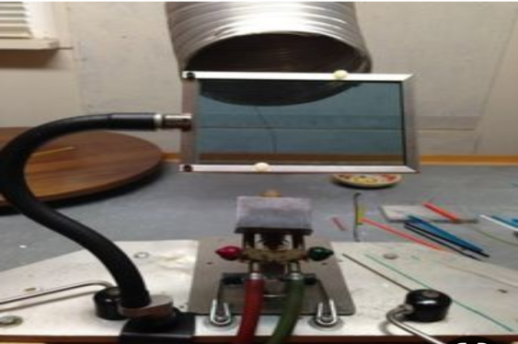
Fig 2. Ventilator manufacturing

Fig 3. COVID-19 Patient facility
Introducing an element of standardization for health care technology will help you to limit the wide variety of makes and models of equipment found in your stock, due to the sudden pandemic most people were not economically prepared. By concentrating on a smaller range for each equipment type, your technical, procedural, and training skills will increase and your costs and logistical requirements will decrease.

It is easier to achieve standardization if equipment is planned and ordered on a country-wide, district-wide or health service provider basis. It is therefore important to combine forces with other facilities or health service providers, and it may be wise to follow standardization strategies of the Ministry of Health. It is important that these standardization efforts do not just apply to products purchased by health facilities, but also to donations.

Proper maintenance affects the performance and safety of equipment. Poorly maintained equipment deteriorates more quickly and is more likely to break down. Unreliable or inaccurate equipment is often worse than no equipment at all. A sterilizer, for example, with a leaky seal will not sterilize its contents properly. Both day-to-day maintenance by users and Planned Preventive Maintenance (PPM) are essential to keep equipment in good working condition. This section discusses user maintenance and PPM, illustrated by examples of practical care
and maintenance of items of equipment including stainless steel instruments, microscopes, steam sterilizers, and refrigerators.
Planned Preventive Maintenance (PPM) is a regular service, recommended by manufacturers and carried out by trained technicians, to check equipment performance and replace parts. PPM should support and supplement user maintenance carried out by staff using the equipment. The frequency of PPM depends on the type of equipment and the manufacturer’s recommendation. PPM can double the life time of equipment and reduce breakdowns. For example, a microscope will last around 15 years with proper care and maintenance but only around 8 years if it is not looked after properly. Refrigerators and weighing scales should last for about 8 years, sterilizers for about 6 years, and ward beds about 12 years. In this case Ventilators are our major concern.
Manufacturers and suppliers usually provide maintenance and repair services, but may not have representatives or authorized service agents in every country. If there is no representative or authorized agent in your country, you will need to identify a specialized organization that can provide PPM for particular items of equipment, such as the technical unit of your local hospital as to avoid unnecessary spread of disease. All maintenance and repair should be carried out according to the manufacturer’s instructions on the Ventilator.

- Development Strategies
Strategic thinking implies prioritization and sequencing, seeking to do first that which is necessary or helpful to achieve later goals. A strategy begins by defining a clear objective (e.g., are we aiming in the first instance at economic growth, democratization, establishment of a rule of law, a more vigorous civil society?), and then assesses constraints that prevent the achievement of this objective. Strategic thinking looks at alternative pathways that get around those constraints; if this is not possible, it requires the redirection of energies to other goals that are more realistically achievable.
Yet development policymakers and practitioners seldom think in this manner. That is, they do not integrate political, economic, and social strategies; they do not set clear priorities or sequence reforms over time; and they do not pay sufficient attention to constraints. Development strategies in official documents often read like wish lists of all of the good things that the sponsors would like to see happen, with little appreciation for what needs to be done first in order to facilitate the achievement of other objectives down the road.
There are several reasons for this lack of strategic thinking about development. Development specialists tend to be compartmentalized by academic discipline. While economists, for example, have recently come to take politics and institutions more seriously, their first inclination is usually not to think about the political preconditions for achieving economic goals. Conversely, people in the democracy promotion field often do not pay attention to economic issues, or else relegate growth to a second-order priority. In the donor community, there is a great deal of political sensitivity on the question of sequencing or prioritization. If one admits that there is little chance for a democratic breakthrough or for cleaning up a particular corrupt bureaucracy, one appears to be endorsing a bad status quo.
The one strategic issue that has generated a substantial amount of debate concerns the sequencing of economic and political reforms. Proponents of the so-called “authoritarian transition” like Huntington have argued in favor of putting economic development and establishment of a liberal rule of law ahead of democratization, given that a stronger causal connection appears to exist from economic growth to democracy than the other way around. Others have argued that such sequencing is not a practical option in most cases, and that advocates of reform in developing and transitional countries usually want both rule of law and democracy simultaneously.
This paper suggests a more comprehensive framework for thinking about development strategies and for integrating political, economic, and social policies. The next section introduces each of six dimensions, and summarizes briefly what is known about their causal links with one another. Section III lays out four distinctive sequences via which the different dimensions might interact and evolve over time. The final section examines how the ‘sequences framework’ can aid development decision-making.

  - Application Development to aid R&D on COVID-19
- PROGRAM DEVELOPMENT CYCLE
CONCEPTUALIZATION: Due to the current pandemic that hit the world, the world has been greatly affected economically, financially and health wise. Actions have been taken by various health bodies to curb the spread of the virus. The purpose of this program is to create a more effective way to test the Virus and detect it before it is given the chance to be spread.

SPECIFICATION: The Program is a software that is not machine independent as the programmer needs to understand the hardware in order to operate. The software would be able to test the presence of the virus, display the results and degree of infection, store the date and transmit the data to the company’s server where it could be used for R&D purposes.
DESIGN: This stage involves the development of the algorithm and flow chart in order to understand the program flow. The Algorithm, flowchart, modular design would be elaborated later.
IMPLEMENTATION: The program would be implemented using the following programs
- Java & Java FX : For the structure and program construct
- Firebase SQL: For the programs database
- Javascript & CSS: For the programs web and graphical display
- Html : For the program’s web construct and design.
TESTING AND DEBUGGING: After the program is built, it would be run and tested for any logical errors and debugged of any if found. The program is tested across a variety of cases and made sure it goes along with SSL privacy terms and WHO health’s specifications.
RELEASE & UPDATE: The program would be released and used to test patients all over the globe and if any recent development occurs, we would update the application to fit the new specifications.

- HARDWARE AND SOFTWARE FEATURES
HARDWARE FEATURES:
The hard ware features necessary is the virus testing kit which is based on either:
- Real time reverse transcription- polymerase chain reaction (rRT-PCR)
- Isothermal and nucleic acid amplification
The techniques mentioned above involves taking the of air samples from the lungs to test for the presence of the virus.
CHEST SCAN: The chest scan is used to show the degree of infection once the presence of the virus has been predetermined be the above features, thus to the level of medication needed for the patient.
SERVER: A server would be needed to store the data collected from the various test for future reference and also research and development purposes.
FIBRE OPTICS: To ensure the speedy transfer of date from the hardware to the server and through development Laboratories.

SOFTWARE FEATURES:
DETECTION: The RNA of the COVID-19 virus would be stored on the program and used as a reference point. Once a sample comes in that matches the RNA stored, program would show detected.
DEGREE OF INFECTION: Once the virus has been the detected, the patient would be taken for a chest scan to know the rate of infection, if the scan falls in any of the four scan photos representing the various stages already stored on the program. The it would select the stage in reference.
DISPLAY: The program would the send the date to the LED interface built with Touch screen clarification where the operator can input some specifications before sending it to the server.

- ALGORITHM & FLOW CHART
ALGORITHM:

Start
Read A= User’s air Sample // Stored sample
Read G= User’s CT photo //Patients CT scan
Read C,D,E,F //Already stored CT scan foe determining stages
Read B= Stored RNA sample of virus //Stored RNA sample of virus
If A=B
Print positive
Else
Print Negative
While A=B
If G=C
Print stage 1
Else if G= D
Print Stage 2
Else if G=E
Print stage 3
Else if G=F
Print stage 4
End

FLOW CHART

START
IF A=B
ENTER A
ENTER G
READ C,D,E,F
READ B

NO YES
PRINT POSITIVE
PRINT NEGATIVE

WHILE A=B
IF G= C
PRINT STAGE 1
ELSE IF G= D
PRINT STAGE 2

PRINT STAGE 3
ELSE IF G=E

ELSE IF G=F
PRINT STAGE 4

END

MODULAR DESIGN

COVID-19 PROGRAM
STAGE DETERMINATION SSYTEM
VIRUS DETECTION SYSTEM
DATABASE

OPERATION
OPERATION
USER’S CT
STORED VIRUS RNA
DETECTION RESULT
STORED CT SAMPLE
USER’S RNA
STAGE RESULT

  - Environmental Structures
Due to the high population of people infected with the COVID-19 a lot of public offices and buildings could be converted to Health Centres following the guidelines given below:
- Environment: A hospital and other health facilities shall be so located that it is readily accessible to the community and reasonably free from undue noise, smoke, dust, foul odor, flood, and shall not be located adjacent to railroads, freight yards, children's playgrounds, airports, industrial plants, disposal plants.
- Occupancy: A building designed for other purpose shall not be converted into a hospital. The location of a hospital shall comply with all local zoning ordinances.
- Safety: A hospital and other health facilities shall provide and maintain a safe environment for patients, personnel and public. The building shall be of such construction so that no hazards to the life and safety of patients, personnel and public exist. It shall be capable of withstanding weight and elements to which they may be subjected.
- Security: A hospital and other health facilities shall ensure the security of person and property within the facility.
- Patient Movement: Spaces shall be wide enough for free movement of patients, whether they are on beds, stretchers, or wheelchairs. Circulation routes for transferring patients from one area to another shall be available and free at all times.
- Lighting: All areas in a hospital and other health facilities shall be provided with sufficient illumination to promote comfort, healing and recovery of patients and to enable personnel in the performance of work.
- Ventilation: Adequate ventilation shall be provided to ensure comfort of patients, personnel and public.
- Auditory and Visual Privacy: A hospital and other health facilities shall observe acceptable sound level and adequate visual seclusion to achieve the acoustical and privacy requirements in designated areas allowing the unhampered conduct of activities.
- Water Supply: A hospital and other health facilities shall use an approved public water supply system whenever available. The water supply shall be potable, safe for drinking and adequate, and shall be brought into the building free of cross connections.
- Waste Disposal: Liquid waste shall be discharged into an approved public sewerage system whenever available, and solid waste shall be collected, treated and disposed of in accordance with applicable codes, laws or ordinances.
- Sanitation: Utilities for the maintenance of sanitary system, including approved water supply and sewerage system, shall be provided through the buildings and premises to ensure a clean and healthy environment.
- Maintenance: There shall be an effective building maintenance program in place. The buildings and equipment shall be kept in a state of good repair. Proper maintenance shall be provided to prevent untimely breakdown of buildings and equipment.
- Material Specification: Floors, walls and ceilings shall be of sturdy materials that shall allow durability, ease of cleaning and fire resistance.
- Segregation: Wards shall observe segregation of sexes. Separate toilet shall be maintained for patients and personnel, male and female, with a ratio of one (1) toilet for every eight (8) patients or personnel.

CONCLUSION
In conclusion, the growth and development of a Nation’s workforce lies completely on the health of her workers. If the health of the workers are neglected, the nation would be in a turmoil. The purpose of this paper is to explore other methods that could aid in the prevention of death in the country due to the COVID-19 virus. Adopting the methods outlined above would go a long way in ensuring the global population health status is restored.

References
1.OECD (2001).The DAC guidelines for strategies for sustainable development: Guidance for development cooperation Paris Cedex : OECD publications, France, p 14.
2.FRENCH RED CROSS (2006). A source of design reference standards handbook to build a hospital. France.
3.Graham M. Brooker. Introduction to Biomechatronics.
4.MicroElectroMechanical Systems (MEMS). Sandia National Laboratories. 2017.
5.Khan, M.S.; Misra, S.K.; Dighe, K.; Wang, Z.; Schwartz-Duval, A.S.; Sar, D.; Pan, D. Electrically-receptive and thermally-responsive paper-based sensor chip for rapid detection of bacterial cells. Biosens. Bioelectron. 2018,
6.Saylan, Y.; Yılmaz, F.; Özgür, E.; Derazshamshir, A.; Bereli, N.; Yavuz, H.; Denizli, A. Nanotechnology Characterization Tools for Biosensing and Medical Diagnosis. In Surface Plasmon Resonance Sensors for medical Diagnosis; Kumar, C.S.S.R., Ed.; Springer: Berlin/Heidelberg, Germany, 2018; pp. 425–458.

