NAME: AFUWAPE OLAMIDE MARY
MATRIC NUMBER: 19/MHS01/049
DEPARTMENT: MEDICINE AND SURGERY
PHY 102 ASSIGNMENT
SECTION A
1. (a) Electric charges can be obtained on an object without touching it, by a process called electrostatic induction.
Suppose a positively charged rubber rod brought near a neutral (uncharged) conducting sphere that is insulated so that there is no conducting path to ground. The repulsive force between the protons in the rod and those in the sphere causes a redistribution of charges on the sphere so that some protons move to the side of the sphere farthest away from the rod. The region of the sphere nearest the positively charged rod has an excess of negative charge because of the migration of protons away from this location. If a grounded conducting wire is then connected to the sphere, some of the protons leave the sphere and travel to the earth. If the wire to ground is then removed, the conducting sphere is left with an excess of induced negative charge. When the rubber rod is now removed from the vicinity of the sphere, the induced negative charge remains on the ungrounded sphere and becomes uniformly distributed over the surface of the sphere.
+ + + + + + + + +
+ + + + +
+ + + + +
=
=
=
=
1
2
3
4

(b) K = 8.9875 $×{10}^{9}$ Nm²/C², F = 1N, r = 2m, q₁ + q₂ = 5 $× {10}^{-5}$ C
Find the charge on each sphere.

F = $\frac{kq1q2}{r^{2}}$
1 = $\frac{(8.9875 × {10}^{9}) ×q1 ×(\left(5 × {10}^{-5}\right)-q1^{2})}{2^{2}}$
4 = 449375q₁ – (8. 9875$×{10}^{9}$) q₁²
8.9875 $×$ ${10}^{9}$q₁² – 449375q₁ + 4 = 0
Therefore, q₁ = 3.84 $× {10}^{-5}$ C and q₂ = 1.16 $× {10}^{-5}$ C
(c) 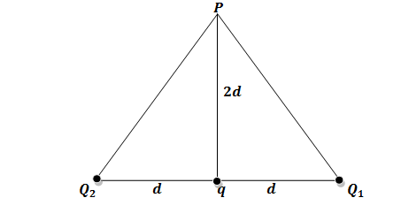
Q₁ = Q₂ = 8$μC$, d = 0.5m,
Line PQ₂ = Line PQ₁ = $\sqrt{1^{2}+ {0.5}^{2}}$ = 1.118m
<Q₂ = <Q₁ = tan⁻¹($\frac{1}{0.5}$) = 63.4$°$
F₁ =F₂ = $\frac{kq1q2}{r^{2}}$ = $\frac{{9 × 10}^{9} ×8 × {10}^{-6}}{{1.118}^{2}}$ = 57603.5 N
Fq =$\frac{kq}{{(Pq)}^{2}}$ = $\frac{9 × {10}^{9}×q}{1}$ = ${9 × 10}^{9}$q N
Vector | Angle | x- component | y- component
F₁ = 57603.5 | 63.4 | - 25792.49 | 51506.4
F₂ = 57603.5 | 63.4 | + 25792.49 | 51604.4
 |  | $$\sum{F_{X}=0}$$ | $$\sum{F_{Y}=103012.8313}$$
Fq = ${9 × 10}^{9}$q | 90 | 0 | ${9 × 10}^{9}$q
F_{p} =
= $\sqrt{0^{2}+ {103012.8313}^{2}}$
F_{P} = 103012.8313 N
E_{P} = 0
E_{P} = F_{q} + F_{P}
0 = (${9 × 10}^{9}$q) + 103012.8313
$-\frac{103012.8313}{{9 × 10}^{9}}$= $\frac{{9 × 10}^{9}}{{9 × 10}^{9}}$q
q = $-$ 1.14 $×{10}^{-5}$ C= $-$11.4 $× {10}^{-6}$ C= $-$ 11.4$μ$C
3. (a) I Volume charge density, $ρ=\frac{dQ}{dV} →dQ=ρdV$
II Surface charge density, $σ=\frac{dQ}{dA} →dQ=σdA$
III Linear charge density, $λ=\frac{dQ}{dL} →dQ=λdL$
(b) Electric potential difference between two points in an electric field can be defined as the work done per unit charge against electrical forces when a charge is transported from one point to the other. It is measured in Volt $(v)$ or Joules per Coulomb (J/C). It is a scalar quantity.
E
q
0

In the diagram above, suppose a test charge $q_{o}$ is moved from point $A$ to point $B$ along an arbitrary path inside an electric field, E. The electric field $E$ exerts a force $F=q_{o}E$ on the charge. To move the test charge from $A$ to $B$ at constant velocity, an external force of $F=-q_{o}E$ must act on the charge. Therefore, the work done $dW$ is given as:
$$dW=F.dL … (i)$$
But
$$F=-q_{0}E … (ii)$$
Substituting equation $(ii)$ in $(i)$ yields
$$dW=-q_{0}EdL … (iii)$$
Then total work done in moving the test charge from $A$ to $B$ will be:
$${W(A→B)}_{Ag}=-q_{0}\int_{A}^{B}{EdL} … (iv)$$
From the definition of electric potential difference, it follows that:
$$V_{B}-V_{A}=\frac{{W(A→B)}_{Ag}}{q_{0}} … (v)$$
Putting equation $(iv)$ in $(v)$ yields
$$V_{B}-V_{A}=-\int_{A}^{B}{EdL} … (vi)$$
(c) Q₁ = 10$μ$C at x = 0, Q₂ = -2$μ$C at x = 4, V = 0
V₁ + V₂ = 0
$\frac{kq1}{r}+ \frac{kq2}{4+r}$ = 0
$\frac{\left(9 × {10}^{9}\right) ×(10 ×{10}^{-6 })}{r}$ + $\frac{\left(9 × {10}^{9}\right)×(-2×{10}^{-6})}{4+r}$ = 0
$\frac{90000}{r}$ $-$ $\frac{18000}{4+r}$ = 0
90000(4 + r) = 18000r
360000 + 90000r = 18000r
r = $\frac{-360000}{72000}$
r = $-$ 5
Therefore, the distance can be -5 which is at the left of x axis
SECTION B
4. (a) Magnetic flux: the number of magnetic lines of forces set up in a magnetic circuit. It is analogous to electric current, I in an electric circuit. Its SI unit is Weber (Wb) and its CGS unit is Maxwell. It is denoted by $φ$_{m}. It measures through flux meter. The flux meter has to measure coil which measures the variation of voltage to measure the flux.
Magnetic flux for open surface
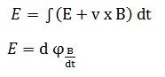
Where
E – electromotive force
v – velocity of the boundary
E – electric field
B – magnetic field
øB – magnetic flux through the open surface
dl – infinitesimal vector element
The magnetic flux through a closed surface is always zero, but in the open surface, it is not zero.
(b) m = 9.11 $×$ ${10}^{-31}$kg, r = 1.4 $×$ ${10}^{-7}$m, B = 3.5 $×$ ${10}^{-1}$w/m², $ω$ = ?
$ω$ = $\frac{v}{r}$ = $\frac{qB}{m}$
$ω$ = $\frac{qB}{m}$ = $\frac{1.6 × {10}^{-19} ×3.5 × {10}^{-1}}{9.11 × {10}^{-31}}$ = $\frac{5.6 × {10}^{-20}}{9.11 × {10}^{-31}}$= 6.147 $×$ ${10}^{10}S^{-1}$
(c) The net force experienced by a charged particle, by Newton second law is
$$\sum{F= F_{B}}=ma$$
Because the motion of the charged particle is a uniform circular motion, we replace the acceleration$a$ with centripetal acceleration $\frac{v^{2}}{r}$.
$${ F}_{B}=qVB= \frac{mv^{2}}{r}$$
This expression leads to the following equation for the radius of the circular path
$$r= \frac{mv}{qB}$$
The indication of this is that the radius of the path is proportional to the linear momentum ‘$mv$’ of the particle and inversely proportional to the product of the charge on the particle and the magnetic field. The angular speed of the particle is
$$ω= \frac{v}{r}= \frac{qB}{m}$$
The period of the motion (the time interval the particle requires to complete one revolution) is equal to the circumference of the circle divided by the speed of the particle.
$$T=\frac{2πr}{v}= \frac{2π}{ω} = \frac{2πm }{qB}$$
The angular speed $ω$ is often referred to as the cyclotron frequency because the charged particle circulates at this angular frequency or angular speed in the type of accelerator called cyclotron.
Therefore, $ω$ was used to find the cyclotron frequency with the formula below:$$ω= \frac{v}{r}= \frac{qB}{m}$$
5. (a) The Biot - Savart Law is an equation that describes the magnetic field created by a current-carrying wire, and allows you to calculate its strength at various points.
To derive this law, we first take this equation for the electric field. This is the full version, where we use muu-zero over 4pi instead of the electrostatic constant k. Since we're looking at a wire, we replace the charge q with I dl, which is the current in the wire, multiplied by a length element in the wire. Basically, it's treating this little chunk of the wire as our charge. And we also replace the electric field E with a magnetic field element dB because a moving charge produces a magnetic field, not an electric field.
Last of all, we have to realize that a current has a direction (unlike a charge). So we need to make sure the direction of the current affects our result. We do that by adding sine of the angle between the current and the radius. That way, if the wire is curvy, we'll take that into account. And that's it - the Biot-Savart law.
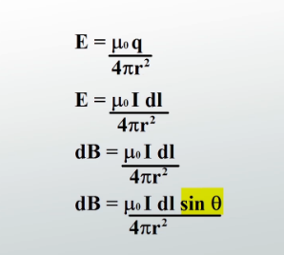

(b)
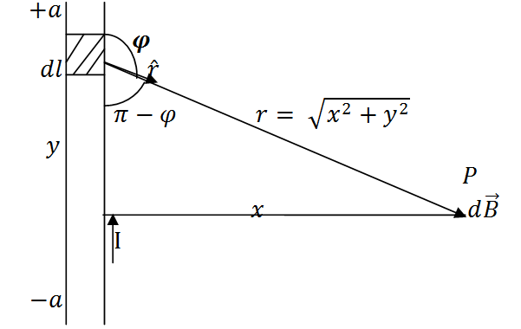
A section of a Straight Current Carrying Conductor
Applying the Biot-Savart law, we find the magnitude of the field $d\vec{B}$
$$B= \frac{μ_{o}I}{4π}\int_{-a}^{a}{\frac{dl\sin{φ}}{r^{2}}}$$
$$sin\left(π –φ\right)= sinθ$$
$$∴B= \frac{μ_{o}I}{4π}\int_{-a}^{a}{\frac{dlsin(π-φ)}{r^{2}}}$$
From diagram, $r^{2}=x^{2}+y^{2} (Pythagoras theorem)$
$$B= \frac{μ_{o}I}{4π}\int_{-a}^{a}{\frac{dlsin(π –φ)}{x^{2 }+ y^{2}}} … (i)$$
$$But sin\left(π-φ\right)= \frac{x}{\sqrt{x^{2 }+ y^{2}}}=\frac{x}{{\left(x^{2 }+ y^{2}\right)}^{1/2}} … (ii)$$
Substituting $(ii)$ into$(i)$, we have
$$B= \frac{μ_{o}I}{4π}\int_{-a}^{a}{dl}\frac{x}{{{(x}^{2}+ y^{2})\left(x^{2 }+y^{2 }\right)}^{1/2}}$$

$$B= \frac{μ_{o}I}{4π}\int_{-a}^{a}{dl}\frac{x}{{\left(x^{2 }+y^{2 }\right)}^{3/2}}$$
Recall $dl=dy$
$$B= \frac{μ_{o}I}{4π}\int_{-a}^{a}{\frac{x}{{\left(x^{2 }+y^{2 }\right)}^{3/2}}dy}$$
$$B=\frac{μ_{o}Ix}{4π}\int_{-a}^{a}{\frac{1}{{\left(x^{2 }+y^{2 }\right)}^{3/2}}dy} … (iii)$$
Using special integrals:
$$\int{\frac{dy}{{{(x}^{2 }+ y^{2})}^{3/2}}}=\frac{1}{x^{2}}\frac{y}{{(x^{2 }+ y^{2})}^{1/2}}$$
Equation $(iii)$ therefore becomes
$$B= \frac{μ_{o}Ix}{4π}{\left[\frac{y}{x^{2}{\left(x^{2 }+y^{2}\right)}^{1/2}}\right]}_{-a}^{a}$$
$$B=\frac{μ_{o}Ix}{4π}\left(\frac{2a}{x^{2}{\left(x^{2 }+ a^{2}\right)}^{1/2}}\right)$$
$$B=\frac{μ_{o}I}{4πx}\left(\frac{2a}{{\left(x^{2 }+ a^{2}\right)}^{1/2}}\right)$$
When the length $2a$ of the conductor is very great in comparison to its distance $x$ from point P, we consider it infinitely long. That is, when $a$ is much larger than$x$,
$${(x^{2 }+ a^{2})}^{1/2}≅a, as a→∞$$
$$∴B= \frac{μ_{o}I}{2πx}$$
In a physical situation, we have axial symmetry about the y- axis. Thus, at all points in a circle of radius$r$, around the conductor, the magnitude of B is
$$B= \frac{μ_{o}I}{2πr} … (iv)$$
Equation $(iv)$ defines the magnitude of the magnetic field of flux density B near a long, straight current carrying conductor.

