NAME: MICHEAL CHISOM IMMACULATE
DEPARTMENT: PHARMACOLOGY
MATRIC NUMBER: 17/MHS07/016
COURSE: PHA 312 CHEMOTHERAPY OF PLASTIC DISEASES, ANTISEPTIC AND DISINFECTANT.

QUESTIONS
- Draw and explain the life cycle of the malaria parasite.
- Mention two major classification of anti amoebic drugs
- Highlight the name of the drugs used under each group and give appropriate examples.
- Explain vividly the mechanism of action of Metronidazole

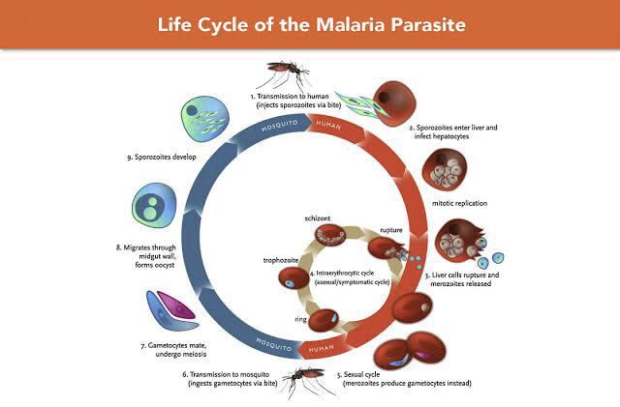
• Transmission of malaria occurs through a vector, the mosquito, that ingests gametocytes the sexual form of the parasite when feeding on an infected human.

•Gametocytes, which are both male and female, mate within the gut of the mosquito and undergo meiosis and then migrate through the midgut wall of the mosquito and form an oocyst, within which thousands of sporozoites develop.

•These are then injected into a human during the next blood meal(s), where they rapidly make their way to the liver and infect hepatocytes and begin asexually (mitotically) replicating.

•After a period of 6-15 days, the liver schizonts rupture, releasing thousands of merozoites into the blood where they invade red blood cells.

•Over the next 48 hours, the parasite begins replicating mitotically, progressing through a set of stages (ring, trophozoite and schizont), and produces an average of 16 new daughter merozoites per schizont.

• The schizonts then burst in near synchrony with other parasites, producing the characteristic fever cycle that embodies the clinical manifestations of the disease.

• With each replication, some of the merozoites, instead of producing new merozoites, develop into gametocytes, which can then infect susceptible mosquitoes, bringing the transmission cycle full circle.

- Classification of anti amoebic drugs
• Tissue Amoebiasis
• Luminal Amoebiasis

- Highlight the name of the drugs used under each group and give appropriate examples.

• Tissue Amoebiasis
*for Both intestinal and extra intestinal
- Nitroimidazoles – examples are : Metronidazole, Tinidazole, Secnidazole, Ornidazole.
- Alkaloids – examples are : Emetine, Hydroemetine

*for extra intestinal only
1. Chloroquine

• Luminal Amoebiasis
- Amides – example : Diloxanide furoate
- 8-Hydroxy quinolone – example: Quinidochlor
- Antibiotics – examples are : Tetracycline, Paromomycin

- Mechanism of action for metronidazole

Metronidazole diffuses into the organism, inhibits protein synthesis by interacting with DNA and causing a loss of helical DNA structure and strand breakage. Therefore, it causes cell death in susceptible organisms.

The mechanism of action of metronidazole occurs through a four-step process.
• Step one is the entry into the organism by diffusion across the cell membranes of anaerobic and aerobic pathogens. However, antimicrobial effects are limited to anaerobes.

•Step two involves reductive activation by intracellular transport proteins by altering the chemical structure of pyruvate-ferredoxin oxidoreductase. The reduction of metronidazole creates a concentration gradient in the cell that drives uptake of more drug and promotes free radical formation that is cytotoxic.

• Step three, interactions with intracellular targets, is achieved by cytotoxic particles interacting with host cell DNA resulting in DNA strand breakage and fatal destabilization of the DNA helix.

•Step four is the breakdown of cytotoxic products. Metronidazole is also cytotoxic to facultatively anaerobic bacteria like Helicobacter pylori and Gardnerella vaginalis.

