MATRIC NO: 16/MHS02/035
NAME: OJO AISHA AYOKUNBI
COURSE CODE: NSC 414
ASSIGNMENT

QUANTITATIVE DATA COLLECTION
A data that can be counted or expressed in numerical constitute the quantitative data. It is commonly used to study the events or levels of concurrence.
METHODS FOR QUANTITATIVE DATA COLLECTION
- PROBABILITY SAMPLING: A definitive method of sampling carried out by utilizing some form of random selection and enabling researchers to make a probability statement based on data collected at random from the targeted demographic. There are three significant types of probability sampling
- Simple random sampling: More often, the targeted demographic is chosen for inclusion in the sample.
- Systematic random sampling: Any of the targeted demographic would be included in the sample, but only the first unit for inclusion in the sample is selected randomly, rest are selected in the ordered fashion as if one out of every ten people on the list.
- Stratified random sampling: It allows selecting each unit from a particular group of the targeted audience while creating a sample. It is useful when the researchers are selective about including a specific set of people in the sample, i.e., only males or females, managers or executives, people working within a particular industry.

- INTERVIEWS: Interviewing people is a standard method used for data collection. However, the interviews conducted to collect quantitative data are more structured, wherein the researchers ask only a standard set of questionnaires and nothing more than that. There are three major types of interviews conducted for data collection
- Telephone interviews: For years, telephone interviews ruled the charts of data collection methods. However, nowadays, there is a significant rise in conducting video interviews using the internet, Skype, or similar online video calling platforms.
- Face-to-face interviews: It is a proven technique to collect data directly from the participants. It helps in acquiring quality data as it provides a scope to ask detailed questions and probing further to collect rich and informative data.
- Computer-Assisted Personal Interviewing (CAPI): It is nothing but a similar setup of the face-to-face interview where the interviewer carries a desktop or laptop along with him at the time of interview to upload the data obtained from the interview directly into the database.
- SURVEYS/QUESTIONNAIRE: Surveys or questionnaires created using online survey software are playing a pivotal role in online data collection. The surveys are designed in a manner to legitimize the behavior and trust of the respondents. More often, checklists and rating scale type of questions make the bulk of quantitative surveys as it helps in simplifying and quantifying the attitude or behavior of the respondents.
- OBSERVATION: It is a pretty simple and straightforward method of collecting quantitative data. In this method, researchers collect quantitative data through systematic observations by using techniques like counting the number of people present at the specific event at a particular time and a particular venue or number of people attending the event in a designated place
- DOCUMENT REVIEW: Document review is a process used to collect data after reviewing the existing documents. It is an efficient and effective way of gathering data as documents are manageable and are the practical resource to get qualified data from the past. Apart from strengthening and supporting the research by providing supplementary research data document review has emerged as one of the beneficial methods to gather quantitative research data.

QUALITATIVE DATA COLLECTION

Different methods are used in qualitative research. The most common are interviews, focus group discussions, observational methods and document analysis.
METHODS FOR QUALITATIVE DATA COLLECTION
- INTERVIEWS: Interviews are useful to explore experiences, views, opinions, or beliefs on specific matters. Accounts can be explored and compared to others, to develop an understanding of the underlying structures of beliefs. There are different grades of structuring the interview: structured, semi-structured or open/in-depth, dependent on the characteristics of structuring the interview by the researcher. Often the researcher develops a topic list before the start of the interview, which can be used in a flexible manner. As the interview is a product of interaction between the researcher and the interviewee, the setting and skills of the researcher are of importance (e.g. the ability to build a sense of trust (developing rapport), the way of phrasing questions, give the interviewee room to tell a story, body language).
- FOCUS GROUP DISCUSSIONS: Focus group discussions are useful to examine how social knowledge is produced. The researcher stimulates discussion in order to examine how knowledge and ideas develop and operate in a given group. Most of the times, a facilitator guides a discussion about a particular topic in a group of usually 6-12 people. Some sensitive issues might be more easy discussed within a group, although other (personal) information might be withheld, for instance when persons are acquainted with each other or because of hierarchical relations within the group. The role of the facilitator is to create an open atmosphere, involve participants in the discussion and manage this discussion. The organization of a focus group requires careful attention. This includes the sampling and recruitment of participants, the composition of the topic list and how the data will be collected.
- OBSERVATIONAL METHODS: Observational methods are used to understand phenomena by studying people’s accounts and actions in an everyday context. There are different types of observations, with various degrees of research participation, like non-participating observation (e.g. by using video recordings), and participant observation or ethnography. Ethnography ‘usually involves the researcher participating, overtly or covertly, in people’s daily lives for an extended period of time, watching what happens, listening to what is said, and/or asking questions through informal and formal interviews, collecting documents.
- DOCUMENT ANALYSIS: Document analysis is based on existing sources, like government reports, personal documents, articles in newspapers, books or medical records.
- OPEN-ENDED SURVEYS AND QUESTIONNAIRES: Opposite to closed-ended are open-ended surveys and questionnaires. The main difference between the two is the fact that closed-ended surveys offer predefined answer options the respondent must choose from, whereas open-ended surveys allow the respondents much more freedom and flexibility when providing their answers.
Here’s an example that best illustrates the difference:
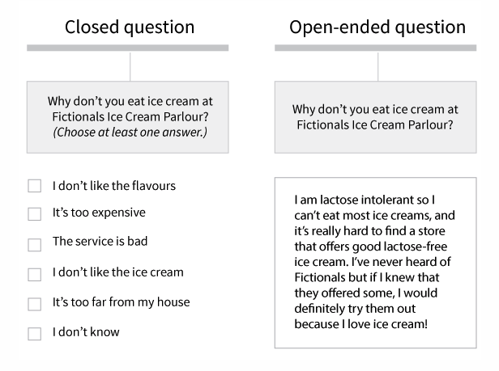
- 1-ON-1 INTERVIEWS: One-on-one (or face-to-face) interviews are one of the most common types of data collection methods in qualitative research. Here, the interviewer collects data directly from the interviewee. Due to it being a very personal approach, this data collection technique is perfect when you need to gather highly-personalized data.
Depending on your specific needs, the interview can be informal, unstructured, conversational, and even spontaneous (as if you were talking to your friend) – in which case it’s more difficult and time-consuming to process the obtained data – or it can be semi-structured and standardized to a certain extent (if you, for example, ask the same series of open-ended questions).

