CONCEPT OF SEDIMENT TRANSPORT AND HOW IT AFFECTS COASTAL AREAS
BY

SMOOTH TAMARA-EKIA SIMON
15/ENG03/030

DEPARTMENT OF CIVIL & ENVIRONMENTAL
ENGINEERING
COLLEGE OF ENGINEERING
AFE BABALOLA UNIVERSITY, ADO-EKITI.
EKITI STATE, NIGERIA.

ABSTRACT
The paper provides basic information on the description of sediment transport in the coastal zone of the sea. It explains the mechanisms of sediment movement under the influence of the waves and currents interactions, characteristic for the coastal zone. It presents models describing the movement of sediment in the regime of flat bottom, making their divided in accordance with the method of description of vertical structure of sediments transport. Particular emphasis is placed on modeling of graded sediment transport. It presents basis for the three-layer model of graded sediment transport. This allows, among others, the analysis of the variability of particle size distribution in the whole area of sediment movement. The model assumes that the movement of sediment is divided into three layers: bedload layer, contact load layer and outer flow region, as a result of the shear stress influence on the bottom.

CHAPTER ONE
INTRODUCTION
The primary factor leading to the reconstruction of the profile of the seabed is a wave caused by the wind and the return current which is caused by this wave. Wind-induced waves are generated in the deep-water off-shore area, where the seabed does not affect the nature of the waves. As a result of decreased depth, the wave undergoes a transform action process leading to the increase of the wave crest height and shortening its length, each wave through becoming shallower and longer. In the area of Deepwater, it is necessary to use the sinusoidal wave approximation, whereas along with the decrease of the depth, the 2nd Stokes approximation is used and then the conical approximation and solitary waves. In the coastal zone, for the purpose of describing sediment transport, the 2nd Stokes wave approximation is most commonly used. It is characterized by shortened and steep crest and elongated and flattened through, in comparison to the sine wave. In the coastal zone there is an interaction between the hydrodynamic forces and sediment and bathymetric profile of the bottom. The fluid stream due to friction forces, runs the sediment from the bottom and the sediment material is transferred over a certain distance. So, moving water causes the bottom sediment transport, and the spatial variability of sediment transport volume causes changes in morphology of the bottom, which in turn affects the water movement change. The question of what controls the rate and method of sediment transport and the nature of changes in the level of the bottom occupied researchers for over a century. Numerous relations between the level of bottom elevation and the rate of sediment transport and flow parameters, including a number of empirical and far less theoretical relations have been proposed. Empirical relations generally cannot be applied beyond the limited conditions for which they were formulated, and the majority of theoretical propositions depend on arbitrary assumptions with only a little or no physical credibility (ALLEN 1977). Comprehensive description of such a complex system is very difficult and therefore only by successive approximations and simplify, it is possible to describe the phenomena occurring in the coastal zone of the sea. Despite that in recent years there has been a significant progress, still many issues remain unresolved.

CHAPTER TWO
LITERATURE REVIEW
Hydrodynamic processes (waving and wave driven currents) are the driving force of the sediment transport and the evolution of seabed. Actual parameters of morpho dynamic and litho dynamic processes depend on the kind of sediment which residues in the seabed and on the supply of these fractions of
sediment that are susceptible to the effects of water flow in the bottom layer
(transportation in the form of bedload transport and suspended as a result of
shear bottom stresses impact). First of all, the parameters of the litho – and
morpho dynamic processes depend on the wave climate, the bathymetric
bottom arrangement and hydrotechnical facilities in the coastal zone of the
sea.
In the traditional division (GRADZIŃSKI et al. 1986) adopted in considerations concerning the transport of sediment, the sediments are transported in
three layers, starting from the lowest point: bedload, saltation and in the layer
of suspended sediments. The bedload layer covers an area below the bottom of
the theoretical level of very high concentration of sediment particles set in
motion under the influence of the shear stress impacting the bottom surface.
Shearing the bottom layer being the result of shear stress causes only a slight
increase in the space between the particles of sediment. Surface friction and
intermolecular collisions cause energy transfer between individual molecules
of the sediment. The thickness of the bedload layer ranges from one to several
tens of sediment grain diameters (NIELSEN 1992, O’DONOGHUE, WRIGHT 2003).
In saltation layer with a thickness of about few centimeters, the sediment
particles are transported and they are raised from the bottom as a result of
turbulent pulsations and punching through the falling sediment particles on
the small height above the bottom. Due to the short time of the particles
staying in suspension, their transport depends on the oscillation velocity of the
wave motion (GRADZIŃSKI et al. 1986). Suspension layer with a thickness of
about meters covers an area over the saltation layer up to the free surface of
the water column. In this layer, sediment particles reside for a period longer
than the period of the wave, and their resultant transport is mainly related to
the return current which is characteristic for the coastal zone of the sea. To
describe the transport of sediment in suspension it is applied the theory of
compensating return current (SVENDSEN 1984).

CHATPTER THREE
METHODOLOGY
MODELING THE SEDIMENT TRANSPORTATION IN THE FLAT BOTTOM REGIME
The sediment transport rate, under the action of waves and currents is
defined as integrated (summed by depth) product of velocity and sediment
concentration. The sediment transport rate is highly variable during the
period of the wave. Stationary models of sediments transport models base on
the analytical or numerical solution of basic equations of momentum (amount
of motion) and the continuity of the fluid and the equation mass conservation
– equation of diffusion-advection. Stationary models describe the transport of
bottom sediment in the simplified manner. In this case, the empirical or
quasi-empirical formulas are used. They are based mainly on the characteristic
parameters of the wave motion, such as: the maximum (in wave period) water
velocity at the bottom or the maximum bottom friction value. Sediment
transport models can be divided into three main groups, according to the
criterion of how to describe the vertical structure of the sediment transport:
– models describing suspended sediment transport,
– models describing bedload sediment transport,
– two- and three-layer models, i.e. describing the transport of suspended
and bed loaded sediments; possible third layer describes transition region
between the layers and corresponds to the saltation layer.
Suspended sediment transport models put the emphasis on the solution of
the equations of water momentum and advection – diffusion equation describing the instantaneous concentration of sediment being suspended. In case of
flatbed (1DV), i.e. when only the variability of flows in vertical is taken into
consideration. To determine the sediment concentration distribution in the vertical profile it is necessary to know the size of the concentration at reference level, i.e. at the lower limit of the modeling. In simplified models, it is generally assumed that the turbulent diffusion factor is constant in time – mostly during the wave period. In addition, it is assumed its constancy throughout the whole depth
range. In addition, sometimes, additional simplification may also relate to the
concentration at reference level.

CHAPTER FOUR
RESULTS
The three-layer model of graded sediments transport
Complete description of sediment transport, i.e. the description of grain
heterogeneous sediment transport within the entire area of motion may be
made on the basis of the three-layer model of graded sediments transport
(KACZMAREK et al. 2004). The model assumes that the movement of sediment is
carried out in three layers (Fig. 3): bedload layer, contact load layer and outer
flow region, as a result of the shear stress influence on the bottom. In the area
of each layer there is a different character of the deposits movement and the
momentum exchange between the water and sediment particles and therefore,
they are described with various equations. At the contact of layers, there is
a “stitching” of solutions, so as to ensure the continuity of sediment movement
description.
The model assumes that all fractions in the bedload layer move at the same
speed in the form of a dense water and solid mixture and sediments sorting is
carried out in this layer. It was assumed that the interactions between the
sediment fractions are so strong, that finer fractions are slowed down by the
coarser ones, and finally all fractions move at the same speed. Thus, this layer
does not apply to the simple summation of transport flow for individual
fractions, treated as the homogeneous sediment.

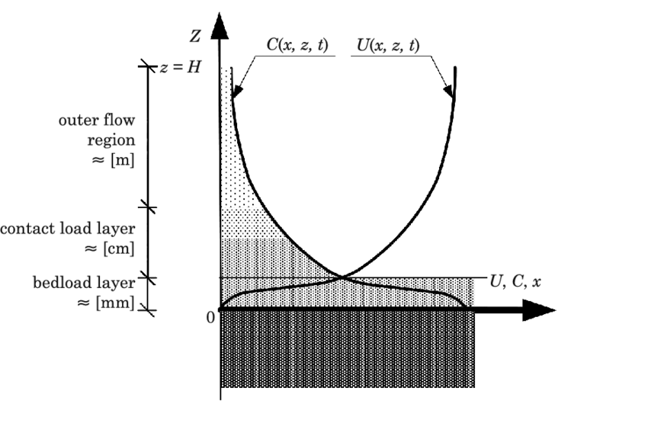
Fig1: Scheme of the three-layer sediment transport mode

CONCLUSION
As a result of the review of sediments transport models, presented in this
paper, it has been indicated that the primary advantage of the two- and
three-layer models in comparison with classic models (formulas), based on
empirical and semi-empirical relations, is the fact, that such models allow to
evaluate a concentration of sediments at any level, depending on the instantaneous hydrodynamic force. Furthermore, they allow for the description of
the vertical profiles of velocity and sediment concentration throughout the
entire area of sediment motion. The three-layer theoretical model of graded
sediments transport details the bedload, contact load layer and outer flow
region. Character of interactions between water and sediments is different in
each of the above layers and that is why they are described in different
equations, while at the contact between the layers there is a stitching of
solutions, providing a complete theoretical description of the structure of
transportation of the sandy sediment of a various grain size.

REFERENCES
ALLEN J.R.L. 1977. Fizyczne procesy sedymentacji. PWN, Warszawa.

GRADZINSKI R., KOSTECKA A., RADOMSKI A., UNRUG R. 1986. Zarys sedymentologii.

NIELSEN P. 1992. Coastal bottom boundary layers and sediment transport. Advanced Series on Ocean
Engineering, 4

