1. In an uncontrolled rectifier, once it has been triggered into ON state, it has to be manually shut down by cutting off the source voltage. In a controlled rectifier, the gate pulse signal supplied to the thyristor is used to automatically put output into ON or OFF mode.
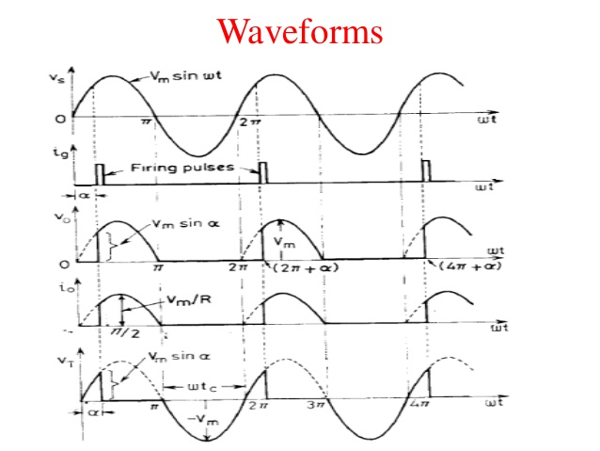
Figure 1: Waveform of a Controlled rectifier rectifying AC voltage
2. A single phase half-wave rectifier limits the current flow in one direction meaning that only half of the AC waveform can pass through while single phase full-wave rectifier allows the input AC source to complete its current flow circuit in both positive and negative half of an AC cycle.
Figure 2: Waveform of a Single phase half-wave rectifier
3a. The DIAC (Diode for Alternating Current) performs like an open-circuit until its switching is exceeded. At that position the DIAC performs until its current decreases toward zero. Once the DIAC goes into transmission, it preserves an almost continuous negative resistance characteristic. This means that voltage reduces with the increase in current. When the applied voltage in either polarity exceeds the breakdown voltage, DIAC current rises and the device conducts in accordance with its V-I characteristics.
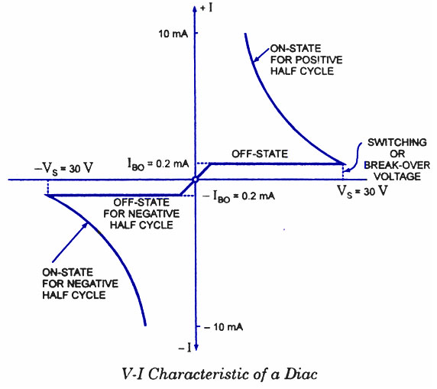
Figure 3: V-I Characteristics of a DIAC

3b. The TRIAC (Triode for Alternating Current) can be triggered with either positive or negative gate control voltage and will continue to conduct even if the gate current ceases, until the main current drops below a certain level called the holding current. In typical operation generally the gate voltage is positive in first quadrant and negative in third quadrant.
The supply voltage of the TRIAC to switch ON depends upon the gate current. This allows utilizing a TRIAC to regulate AC power in a load from zero to full power in a smooth and permanent manner with no loss in the device control.
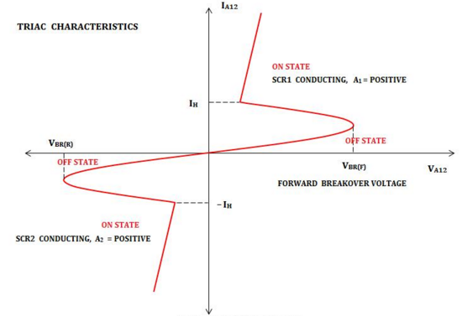
Figure 4: V-I Characteristics of a TRIAC

