MATRIC NUMBER: 16/MHS02/036
COURSE TITLE: MATERNAL AND HEALTH AND NORMAL MIDWIFERY II
COURSE CODE: NSC 404
ASSIGNMENT
Reading assignment
1. USE OF PARTOGRAPH IN THE MANAGEMENT OF FIRST STAGE OF LABOUR
2. MANAGEMENT OF 2ND AND 3RD STAGES OF LABOUR
MANAGEMENT OF FIRST STAGE OF LABOR USING PARTOGRAPH
A partograph is a composite graphical record of key data (maternal and fetal) during labor entered against time on a single sheet of paper. Relevant measurements might include statistics such as cervical dilatation, fetal heart rate, duration of labour and vital signs.
COMPONENTS OF A PARTOGRAPH
- Patient identification
- Time: It is recorded at an interval of one hour. Zero time for spontaneous labor is time of admission in the labor ward and for induced labor is time of induction.
- Fetal heart rate: It is recorded at an interval of thirty minutes.
- State of membranes and colour of liquor: "I" designates intact membranes, "C" designates clear and "M" designates meconium stained liquor.
- Cervical dilatation and descent of head
- Uterine contractions: Squares in vertical columns are shaded according to duration and intensity.
- Drugs and fluids
- Blood pressure: It is recorded in vertical lines at an interval of 2 hours.
- Pulse rate: It is also recorded in vertical lines at an interval of 30 minutes.
- Oxytocin: Concentration is noted down in upper box; while dose is noted in lower box.
- Urine analysis
- Temperature record
USES OF PARTOGRAPH
It is intended to provide an accurate record of the progress in labor, so that any delay or deviation from normal may be detected quickly and treated accordingly.
The essential features and the rationale are, however, summarized below;
The central feature is the cervicograph where cervical dilatation is plotted against time. While accepting that the transition from the latent to the active phase of labor may take place at differing cervical dilatations in individual cases, 3 cm dilatation is believed to be the most frequent dilatation at which the transition takes place and the cervicograph is marked accordingly. It was thought that the observed length of the latent phase should not be more than 8 hours, and a heavy vertical line from 0 to 3 cm dilatation after 8 hours of observed latent phase indicates this.
In the active phase of labor, a rate of dilatation of 1 cm per hour represents the mean dilatation rate of the slowest. All partographs designed accept 1 cm per hour or faster as an acceptable level of dilatation. This rate is designated the alert line on the partograph. The action line on the partograph is drawn parallel to, but 4 hours to the right, of the alert line. The "four hour action line" was found by Philpott'9 > and Bird03> to be the most efficient means of identifying particularly slow labours and avoiding unnecessarily early or dangerously late intervention.
The cervicographic features are incorporated into the WHO partograph together with the facility to record all other essential observations in labor on an hourly or half hourly basis. Experience with partography has shown that fewer recording errors are made when the action, alert and latent phase lines are pre-printed on to the partograph rather than being drawn on by the observer.'16 > When admitted in labour in the latent phase (cervix <3 cm dilated with 2 contractions or more in 10 minutes, lasting 20 seconds or more), cervical dilatation is plotted at 'O' hours at the beginning of the partograph. When labor subsequently reaches the active phase (cervix ~3 cm dilated) within 8 hours of admission, plotting is transferred to the alert line (see Figure 1.1). If admission occurs already in the active phase, the cervical dilatation is plotted directly on to the alert line but contractions must be 1 or more in 10 minutes, lasting 20 seconds or more. Vaginal examinations are recommended at 4 hourly intervals, though more frequently if indicated by complications or advanced labour.
The level of the fetal head and the duration and frequency of contractions are also recorded in the central part of the partograph. All routine observations of maternal and fetal condition are also recorded on the partograph (Figure 1.1). Additional writing is rarely needed.
The partograph with associated management guidelines is designed to improve the timing of critical management decisions in labor. These are:
a. Transfer of a woman in labor from a peripheral unit (health center) to a central unit (hospital with facilities for caesarean section delivery).
b. Augmentation of labor with oxytocin infusion.
c. Termination of labor by operative delivery (usually caesarean section).
Poor timing of, or failure to perform, these actions may lead to problems of iatrogenesis or neglect. Without management guidelines, these decisions may be made on the basis of intuition or experience which probably contributes to the widely varying rate of, for example, caesarean section delivery.
Based on the experiences of Philpott<s.9> and Bird,<13> the WHO Working Group considered that the actions appropriate at different points on the partograph should be as follows:
a. If cervical dilatation remains on or to the left of the alert line in the active phase - no action is indicated.
b. If cervical dilatation moves between the alert and action lines (but not to the action line) if in a peripheral unit, transfer to a central unit if in a central unit, no specific action indicated.
c. If cervical dilatation reaches or crosses the action line: this is reviewed by medical staff with a view to augmentation, termination of labour, or supportive therapy.
d. Prolonged latent phase (8 hours of observed latent phase): this is reviewed by medical staff.
The WHO manuals for use with the partograph give little detail on the suggested managements. The manuals advise the development of local
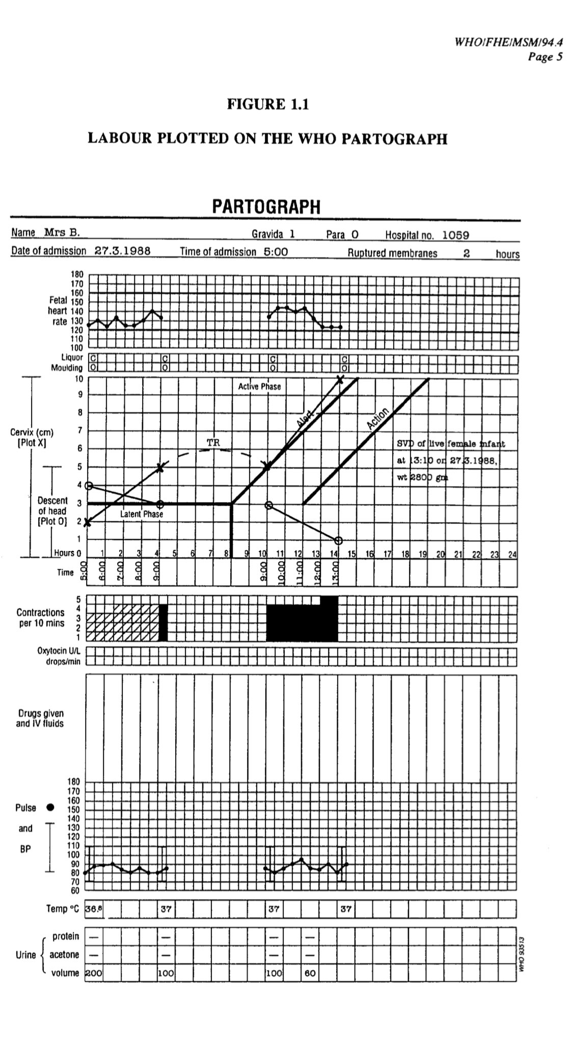
MANAGEMENT OF SECOND STAGE OF LABOR
The second stage of labour is when the cervix is fully dilated until complete expulsion of the baby. Women should be informed that the duration of the second stage varies from one woman to another. In first labours, birth is usually completed within 3 hours whereas in subsequent labours, birth is usually completed within 2 hours. It is defined in two stages.
Passive second stage of labour is defined as full dilatation of the cervix prior to or in the absence of persistent (occurring with every contraction) involuntary expulsive contractions.
Active second stage of labour: The baby is visible; Persistent involuntary expulsive contractions with a finding of full dilatation of the cervix or other signs of full dilatation of the cervix; Active maternal effort following confirmation of full dilatation of the cervix in the absence of expulsive contractions.
- Observations during the second stage of labour should be recorded in the healthcare records by the midwife: Hourly check of vital signs; temperature, blood pressure and pulse (palpated simultaneously with the FHR)
- Vaginal examination should be offered hourly in the active second stage or as the patient wishes, acknowledging the fetal position and station at the onset of the second stage;
- Abdominal palpation (with reference to the presentation and position of the baby) prior to vaginal examination
- Half-hourly documentation on the frequency, length and strength of contractions
- Ensure bladder emptied at least 4 hourly and a urinalysis performed; record frequency of passing urine; Observation on the colour and the amount of the liquor if membranes ruptured.
- Assessment of progress should include maternal behaviour, effectiveness of pushing and fetal wellbeing, taking into account fetal position and station at the onset of the second stage and the subsequent descent of the presenting part. These factors will assist in deciding the timing of further vaginal examination and the need for obstetric review.
- Document the effectiveness of pushing, the patient’s position, behaviour and how she feels she is managing her labour.
- Best practice recommends that the midwife should assess the FHR at least every 5 minutes, immediately following a contraction for one minute. If circumstances prevent this assessment from occurring please document as above.
- The midwife responsible for caring for the woman should be alert to the possibility of quick transition between different phases of labour and increase fetal surveillance accordingly.
- If the second stage of labour is suspected but not confirmed the responsible midwife caring for the patient should assess the FHR immediately after a contraction for at least 1 minute, every 5 minutes.
- Assess the patient’s pain, discussing her preferred coping strategies and supporting her wishes.
- Discourage the woman from lying supine or semi-supine in the second stage of labour and encourage her to adopt any other position that she finds most comfortable.
- Inform the woman that in the second stage she should be guided by her own urge to push. If pushing is ineffective or if requested by the woman, offer strategies to assist birth, such as support, change of position, emptying of the bladder and directed pushing can be encouraged.
- If any of the indications for transfer are met transfer the woman to obstetric-led care.
- Follow the general principles for transfer of care described in the guideline entitled ‘Transfer of mothers and babies to different care settings’.
INTRAPARTUM INTERVENTION TO REDUCE PERINEAL TRAUMA DURING THE SECOND STAGE
- ‘Hands on’ (guarding the perineum and flexing the baby’s head) or the ‘hands poised’ (with hands off but in readiness) techniques should be used and consent gained from the woman.
- Midwives should ask women if they would like a warm compress to be used on the perineum to help reduce the risk of serious tears.
- In the event of a water birth a hands off approach should be used, and verbal direction and encouragement should be given to achieve a controlled birth.
- Do not carry out a routine episiotomy during spontaneous vaginal birth.
MANAGEMENT OF THIRD STAGE OF LABOR
The third stage of labour is the time from the birth of the baby to the expulsion of the placenta and membranes.
- Explain to the woman antenatally and during the initial assessment in labour about what to expect with each package of care for managing the third stage of labour and the benefits and risks associated with each. Document in the records the decision that is agreed with the woman about management of the third stage
- Physiological management as follows: Uterotonic drugs (oxytocin) are not used; The cord is not clamped until the pulsations have ceased; The placenta is delivered by maternal effort.
- Explain to the woman that physiological management: Is associated with nausea and vomiting in about 50 in 1000 women; Is associated with an approximate risk of 29 in 1000 of a haemorrhage of more than 1 litre; Is associated with an approximate risk of 40 in 1000 of a blood transfusion
- If a woman at low risk of postpartum haemorrhage requests physiological management of the third stage, support her in her choice
- Active management of the third stage involves a package of care comprising the following components:10 IU of oxytocin by intramuscular injection with the birth of the anterior shoulder or immediately after the birth of the baby and before the cord stops pulsating or is clamped and cut, this is to reduce the risk of Postpartum Haemorrhage. Use oxytocin as it is associated with fewer side effects than oxytocin plus ergometrine; Deferred clamping and cutting of the cord; Controlled cord traction after signs of separation of the placenta.
- Explain to the woman that active management: Shortens the third stage compared with physiological management; Is associated with nausea and vomiting in about 100 in 1000 women; Is associated with an approximate risk of 13 in 1000 of a haemorrhage of more than 1 litre; Is associated with an approximate risk of 14 in 1000 of a blood transfusion.
- Changing from physiological management to active management is indicated as follows: Excessive bleeding of haemorrhage occurs; Failure to deliver the placenta within one hour; The patient’s desire to shorten the third stage.
- After administering the oxytocic, clamp and cut the cord.
- Do not clamp the cord earlier than 1 minute from the birth of the baby unless there is concern about the integrity of the cord or the baby has a heartbeat below 60 beats/minute that is not increasing.
- Clamp the cord before 5 minutes in order to perform controlled cord traction as part of active management. If the woman requests that the cord is clamped and cut later than 5 minutes, support her in her choice.
- After cutting the cord, use controlled cord traction.
- Record the timing of cord clamping in both active and physiological management.
- Do not use either umbilical oxytocin infusion or prostaglandin routinely in the third stage of labour. If retained placenta is diagnosed
- Observations in the third stage of labour should include: Estimating the amount of vaginal blood loss; Assessing the general condition of the mother i.e. her respirations, colour and her own report of how she feels; Where haemorrhage, retained placenta or maternal collapse is diagnosed
- Documentation

