ENGINEERING STRATEGIES FOR HANDLING COVID-19 FOR ENVIRONMENTAL HEALTH AND ECONOMIC SUSTAINABILITY
PREPARED BY
UMOH PAUL STEPHEN
17/ENG06/085
ENG 384
TO BE SUBMITTED,
IN PARTIAL FULLFILMENT IN THE AWARD OF THE DEGREE OF BACHELOR OF PETROLEUM ENGINEERING (B.Eng.),
COLLEGE OF ENGINEERING
AFE BABALOLA UNIVERSITY ADO-EKITI (ABUAD)
DATE OF SUBMISSION: 13TH APRIL, 2020

Contents
INTRODUCTION 4
ENGINEERING & ENVIRONMENTAL HEALTH 4
ENGINEERING & ECONOMIC SUSTAINABILITY 5
LITERATURE REVIEW 8
OVERVIEW OF COVID-19 8
WHAT IS A VIRUS? 8
CORONAVIRUS 8
MODE OF TRANSMISSION 9
PREVENTIVE MEASURES 10
EFFECT OF COVID-19 ON THE ECONOMIC SUSTAINABILITY AND DEVELOPMENT 11
EFFECT OF COVID-19 ON THE ENVIRONMENTS & ENVIRONMENTAL HEALTH 12
METHODOLOGY 14
ENGINEERING STRATEGIES 14
ENGINEERING STRATEGIES TO ECONOMIC SUSTAINABILITY DURING COVID-19 18
ANALYSIS OF RESULT 20
DEVELOPMENT AND DESIGN PLAN 20
AWARENESS FOR ECONOMIC SUSTAINABILITY 22
CONCLUSION 24
REFERENCES 24

ABSTRACT
Engineering encompasses a whole range of industries that could include on-site, practical construction work as well as evaluating safety systems from an office. They use the knowledge they have within a specific industry in order to make things work and solve problems, whether this be with transport, medicine, entertainment, space or the environment.
The modern environmental engineer is dedicated to keeping our air and water clean of pollutants and promoting good health and these days, protection against radioactive and toxic materials too
The pandemic, Coronaviruses: are a group of related viruses that cause diseases in mammals and birds. The virus can be transmitted through droplets of different sizes: when the droplet particles are >5-10 μm in diameter they are referred to as respiratory droplets, and when then are <5μm in diameter, they are referred to as droplet nuclei. According to current evidence, COVID-19 virus is primarily transmitted between people through respiratory droplets and contact routes.

CHAPTER ONE

INTRODUCTION
Engineering is a profession in which scientific knowledge and mathematics is used and experimented with to develop ways that benefit mankind, making it extremely important to society for several reasons. Engineering encompasses a whole range of industries that could include on-site, practical construction work as well as evaluating safety systems from an office. They use the knowledge they have within a specific industry in order to make things work and solve problems, whether this be with transport, medicine, entertainment, space or the environment. In fact, engineering is behind everything. Mobile phones? They’re down to engineers. Make-up? Also, down to engineers. Cars, computers, shoes and even cutlery? It’s all down to engineers. The environment that engineers work in ranges from offices to studios and laboratories to the outdoors and even underground. Engineering is very closely linked to technology, and the rise of it, which is why it has played a huge part in technological advances including computers, hospital machines, the internet and more. Healthcare has also improved dramatically thanks to advancements in medical technology thanks to engineers. The improvement of medical technology has meant that the discovery of illnesses and treatment has helped to save and improve the lives of many people.

ENGINEERING & ENVIRONMENTAL HEALTH
Environmental engineering applies scientific and engineering principles for protection of human populations from the effects of adverse environmental factors; protection of environments from potentially deleterious effects of natural and human activities; and general improvement of environmental quality. Environment engineering carefully details the effect of engineers on public health & how engineers are useful to the environmental health. Sanitation is a large part of our civil evolution; without it, we would succumb more often to water-borne disease and illness - raising our mortality rates and lowering our quality of life. Therefore, we've always needed to find bigger and better ways of taking away our sewage, cleaning our water and harnessing natural or artificial water supplies for our health and environment.
During period like this, the COVID-19 cells attach itself to metal surface and thus comes in contact with a host when touched, to prevent this- it is quite essential to get rid of all solid waste judiciously. Food packaging, white goods, broken electronics and everything else that we dispose of is considered solid waste. In the western world, we recycle a lot of solid material, but not nearly enough and new technologies will bring problems of their own in reclamation, recycling or otherwise disposal of those material. In the developing world where recycling is limited or non-existent, this is expected to be a major problem as they seek to industrialise to the point that they too can join the developed world. Washing of hand & body reguraly with alcohol based product is a preventive measure, although the won’t be possible without constant water supply. As the human population expands, we need access to an ever-increasing supply of water - whether that is drinking water, to keep our crops nourished so we can eat, to preserve local wildlife and the delicate ecosystem, water is vital to life. The majority of this water goes to waste treatment facilities is filtered, processed and pumped back to us after a rigorous cleaning process. The future is likely to see more technological development, population growth and a greater need for enough food for our growing population, housing and facilities to cater to our growing needs, new farming methods and so on. These are likely to see more areas needing management to avoid pollution or ecological damage; we will see new potential contaminants as well as a need to change conditions in some areas to cope with the changing climate. There will be an even greater need for environmental engineers to help us deal with the potential problems that this future will bring.

ENGINEERING & ECONOMIC SUSTAINABILITY
Economic sustainability refers to practices that support long-term economic growth without negatively impacting social, environmental, and cultural aspects of the community. The environment is an essential part of man’s existence and human beings are at the centre of concern for environmental sustainability. Nigeria is an oil and gas producing nation. The exploration and exploitation in the Nigerian oil and gas sector impact negatively on the environment. The Nigerian environment is in danger, having been degraded by human activities. Economic activities are not carried out in an environmentally sustainable manner and with adequate attention and concern for the environment. Despite the huge resources in Nigeria, the country ranks low in economic performance. Nigeria has not been able to maintain the growth rate necessary to reduce poverty. Nigeria suffers from lack of balanced development where economic, social and environmental dimensions are given due consideration for long term sustainable development. Nigeria can assemble a Sustainable Economic Development Initiatives, drawing on economic development best practices as well as environmental best practices to create an integration of sustainability and economic development. Such sustainable economic initiative includes formulation of the of the objective for the initiative, green programs etc. which can be made use of to formulate an appropriate sustainable economic development strategy for Nigeria. This will help in better understanding of sustainability concept and enable people to participate in the process of building sustainable economy
Engineers play a crucial role in creating infrastructure in the world. Engineers are problem solvers who apply their knowledge and experience to building projects that meet human needs, and to cleaning up environmental problems. Engineers can contribute to sustainable development along the entire chain of modern production and consumption, including the following:
- Extracting and developing natural resources
- Processing and modifying resources
- Designing and building transportation infrastructure
- Meeting the needs of consumers
- Recovering and reusing resources
- Producing and distributing energy

All these are needed if humanity is to stand a chance against a heavy pandemic such as the COVID-19. So far due to the virus, the oil price has dropped leading to collaspe of global economics. China, the home of the deadly coronavirus has experienced a drop in its stock and foreign exchage as more and more of its international buyer are withdrawing of their stocks and neighbouring asian countries has closed borders to the sovereign state.

CHAPTER TWO

LITERATURE REVIEW

OVERVIEW OF COVID-19

WHAT IS A VIRUS?
Viruses are the smallest of all the microbes. They are said to be so small that 500 million rhinoviruses (which cause the common cold) could fit on to the head of a pin. They are unique because they are only alive and able to multiply inside the cells of other living things. The cell they multiply in is called the host cell. A virus is made up of a core of genetic material, either DNA or RNA, surrounded by a protective coat called a capsid which is made up of protein. Sometimes the capsid is surrounded by an additional spikey coat called the envelope.
Virus classification is the process of naming viruses and placing them into a taxonomic system. Similar to the classification systems used for cellular organisms, virus classification is the subject of ongoing debate and proposals. This is mainly due to the pseudo-living nature of viruses, which is to say they are non-living particles with some chemical characteristics similar to those of life, or non-cellular life. As such, they do not fit neatly into the established biological classification system in place for cellular organisms. Viruses are mainly classified by phenotypic characteristics, such as morphology, nucleic acid type, mode of replication, host organisms, and the type of disease they cause. The formal taxonomic classification of viruses is the responsibility of the International Committee on Taxonomy of Viruses (ICTV) system, although the Baltimore classification system can be used to place viruses into one of seven groups based on their manner of mRNA synthesis.

CORONAVIRUS
Coronaviridae is a family of enveloped, positive-sense, single-stranded RNA viruses. Coronaviruses are a group of related viruses that cause diseases in mammals and birds. In humans, coronaviruses cause respiratory tract infections that can range from mild to lethal. Mild illnesses include some cases of the common cold (which has other possible causes, predominantly rhinoviruses), while more lethal varieties can cause SARS, MERS, and COVID-19. Symptoms in other species vary: in chickens, they cause an upper respiratory tract disease, while in cows and pigs they cause diarrhea. There are yet to be vaccines or antiviral drugs to prevent or treat human coronavirus infections. In December 2019, a pneumonia outbreak was reported in Wuhan, China.On 31 December 2019, the outbreak was traced to a novel strain of coronavirus, which was given the interim name 2019-nCoV by the World Health Organization (WHO), later renamed SARS-CoV-2 by the International Committee on Taxonomy of Viruses. Some researchers have suggested the Huanan Seafood Wholesale Market may not be the original source of viral transmission to humans.
As of 9 April 2020, there have been at least 93,425 confirmed deaths and more than 1,536,979 confirmed cases in the coronavirus pneumonia pandemic. The Wuhan strain has been identified as a new strain of Betacoronavirus from group 2B with approximately 70% genetic similarity to the SARS-CoV. The virus has a 96% similarity to a bat coronavirus, so it is widely suspected to originate from bats as well. The pandemic has resulted in travel restrictions and nationwide lockdowns in several countries.

MODE OF TRANSMISSION
Respiratory infections can be transmitted through droplets of different sizes: when the droplet particles are >5-10 μm in diameter they are referred to as respiratory droplets, and when then are <5μm in diameter, they are referred to as droplet nuclei. According to current evidence, COVID-19 virus is primarily transmitted between people through respiratory droplets and contact routes. In an analysis of 75,465 COVID-19 cases in China, airborne transmission was not reported.
Droplet transmission occurs when a person is in in close contact (within 1 m) with someone who has respiratory symptoms (e.g., coughing or sneezing) and is therefore at risk of having his/her mucosae (mouth and nose) or conjunctiva (eyes) exposed to potentially infective respiratory droplets. Transmission may also occur through fomites in the immediate environment around the infected person. Therefore, transmission of the COVID-19 virus can occur by direct contact with infected people and indirect contact with surfaces in the immediate environment or with objects used on the infected person (e.g., stethoscope or thermometer). The COVID-19 attachs itself to the host cell, infecting neighbouring cell when the immune system send out white blood cells. The host cell releases chemical signals that confuses WBCs and makes them kill themselves. This is how deadly the coronavirus is.

PREVENTIVE MEASURES
- Regularly and thoroughly clean your hands with an alcohol-based hand rub or wash them with soap and water. Washing your hands with soap and water or using alcohol-based hand rub kills viruses that may be on your hands.
- Maintain at least 1 metre (3 feet) distance between yourself and anyone who is coughing or sneezing. When someone coughs or sneezes they spray small liquid droplets from their nose or mouth which may contain virus. If you are too close, you can breathe in the droplets, including the COVID-19 virus if the person coughing has the disease.
- Hands touch many surfaces and can pick up viruses. Once contaminated, hands can transfer the virus to your eyes, nose or mouth. From there, the virus can enter your body and can make you sick.
- Make sure you, and the people around you, follow good respiratory hygiene. This means covering your mouth and nose with your bent elbow or tissue when you cough or sneeze. Then dispose of the used tissue immediately. Droplets spread virus. By following good respiratory hygiene you protect the people around you from viruses such as cold, flu and COVID-19.
- Stay informed on the latest developments about COVID-19. Follow advice given by your healthcare provider, your national and local public health authority or your employer on how to protect yourself and others from COVID-19. National and local authorities will have the most up to date information on whether COVID-19 is spreading in your area. They are best placed to advise on what people in your area should be doing to protect themselves.

EFFECT OF COVID-19 ON THE ECONOMIC SUSTAINABILITY AND DEVELOPMENT

GLOBAL ECONOMY
It is clear that China will suffer the most. But so will Japan, the Middle East, the US and EU economies along with many other smaller economies. Hence there is no reason for the rivals of China to rejoice.With maximal containment costs and panic, Chinese GDP will decline by several percentage points. EU will lose about two percentage points and US about between one and one and a half per cent.But some of the model results already at hand should give thoughtful ME, US and EU citizens pause. With declining oil prices, the oil producing economies are already experiencing economic downturns. The direct and indirect effects of COVID-19 will worsen this trend. With infections surging, cities in lockdown, businesses downing shutters and most travel on ice, staff layoffs are likely to mushroom. That showed up in the number of Americans filing unemployment benefit claims which hit a record of more than 3 million. Economists polled by Reuters had forecast claims would rise to 1 million, though some estimates were as high as 4 million. China’s social isolation policies appear to have contained the coronavirus at home, allowing work and travel to resume. But major economic damage may be yet to come. With infections climbing exponentially in the United States, Europe and the other markets China exports to, and with supply chains in disarray, China is getting neither the imported components it needs nor demand for its products. Oil-producing countries like Angola, Ghana, Gabon and Nigeria have seen their dollar-denominated debt drop sharply, with yields of some issues shooting above 20%, indicating soaring borrowing costs. Many countries on the continent lack the financial firepower or foreign currency reserves needed to combat the coronavirus and prop up their economies, with healthcare systems already under strain.

NIGERIA ECONOMY
The emergence of COVID-19 and its increasing incidence in Nigeria has called for drastic review and changes in the earlier revenue expectations and fiscal projections. Compared to events that led to recession in 2016, the current state of the global economy poses more difficulties ahead as the oil price is currently below US$30 with projections that it will dip further going by the price war among key players in the industry. Unfortunately, the nation has grossly underachieved in setting aside sufficient buffers for rainy days such as it faces in the coming days. In addressing these daunting economic challenges, the current considerations to revise the budget downward is inevitable. However, certain considerations that are expected in the review must not be left out. The assumptions and benchmarks must be based on realizable thresholds and estimates to ensure optimum budget performance, especially on the non-oil revenue components.
The decision to cut the retail price of gasoline under a price modulation arrangement is a welcome development. The cut is expected to curb rising inflation, especially food price inflation which will mainly benefit the poor. What the consequences of COVID-19 pandemic should further offer the Nigerian economic managers and policymakers, is that the one-tracked, monolithic reliance on oil is failing. Diversification priorities to alternative sectors such as agriculture, solid minerals, manufacturing and services sectors, should be further intensified.

EFFECT OF COVID-19 ON THE ENVIRONMENTS & ENVIRONMENTAL HEALTH
As industries, transport networks and businesses have closed down, it has brought a sudden drop in carbon emissions. Compared with this time last year, levels of pollution Globally have reduced by nearly 45% because of measures to contain the virus.
In China, emissions fell 25% at the start of the year as people were instructed to stay at home, factories shuttered and coal use fell by 40% at China’s six largest power plants since the last quarter of 2019. The proportion of days with “good quality air” was up 11.4% compared with the same time last year in 337 cities across China, according to its Ministry of Ecology and Environment. These are remarkable changes to the environment, but a global pandemic that is claiming people’s lives certainly shouldn’t be seen as a way of bringing about environmental change.
Global shelter-in-place orders to battle the Covid-19 pandemic have resulted in a widely-reported climate benefit: cleaner air in China, Europe and Africa. In the U.S., some cities have halted recycling programs as officials worry about the risk of spreading the virus in recycling centers. In particularly hard-hit European nations, waste disposal options have been rolled back. Italy has banned infected residents from sorting their waste at all.
Industry has seized the opportunity to overturn disposable bag bans, despite the fact that environmental experts say single-use plastics can still harbor viruses and bacteria. In Nigeria, places like Warri, Port harcourt & Lagos that contains more industry have been noticed to have cleaner air as well.

CHAPTER THREE

METHODOLOGY

ENGINEERING STRATEGIES
An Engineering Strategy defines how the Engineering organization will meet its objectives. It describes the essential resources and how they will be organized and committed to achieving the objectives. It describes the policies that will apply for the management and use of resources. Most of these Engineering organization are charged with the objective of designing and producing equipments for handling the current pandemic in areas of preserving the environmental health and confining the global/local economic sustainability/development.
Some of the equipments that researched by engineering organization are:
- Isolation rooms: Many engineer had offers way to manage to air flow in an airborne infection isolation treatment room, using a mixed ventilation system strategy. While several teams have quickly set up COVID-19-related field hospitals in convention centers and places of public assembly—considered the low-hanging fruit of alternative sites for coronavirus surge beds—others are working behind the scenes on longer lead time retrofits and conversions for hospitals, hotels and dormitories. Many of these are aimed at increasing the supply of coronavirus patient intensive care units and airborne infection isolation rooms, with the goal of protecting health care workers from getting sick. Engineers are seeking the best ways to quickly design code-compliant and safe ICU and airborne infection isolation rooms, suites or wards, in a time of changing intelligence about virus transmission. The main reason for AII, rather than ICU-only rooms, is to keep health care personnel from contracting COVID-19. Mixing typically delivers air into the upper level of the room and uses the momentum of the incoming air to distribute it around the room—mixing the clean incoming air and contaminants in the room as it does so. The exhaust duct, usually in the ceiling or behind the patient bed, extracts the mixed air and moves it through a HEPA-filter air purifier before releasing it either outdoors or into a corridor. The filter does not catch the COVID-19 virus but it catches particulates that trap the virus. 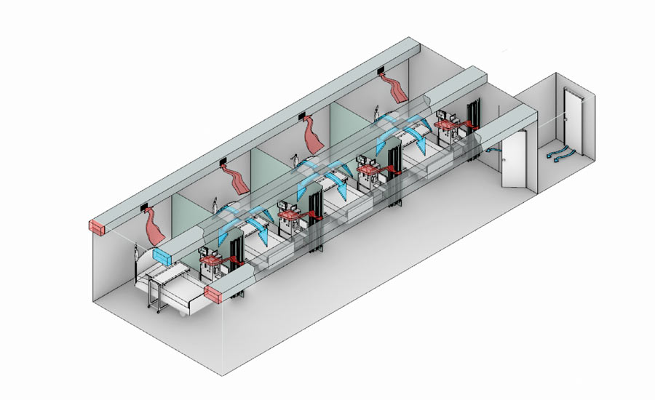A negative air pressure system directs air flow in a room through ventilation that generates pressure lower than the room’s surrounding air. Air naturally flows from areas of higher pressure to areas of lower pressure. In AII rooms, the air stays in the room, thanks to the negative pressure, and is exhausted mechanically. There is no great mystery about the design of AII rooms or ICUs with AII. The pandemic has put pressure on the health care design and construction community to get the rooms designed, approved, built and operating quickly. The goal is to keep the designs simple so they can be deployed and maintained efficiently, with a minimum number of maintenance personnel. The room works because the cooler ventilation air, warmed by occupants and equipment, lifts the contaminants as it rises. The fresh air does not mix as much with the contaminated air. Larger droplets will still fall to the floor and other surfaces because of the low speed of the rising fresh air. Because the smaller aerosol droplets are light and track with air, they become stratified at the ceiling while the exhaust is pulling them from the room.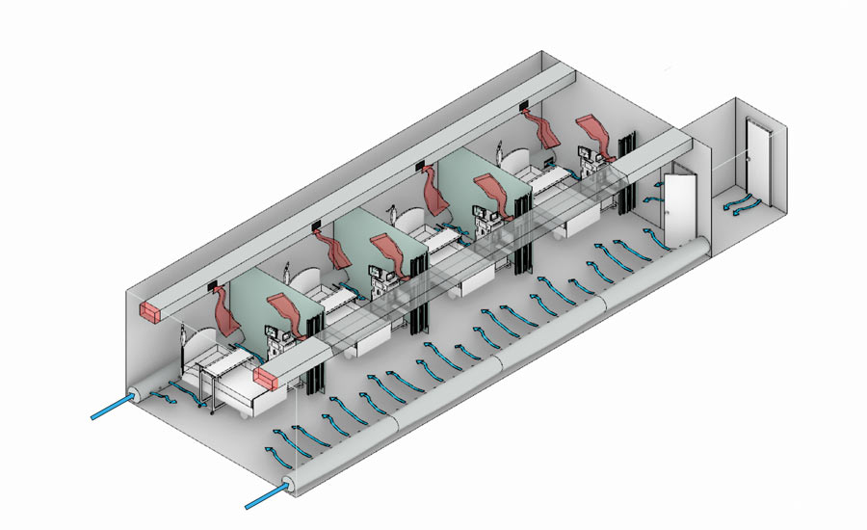
- Personal Proctective Equipment: PPE is usually worn by medical doctors and officials that are stationed at the COVID-19 wards, thus there is a need to enhance the PPE.
  - Since the onset, questions has been raised corcerning the need for eye proctection. COVID-19 patients rarely experience conjuctivies, so eye-mode of infection is slightly impossible but since the respiratory droplets could reach the eyes. Eye protection equipment should be used for primary and community care when assessing patients with possible SARS-CoV-2 infection. Eye protection is most effective when used in combination with other PPE measures in this situation and for protection against any blood or other body fluid splashes that may occur with procedures. Close eye examinations and ophthalmoscopy should be avoided if possible during an outbreak of COVID-19, but in some cases these procedures may still be necessary. Where close contact is required, eye protection equipment should be used as part of a full PPE. The aim is to create eye protection for respiratory droplet.
  - N95 respirators: N95 respirators are the PPE most often used to control exposures to infections transmitted via the airborne route, though their effectiveness is highly dependent upon proper fit and use. The optimal way to prevent airborne transmission is to use a combination of interventions from across the hierarchy of controls, not just PPE alone. Applying a combination of controls can provide an additional degree of protection, even if one intervention fails or is not available. The surgical mask control and filter the air that penetrates it and removes the coronavirus droplets. This refers to wearing the same respirator while caring for multiple patients who have the same diagnosis without removing it, and evidence indicates that respirators maintain their protection when used for extended periods. However, using one respirator for longer than 4 hours can lead to discomfort and should be avoided. Biomedical engineers are currently tasked with the objectives of extending the life span of newly produced surgical masks. Engineering controls reduce exposures for HCP (health care personnels) by placing a barrier between the hazard and the HCP. Engineering controls can be very effective as part of a suite of strategies to protect HCP without placing primary responsibility of implementation on them. A new respirator could be produced one that is alcohol based but reduces the adverse effect of prolonged wearing. The strain filter sheets within the mask must be increased as well to prevent droplets of 4µm of COVID-19. Also minimizing the one in circulation, by decontamination and reuse should be a priority which is to be dicussed in the analysis of result.
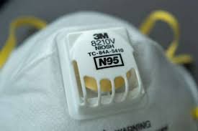

ENGINEERING STRATEGIES TO ECONOMIC SUSTAINABILITY DURING COVID-19
The only strategy is to ensure the continous work of engineers in every industrial sector in order to keep the nation economy thriving. The only way to meet this end is to ensure workplace harzard control for the pandemic. Workplace hazard controls for COVID-19 are the application of occupational safety and health methodologies for hazard controls to the prevention of coronavirus disease 2019 (COVID-19). The proper hazard controls in the workplace depend on the worksite and job task, based on a risk assessment of sources of exposure, disease severity in the community, and risk factors of individual workers who may be vulnerable to contracting COVID-19.
- Planning and risk assesment: COVID-19 outbreaks can have several effects within the workplace. Workers may be absent from work due to becoming sick, needing to care for others, or from fear of possible exposure. Patterns of commerce may change, both in terms of what goods are demanded, and the means of acquiring these goods (such as shopping at off-peak hours or through delivery or drive-through services). Lastly, shipments of items from geographic areas severely affected by COVID-19 may be interrupted. Objectives for response to an outbreak include reducing transmission among staff, protecting people who are at higher risk for adverse health complications, maintaining business operations, and minimizing adverse effects on other entities in their supply chains. The disease severity in the community where the business is located affects the responses taken.
- Hazard control: Objectives for response to an outbreak include reducing transmission among staff, protecting people who are at higher risk for adverse health complications, maintaining business operations, and minimizing adverse effects on other entities in their supply chains. The disease severity in the community where the business is located affects the responses taken. Engineering controls for this and higher risk groups include installing high-efficiency air filters, increasing ventilation rates, installing physical barriers such as clear plastic sneeze guards, and installing a drive-through window for customer service.

CHAPTER FOUR

ANALYSIS OF RESULT

DEVELOPMENT AND DESIGN PLAN
To analyse the methodology of the equipment that will be used to handle COVID-19 pandemic in areas of environmental health and economic sustainability. The design of each of the equipment:
- Design of the isolation rooms: To minimize the spread of airborne infection, healthcare facilities have designed airborne infectious isolation (AII) rooms with negative-pressure differential and/or protective environment (PE) rooms with positive-pressure differential. Negative-pressure isolation rooms are required for quarantined patients with coronavirus to prevent droplets (from sneezing, coughing or exhalation) and contact transmission. Following the outbreak of COVID-19, the need for viral-disease containment spaces in hospitals and healthcare facilities is real. Engineers are currently in a position to respond with urgency to the pressing need for hospital quarantine isolation rooms during the COVID-19 pandemic. The walls are designed as smooth modular walls, doors and windows are resistant to repeat cleaning and the use of several chemicals. They also specifically designed for sterile environments Key features of these design include;
- Clinical hand wash station with hands-free operation
- 100% intake of fresh air (no recirculating air)
- HEPA filtered exhaust air
- Supply air ducts independent from the building air supply
- HEPA filtration system to protect immunodeficient patients
- Self-closing and interlock doors
- Ensuite with shower, hands-free wash station and toilet
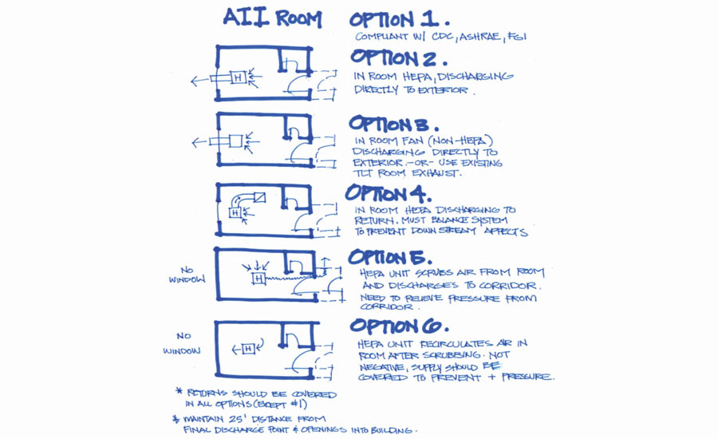

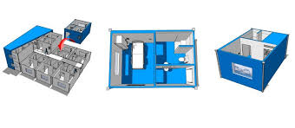
The figure above shows the plan view of the isolation room, while the second figure illustrates the 3D view of the rooms.
- N95 respirator: Taking a look at the design of the respirator reveals that the maks is comprised of 5 filter layer- a 4µm filter cloth, an activated carbon, an efficient filter cloth and an anti-sticking cloth. 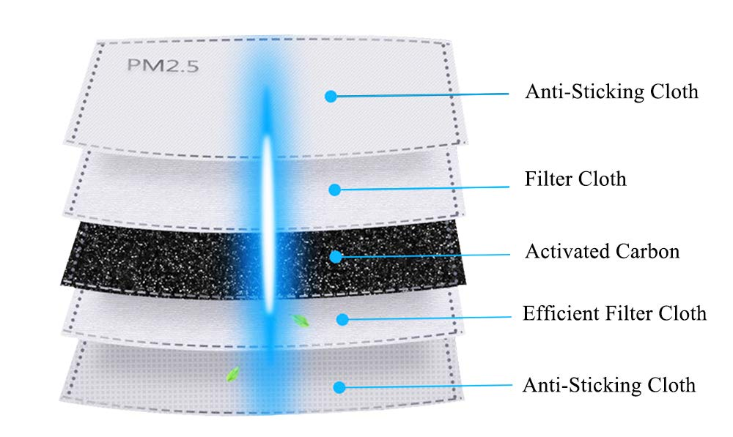
Also the method of decontaminating and reuse the respirator that are available in supply. Ultra violent germicidal irritation (UVGI) is a promising method but the disinfection efficacy is dependent on dose. Not all UV lamps provide the same intensity thus treatment times would have to be adjusted accordingly. Moreover, UVGI is unlikely to kill all the viruses and bacteria on the respirators due to shadow effects produced by the multiple layers of the respirator’s construction.

AWARENESS FOR ECONOMIC SUSTAINABILITY
The hierarchy of hazard controls is a framework widely used in occupational safety and health to group hazard controls by effectiveness. Where COVID-19 hazards cannot be eliminated, the most effective controls are engineering controls, followed by administrative controls, and lastly personal protective equipment. Engineering controls involve isolating employees from work-related hazards without relying on worker behavior, and can be the most cost-effective solution to implement. Administrative controls are changes in work policy or procedures that require action by the worker or employer. Personal protective equipment (PPE) is considered less effective than engineering and administrative controls, but can help prevent some exposures. All types of PPE must be selected based upon the hazard to the worker, properly fitted as applicable (e.g., respirators), consistently and properly worn, regularly inspected, maintained, and replaced, as necessary, and properly removed, cleaned, and stored or disposed of to avoid contamination.

CHAPTER FIVE

CONCLUSION
The study found that extent of coronavirus on the global and local economic sustainability and in areas of environmental areas would be significant in adverse effect. Green economist who believe that the pandemic has brought about a cleaner air better than last years air review, but the piling up of medical waste could result to a more catastrophic emission waste in the environment. In conclusion based on the findings of this study and the empirical analysis earlier reviewed, the isolation room that are been designed would lead to a reduce in the outbreak of the virus and control the economy of the country and the world at large.
I strongly recommend that the awareness of the pandemic to the citizens of Nigeria and thus every citizens who are constantly needed in the industrial sector of the country to keep the economy moving. These engineers should use the respirator and PPE equipment to prevent continous spread.

REFERENCES
CORONAVIRUS. (2020, APRIL 5). Retrieved APRIL 10, 2020, from WIKIPEDIA: https://en.wikipedia.org/wiki/Coronavirus#Human_coronaviruses
EFFICACY OF EYE PROTECTION FOR COVID-19. (2020, APRIL 3). Retrieved from CEBM: https://www.cebm.net/covid-19/what-is-the-efficacy-of-eye-protection-equipment-compared-to-no-eye-protection-equipment-in-preventing-transmission-of-covid-19-type-respiratory-illnesses-in-primary-and-community-care/
IMPLICATION OF COVID-19 ON THE NIGERIA ECONOMY. (2020, MARCH 25). Retrieved from CSEA AFRICA: https://www.voicesofyouth.org/blog/unexpected-environmental-consequences-covid-19
ISOLATION ROOMS FOR HOSPITALS . (2020, APRIL 9). Retrieved APRIL 11, 2020, from MECART CLEANROOM : https://www.mecart-cleanrooms.com/applications/isolations-rooms-for-hospitals-covid-19/
MASON, M. (2018, MARCH). ENVIRONMENTAL ENGINEERING. Retrieved from ENVIRONMENTAL SCIENCE: https://www.environmentalscience.org/environmental-engineering

