NAME: SHOSAN HADIJAT ABIMBOLA
MATRIC NO: 17/SCI01/076
COURSE: CSC312
Assignment
With the aid of a diagram, describe how a C++ code can be converted to Machine Language code.
Solution
A compiler takes the program code (source code) and converts the source code to a machine language module (called an object file). Another specialized program, called a linker, combines this object file with other previously compiled object files (in particular run-time modules) to create an executable file. The diagram represents the process.
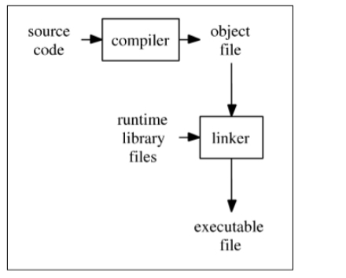
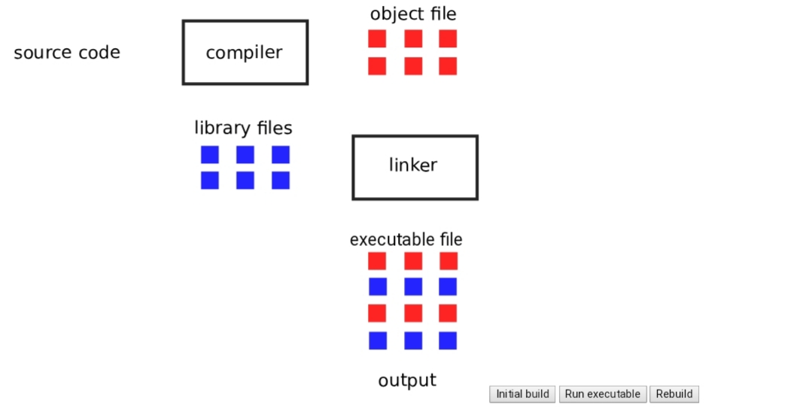
So, for a compiled language (C++) the conversion from source code to machine executable code takes place before the program is run. This is different process from what takes place for an interpreted programming language like Python. It is somewhat simplified as many modern programs that are created using compiled languages makes use of dynamic linked libraries or shared libraries. Therefore, the executable file may require these dynamic linked libraries (Windows) or shared libraries (Linux, Unix) to run.

