EDIDIONG IME- ESSIEN
CSC 312
17/SCI01/041

Question
With the aid of a diagram, describe how a C++ code can be converter to Machine Language code.
Answer
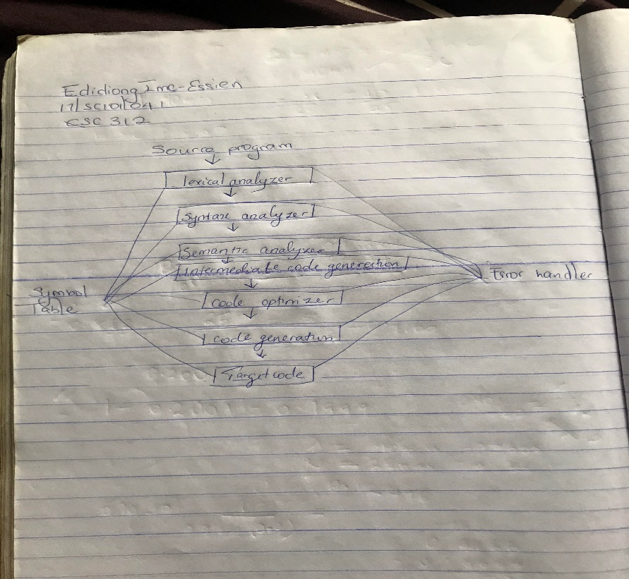
A compiler takes the program code (source code) and converts the source code to a machine language module (called an object file). Another specialized program, called a linker, combines this object file with other previously compiled object files (in particular run-time modules) to create an executable file. So, for a compiled language the conversion from source code to machine executable code takes place before the program is run. This is a very different process from what takes place for an interpreted programming language. The conversion process is referred to as assembly, or assembling the source code. A compiler is computer software that transforms computer code written in one programming language (the source language) into another programming language (the target language). Compilers are a type of translator that support digital devices, primarily computers. The name compiler is primarily used for programs that translate source code from a high-level programming language to a lower level language to create an executable program.

