TECHNICAL REPORT
ON
ENGINEERING LAW AND MANAGERIAL ECONOMICS
TOPIC:
ENGINEERING STRATEGIES FOR HANDLING COVID-19 FOR ENVIRONMENTAL HEALTH AND ECONOMICS SUSTAINABILITY

PREPARED BY:
EMEROLE CHINAEME IKENNA
17/ENG05/012

SUBMITTED TO
MR OYEBOBE OLUWADARE JOSHUA

COLLEGE OF ENGINEERING
AFE BABALOLA UNIVERSITY

IN FULFILLMENT OF REQUIREMENTS FOR THE AWARD OF BACHELOR OF ENGINEERING (B.ENG) DEGREE IN MECHATRONICS ENGINEERING

Date: 15th April 2020

ABSTRACT
The COVID-19 which is said to be a pandemic disease, began in a place called Wuhan china. This disease in a matter of months has gone on to claim thousands of lives. Generally leading to deprecation of economic sustainability and environmental health. As promising engineers we aim at seeking solutions and strategies for handling COVID-19.

TABLE OF CONTENT
CHAPTER 1: INTRODUCTION

CHAPTER 2: LITERATURE REVIEW
Environment health
Economic Sustainability
CHAPTER 3: METHODOLOGY;
Engineering strategies
CHAPTER 4: ANALYSIS OF RESULT

CHAPTER 5: CONCULSION

INTRODUCTION
Coronavirus disease (COVID-19) is an infectious disease caused by a newly discovered coronavirus.
Most people infected with the COVID-19 virus will experience mild to moderate respiratory illness and recover without requiring special treatment. Older people, and those with underlying medical problems like cardiovascular disease, diabetes, chronic respiratory disease, and cancer are more likely to develop serious illness.
The best way to prevent and slow down transmission is be well informed about the COVID-19 virus, the disease it causes and how it spreads. Protect yourself and others from infection by washing your hands or using an alcohol-based rub frequently and not touching your face.

Research Engineering universities are at the forefront of the battle against COVID-19 and are working to protect us from other pandemics. From assisting communities developing response strategies, to increasing testing capacity and researching possible vaccines, to treating people who have contracted the novel coronavirus, universities are working tirelessly to address the full impact of this pandemic.

LITERATURE REVIEW
ENVIRONMENT HEALTH:
The COVID-19 pandemic is wreaking havoc on countries around the world, causing a global health crisis while forcing economies to shut down in the face of strict quarantine measures. But the outbreak is also having an intriguing impact on Earth's environment, as nations restrict the movement of people.
One of the areas that scientists are witnessing a big difference is in air quality. It seems that the pandemic is already leading to huge reductions in air pollution in those regions that have been significantly affected by COVID-19 such as China and Italy as industry, aviation and other forms of transport grind to a halt.
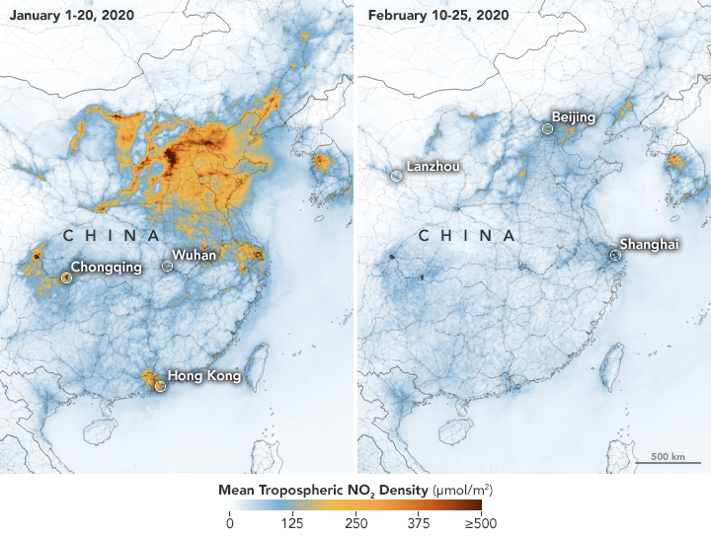
Fig1 showing the atmospheric condition due the COVID 19
Air pollution levels as observed by satellite are showing drastic improvements in many areas that have been undergoing restrictive quarantines due to COVID-19,
But Nevertheless, this virus is still on the negative side because it hinders the normal day to day functionality of various individuals and organizations

ECONOMIC SUSTAINABILITY:
The coronavirus outbreak is already having a negative economic and business bearing, affecting everything from tourism to the supply of parts to the automotive and technology industries. Stock markets have stood unstable.
COVID-19 could affect the global economy in three main ways: by directly affecting production, by creating supply chain and market disruption, and by its financial impact on firms and financial markets.
- Direct impact on production. Chinese production has already been substantially affected by the shutdown in Hubei province and other areas. Some other countries are also beginning to feel a direct impact as their authorities put in place
The slowdown in China has effects on exporters to China. China’s largest sources of imports are Korea, Japan, and other Asian countries, according to the World Bank. Thus, even without new outbreaks of the disease, these areas will likely experience slow growth in the first half of 2020.
- Supply chain and market disruption. Many manufacturing firms rely on imported intermediate inputs from China and other countries affected by the disease. Many companies also rely on sales in China to meet financial goals. The slowdown in economic activity and transportation restrictions in affected countries will likely have an impact on the production and profitability of specific global companies, particularly in manufacturing and in raw materials used in manufacturing. For companies that rely on intermediate goods from affected regions, and that are not able to easily switch sourcing, the size of the impact may depend on how quickly the outbreak fades. Small and medium-sized firms may have greater difficulty surviving the disruption. Businesses tied to travel and tourism are facing losses that are likely not recoverable.
- Financial impact on firms and financial markets. Temporary disruptions of inputs and/or production might stress some firms, particularly those with inadequate liquidity. Traders in financial markets may or may not correctly anticipate or understand which firms might be vulnerable. The resulting rise in risk might reveal that one or more key financial market players have taken investment positions that are unprofitable under current conditions, further weakening trust in financial instruments and markets. A possible (likely low-probability) event would be a significant financial market disruption as participants become concerned about counterparty risk. A somewhat more likely possibility is a significant decline in equity markets and corporate bond markets, with investors preferring to hold government securities (particularly US treasuries) because of the uncertainty created by the pandemic.

The coronavirus outbreak is already having a negative economic and business bearing, affecting everything from tourism to the supply of parts to the automotive and technology industries. Stock markets have stood unstable.

METHODOGLY
ENGINEERING STRATEGIES.
(Environmental health)
With basic mathematical models, Mechatronics research Engineers can begin to forecast the progression of diseases and understand the effect of interventions on disease spread. With more complex models, we can start to answer questions about how to efficiently allocate limited resources or tease out the consequences of public health interventions, like closing pubs and banning gatherings.
Insights from mathematical modelling are vital to ensuring that authorities can prevent as many deaths as possible. As the COVID-19 pandemic escalates, here's a look inside the modelling that experts use to try and stay one step ahead of the virus.

(ECONOMIC SUSTAINABILTY)
Mechatronics Engineers have assisted Doctors by gathering resources and building open-source tools and equipment to help Doctors survive and tackle coronavirus. Initial focus = PPE mask shortage.
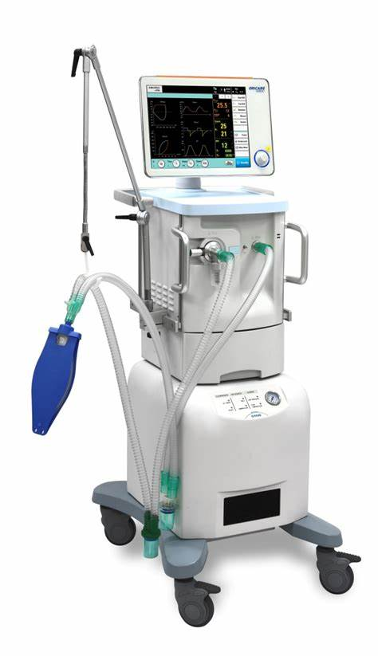Fig2 ventilators
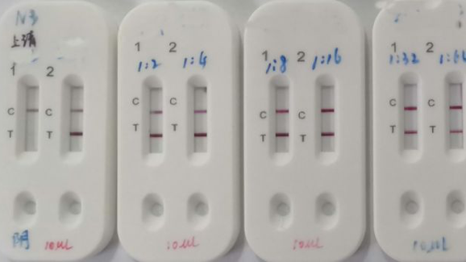
Fig3 Testing kit for COVID-19
Also to ensure that necessary production takes place and then economic sustainability is upheld to an adequate level.

ANALYSIS OF RESULT
Well the result to be analyzed is yet to come because it will take place when the number of cases subside and economical production begins to stabilize again
For what we know so far, the action taken by the mechatronics engineers is still ongoing that is in Manufacturing of ventilator and test kit has lead to awareness and fast recoveries of this case
We are looking forward to ways to completely solve and mitigate further cases of COVID-19.

CONCULSION
In conclusion, we will ensure that the problem is solved and the virus is properly managed to the best of our abilities as Mechatronics engineers. By the grace of God, we triumph.

