RUFUS-JEGEDE O.
17/MHS01/289
NURSING SCIENCE
NSC 306

ASSIGNMENT
- The Different disorders of the prostrate gland
- Their aetiologies
- The therapeutic interventions as well as surgeries
- The nursing care and client teaching in the different conditions

The Different disorders of the prostrate gland:
Benign prostatic hyperplasia, or BPH, is a non-cancerous enlargement of the prostate that affects millions of men. Symptoms are usually related to problems with urination. Symptoms may include:
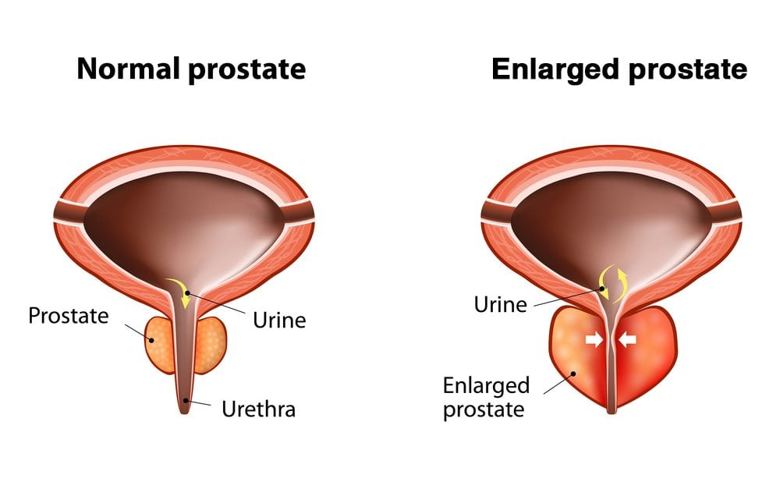
- Slow urinary stream
- Straining to empty the bladder
- Urinary frequency
- Urinary urgency
- Nocturia – Waking at night to urinate
- Urinary retention – inability to urinate
Treatment of this condition is usually driven by the symptoms. If the symptoms are mild, some men elect no treatment. More bothersome symptoms may necessitate treatment.
There are many available treatments for this common condition including:

1. Observation:
Some men with mild symptoms choose no active treatment, with regular follow-up by their physician to monitor for progression.
2. Medications:
Several medications are available to treat the symptoms of BPH including alpha-blockers such as terazosin, doxazosin, or tamsulosin. Another group of drugs, known as 5 alpha reductase inhibitors ( e.g., finasteride or dutasteride), may be used in combination with the alpha-blockers to control the symptoms of BPH including urinary frequency, slow stream, and nocturia.
3. Thermotherapies:
There are several urologic procedures that involve placing an instrument into the urethra to heat the prostate and destroy prostate tissue. These include microwave therapy, interstitial laser therapy , and needle ablation therapy.
4. Surgical Therapies including:
- Laser ablation: A surgeon uses a laser guided through a telescope placed in the urethra to vaporize the prostate tissue under anesthesia. Examples include the GreenLight HPS (available at the Univeristy of Virginia), and the Holmium Laser. This therapy uses a high power laser to evaporate the prostate tissue. Patients can often go home the same day with a catheter in their bladder that is removed in 1-2 days.
- TURP: This is traditional prostate surgery using an electocautery loop and is done under anesthesia. This is sometimes called “the roto-rooter” operation by laymen. A telescope is introduced into the urethra to visualize the prostate as tissue is removed from the prostate while cautery is applied (diagram). Patients stay overnight and have a catheter in their bladder for 1-2 days.
- Open surgery: In highly selected patients with very large prostates, the traditional open surgery with anesthesia may be necessary to remove the obstructing tissue in the prostate. A catheter is placed for several days and a hospital stay of several days is the norm.
PROSTATITIS
The prostate is a walnut-sized gland that all men have. It’s found below your bladder and in front of your rectum. The job of the prostate is to make fluid that contains sperm (semen). This fluid protects the sperm when they travel toward a female’s egg.
If your prostate becomes swollen, tender, and inflamed, you have a condition called “prostatitis.” This isn’t cancer, and it’s different from having an “enlarged prostate.”
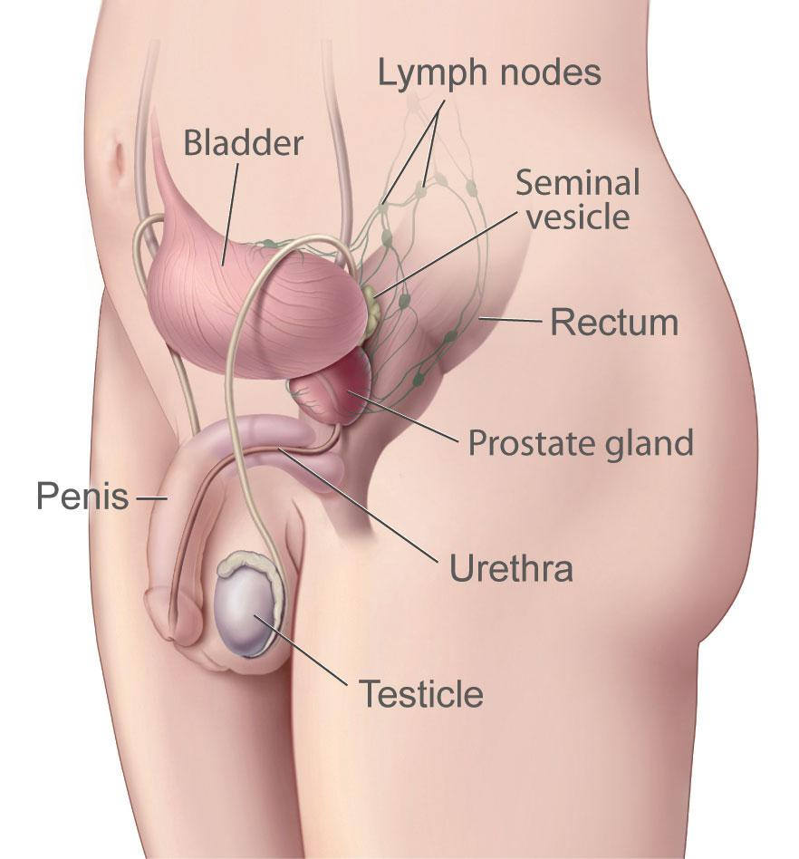

Prostatitis Risk Factors
You’re more likely to have problems with your prostate if:
- You’ve had a UTI
- You’ve had a groin injury
- You use a urinary catheter
- You’ve had a prostate biopsy
- You have HIV/AIDS
- You’ve had prostatitis before
Treatment for prostatitis depends on the underlying cause and type of prostatitis. Antibiotics are prescribed if the cause is a bacterial infection. All forms of prostatitis require pain control if needed, treatment, relief of complications and side effects, and need to be closely monitored by your doctor. In certain instances, some people with prostatitis may need to be hospitalized for treatment.
- Antibiotics: Your doctor will decide the specific antibiotic and the duration of treatment.
- Anti-inflammatory medications: These can help manage your pain.
- Alpha-blockers: By relaxing the muscle fibers around the bladder and prostate gland, alpha-blockers may decrease your urinary symptoms and help you empty your bladder.

POSTRATE CANCER
Prostate cancer is the most common cancer in men after skin cancer. Risk factors include age, family history, ethnicity, and diet. Prostate cancer is diagnosed by digital rectal exam, prostate specific antigen (PSA) test, and prostate biopsy.
Symptoms may include frequent need to urinate, incontinence, pain, blood in the urine, fatigue, and more. Prognosis and treatment depend on cancer staging. Watchful waiting, surgery, radiation, cryotherapy, and other management strategies are available. Research and clinical trials strive to find new and better treatments for prostate cancer.
Treatments for Prostate Cancer
Current treatments for prostate cancer are evaluated based upon the patient’s current health and the extent of the disease.
Biopsy. If cancer is suspected, a transrectal needle biopsy may be performed. This test is performed on an outpatient basis. The tissue sample is analyzed microscopically by a pathologist. The pathologist can confirm the diagnosis of cancer and provide an assessment of the growth rate. Prostate biopsies may also be performed using transrectal ultrasound (TRUS). Sound waves are sent out by a probe that has been inserted into the rectum. The sound waves bounce off the prostate, and a computer uses the echoes to generate a digital image called a sonogram, which assists in the guidance of the biopsy needle placement.
Our urologists choose the appropriate treatment for an individual based upon the type of prostate cancer, the degree to which the cancer has spread, the patient’s age and general state of health and any prior prostate cancer treatment.
Radical prostatectomy: The surgical option for prostate cancer. The radical retropubic prostatectomy procedure involves the complete removal of the prostate.
Brachytherapy: this treatment involves treatment with radiation through the implantation of radioactive pellets or seeds by a radiation oncologist and urologist. The radioactive pellets treat the prostate and local tissue over a period of time.
Chemotherapy: the use of drugs to attack and destroy cancerous cells. Chemotherapy may be taken orally or injected into the bloodstream. Injections are typically used in the treatment of prostate cancer and are administered periodically in the Urology clinic. Injections delivered every three or four months are typical time periods for administration of the chemotherapy for prostate cancer patients.
Cryoablation of the prostate: this treatment is an option for patients who have advanced prostate cancer. Transrectal ultrasound is used to image the prostate and direct placement of cryo needles into the prostate to permit freezing of the prostate.
Nursing care at the time of Prostrate Disorder diagnosis
Men with Prostate Disorder have described physical and emotional difficulties around the time of diagnosis.¹⁴ Thus, nurses must encourage these patients to describe their experiences with diagnosis and the illness to facilitate their understanding of Prostate Disorder. Nurses should provide accurate, complete, and consistent information to help patients understand the full implications of the disease process.^{15,16} Several studies reported that many men do not understand the information provided about Prostate Disorder, its diagnosis, or treatment, including side effects such as urinary dysfunction, fatigue, and sexual issues. The lack of information about their diagnosis, available treatments, and prognosis causes patients to feel anger, frustration, fear, and uncertainty.^{14,17}
In these cases, nurses can individualize patient care using an approach based on the experiences and understanding of men with Prostate Disorder.¹⁶ Clinical nurse specialists are very important in providing this kind of assistance because they help patients understand and come to terms with their diagnosis and treatment by presenting medical information in an understandable manner. This process involves patient-centered communication and the use of nonmedical language.¹⁸
In the diagnosis period, nurses must encourage men with Prostate Disorder to participate in making the best treatment decisions, and support their families to enable them to face this problem without emotional distress.¹⁵ Patients assisted by specialist nurses are more likely to state that they selected the type of treatment, and that nurses provided the opportunity to talk about and reflect on the diagnosis, as well as providing information, support, and assistance with self-care.¹⁸
Clinical nurse specialists in urology are the ideal health professionals to help patients and their families through education, support, encouragement, and active listening.¹⁵ Nursing interventions must address the aspects most important to each patient, including helping him to understand Prostate Disorder; the benefits, risks, and potential side effects of available treatment options; and ways to cope with side effects.^{14,15,19}
After treatment selection, these patients require careful follow-up to ensure the improvement of their knowledge and ability to cope with difficulties that may adversely influence treatment decisions and self-image, such as low socioeconomic status (eg, limited medical insurance, language difficulties, homelessness, cultural attitudes and beliefs);¹⁹ impotence and UI (common side effects of prostatectomy); feminization and loss of libido (after hormone therapy); and bowel disturbance (after internal- and external-beam radiotherapy).²⁰ Besides providing information about the disease and treatment offered and helping patients and family members cope with the illness throughout its trajectory, nurses should help patients manage symptoms and side effects and implement self-care measures.⁶ In addition to the management of self-care, the support provided by a health specialist team should include guidance in pre- and postoperative pelvic floor exercises and diets to manage the bowel effects of radiotherapy, penile rehabilitation for erectile dysfunction, and instruction in exercise programs to address fatigue caused by hormone therapy.²⁰

Nursing care in the pretreatment period
During the preoperative period, when patients must come to terms with the indication for prostatectomy, nurses should encourage them to express their feelings and allow an exchange of information facilitating the planning of a high-quality nursing intervention.^{21,22}
In a qualitative study in which the experience of RP was considered to be a transition, ie, the interruption of a patient’s current reality requiring the construction of a new reality, men mentioned the role of nurse educators in this transition process, referring to the influence of information provision and preoperative preparation, including education in the use of adaptive strategies to cope with problems in the postoperative period.¹³
The information offered by nurses in the preoperative period is usually related to routine surgical procedures, such as skin preparation, fasting, time of surgery, and use of bladder catheters.²² However, some studies reported weaknesses in the nurse–patient communication process before prostatectomy that interfered in interpersonal relationships based on empathy, respect, and trust.^{22,23} Furthermore, these studies revealed a lack of concern about the psychosocial and emotional aspects of prostate surgery, such as patients’ expectations about sexuality and the possibilities of UI and infertility.^{22,23}
The quality of information increases patients’ involvement in treatment. Although most patients can initially adapt to the side effects of RP, particularly UI, nurses must understand that this adaptation does not mean that symptoms are unimportant or easily managed. The treatment of post-prostatectomy UI should begin at the time of Prostate Disorder diagnosis and surgical planning, when this problem can be self-managed.¹⁷ In other words, instruction in pelvic muscle exercises during the preoperative and postoperative periods can help patients control UI.²⁴
Psychosocial issues related to radiotherapy include patients’ concerns about sexuality and radioactivity. Patient education should be focused on the specific treatment modality and its curative or palliative intent. Information about the experience of radiotherapy must be provided objectively and include descriptions of the temporal aspects of procedures, the treatment environment, and common physical sensations. One study found that comparison of radiotherapy with an X-ray exam was helpful.⁶

