DEVELOPMENT OF ENVIRONMENTAL HEALTH ENGINEERING FACILITIES, EQUIPMENT, SENSORS AND PUBLIC HEALTH SYSTEMS FOR TACKLING COVID-19 PANDEMIC
WRITTEN BY
KAKIRA IMRAN NURA
17/ENG02/040
A TERM PAPER SUBMITTED TO
COLLEGE OF ENGINEERING, AFE BABALOLA UNIVERSITY, ADO-EKITI, EKITI STATE.
FOR ENGINEERING LAW AND MANAGERIAL ECONOMICS (ENG 384)
IN PARTIAL FULFILMENT TO THE REQUIREMENTS FOR THE DEGREE OF BACHELOR OF ENGINEERING IN ENGINEERING.
11th of APRIL, 2020
TABLE OF CONTENTS

TITLE PAGE………………………………………………..…………………………………1

TABLE OF CONTENTS………………………………………………………………………2

ABSTRACT…………………………………………………………………………………...3

- INTRODUCTION…………………………………………………….……………..…….4

- LITERATURE REVIEW……………………………………………………………….....6

3.0 CHALLENGES…………………………………………………………………………..22

4.0 RECOMMENDATION……………………………………….………………………….23

5.0 CONCLUSION…………………………………………………………………………..25

6.0 REFERENCES…………………………………………………………………………...27

ABSTRACT
Coronaviruses are a large family of viruses that are known to cause illness ranging from the common cold to more severe diseases such as Middle East Respiratory Syndrome (MERS) and Severe Acute Respiratory Syndrome (SARS). All viruses are like zombies -- they try to take over people's bodies -- but they aren't really alive. Outside the host's body they are dormant, surviving without living. Once touched or inhaled and brought inside, their ancient machinery springs into action, using proteins to latch onto and invade human cells. There they set up shop, producing millions of copies of themselves and causing those cells to rupture. Like the famous scene from the movie "Alien," the viral offspring shoot out into the bloodstream, with the goal of invading more and more cells. As they multiply, humans began to spit them out into the universe with each exhalation, making us contagious days before we begin to cough, sneeze or have diarrhea -- all symptoms the virus creates to ensure it can leap from human to human, thus ensuring its survival.
This "virus zombie invasion" comes in all sort of shapes, sizes and genetic strategies. All coronaviruses are covered with pointy spires of protein, giving them the appearance of having a crown or "corona" -- hence the name. Coronaviruses use these spikes to latch onto and pierce our cells. Coronaviruses are part of the RNA brigade of viruses, which are much less stable than their DNA-based comrades. Why is that important? Because instability leads to mistakes in copying genetic code. That leads to mutations -- thousands, millions, billions of mutations. Sooner or later, one mutation hits pay dirt and allows the virus to cross the great divide between different species. A few million/billion/trillion more mistakes creates another mutation that allows that virus to spread easily. Now the virus is both in its new host and it is contagious. It's that type of mutation which gives humanity viruses like SARS-CoV-2.

1.0 INTRODUCTION
The animal kingdom is teeming with coronaviruses. They are found in cats and dogs, pigs and cattle, turkey and chickens, mice, rats, rabbits and of course, humans. Insects too. Some of those coronaviruses can cross species, such as between pigs, cats and dogs, but for the most part coronaviruses stay loyal to their original hosts. Until, of course, they become that lucky mutation. "Usually viruses from one animal really don't effectively transmit to other animal species or even to people," said Dr. John Williams, chief of the division of pediatric infectious diseases at the University of Pittsburgh Medical Center Children's Hospital of Pittsburgh. "So usually if a virus goes from an animal to a human, it's sort of dead end. That person gets sick but it doesn't spread further," said Williams, who has studied coronaviruses for decades.
Besides the newly hatched novel coronavirus, there are actually six additional coronaviruses that infect humans -- four of them cause the common cold. Two more can be deadly. MERS-CoV is the villian behind Middle East Respiratory Syndrome, or MERS, which has killed over 800 people worldwide since it first appeared in 2012. SARS-CoV causes a serious form of pneumonia that can also be life-threatening. Globally, it killed 774 people between 2002 and 2004. No other cases have been reported worldwide since. {To put that into context, the death toll of the novel coronavirus since it burst on the scene in December is approaching 40,000).
The coronaviruses that cause MERS and SARS are though to have crossed from mammals to humans, where they mutated to become contagious. MERS-CoV first appeared in Jordon and Saudi Arabia in 2012 and it's thought to have crossed over to humans from dromedary camels in Africa, the Middle East and southern Asia. "MERS is extremely deadly, about 30% of people who are infected with MERS will die," Williams said. "So the virus got over one of the barriers -- it's able to infect humans, grow in them and cause disease -- but thankfully it really doesn't spread well person to person, other than very, very close contacts."
SARS has been more difficult to pin down. Because one of the most common carriers for coronaviruses are bats, it's thought that the virus may have started there. Then it supposedly mutated to the masked palm civet, a small cat-like mammal eaten in some parts of China. But even that theory is disputed. "SARS caused death in about 10% of people that became infected and it did spread person to person but not super effectively," Williams said. "There weren't many people walking around without symptoms or with mild symptoms, who could be spreading it. "This new virus, SARS-CoV-2, has overcome more barriers," Williams added. "It spreads easily person to person and a lot of people can have either mild disease or they might not even have symptoms, yet they can have the virus and spread it."
The novel coronavirus appears to have originated in bats. A study published in February found the coronavirus found in bats shared 96% of the same genetic makeup as the novel coronavirus. But it wasn't a direct link, so the bat had to have infected another species, which then infected humans. Early reports pointed to snakes bought at a "wet market" in China were people buy live animals to eat. A recent report of the initial cases of coronavirus in China debunks the "snake flu" theory, reporting that in 13 of the 41 early cases the infected patients had no link to the wet market. A recent hypothesis claimed the intermediate host was the pangolin, an endangered scaly, ant-eating creature beloved for its meat and scales, which are used in traditional Chinese medicine. But critics have been skeptical, sending genetic scientists back to their labs to continue the search. At this time, scientists don't know where the novel coronavirus began.
"These things are more difficult than [identifying] dinosaurs, because there's no fossil record of a virus," Williams said. "For example, the main virus I study, human metapneumovirus, is clearly a virus that has circulated in humans for decades if not a few centuries. "However, when you look at the genetics of the virus, its closest genetic relative is a bird virus," he added. "So, did that virus jump to humans way back and become established? That's what we think. But it isn't impossible that a human virus jumped to birds and became established there." The source of the coronavirus is believed to be a "wet market" in Wuhan which sold both dead and live animals including fish and birds.
Such markets pose a heightened risk of viruses jumping from animals to humans because hygiene standards are difficult to maintain if live animals are being kept and butchered on site. Typically, they are also densely packed allowing disease to spread from species to species. The animal source of Covid-19 has not yet been identified, but the original host is thought to be bats. Bats were not sold at the Wuhan market but may have infected live chickens or other animals sold there. Bats are host to a wide range of zoonotic viruses including Ebola, HIV and rabies.
There is no specific treatment, although doctors are trialling existing drugs for viruses such as Ebola, malaria and HIV. Early results seem promising but, until full clinical trials have been concluded, doctors cannot be certain that the drugs are effective. Work to develop a vaccine is accelerating but it is unlikely to be available until next year.
2.0 LITERATURE REVIEW
2.1 ENVIRONMENTAL HEALTH ENGINERING FACILITIES FOR SOLVING COVID-19
2.1.1 THE USE OF VENTILATORS
It has been gathered that the isolation centre in the Mainland Infectious Disease Hospital (IDH), Yaba has nine ventilators and the newly built isolation centre donated to the state by GTB at Onikan, has some ventilators. Sources at the Lagos State University Teaching Hospital, Ikeja, said there were about 15 ventilators there, while the Lagos University Teaching Hospital has four ventilators. While answering questions from newsmen on Monday, the Minister of Health, Dr. Osagie Ehanire, said even though there were no enough ventilators in Nigeria, the country might not need many of them for the treatment of patients suffering from COVID-19, an ailment that attacks respiratory system. The minister said most of the over 130 cases so far recorded in the country were being managed without ventilators because the patients showed mild symptoms.
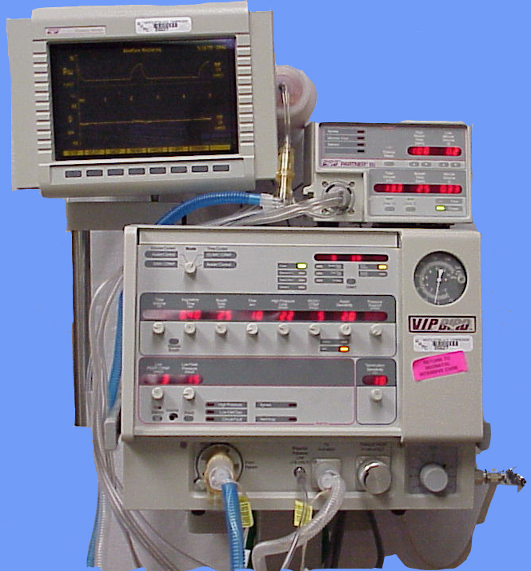
Fig 1: A Ventilator
2.1.2 NUMBER OF VENTILATORS IN NIGERIAN STATES
In Kano State, the deputy governor, Dr. Nasir Yusuf Gawuna, who is the chairman of the Task Force Committee on COVID-19, said there are 27 ventilators at the newly converted isolation centre at the Kwanar Dawaki Pfizer Hospital. Gawuna said this was in addition to a number of ventilators at different hospitals, which could be used when the need arises, noting that only about 20 per cent of patients need ventilators. The Aminu Kano Teaching Hospital (AKTH), which was listed as one of the possible isolation centres by the Kano Task Force on COVID-19, has eight ventilators in its Intensive Care Unit. However, the Director, Infections Control of the hospital, Professor Isah Abubakar, said the number would be grossly inadequate in case of an outbreak as some of the beds were already occupied by other patients with respiratory challenges. He equally requested that the AKTH laboratory be upgraded to one of the centres for testing and diagnosis of the COVID-19 in the North. In Ogun, the Commissioner for Health, Dr. Tomi Coker, said there are 24 functional respiratory ventilators in the state. Coker told Daily Trust that the ventilators belong to the Federal Medical Centre, Idi Aba, Olabisi Onabanjo University Teaching Hospital (OOUTH), Sagamu and Babcock University Teaching Hospital, Ilishan.
Similarly, the Edo State government said it has 25 ventilators spread across the three isolation centres located in Benin in Edo South, Irrua in Edo Central and Auchi in Edo North Senatorial districts. This was made known by the deputy governor, Comrade Philip Shaibu who is the chairman, Edo State COVID-19 Taskforce Team.
In Delta, the State Commissioner of Information, Mr. Charles Aniagwu, said the government had dedicated 19 ventilators for the treatment of coronavirus, should the pandemic break out. Fielding questions from journalists at an interactive session on COVID-19 update, he said the government made the provision despite the fact that there was no confirmed case of COVID-19 in the state at the moment. "Ventilators become necessary when the attack becomes acute. Prevention is better and far cheaper. What is important at this moment is Personal Protective Equipment (PPE) and personal hygiene, which we are making concerted efforts to sensitize our people," he said.
Adamawa State has a total of five ventilators with two at the Federal Medical Centre, one at Adamawa-German Hospital, Yola and two at the COVID 19 Isolation Centre. This is according to the Director of Public Health, Adamawa State Ministry of Health, Dr. Bwalki Dilli.
In Kwara, the state government said it has eight new ventilators in its 60-bed capacity isolation centre at Sobi Specialists Hospital, Ilorin. The Chief Press Secretary to the governor, Rafiu Ajakaye also said the state government had placed an order for eight more ventilators. He said before the coming of the present administration, Kwara state government had no isolation centre with a single ventilator. "If any ventilator existed in Kwara, it was at the University of Ilorin Teaching Hospital, a federal institution," he said.
Bayelsa State said it currently has five ventilators at the moment to combat the ravaging coronavirus pandemic in the state. The Director of Public Health in the state ministry of health, Dr. Yerinbuluemi Stowe, who disclosed this said the state government may acquire more ventilators in due course. Out of the five ventilators, he said three were stationed at Federal Medical Centre (FMC) in Yenagoa, while two were at the state isolation centre located inside the Niger Delta University Teaching Hospital in Okolobiri.
In Katsina, our correspondent reports that there are only five ventilators available at the two designated isolation centres established for any eventualities from the COVID- 19 outbreak. Three of them are located at the Federal Medical centre (FMC) Katsina, while two are at the state government-owned General Amadi Rimi Specialist hospital.
In Borno State, it was gathered that there are 15 functional ventilators and three mobile ventilators while in neighbouring Yobe State, the isolation centre at Sani Abacha Specialist Hospital, Damaturu has three ventilators, two oxygen concentrators and one physio-control defibrillator.
The Benue State Commissioner of Health and Secretary, State Action Committee on Coronavirus, Dr. Sunday Ongbabo, said there were six ventilators in the state. According to the commissioner, four of the ventilators were located at the Federal Medical Centre in Makurdi, while the remaining two are at the isolation centre in Benue State University Teaching Hospital, Makurdi.
Bauchi State is said to have four ventilators in one hospital among the designated isolated centres for the patients of coronavirus. A source at the ministry of health who crave anonymity told Daily Trust that there were four ventilators at the Abubakar Tafawa University Teaching Hospital (ATBU-TH). But a reliable source in the hospital said, "ATBU-TH has only one ventilator but it was taken to the isolated centre where some people have been quarantined. When contacted, the state Commissioner of Health, Dr. Aliyu Mohammed Maigoro, declined to comment saying, "I will not answer any questions on the phone. If you want clarification on the COVID-19 issues, let us meet at the media briefing."
The Infectious Disease Control Centre (IDCC) in Kakuri, Kaduna State and the Barau Dikko Teaching Hospital in the state have two functioning ventilators each, our correspondent gathered. Daily Trust reports that the Kaduna State Commissioner of Health, Dr. Amina Mohammed-Baloni, had earlier said that the IDCC has been equipped with specialised equipment like ventilators, oxygen concentrators and monitors in preparedness for case management of COVID-19. She did not respond to an inquiry on the total number of ventilators in the state but the Kaduna State Epidemiologist, Jeremiah Daikwo, told Daily Trust on the phone that there are two ventilators at the Kaduna IDCC, saying he cannot verify the number of ventilators in the entire state. Our correspondent contacted the Chief Medical Director of Barau Dikko Teaching Hospital, Prof. Abdulkadir Musa Tabari, who also said the hospital has two functioning ventilators.
Ebonyi State has four ventilators, according to the Commissioner for Health, Dr. Daniel Umezurike.
In Gombe, the state Chairman of the Nigerian Medical Association (NMA), Dr. Kefas Zawaya, said the three isolation centres set up by the state government do not have functional ventilators. "I can boldly tell you that Gombe State does not have up to three ventilators that are functioning to treat COVID-19 cases. "Although we have functional ventilators at ICU of the FTH, Gombe but it cannot be released to the state government for the treatment of the coronavirus because they need them to take care of their patients," he said.
The Plateau State government said there were eight ventilators available in the state for coronavirus patients in the event the need arise. The Commissioner of Information and Communication, Mr. Dan Manjang, told Daily Trust that the state government had plans to buy additional five ventilators that would be sent to the three senatorial districts of the state.
In Kebbi, there are no ventilators.
In Nasarawa, it was gathered that the state does not have ventilators specifically for COVID-19. A source said that the public hospitals in the state do not have any ventilator either, but this could not be independently verified as those who supposed to speak on the matter were not willing to talk. According to one of the sources, the hospitals have informed the state ministry of health, which has also notified the government on the need to make provision for ventilators and other equipment. The source, however, said the contract for the supply of ventilators had just been awarded. The Commissioner for Health, Pharmacist Muhammed Ahmed Yahaya, did not answer his calls and did not reply to a text message sent to him on the issue.
In Kebbi, the State Commissioner for Health, Mohammed Jafar, said he could not give the figure of the ventilators available in the state at present, saying the state government had placed order for new ones. He said he would only give the number of the ventilators after the new ones had all been installed. There are not enough ventilators available in hospitals right now for all of the potential patients who will be struck by the virus.
An influential report from Imperial College London estimates that 30% of Covid-19 hospitalised patients are likely to require mechanical ventilation. The only way to avoid overwhelming intensive care units, it says, is with a mandatory lockdown that reduces social contact by 75%. But some countries have been slow to act accordingly – and it is still uncertain that we can sustain extended isolation measures over the “several months” they may be needed. As a result, a ventilator shortage remains imminent in many parts of the world, as New York Governor Andrew Cuomo’s plea for 30,000 units shows. In terms of their core function, ventilators are not extraordinarily complicated machines. Basically, they are sophisticated pumps – they control the oxygen and air flow from the patient’s lungs, supporting them while they cannot do their work.
The race is on. Governments and health authorities are keenly aware of the challenge. The UK government aims to add more than 1,200 ventilators to its system in less than two weeks, and is forecasting it will need 30,000 at the peak of the outbreak. For that, it has called on non-health industries and universities to help in a wartime-like effort.
Philips, one of the top medical equipment companies worldwide, told BBC Future that it is “adding manufacturing lines and increasing the number of shifts, and hiring additional manufacturing employees and shifting current employees to support increased demand immediately”. Many other big corporations are following suit, even as their production capacity already has been strained due to the crisis and lockdowns in China.
Even Formula One racing teams are joining the effort. Dyson, the vacuum cleaner company, already received an order for 10,000 ventilators, and Smiths Medical’s efforts to treat less critical patients with CPAP (Continuous Positive Air Pressure) devices, more commonly used for controlling sleep apnoea, are advancing rapidly. Meanwhile, engineers and researchers are coming up with other creative solutions – such as the Ventil, a new machine that, when attached to a ventilator, can allow for the ventilation of two patients simultaneously. But while high-income countries may have the possibility of scaling up an industrial effort in weeks, most countries do not. And even high-income countries may find themselves in a position where they need additional ventilators, too: there are reports that prices are skyrocketing as the demand rises globally.

2.1.3 DIY DEVICES
“You don't want do-it-yourself ventilators out there if they don't need to be. But if we reach the point where hundreds of thousands or millions of people are dying because there are not enough ventilators, then the DIY ones are the backup,” says Andrea Ippolito, a lecturer in engineering management in Cornell University who volunteers in a group called End Coronavirus, which is devoted to coordinating efforts between different DIY and open source ventilator projects. If we reach the point where hundreds of thousands or millions of people are dying because there are not enough ventilators, then the DIY ones are the backup – Andrea Ippolito
As a result, thousands of experts, entrepreneurs and volunteers around the world are developing a different potential solution: creating open-source ventilators. With access to relatively simple designs, makers in Africa or South America could build ventilators quickly and cheaply using already available hardware and infrastructure. And since all the intellectual property of these projects will be free to use, licencing and copyright issues won’t get in the way of builders. These designers are working at breakneck speed – at least a dozen ventilator prototypes at different stages have been developed in March 2020 alone by teams in different countries – and organising on Slack channels, Facebook groups, and GitHub repositories. They think they can help solve the bottleneck, particularly in parts of the world with less capability to respond to the crisis, like Africa or South America.
Colin Keogh, an expert in 3D printing at University College Dublin, has been leading a team of volunteers looking at community-sourced and open-sourced projects. His team already has released a first prototype that works by automating “ambu-bags”, the pumps often used in ambulances and urgent care. “We are just looking for a kind of very low-cost emergency ventilator system that could be provided as a last line of defence,” Keogh says. Its creators expect it to help doctors help patients in places with critical device shortages.
Pomo co-founder Serey’s idea is similar. It is an ambu-bag continually pushed by a lever moved by a small motor, programmed to push at different pressures and paces so the operator can control the air pressure and supply. Even more frugal than Keogh’s design, it does not use any 3D printed materials: it only requires string, a stand for the bag that could be easily made with aluminium or other materials, and an electric motor easily available off-the-shelf at hardware stores or at mechanic shops.
Other initiatives are more ambitious. Researchers from Oxford University and King’s College London set up OxVent, a project aimed at developing prototype ventilators “that are not as sophisticated as the ones that are currently used in hospitals, but that nonetheless meet the requirements in terms of safety and features that are required,” says Federico Formenti, a senior lecturer in Human Physiology at King’s College London who is part of OxVent. The OxVent uses readily available materials, and is meant to be quickly buildable in university workshops
Such a machine would not be intended to replace existing ventilators, but rather to support patients during the disease’s most acute phase and “provide an option for respiratory support to patients when hospitals run out of standard ventilators”. Formenti’s team is trying to use widely available technologies and equipment, like parts already used by the NHS, generic electronics, and open-source software. “Our aim is to be able to produce these prototypes with components and materials which are available on the market, so people can build the device in, say, university laboratories,” says Formenti.
Road bumps: One obstacle that remains is testing. Both the FDA and the MHRA set up fast approval processes for ventilators and other medical devices on the Covid-19 crisis, and Formenti says his team is readying steps to undergo MHRA testing in days’ time. Other groups believe that will still take too long, so they’re working on other approaches. The End Coronavirus group, for example, is working towards developing or obtaining an “iron lung”: a machine that simulates the pressures and airflow of a human lung. Through these kinds of tests, they hope to produce enough proof for physicians to use them on patients – at least as a last resort. If a doctor must choose between using a ventilator tested only on an “iron lung” or nothing, the leaders of End Coronavirus believe doctors will opt for the former. Materials are another challenge. They should be able to endure extensive wear and tear, not be likely to spread infection, and hold up under different cleaning methods, like chemicals or UV. These requirements seriously entangle the design process, as they complicate engineering choices. “It cannot be a fire hazard, and oxygen is very corrosive for many materials,” says Medellin engineer Toro.
This can be tricky: for instance, while 3D printing process itself makes the devices sterile, the plastic used in it is very porous, so it is it difficult to keep pieces clean and safe once printed. It means the technique is best suited for creating disposable items and not for replacing conventional parts or entire machines. Even if designers and engineers can solve all of this, the machines must be easy for health professionals to use, meaning they should be as similar to existing ones as possible or very simple to learn to operate. This is key in order for them to be useful in this crisis: the US National Academy of Medicine, for example, recommends hospitals “minimise the need to train staff” to operate ventilators so they can respond with the rising demand.
The machines must be easy for health professionals to use, meaning they should be as similar to existing ones as possible or very simple to learn to operate. Formenti and the OxVent team plan to create “a simplified version of what is available in the hospitals already”, so it should be easy for users to operate. However, this is still a work in progress for most initiatives. In one evaluation of 20 projects, it was found that only one of them was “clinician-friendly” enough to be usable.
Hospital doctors are taught how to handle a ventilator at the Universitaetsklinikum Eppendorf in Hamburg, Germany in March 2020. Another challenge is managing thousands of enthusiastic volunteers to work productively. It sounds like a good problem, but it is still a problem, says Diana Rodriguez, a US-based Venezuelan software developer who has worked in other health-tech open source projects: “Directing people’s efforts is going to be a huge challenge. Some people will work a lot and have a lot of knowledge, but this is very complex.” A sharp goal and a sensible division of labour are crucial: “Not everyone has the same skills, so people should do what they are good at.”
Fortunately, DIY makers and open-source software movements already have experience with these types of self-organising teams, so it’s a challenge that can be overcome. And for most makers and designers, all of these problems are secondary compared to the importance of the goal: creating more ventilators to save lives. As Keogh says, “it just needs to be done.” This is why they’re putting in thousands of hours with little sleep and putting the rest of their lives aside. It could, literally, be a matter of life or death.
In 20% of those infected in the current pandemic, the SARS CoV-2 viruses are lodged deep in the lungs, since COVID-19 mainly affects the lower respiratory tract. Then the illness quickly becomes critical, and the most severe cases must be immediately connected to a ventilator in the intensive care unit. Because there are too few intensive care beds with ventilators even in high-technology countries such as Italy and Spain, doctors are increasingly having to decide who gets the lifesaving treatment and who doesn't.
Who needs to be ventilated and why?: Artificial respiration can save lives because if breathing stops, the organs are no longer supplied with oxygen. At the same time, the carbon dioxide produced during breathing is no longer exhaled via the lungs. A short time after a respiratory arrest, the heart also stops beating and the circulation ceases, so that the patient dies within minutes.
How do ventilators work?: In simple terms, a ventilator pushes oxygenated air into the lungs at positive pressure and displaces fluid from the pulmonary alveoli, the tiny, balloon-shaped air sacs in which the exchange of oxygen and carbon dioxide molecules to and from the bloodstream takes place. This sounds simple but is actually a highly complex treatment option. That is because modern ventilators can adapt the form of ventilation to the individual needs of the patient. For pressure-controlled ventilation (PCV ventilation), the ventilator creates a certain pressure in the airways and the alveoli so that as much oxygen as possible can be absorbed. As soon as the pressure is high enough, exhalation begins. The respirator thus takes over the entire breathing process of the patient.
What do patients notice during artificial respiration?: In non-invasive artificial ventilation, the air is passed over the mouth and nose with the help of a tightly fitting ventilation mask. In invasive ventilation (intubation), the tube is pushed through the mouth or nose and into the trachea (windpipe). In the case of a tracheotomy, the doctor has direct access to the trachea through a small hole in the throat. People who are connected to a ventilator can neither speak nor eat and are artificially fed through a tube. Since invasive ventilation, in particular, is very unpleasant, patients are usually put into an artificial coma with anesthetics for the duration of the treatment.
Why are there too few ventilators?: During the coronavirus crisis, the demand for ventilators has increased dramatically because the health care systems in many countries are not geared to the need for so many respirators simultaneously. However, such high-performance ventilators for intensive care use, which cost up to €50,000 ($55,842) apiece, cannot be purchased at short notice. There are only a few manufacturers of ventilators and so-called ECMO devices, which can enrich the blood with oxygen, i.e. work as an artificial lung. Although these companies have increased their production capacities to the maximum, there are still supply bottlenecks, including for consumables such as breathing tubes and cannulas. Dramatic shortfalls in the care of seriously ill COVID-19 patients can also occur if, for example, illness or quarantine leads to a lack of highly qualified personnel who can reliably operate these sometimes highly complex devices in intensive care.

2.2. THE APPLICATION OF SENSORS FOR SOLVING THE ISSUE
An ERDF-funded project is helping to tackle the COVID-19 crisis in Italy. New sensors created by the project allow healthcare staff to monitor patients suffering from the disease at a distance. The biosensors, created by the MEDIWARN project, can monitor a patient’s vital signs such as heartbeat, respiratory rate, blood pressure and body temperature. It is difficult and dangerous for medical and nursing staff to monitor COVID-19 patients in person. Patients infected and symptomatic need to be isolated in rooms with negative pressure. The new sensors allow staff to more easily monitor such patients from another room.

2.4 PUBLIC HEALTH SYSTEMS TO THE RESCUE
Existing modern solutions in diagnostics, monitoring, and molecular development are being used as powerful tools to help fight the current pandemic. These technologies can help identify outbreak hotspots, prevent infections, reduce the need for physical contact in diagnostics, and even work towards developing a vaccine for COVID-19.
Molecular Diagnostics
As of March 20, 2019, the CDC has identified 15,219 confirmed cases of COVID-19 in the United States and 201 deaths. However, public health experts say the only reason why those numbers have not exploded is that the nation has far too few diagnostic test kits. Lagging inventory has slowed testing. That means people simply don’t have them where and when they need them. The need for a scalable diagnostic solution is beyond doubt. Here are a few startups taking on this challenge.
Biomeme
Biomeme's platform transforms your smartphone into a mobile lab for advanced DNA diagnostics and real-time disease surveillance. The system includes a docking station for real-time PCR (Polymerase Chain Reaction), a mobile app to control the system and analyze results, and targeted test kits for preparing samples and identifying pathogens or diseases by their specific DNA or RNA signatures. The cutting edge platform performs to the gold standard used by the world's most advanced central labs but requires no lab equipment or special experience to use. The low-cost, user-friendly system enables mobile testing at the point-of-need for health care, such as in mobile clinics, for disease tracking and home use.
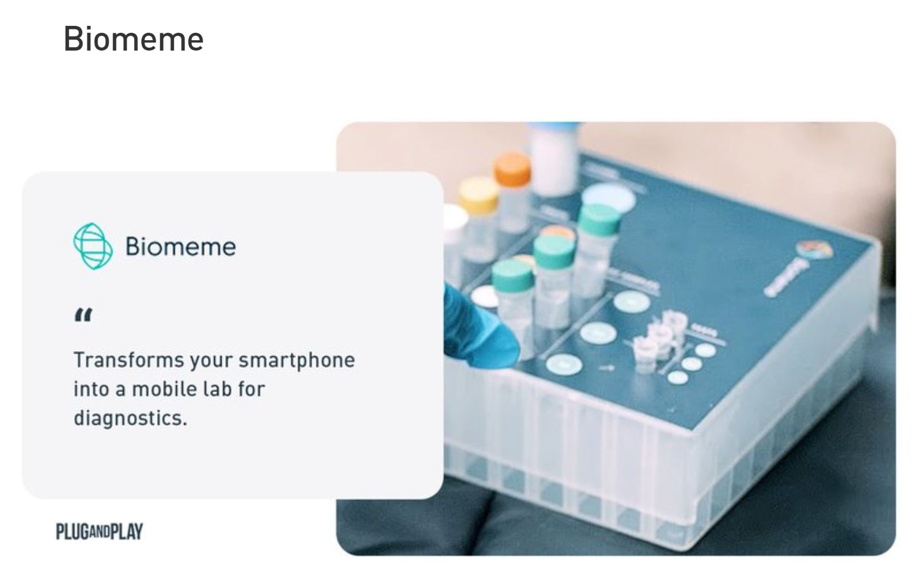
Fig 2: Biomeme Platform
Biomeme allows pharma companies to quickly set up pop up labs all over the world by leveraging smartphone devices. From sample collection to data management, Biomeme’s end-to-end mobile platform empowers them to take real-time PCR everywhere they need it. Biomeme SARS-CoV-2 tests allow the detection of the RNA of the severe acute respiratory syndrome coronavirus 2 which causes the COVID-19. The two novel coronavirus RNA targets are multiplexed together with Biomeme's RNA extraction and RT-PCR control (MS2). Each order contains your exogenous positive controls and everything is shelf-stable (15-30C). Each reaction contains lyophilized master mix, multiplexed primers, and probes for the following triplex: SARS-CoV-2-Orf1ab gene, SARS-CoV-2-S gene, RNA Process Control (RNA extraction and RT-PCR control utilizing MS2 bacteriophage)
Genomtec
Genomtec developed a smartphone-sized genetic analyzer for infection detection in the doctor's office in less than 15 minutes, thanks to patent-pending optical, contactless heating technology. Their technology combines optical heating and detection with microfluidics and reagents stable at room temperature.
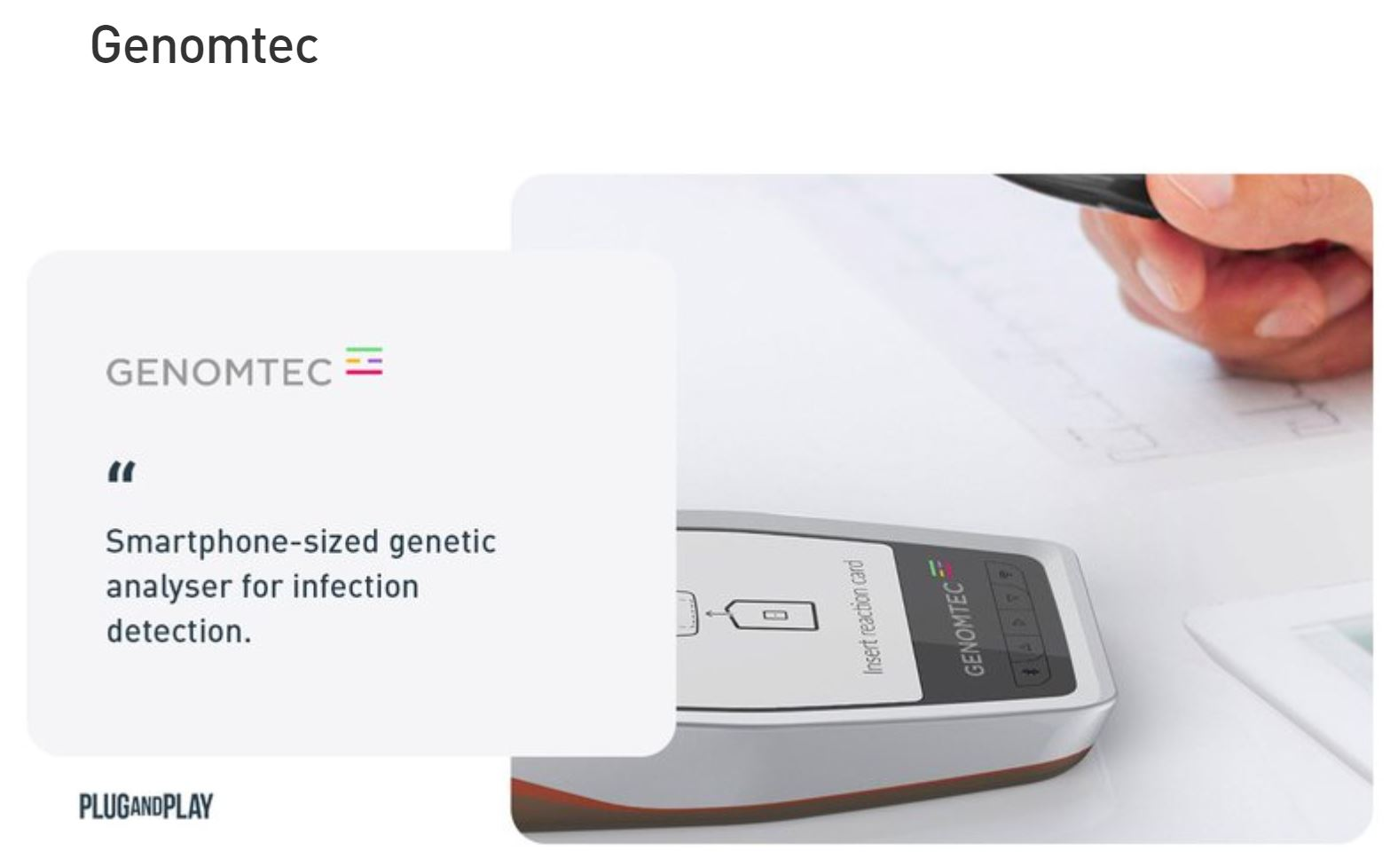
Fig 3: Geomtec

Genomtec technology offers fast, inexpensive and reliable molecular diagnostic testing. The device works independently and automatically, it is enough to apply a drop of biological material to the reaction card and then place it in the analyzer. The test results can then get directly sent to an email address or fed into the medical records of the patient. Thanks to its ease of use and its automated diagnostic approach, Genomtec is able to effectively fight complications that result from viral infections, such as COVID-19. Genomtec is currently operating in the US and European markets.
Mammoth Biosciences
Mammoth Biosciences offers a CRISPR platform for nucleid acid diagnostics. Mammoth Biosciences, in collaboration with Charles Chiu, MD, PhD, is developing a rapid diagnostic test that could more quickly and widely monitor for the disease. The new test is a color-changing test strip that uses CRISPR to detect viral RNA and can be run in 30 minutes to an hour. “We’ve been able to run this rapid test on both control samples and patient samples and it appears to be working,” said Chiu. He hopes to optimize the test so that it can be run by anyone and deployed in low-resource areas.
BioMedomics
BioMedomics focuses on building fast and easy-to-use testing kits for various diseases at a patient's point of care. BioMedomics specialized in product offerings that help in the diagnosis of blood disorders and in the identification of microorganisms and pathogens which are of global concern. They recently developed a quick immunoassay diagnostic test for COVID-19 in two ways: antibody and PCR (polymerase chain reaction) testing. At the point of care, the BioMedomics solution can deliver results within 15 minutes using just a blood sample. This blood sample can be used for rapid screening for carriers of the virus that are symptomatic or asymptomatic.
Recent studies around the new COVID-19 outbreak suggest that a high percentage of patients show no clinical symptoms of the virus, thus screening patients is key. This kind of testing is perfectly tailored for hospitals, clinics, and test laboratories, but can also be effectively deployed in businesses, schools, airports, seaports and train stations giving it the potential to become a compelling force in the fight against this global threat.
Bat-Call
Bat-Call is a startup that focuses on respiratory and cardiovascular diagnosis through chest sound and machine learning classification. They developed a wide range of devices to use in different settings. Their latest invention is a vest that patients can wear to collect sound samples from various angles and which get wirelessly communicate to doctors for an accurate diagnosis. Another device they developed is called CompuSteth, which is a digital Stethoscope that enables doctors to use them at patient’s bedside, the device is able to detect inaudible sounds, analyze them and visually present them to doctors, thus making the diagnosis faster and more precise.

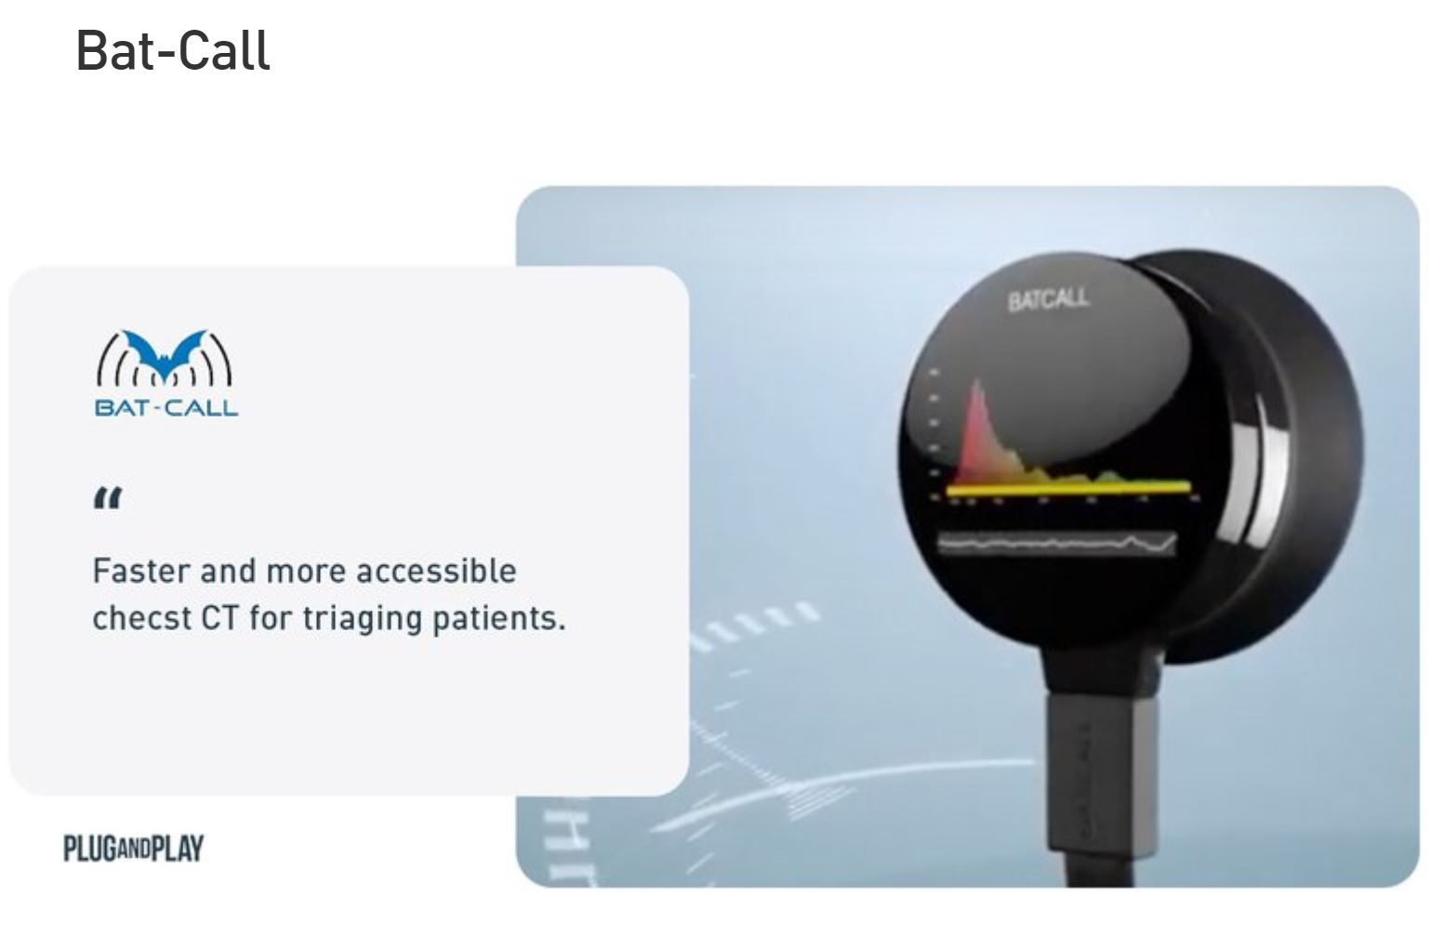
Fig 3: Bat-Call
To combat COVID-19, constant monitoring and quick diagnosis are key. Chest CT is widely used in China to rapidly diagnose and screen for people who got infected and has proven to be as accurate for testing as a testing kit which may not be accessible in some areas. Bat-call can offer a more accessible and faster scan that could significantly help in triaging patients and thus in relieving the limited capacities of healthcare providers.
Codagenix
Codagenix Inc. utilizes a breakthrough platform technology called SAVE to construct live-attenuated viral vaccines against multiple targets. All live-attenuated vaccines that are currently used in clinics were created using a trial-and-error based testing developed in the 1880s, pre-dating the discovery of the DNA double helix. The SAVE platform relies on synthetic biology and the “re-designing” of a target virus’s entire genome to yield a vaccine strain. This customization process uses software-based algorithms to ‘re-code’ the genome of a target virus.
Codagenix is currently developing a live-attenuated vaccine that will carry all proteins from a natural virus. They will be targeting the spike protein, along with all other structural and non-structural proteins of SARS-CoV-2. A coronavirus vaccine is now a part of the pipeline.
Codagenix is working on bringing the vaccine into Phase I trials within the next 4 months. After that, through a partnership with the Serum Institute, they will manufacture and distribute the vaccine under a US EUA.
Meissa Vaccines
Meissa Vaccines is a pharmaceutical development startup focused on the in-licensing and advancement of vaccines for the respiratory syncytial virus (RSV, the largest unmet respiratory medical need in pediatrics) and rhinovirus (the leading cause of infectious disease worldwide).
Meissa Vaccines is applying synthetic biology and genetic engineering to respiratory viruses for the rational design of vaccine strains that solve challenging obstacles in modern vaccinology such as suboptimal immune responses, vaccine stability, and manufacturing. Initially developed at Emory University, proprietary technologies of reverse genetics, codon deoptimization, and stabilization of key antigenic conformations allow for the rapid generation of best-in-class vaccine formulations.
Sonovia
Sonovia’s special chemical formulations give textiles the ability to destroy pathogens, providing protection for doctors and patients alike against potentially harmful bacteria and infections. Patients in hospitals are exposed to millions of bacteria causing post-treatment infections, which can result in medical complications, longer hospital stays, and death. 30% of patients in ICU are affected by healthcare-associated infections. 130k deaths every year are attributed to Hospital Acquired infections in the USA and Europe. COVID-19 is transmitting with droplets or by touch, general protection is necessary to lower the chance of being infected.
BlueDot
BlueDot protects people around the world from infectious diseases, leveraging human and artificial intelligence. The startup has developed a patented global early warning system to track and predict the spread of dangerous infectious diseases. BlueDot benefits from a strong track record and reputation built off of repeated success stories, including predicting the spread of Zika into the Miami area Florida 6 months before the first case got detected. BlueDot can help governments to protect their citizens, hospitals to protect their staff and patients, and businesses to protect their employees and customers.
Sickweather
The Sickweather app is the world's first real-time map of human health. It uses social listening to track reported illnesses and symptoms and delivers an overview of all illnesses that are going around in your community – like the flu. Thanks to its patented algorithm, Sickweather can analyze social sentiment data to generate a flu forecast and deliver daily SickScore. The app can minimize stock-outs, supporting the effective distribution of vaccines, over-the-counter medication, and disinfectants, serving different geographic areas at the right time.

3.0 CHALLENGES
1. As the number of confirmed cases from the deadly COVID-19 pandemic increases in the country, there are only 169 ventilators in sixteen out of the 36 states. This means there is an average of 10 ventilators in each of the states, and in real terms, some of the states do not have more than five ventilators.
2. There are some states that are yet to procure any ventilator for the treatment of COVID-19, while others say they have placed orders and were expecting the delivery of the equipment any moment from now. Credible sources said most of the 169 ventilators in the states covered by this report have been there for long, indicating that they were not purposely procured to manage the crisis that might likely come with the coronavirus. The states include Kano, Ogun, Edo, Delta, Adamawa, Kwara, Bayelsa, Katsina, Borno, Yobe, Benue, Bauchi, Kaduna, Ebonyi, Gombe and Plateau.
3. Findings revealed that a hospital-grade ventilator is between $25,000 (N9.175million) and $50,000 (N18.350 million) each, based on the official CBN rate of N367 as of Monday, March 30, 2020. Though Lagos and Abuja were the worst hit by the coronavirus, efforts to get the exact number of ventilators in the two cities were not successful.
4. A respiratory expert who craved anonymity said Nigeria requires about 10, 000 respirators for emergency cases. He said at the moment, there are less than 50 in both public and private hospitals in the Federal Capital Territory (FCT). He estimated that the country had less than 500 ventilators, adding that it was mostly public tertiary hospitals that have them. He said ventilators were very important equipment, not only being used for treatment of COVID-19, but other respiratory illnesses, adding that it was important for all hospitals to have them. "I pray the country does not find itself in emergency situations like what is presently happening in the US because there wouldn't be enough ventilators to handle the situation," he said.
5. There aren’t enough A.I engineers in Nigeria and it takes years of rigorous training for a person to become adept in machine learning and artificial intelligence.

4.0 RECOMMENDATIONS
1. The Usage of Clinical AI Chatbots/Symptom Checkers
Symptom checkers offer an easy way for people to quickly learn if they are sick or not. Normally symptom checkers come in the form of a questionnaire. However, more and more startup solutions shift to a format of a chatbot solution, which helps to feel more relaxed and mimic a real interaction with a doctor. In the case of COVID-19, the symptoms appear to be very similar to suffering from either the flu or undergoing a cold. Symptom checkers can help people to distinguish the difference and provide care triaging to guide patients to the right provider and diagnostic centers.
2. Population Outbreak Management
Outbreak management systems offer software solutions that help to detect an imminent outbreak of infectious diseases. Powerful AI and algorithms run on the backend of those management systems and build predictive models to alert people of the danger.
3. Healthcare systems should plan to use digital technology. For example, ‘virtual clinics’ could be set up through the use of tele-medicine consultations with imaging data (e.g., chest X-ray and/or CT of the thorax) uploaded from peripheral sites and interpreted remotely. This would ensure that patients continue to receive standard clinical care while reducing physical crowding of patients into hospital premises. For other key hospital activities (e.g., research and education), virtual e-learning platforms are increasingly being explored to eliminate physical meetings.
4. The utilization of various AI-based triage systems could potentially alleviate the clinical load of physicians. An online medical ‘chat bot’ could help patients recognize early symptoms, educate people on the importance of hand hygiene and refer people for medical treatment should symptoms worsen. Additionally, phone-based software that detects and records patients’ data (e.g., daily temperature and symptoms) may prevent unnecessary hospital consultations for patients with mild flu-like symptoms. These data could also be developed into AI algorithms for the detection of COVID-19.
5. Many hospitals in China are collaborating with blockchain companies and pharmacies to deliver patients’ medication to their doorsteps. Through the use of blockchain, hospitals could ensure timely delivery of medications with accurate tracking.
6. The immediate use and successful application of digital technology to tackle a major, global public-health challenge in 2020 will probably increase the public and governmental acceptance of such technologies for other areas of healthcare, including chronic disease in the future. As the saying goes, ‘a crisis provides an opportunity’; this first great crisis of 2020 provides a great opportunity for digital technology.
7. Vaccines
Vaccines are an effective tool to quickly gain immunity against infectious diseases. A vaccine typically contains an agent that resembles a disease-causing microorganism and is often made from weakened or killed forms of the microbe, its toxins, or one of its surface proteins. Vaccination is a key contributor to the population’s health but underlies a very expensive and time-consuming development process. However, innovative technologies like machine learning and computer simulations are gradually changing how scientists develop vaccines.
8. Patients who are feeling ill can schedule an appointment with a doctor through video, allowing them to remain at home while they may be contagious, instead of interacting with other patients and medical staff at a local facility. This is especially relevant in times of pandemic outbreaks such as COVID-19 that ask to avoid close personal contact.
9. Remote Patient Monitoring
Remote patient monitoring solutions collect medical health data and vitals, including heartbeat, weight, blood pressure, and oxygen rate from the user's device. This data is then transmitted to providers, who can remotely monitor these patients and take action when necessary. Often in the form of apps and medical wearables, remote patient monitoring can allow physicians and hospitals to monitor patients outside of the conventional clinic setting. Remote monitoring can either be performed contactless or through medical devices. Given most patients with initial signs of fever and cough will visit their healthcare providers, a common behavior shown in COVID-19 is that patients revisit or visit multiple clinics when they do not recover from initial flu medication, causing further infections. With remote monitoring, patients that have increased temperatures or decreased blood oxygen levels can be advised to seek help from stipulated centers directly.

10. Population Outbreak Management
Outbreak management systems offer software solutions that help to detect an imminent outbreak of infectious diseases. Powerful AI and algorithms run on the backend of those management systems and build predictive models to alert people of the danger.

7.0 CONCLUSION
The development of environmental health engineering facilities, equipment, sensors and public health systems such as ventilators for tackling the coronavirus pandemic will help to quickly eradicate the spread of the virus.

8.0 REFERENCES
AllAfrica.2020. “Nigeria: COVID-19 – Only 169 Ventilators in 16 States”.“https://allafrica.com/stories/202004010571.html”
Association for Project Management (2006) APM Body of Knowledge. Association for Project Management, Buck-inghamshire.
British Standards Institution (2010) BS 6079-1:2010—Project Management: Principles and Guidelines for the Management of Projects. British Standards Institution, London.
COVID-19 and the Race in Startup Technology(2020). Alex Tran, Darren Yang, Desiree Wagner & Linly Ku. Available at: “https://www.plugandplaytechcenter.com/resources/covid-19-and-race-startup-technology/”
Coronavirus: How do ventilators work?. Alexander Freund(2020). “https://www.dw.com/en/coronavirus-how-do-ventilators-work/a-52967999”
Digital technology and COVID-19(2020). Daniel Shu Wei Ting, Lawrence Carin, Victor Dzau & Tien Y. Wong. Available at: “https://www.nature.com/articles/s41591-020-0824-5”
Jose Luis Penarredonda(2020): “Covid-19:The race to build coronavirus ventilators”. Available at: “https://www.bbc.com/future/article/20200401-covid-19-the-race-to-build-coronavirus-ventilators”
Sandee LaMotte(2020): “What is coronavirus and Covid-19? An explainer”. Available at: “https://edition.cnn.com/2020/03/31/health/what-is-coronavirus-covid-19-wellness/index.html”
Sarah Newey & Anne Gulland.2020. “What is coronavirus, how did it start and how big could it get?”. “https://www.telegraph.co.uk/news/2020/04/01/what-is-covid-19-virus-coronavirus-pandemic/?google_preview=JqtL0hS47k4YluTp8wUwloCf-wWIAYCAgKDnmojFKA&iu=6582&gdfp_req=1”
Modesto, S.T. and Tichapondwa, S.P. (2009) Successful Project Management: Insights from Distance Education Prac-tices. Virtual University for the Small States of the Commonwealth, Vancouver.
Project Management Institute (2000) A Guide to the Project Management Body of Knowledge (PMBOK Guide). Pro-ject Management Institute, Newtown Square, Pennsylvania.

