NAME: BLESSING-ONYEIKE CHIAGOZIWOM
DEPT: CIVIL ENGINEERING
MATRIC NO: 19/ENG03/007
CHM 102
- CH₃OCH₃ - methoxymethane
CH₃CH₂OCH₂CH₃- ethoxyethane
(CH₃CH₂CH₂CH₂)₂O- Butoxymethane
CH₃CH₂ OCH₃- methoxyethane
CH₃CH₂CH₂OCH₂CH₃- ethoxypropane
- Properties of Ethers
- Ethers are colorless, neutral liquids with pleasant odours at room temperature.
- Ethers are less soluble in water than are the corresponding alcohols. As the hydrocarbon content of the molecules increase, there is a rapid decline in solubility. They are miscible with most organic solvents
- Most of simple ethers are less dense than water, although the density increases with increasing relative molecular mass and some of the aromatic ethers are in fact denser than water.
- Low molecular mass ethers have a lower boiling point than the corresponding alcohols but those ethers containing alkyl radicals larger than four carbon atoms, the reverse is true.
- Ethers are inert at moderate temperature. Their inertness at moderate temperatures leads to their wide use as reaction media.

- Methods of preparing ethers
- Dehydration of alcohols: In the presence of sulphuric acid, dehydration of ethanol yields ethoxyethane at 413 K. This is an ideal method of preparation through primary alcohols. Preparation of ethers by dehydration of an alcohol is a nucleophilic substitution reaction.
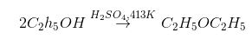
- Williamson’s synthesis: When an alkyl halide reacts with sodium alkoxide, ether is formed. This reaction is known as Williamson’s synthesis. The reaction generally follows the S_{N}2 mechanism for primary alcohols.
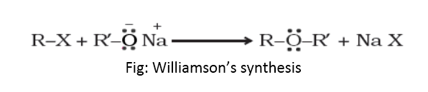
- i) ethylene oxide is used as an intermediate in the hydrolytic manufacture of ethylene glycol
ii) it is used in the preparation of nonionic emulsifying agents, plastics, plasticizers and several synthetic textiles
iii) it is used as a gaseous sterilizing agent.

