ENGINEERING LAW AND MANAGERIAL ECONOMICS FOR INFRASTRUCTURAL DEVELOPMENT IN NIGERIA CHALLENGES AND WAY FORWARD
BY
IDOWU OLAGOKE
17/ENG03/025
CIVIL ENGINEERING
TO
ENG 384÷ ENGINEERING LAW AND MANAGERIAL ECONOMICS
ON
APRIL 11TH, 2020.

CERTIFICATION
This is to certify that IDOWU OLAGOKE SAMUEL with matric number 17/ENG03/025 in the department of Civil Engineering, College of Engineering, Afe Babalola University, Ado – Ekiti, during 2019/2020 academic session prepared and presented this report.

Student Signature Date

Lecturer Date

Table of Contents
CERTIFICATION 2
ACKNOWLEDGEMENT 4
ABSTRACT 5
INTRODUCTION 6
What is Infrastructure? 6
Types of Infrastructures 6
INFRASTRUCTURE DEVELOPMENT 9
Importance of sector specific infrastructure for economic growth of Nigeria: 9
MANAGERIAL ECONOMICS IN INFRASTRUCTURAL DEVELOPMENT 13
CHALLENGES OF INFRASTRUTURAL DEVELOPMENTS 15
WAY FORWARD FOR INFRASTRUCTURAL DEVELOPMENT in Nigeria: 17
CONCLUSIONS 20
RECOMMENDATIONS 20
REFERENCES 20

ACKNOWLEDGEMENT
First and foremost, I give glory and honor to God almighty for His grace, love and mercy upon my life and for giving me the grace to attend this lecture.
I also appreciate my parents Mr. and MRS Idowu for their support (moral, spiritual and finically) for the journey so far. I am thankful to the founder of ABUAD AFE BABALOLA, the provost of engineering college Prof. Dada, The head of department civil engineering prof. S.A OLA, and my ENG 384 lecturers.
Finally, I sincerely appreciate the efforts of every other persons who have in one way or the order contributed to the success of my undergraduate program.

ABSTRACT
Engineering law is the empirical study of the applications of laws and legal strategy in engineering. Applied law aims to explain how law interacts with industry. Managerial economics deals with the application of the economic concept, theories, tools, and methodologies to solve practical problems in business.
Engineers have an added responsibility and that is to include economics in their calculation and decisions to solve real life problem. The purpose of managerial economics is to provide a systematic framework for problem analysis and solution. The pluses and minuses of various decision alternatives must be carefully measured and weighed. Costs and benefits must be reliably measured; time differences must be accurately reflected.

INTRODUCTION

What is Infrastructure?
The term infrastructure can be defined as the basic physical and organizational structures and facilities (e.g. buildings, roads, power supplies) needed for the operation of a society or enterprise. Infrastructure is the fundamental facilities and systems serving a country, city, or other area, including the services and facilities necessary for its economy to function. In general infrastructure can be defined as the “physical components of interrelated systems providing commodities and services essential to enable, sustain, or enhance societal living conditions.
There are two general types of ways to view infrastructure, they are:
- Hard infrastructure.
- Soft infrastructure.

- Hard Infrastructure: refers to the physical networks necessary for the functioning of a modern industry. Hard infrastructures include:
- Roads.
- Bridges.
- Railways. etc.
- Soft Infrastructure: Soft infrastructures refer to all the institutions that maintain the economic, health, social and cultural standards of a country. They include:
- Educational Programs.
- Official statistics,
- Parks and recreational facilities.
- Law enforcement agencies.
- Emergency services.

Types of Infrastructures
Infrastructure can be divided into two categories:
- Economic infrastructure.
- Social infrastructure

- Economic Infrastructure: Economic infrastructure means those basic facilities which directly benefit the process of production and distribution of an economy. Some of the types of economic infrastructures.
- Social Infrastructure: these are those basic activities and services which in addition to achieving certain social objectives, indirectly help various economic activities. For example education does not directly affect economic activities like production and distribution but indirectly helps in economy development of the country by producing scientist, technologist and engineers.
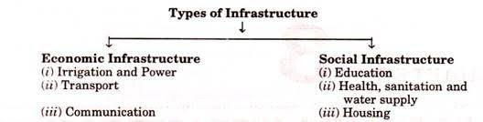
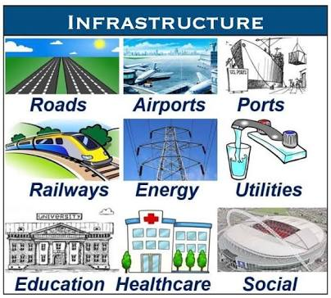

INFRASTRUCTURE DEVELOPMENT
Infrastructure development ca be defined as the construction and improvement of foundational services with the goal of sparking economic growth and improvements in quality of life. It needs to be emphasized that good quality infrastructure is important not only for faster economic growth but also to ensure inclusive growth. By inclusive growth we mean that benefits of growth are shared by the majority of the people of a country, thus the inclusive growth will lead to the alleviation of poverty and reduction in income inequality in the country.
For farmers in Nigeria improved infrastructure especially on transport will reduce their input cost and increase agricultural production and reducing traders’ monopoly by improving their access to markets. A huge percentage of Nigeria farmers were cut off from national and world markets, because of poor infrastructure and market access. Therefore the expansion and development of infrastructure facilities in Nigeria will ensure sustained growth of employment in agricultural and small scale rural industries and bring prosperity in the rural areas and in this way ensure inclusive growth. Beside, this will also prevent the mass exodus of the rural people to the urban areas where they cause problems if urban congestion, growth of slums and acute housing shortage.

Importance of sector specific infrastructure for economic growth of Nigeria:
- Power or energy: Energy is a crucial input into all economic activities and therefore rapid growth is possible only if adequate power is made available everywhere. It is essential not only for growth of the industry, agriculture and commercial business but also for household lighting. There is no doubt that there are sufficient domestic resources to meet the power needs of Nigeria. These resources include oil and gas, coal, substantial hydropower capacity and other forms of renewable resources. The exploitation and utilization of these resources have been hampered like other aspects of the nation development. The main cause of Nigeria inadequate power supply is lack of investment in the sector.
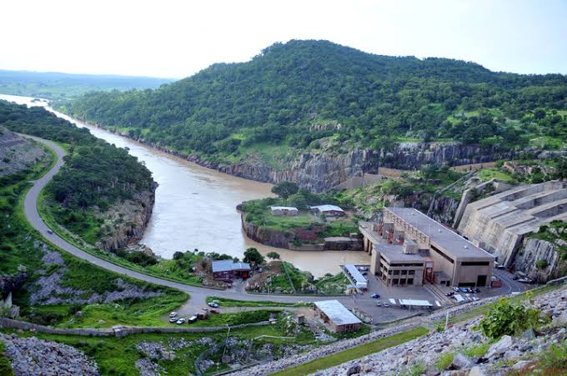
Turbine and generator house for the jebba hydro-electric power station
- Transport: transportation plays a huge role in developing economy. Transport development helps to open up more regions and resources for production. Some parts of the country may have abundant forest and reserves of mineral resources but they remain unexploited because they are remote and in accessible through means of transport. Types of transport include;
- Road
- AIR
- Rail
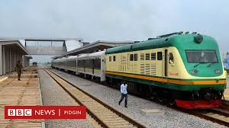
Murtala international airport Abuja-kaduna railway station.

Lagos-Ibadan expressway

- Telecommunication; telecommunication occupy an important place in modern economy. E-commerce and e-governance require the efficiency of telecommunications services. The companies like Julia, konga, payporte etc. engage in e-commerce for the sale of goods, they work through mobile phones and internet network.
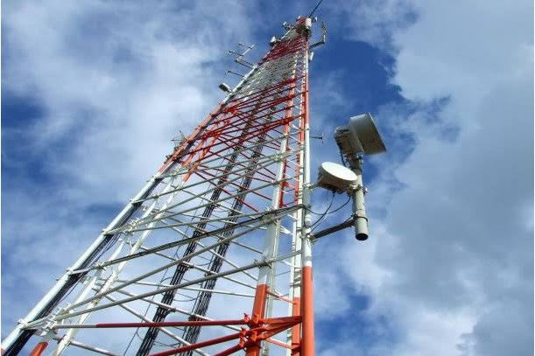
Telecommunication tower in Nigeria
- ICT;

MANAGERIAL ECONOMICS IN INFRASTRUCTURAL DEVELOPMENT
What is managerial economics?
Managerial Economics is a discipline that combines economic theory with managerial practice. It tries to bridge the gap between the problems of logic that intrigue economic theorists and the problems of policy that plague practical managers. “Managerial Economics is concerned with the application of economic concepts and economic analysis to the problems of formulating rational managerial decisions.” Management can be defined as the organ or body of an organization specifically charged with planning, organizing, directing and controlling the use of the organization’s resources effectively and economically to attain the organization’s objectives. Managerial economics for engineers is concern with the systematic evaluation of the costs and benefits of proposed technical and business projects. It involves technical-economic analysis with a decision assisting objectives; mathematical modeling with emphasis on the
Role of Managerial economics include:
- He studies the economic patterns at macro-level and analysis it’s significance to the specific firm he is working in.
- He has to consistently examine the probabilities of transforming an ever-changing economic environment into profitable business avenues
- He assists the business planning process of a firm.
- He also carries cost-benefit analysis.
- He assists the management in the decisions pertaining to internal functioning of a firm
- A managerial economist helps the management by using his analytical skills and highly developed techniques in solving complex issues of successful decision-making and future advanced planning.
- Accurately values all operations (support and production) of an entity (i.e. the supply and consumption of resources) in monetary terms.
- Provides information that aids in immediate and future economic decision making for optimization, growth, and/or attainment of enterprise strategic objectives.
- Project Management
- Planning, directing, and controlling resources (people, equipment, material) to meet the technical, cost, and time constraints of the project.
- The application of knowledge, skills, tools, and techniques to project objectives to meet stakeholder needs and expectations
- Project as “an organization of human, materials and financial resources in a novel way, to undertake a unique scope of work, of given specification within constraints of cost and time, defined by quantitative and qualitative objectives so as to achieve a beneficial change”.
- Achieving Quality on Projects requires:
- Quality of the management process (most important)
- Quality of the product (ultimate goal)

CHALLENGES OF INFRASTRUTURAL DEVELOPMENTS
The challenges of infrastructural development in Nigeria are:
- Dearth of Visionary Leaders: Visionary leaders are the builders of a new dawn, working with imagination, insight, and boldness. They present a challenge that calls forth the best in people and brings them together around a shared sense of purpose. Visionary leaders are change agents. Nigeria contains few change agents and therefore lacks the needed infrastructure to develop the nation.
- Demand and supply: Due to poor performances of most past leaders in the area of infrastructure provision, the agitation for infrastructure development overwhelms the provision. With a land mass of 9,110,000 square kilometers of land and over 150,000 million people, Nigeria has a total road network of 193,200KM. This comprise of 34,123KM federal roads, 30,500KM state roads and 129,577 KM local government roads. Unfortunately, over 70% of the federal roads are in bad state of repair. In the area of housing, Nigeria requires about 17 million housing units and 60 trillion naira in order to meet its housing needs.
- PESTLES Analysis: The challenges of infrastructural development in Nigeria can be discussed under PESTLES Analysis. Challenges infrastructural development can be: political, economic, social, technology, legal, environmental and safety. Political environment has to do with the political stability, policy formulation and politics of the project environment both within and without. Economic environment deals with issues like interest rate, inflation, currency exchange rate, price fluctuation etc. Social environment has to do with workforce diversity including cultural difference, age difference etc. Technology environment deals with the machineries which are used for the execution of projects. Physical environmental issues like site topography, geology and climatology is also essential. Safety issues have to do with health and safety and security of resources on site, that is, human, material and financial.
- - PARETO Analysis: Pareto analysis is a statistical method in decision making that is used for the identification of a specific number of tasks that produce major impact. It uses the Pareto Principle (which is also called the 80/20 rule). It originated the idea that by doing specific 20% of the work, you can generate 80% of the benefits of doing the whole job. In terms of quality improvement, a large majority of defects (80%) are produced by a few key causes (20%). This is also known as the vital few and the trivial many. In project management, 80% of project delays are caused by 20% of tasks etc. It can also mean that 80% of the tasks are done by 20% of the workforce. The people in charge should strive to improve the number of workforce that are genuinely working.
- Development Matrix: The four requirements of any physical infrastructure projects are: design, finance, technology and management. The appropriate designs that will ensure value for money are not adopted. The finance is not adequate, is procured at high interest rates and financial management is lacked by most Nigerian contractors. The technology of construction is scarce and the management of infrastructure is lacking. The maintenance culture of Nigerians is poor thereby allowing most projects to decay.
- Capital Flight, Capital Sink and Capital Stagnancy: Infrastructure development projects in Nigeria suffer from capital flight, capital sink and capital stagnancy. A lot of materials and managerial services are procured outside the country. The contracts are full of loop-holes that allow leakages of funds. In some cases, there are over-design for the designers to earn more professional fees which are percentage of the contract sum. Capital stagnancy due to abandoned projects are also rampant.
- Corruption: Corruption does not only raise the price of infrastructure, it can also reduce the quality of, and economic returns from, infrastructure investment. The corruption in Nigeria is very high and unbearable for effective infrastructural development. The Bureau of Public Procurement (BPP), the Independent Corrupt Practices Commission (ICPC) and Economic and Financial Crimes Commission (EFCC) have not been able to eradicate corruption in the country.

WAY FORWARD FOR INFRASTRUCTURAL DEVELOPMENT in Nigeria:
The significant infrastructure opportunities in the Nigerian market necessitates a close collaboration between the public and private sectors. This also means regulatory, monetary and fiscal policies have to be aligned with clearly defined overall developmental objectives. These policies should, more importantly, be able to attract investors (local and foreign) into the infrastructure sectors in Nigeria.
While the government continues to work on improving the regulatory environment, articulating infrastructure master plans, building capacity at implementing agencies, and partnering with the private sector investors, it is equally important that private sector sponsors are adequately prepared and well positioned to effectively harness the opportunities that will be unlocked.
From the private investors perspective, some of the important factors that will accelerate sustainable infrastructure development in Nigeria and ensure the realization of the country’s potential include better project planning, stronger technical partnerships, mobilizing the “right” equity for infrastructure projects, and innovative financing arrangements.
1. Better project planning:
Robust and diligent project planning is usually perceived by project sponsors to be an expensive undertaking. However, the shortcuts sometimes taken by sponsors consistently result in very expensive project failures, as well as improperly structured or poorly executed capital projects. These have significant unfavorable implications for the sponsors, investors, and financiers of such projects, and the infrastructure sector track record in Nigeria as a whole.
In developing projects and ensuring that the right results are achieved, it is necessary that the project sponsor be more deliberate about the business case development and project appraisal process. The sponsor should also ensure the necessary feasibility, traffic, environmental, legal/regulatory and other relevant studies are carried out to support the business case for investment. While ensuring that the objectives of infrastructure projects are clearly articulated and communicated among the key stakeholders, attention should be given to risk identification, allocation, and management. It is extremely important that relevant risks are allocated to the stakeholder that is best positioned to handle them, especially when dealing with Public Private Partnerships (PPPs). The importance of technical expertise cannot be overemphasized at this stage. Adequate project preparation
goes a long way to build credibility and demonstrate bankability for a project, and enables the project attract the right “partners” and investors, many who continue to show interest in the Nigerian market but are unable to find properly developed / structured, i.e. bankable, projects to invest in.
2. Stronger technical partnerships and commitment to knowledge transfer:
Infrastructure projects typically require a broad mix of diverse skills and competencies for successful delivery. The level of competence required for successful and timely execution of these projects is usually built over several years of successful project design, development, and delivery. Unfortunately, Nigeria is challenged on this front as there is a dearth of skilled manpower and only a limited number of infrastructure projects have been successfully delivered in the country over the last five decades.
Nigeria must therefore forge stronger relationships between local sponsors and foreign technical partners that have significant experience successfully delivering infrastructure projects in other countries. This is necessary for credible infrastructure development, and the subsequent management and maintenance of the infrastructure assets after delivery. Sponsors must ensure that the interests of their technical partners are aligned with theirs, and the arrangement must deliberately create opportunities for local capacity building by pairing local talent with international expertise right from the start of the project for necessary skills and knowledge transfer.
3. Mobilizing the “right” equity for infrastructure projects:
Many project sponsors sometimes underestimate the quantum of equity required for infrastructure projects and look for ways to seek short-term returns or save on project developments costs. This usually ends up being detrimental to project viability, quality of delivered assets and project completion timeline. It is important for sponsors to understand the long-term nature of infrastructure projects and also seek to work with other co-investors with similar interests as it relates to risk, investment horizon and expected returns.

4. Innovative funding arrangements:
The Nigerian economy is dominated by short-term financing of three to five years terms, traditionally provided by domestic commercial banks. However, a limited number of deals in the market have been funded with seven to ten year loan tenors usually with participation from international banks and development finance institutions, and in some cases with risk guarantees from multilateral organizations like the World Bank.
One of the major issues faced by foreign investors and financiers include the exchange rate risk for dollar-denominated transactions, where revenues of the project / investee companies are in Naira, as well as the limited hedging options / instruments to mitigate this risk. With limited options for hedging against currency risks, investors tend to (1) focus on improving their expected return profile to make up for the potential loss should the Naira devalue, and (2) become more cautious: only investing when there is some comfort around the stability of the Naira, or where there is an opportunity to transfer the currency risk to the users / customers.
Project sponsors should actively explore development grants, project development funds (either loans or convertible instruments) and equity participation by technical partners. There is also a need to explore alternative business models where opportunities exist to collaborate with other stakeholders in the value chain, such as equipment or feedstock suppliers, and other vendors in order to reduce the initial cash outlay for projects. These should be explored in addition to other financing sources such as Sovereign Wealth Funds (SWFs), Development Finance Institutions (DFIs) and International Development Agencies

CONCLUSIONS
Economists, engineering managers, project managers, and indeed any person involved in decision making must be able to analyze the financial outcome of his or her decision. Infrastructural development is vital for the economic growth of a nation. This term paper has identified various challenges facing infrastructural development in Nigeria which includes but are not limited to: corruption, death of visionary leaders, and low participation of private sectors in the provision of infrastructure in the nation.

RECOMMENDATIONS
It is recommended that the Nigerian government should make efforts towards the funding of infrastructural projects and improve the participation of the private sector in realizing the goal of infrastructural development.

REFERENCES
- Oyebode oluwadare 2015, “Engineering Law and managerial economics of development projects in Nigeria”, viewed 10th April 2020, <https:www.researchgate.net/publication/280611130 >.
- Infrastructure.https://en.m.wikipedia.org

