NAME:IKPEN JOSHUA

MATRIC:17/MHS07/013
COURSE CODE:PHA312
COURSE TITLE:CHEMOTHERAPY OF PLASTIC DISEASE,ANTISEPTIC AND DISINFECTANT

LIFECYCLE OF MALARIA
The natural history of malaria involves cyclical infection of humans and female Anopheles mosquitoes. In humans, the parasites grow and multiply first in the liver cells and then in the red cells of the blood. In the blood, successive broods of parasites grow inside the red cells and destroy them, releasing daughter parasites (“merozoites”) that continue the cycle by invading other red cells.
The blood stage parasites are those that cause the symptoms of malaria. When certain forms of blood stage parasites (gametocytes, which occur in male and female forms) are ingested during blood feeding by a female Anopheles mosquito, they mate in the gut of the mosquito and begin a cycle of growth and multiplication in the mosquito. After 10-18 days, a form of the parasite called a sporozoite migrates to the mosquito’s salivary glands. When the Anopheles mosquito takes a blood meal
on another human, anticoagulant saliva is injected together with the sporozoites, which migrate to the liver, thereby beginning a new cycle.
Thus the infected mosquito carries the disease from one human to another (acting as a “vector”), while infected humans transmit the parasite to the mosquito, In contrast to the human host, the mosquito vector does not suffer from the presence of the parasites.
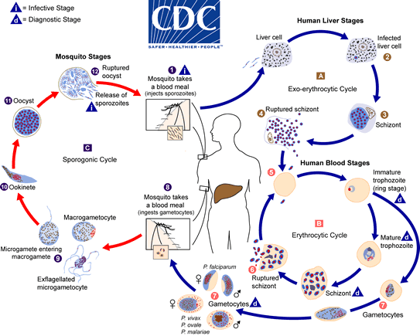

The malaria parasite life cycle involves two hosts. During a blood meal, a malaria-infected female Anopheles mosquito inoculates sporozoites into the human host . Sporozoites infect liver cells and mature into schizonts , which rupture and release merozoites . (Of note, in P. vivax and P. ovale a dormant stage [hypnozoites] can persist in the liver (if untreated) and cause relapses by invading the bloodstream weeks, or even years later.) After this initial replication in the liver (exo-erythrocytic schizogony ), the parasites undergo asexual multiplication in the erythrocytes (erythrocytic schizogony ). Merozoites infect red blood cells . The ring stage trophozoites mature into schizonts, which rupture releasing merozoites . Some parasites differentiate into sexual erythrocytic stages (gametocytes) . Blood stage parasites are responsible for the clinical manifestations of the disease. The gametocytes, male (microgametocytes) and female (macrogametocytes), are ingested by an Anopheles mosquito during a blood meal . The parasites’ multiplication in the mosquito is known as the sporogonic cycle . While in the mosquito’s stomach, the microgametes penetrate the macrogametes generating zygotes . The zygotes in turn become motile and elongated (ookinetes) which invade the midgut wall of the mosquito where they develop into oocysts . The oocysts grow, rupture, and release sporozoites, which make their way to the mosquito’s salivary glands. Inoculation of the sporozoites into a new human host perpetuates the malaria life cycle.
CLASSIFICATION OF ANTIMOEBIC DRUGS
1 luminal
2 tissue

Amoebicide class and examples
Amoebicide
1 Luminal
CLASS
Arsenical compounds
EXAMPLES
Carbarsone, acetarsone or acetarsol, treparsol, diphetarsone, glycobiarsol or bismuth glycolylarsanilate, stovarsol, and thioarsenite, thiocarbarsone or thiocarabazone, arsthinol

Hydroxyquinoline derivatives

Chiniofon or quinoxyl, clioquinol or iodochlorhydroxyquin, and iodoquinol or diiodohydroxyquin

Dichloroacetamide derivatives

Diloxanide furoate or entamide furoate, clefamide, eticlordifene or ethylchlordiphene or etofamide or etophamide, and quinfamide

Benzylamine derivatives

Teclozan, chlorbetamide or mantomide, and chlorphenoxamide or mebinol

Antibiotic amoebicides

Tetracycline, oxytetracycline, chlortetracycline, erythromycin, paromomycin, and fumagillin

Nithrothiazole salicylamide

Nitazoxanide

2 TISSUE
CLASS
Emetine and its derivatives
EXAMPLES
Emetine hydrochloride, emetine bismuth iodide, dehydroemetine dihydrochloride, and dehydroemetine resinate

Aminoquinoline

Chloroquine

Thiazole derivative

Niridazole

Nitroimidazoles

Metronidazole, tinidazole, ornidazole, secnidazole, and nimorazole
MECHANISMS OF ACTION OF METRONIDAZOLE
Metronidazole, marketed under the brand name Flagyl among others, is an antibiotic and antiprotozoal medication.[4] It is used either alone or with other antibiotics to treat pelvic inflammatory disease, endocarditis, and bacterial vaginosis.[4] It is effective for dracunculiasis, giardiasis, trichomoniasis, and amebiasis.[4] It is an option for a first episode of mild-to-moderate Clostridium difficile colitis if vancomycin or fidaxomicin is unavailable.[4][5] Metronidazole is available by mouth, as a cream, and by injection into a vein.[4]
Common side effects include nausea, a metallic taste, loss of appetite, and headaches.[4] Occasionally seizures or allergies to the medication may occur.[4] Some state that metronidazole should not be used in early pregnancy, while others state doses for trichomoniasis are safe.[6] Sources disagree over safety in breastfeeding.[6][7]
Metronidazole began to be commercially used in 1960 in France.[8] It is on the World Health Organization's List of Essential Medicines, the safest and most effective medicines needed in a health system.[9] It is available in most areas of the world.[10] The pills are relatively inexpensive, costing between US$0.01 and US$0.10 each.[11][12] In the United States, it is about US$26 for ten days of treatment.[4] In 2016, it was the 71st most prescribed medication in the United States, with more than eleven million prescriptions.[13]

MECHANISM OF ACTION

Metronidazole is of the nitroimidazole class. It inhibits nucleic acid synthesis by disrupting the DNA of microbial cells.[1] This function only occurs when metronidazole is partially reduced, and because this reduction usually happens only in anaerobic bacteria and protozoans, it has relatively little effect upon human cells or aerobic bacteria.[41]

