PRESENTED BY
NWANKWO CHUKWUERIKE
17/MHS01/205

CRITICAL ASSESMENTS OF LEGAL IMPLICATIONS AND ECONOMIC IMPACT OF LOCKDOWN OF ACTIVITIES IN NIGERIA

ENG384: ENGINEERING LAW
SAT 22, FEBURAY 2020

ACKNOWLEDGEMENT
I dedicate this report to my parents for always being with me even through my illnesses and God for helping me get into this great university, my teacher for giving me such a challenging but beneficial task, and myself for completing such a difficult task and securing my future.

INTRODUCTION
- During a mass catastrophe as the pandemic disease as the novel coronavirus quite possibly the greatest problem might arise from the economic damage caused by such a massive event due to a forced economic freeze by the government to prevent a higher rate of infection and death of the populous and thus to be able to “flatten the curve” that means to keep the number of treatable patients below the capacity of our health care system.

AIM:
- The aim of the report is simply to highlight the likely economic consequences self-quarantine, the shutdown of non-essential businesses, as well as the legal and illegal consequences during and after the lockdown

Abstract
Coronavirus disease (COVID-19) is an infectious disease caused by a new virus.
The disease causes respiratory illness (like the flu) with symptoms such as a cough, fever, and in more severe cases, difficulty breathing. You can protect yourself by washing your hands frequently, avoiding touching your face, and avoiding close contact (1 meter or 3 feet) with people who are unwell.
Coronavirus disease spreads primarily through contact with an infected person when they cough or sneeze. It also spreads when a person touches a surface or object that has the virus on it, then touches their eyes, nose, or mouth.

What we know as of April first:
•On the 1 st of April 2020, 35 new confirmed cases of COVID-19 were recorded in Nigeria
• All new cases were reported from Lagos 9, Osun 9, FCT 7, Akwa Ibom 5, Edo 2 Kaduna 1, Bauchi 1 and Ekiti 1
• Currently, there are total of 174 confirmed cases of COVID-19 in Nigeria
• The 174 confirmed cases are in 13 States: Lagos 91, FCT 35, Oyo 8, Edo 4, Akwa Ibom 5, Kaduna 4, Ogun 4, Bauchi 3, Enugu 2, Osun 14, Benue 1, Ekiti 2 and Rivers 1
• Of the 174 confirmed cases, 9 (5%) have been discharged, 163 (94%) currently receiving care and 2 (1%) deaths from COVID-19 in Nigeria
• Of the nine discharged cases, two (2) are Ogun State cases managed in Lagos State (index and second case), six (6) are Lagos State cases and one (1) Ekiti State case.
• The two (2) death cases were managed in UATH Gwagwalada Abuja
• Of the 174 confirmed cases 93 (52%) have travel history to high risk countries, 18 (10%) are contacts of known confirmed cases and 63 (36%) of cases have incomplete epidemiological information
• Of the 174 confirmed cases 66% are Males, 34% are females, age group most affected is 51- 60 (27%)
• The country is in lockdown
• The National EOC is working with affected State EOCs to identify contacts of the new confirmed cases
• A cumulative total of 6,701 passengers of interest (POI) identified, and being monitored
• A multi-sectoral national emergency operations centre (EOC), activated at level 3, continues to coordinate national response activities.

LEGAL IMPLICATIONS OF THE QUARANTINE, THE CORONAVIRUS PANDEMIC AND THE AFTERMATH

During the spread of the coronavirus pandemic there will essentially be a restriction on the ability of the government to enforce laws and order effectively as security personnel such as police officers may have difficulty apprehending suspects or bringing them to trial for fear of acquiring the illness as well and spreading it to their own loved ones, as well as preventing that spread to prisoners because of the fast contraction rate in such a dense population and little resources to treat them too.
As the economy slows down and it becomes much more difficult to obtain food and medicine or maintain security, desperation will begin to rise which will lead to an increase be it to get food for families or to protect oneself, difficult decisions would have to be made and a likely prediction is that there would be rampant pillaging and looting of pharmacies and stores so as to obtain food and medicine as households run out leaving many people very desperate and with lack of sufficient police force or legal process they will increase significantly.
Another prediction can be made that in the months to come there will be significant back log of cases in all form of court, criminal or civil as most cases would have to be pushed back during the quarantine period.
The legal implications are not limited to civilians in counties but between countries as well, already there are reports of Venezuelan ships ramming a US cruise liner demanding that it be docked in their waters, the likely cause may be due to inflation of their major export, oil. Added with the current economic inflation sparse food, medicine and other essential items it could have led to the desperation for the food in that cruise liner and also possibly a ransom for the multimillion-dollar ship, all these factors could possibly be pointing to a 3rd world war.
In Nigeria’s case to prevent total societal breakdown law makers have been forced to pass laws and bills to prevent citizens from roaming outside and are enlisting the help of the military to enforce lockdown while in lighter areas only curfews are put in place.

ECONOMIC IMPACT OF LOCKDOWN OF ACTIVITIES IN NIGERIA

Due to the forced shutdown of the economy due to the coronavirus in an attempt to shut down the spread the economy has been brought to a screeching halt as stocks plummet and people turn to panic buying as well as stocking up on food Nigeria as a whole is going through an economic freeze.

By the Policy, Research and Statistics Department, UNIDO
The coronavirus (COVID-19) outbreak has already led to a major health crisis in several countries and to major disruptions of the global economy. Yet the situation is likely to become even worse in the coming weeks and months, and the economic fallout from the pandemic might represent one of the biggest shocks of recent decades.
Global value chains (GVCs) have already come under pressure as a viable model for the organization of international production since the outbreak of the COVID-19 epidemic in China, and even more so since the virus turned into a global pandemic. Some analysts expect a major reshuffling of the global production network as a result of the pandemic, which was already triggered by the US-China trade war (CNBC, 2020).
UNIDO’s data on world manufacturing production
UNIDO’s data showed a consistent decline in production growth, indicating an overall economic slowdown already before the outbreak of the COVID-19 crisis. Manufacturing output growth fell below the landmark of 1 per cent and remained at 0.7 per cent in the fourth quarter of 2019 (UNIDO, 2019).
In the fourth quarter of 2019, only three industries registered a positive year-over-year growth rate in all country groups, namely basic pharmaceutical products, beverages and food products. While these three industries represent essential basic consumer goods and are likely to continue to perform well over the coming months, other manufacturing industries are expected to suffer a severe blow due to the coronavirus outbreak and the resulting economic implications. Consequently, world GDP growth can be expected to decline in the coming months.
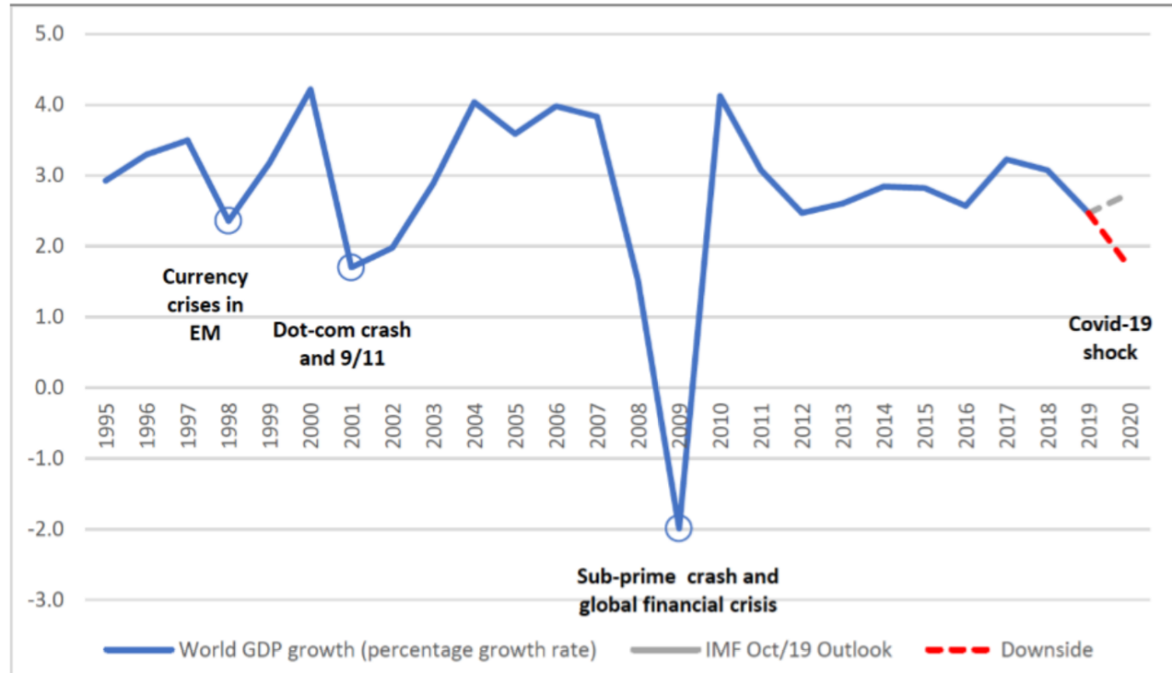
Global GDP growth, 1995–2020. Source: UNCTAD calculations based on IMF, WEO, October 2019
Three main channels of the global economy will be disrupted: demand, supply, and finance
On the demand side, a combination of reduced income and fear of contagion will result in lower private spending. Although some of these effects might be offset by increased government spending, the COVID-19 shock’s net demand effect is expected to be negative in the short run.
This could be amplified by negative supply side effects, attributable to a sudden halt in manufacturing activities in the most affected regions and the resulting bottlenecks in global value chains. If left unaddressed, such disruptions will in turn trigger widespread factory closures due to the lack of intermediary inputs, even in areas less affected by the virus.
Lastly, increased risk aversion and a flight-to-liquidity in the face of uncertainty caused by the COVID-19 shock, the financial markets stress will weigh heavily on the global economy. Further fluctuations are expected in the foreign exchange market.
Substantial increase in unemployment
A substantial increase in global unemployment seems almost certain. The ILO expects the pandemic to disproportionally affect not only those workers with underlying health conditions, but also young people who are more vulnerable to decreased labour demand, women, who are over-represented in those sectors that are likely to be affected most (such as services or in occupations on the front lines of the pandemic, e.g. nurses), as well as unprotected workers in the so-called ‘gig economy’ and migrants. (ILO, 2020).
Capital flight
The pandemic has already triggered capital flight and a sharp reversal of international investment in emerging markets. Whereas a group of 24 emerging markets including China, India, South Africa and Brazil, had a net inflow of investments of US$79bn in 2019, US$70bn in investments had already exited those countries in the last two months alone according to the Institute of International Finance (New York Times, 2020). With this in mind, the decision by the G20 governments to “do whatever it takes” to minimize the social and economic fallout due to the coronavirus - and most importantly, to ensure cross-border flows of vital medical supplies, agricultural products and other goods and services – was welcomed (The Guardian, 2020).
Possibility of insolvency and default
This capital flight has reignited fears that countries such as Argentina, Turkey or South Africa, could be sliding toward insolvency and default soon. This could be further accelerated by currency depreciations in these countries. The Argentine peso continued to devalue and decreased by another 6 per cent against the dollar this year alone. Similarly, the Turkish lira has dropped by 10 per cent since January due to investors pulling out money and Turkish companies facing bankruptcy.
While these are only two examples, the situation is becoming equally dire in many other low- and middle-income countries and requires urgent attention from policymakers and the international community.
Significant contraction of FDI
The effect of the pandemic is similarly dramatic when we look at foreign direct investment (FDI). On 26 March, UNCTAD estimated a collapse of global FDI by - 30 per cent to - 40 per cent during 2020–2021, much more than the previous projections of -5 per cent to -15 per cent two weeks earlier.
While those countries most severely affected by COVID-19 will be hardest hit, other countries are also likely to feel the virus’s full impact as supply chain disruptions on investment prospects. Over two-thirds of the 100 multinational companies tracked by UNCTAD have issued statements on the effects the virus has had on their business. Many are reducing capital expenditure in affected areas, and to date, 41 have issued profit alerts. Lower profits translate into lower reinvested earnings, a major component of FDI.
A wider sample of the top 5,000 listed companies shows that the earnings forecasts for the fiscal year 2020 have been revised down by an average of 30 per cent. The hardest hit sectors are the energy and basic materials industries (-208 per cent for energy, with an additional shock caused by the recent drop in oil prices), airlines (-116 per cent) and the automotive industry (-47 per cent).
Trouble in global value chains and supply chain contagion
As outlined by Richard Baldwin and Eiichi Tomiura in their essay published on 6 March 2020, the hardest hit countries account for the majority of global GDP, manufacturing production and exports. Furthermore, the mitigation policies introduced will result in a global slowdown in aggregate demand. Global supply chains have fundamentally changed how supply shocks propagate. As industrial parts and components are increasingly traded, a supply shock in a globally integrated economy is likely to create ‘supply chain contagion’ via the trade in intermediate goods.
Baldwin and Tomiura develop different supply chain scenarios based on the WTO’s Global Value Chain Development Report 2019 and by citing case studies from The Economist. They also use data from the OECD Trade in Value Added database to quantify the importance of inter-linkages for different countries. The authors find a mixed picture for trade in services, as some industries such as tourism and air travel will be hit hard, while others, such as ICT and medical services, will not be as affected.
Impact on production and trade
According to reports by academics and practitioners on the impacts of the coronavirus, the virus implies both a demand and a supply shock.
The supply shock
From the supply side perspective, production is affected, on the one hand, because of reductions in labour supply as a consequence of the number of workers infected, thus reducing the number of people available to work, and because value chains are disrupted, on the other. Countries that rely on equipment and components from regions affected by the virus may experience disruptions in the production process.
The demand shock
Demand for manufactured goods could reduce as a consequence of the pandemic. This usually occurs for two reasons:
First, the propensity to consume decreases as workers who are required to stay at home in support of “social distancing” measures tend to prioritize saving over spending.
Second, firms that are experiencing disruptions in the production process may decrease their consumption of intermediate goods.
Supply and demand shocks can manifest in different ways across countries and different industries. The differences between various regions could be as follows:
- Economies like China, Europe and the United States are mostly affected by direct impacts on their population’s health condition;
- The majority of developing countries are mostly affected, for the moment, by indirect impacts relating to their level of inter-linkages with countries affected by the coronavirus, i.e. their demand for goods or the supply of goods and services. However, as COVID-19 further spreads to developing countries, the direct impacts on those countries are likely to increase.
- It is plausible to assume that resource-rich developing countries will be also affected by a reduction in commodity prices (e.g. copper, oil) driven by reduced international demand for such goods, and that developed countries will experience a drop in the production of transformed manufactured goods.
Impact on manufacturing industries
The coronavirus is now rapidly spreading around the world. Anecdotal evidence is reporting losses for the manufacturing sector beyond China, namely also for many rich developed countries. According to IBIS World, relevant impacts are being registered in many countries such as Australia, Canada, Germany, New Zealand and the United States. Recurrent losses in these countries are reported in the domestic market, particularly in the food industry due to the closure of pubs, restaurants and other caterers.
Heavy losses are being registered on the international markets in the automotive industry (a huge decrease in sales of 82 per cent in Germany), and in high-tech industries such as computers and electronics, the traditional champions of revealed comparative advantage in rich countries.

METHODOLOGY
I began researching this paper trying to understand the current situation surrounding the coronavirus as wellbeing mostly guided by what the experts or actual authority on the medical and economic field know and what they say is likely to happen, the rest was from my own understanding of the situation by reading news articles or watching tv news.
I analysed this information as objectively as I could.

CONCLUSION
During this current pandemic as everything becomes more hectic and chaotic the legal system as well as the economy will produce greater damage to property and lives after the coronavirus itself and is a grave aftereffect of the virus and the lockdown that we as a country are about to face, but with the right precaution and steps taken we will be able to mitigate the effects to a much lesser degree.

RECOMMENDATION
Everyone should stay indoors and bulk order food and other resources for their family, wash their hand with soap and water for 20 seconds, wipe everything received down with alcohol and continue to wait out for a vaccine with the rest of the world, the economy will recover in a span of a few months to 2 years

