ENGINEERING STRATEGIES FOR HANDLING COVID-19
FOR
ENVIRONMENTAL HEALTH AND ECONOMIC SUSTAINABILITY
BY
ONITIRI OLUWASEUN

MATRIC NO: 17/ENG06/066
SUBMITTED TO
THE DEPARTMENT OF MECHANICAL AND MECHTRONICS, COLLEGE OF ENGINEERING, AFE BABALOLA UNIVERSITY, ADO-EKITI

IN PARTIAL FULFILMENT OF THE REQUIREMENT FOR THE AWARD OF THE DEGREE OF BACHELOR OF ENGINEERING (B.ENG) IN MECHANICAL ENGINEERING
APRIL, 2020

CERTIFICATION

This is to certify that this work titled ENGINEERING STRATEGIES FOR HANDLING COVID-19 FOR ENVIRONMENTAL HEALTH AND ECONOMIC SUSTAINABILITY was submitted to the department of Mechanical Engineering, College of Engineering, Afe Babalola University, Ado-Ekiti.

DEDICATION

I dedicate this report to almighty GOD, the giver of knowledge, the sustainer, the provider for providing the strength and guiding me to complete this report and to my parents for their infinite support and prayers. I also dedicate this report to any and every mechanical engineer all over the world.

ABSTRACT

This work contains the details of coronavirus (covid-19), environmental health, economic sustainability and engineering strategies in handling the coronavirus pandemic.
It also contains some results that have been gained and to be gained, as well as conclusion and recommendations.

AKNOWLEDGEMENT

I would like to express some gratitude towards the lecturers of ENG 384, ENGINEERING LAW AND MANAGERIAL ECONOMICS, for putting forth this task.

TABLE OF CONTENTS
CERTIFICATION ii
DEDICATION iii
ABSTRACT iv
AKNOWLEDGEMENT v
LIST OF FIGURES viii
CHAPTER ONE 1
INTRODUCTION 1
COVID – 19 (CORONA VIRUS) 1
1.1 INTRODUCTION 1
1.2 SIGNS AND SYMPTOMS 2
1.3 CAUSES / TRANSMISSION 2
1.4 PREVENTION 3
CHAPTER TWO 4
LITERATURE REVIEW 4
ENVIRONMENTAL HEALTH AND ECONOMIC SUSTAINABILITY 4
2.1 ENVIRONMENTAL HEALTH 4
2.1.1 INTRODUCTION 4
2.1.2 DEFINITION 4
2.1.3 DISCIPLINES 5
2.1.4 CONCERNS 7
2.2 ECONOMIC SUSTAINABILITY 9
2.2.1 DEFINITION 9
2.2.2 INTRODUCTION 10
2.2.3 ADVANTAGES 10
2.2.4 RISKS 11
2.2.5 GOALS 11
CHAPTER THREE 12
MEHTODOLOGY 12
ENGINEERING STRATEGIES 12
CHAPTER FOUR 16
RESULTS 16
CHAPTER FIVE 18
CONCLUSION AND RECOMMENDATION 18
5.1 CONCLUSION 18
5.2 RECOMMENDATION 18
REFERENCE 19

LIST OF FIGURES
Figure 1: Corona virus 10
Figure 2: Environmental epidemiology 12
Figure 3: Toxicology 13
Figure 4: Exposure science 13
Figure 5: Environmental engineering 14
Figure 6: Engineering law 14
Figure 7: Environmental health 16
Figure 8: Money 17
Figure 9: Economic sustainability 18
Figure 10: Epidemiology 20
Figure 11: Experimental testing 20
Figure 12: Information technology 22
Figure 13: Innovative face mask 23
Figure 14: Mechanical ventilation 24

CHAPTER ONE

INTRODUCTION

COVID – 19 (CORONA VIRUS)

1.1 INTRODUCTION

Coronavirus disease 2019 (COVID-19) is an infectious disease caused by severe acute respiratory syndrome coronavirus 2. The disease was first identified in December 2019 in Wuhan, the capital of China's Hubei province, and has since spread globally due to lack of acknowledgement of the disease and it has resulted in the ongoing 2019–20 coronavirus pandemic. Common symptoms include fever, cough and shortness of breath. Other symptoms may include fatigue, muscle pain, diarrhea, sore throat, loss of smell and abdominal pain. While the majority of cases result in mild symptoms, some progress to viral pneumonia and multi-organ failure. As of 8 April 2020, more than 1.44 million cases have been reported in more than 200 countries and territories, resulting in more than 83,400 deaths. More than 308,000 people have recovered.
The virus is mainly spread during close contact and by small droplets produced when those infected cough, sneeze or talk. These droplets may also be produced during breathing; however, they rapidly fall to the ground or surfaces and are not generally spread through the air over large distances. People may also become infected by touching a contaminated surface and then their face. The virus can survive on surfaces for up to 72 hours. It is most contagious during the first three days after onset of symptoms, although spread may be possible before symptoms appear and in later stages of the disease. The time from exposure to onset of symptoms is typically around five days, but may range from two to 14 days. The standard method of diagnosis is by real-time reverse transcription polymerase chain reaction from a nasopharyngeal swab. The infection can also be diagnosed from a combination of symptoms, risk factors and a chest CT scan showing features of pneumonia.
Recommended measures to prevent infection include frequent hand washing, social distancing (maintaining physical distance from others, especially from those with symptoms), covering coughs and sneezes with a tissue or inner elbow and keeping unwashed hands away from the face. The use of masks is recommended for those who suspect they have the virus and their caregivers. Recommendations for mask use by the general public vary, with some authorities recommending against their use, some recommending their use and others requiring their use. Currently, there is no vaccine or specific antiviral treatment for COVID-19. Management involves treatment of symptoms, supportive care, isolation and experimental measures.

1.2 SIGNS AND SYMPTOMS

Those infected with the virus may be asymptomatic or develop flu-like symptoms, including fever, cough, fatigue and shortness of breath. Emergency symptoms include difficulty breathing, persistent chest pain or pressure, confusion, difficulty waking and bluish face or lips; immediate medical attention is advised if these symptoms are present. Less commonly, upper respiratory symptoms, such as sneezing, runny nose or sore throat may be seen. Symptoms such as nausea, vomiting and diarrhea have been observed in varying percentages.
As is common with infections, there is a delay between the moment when a person is infected with the virus and the time when they develop symptoms. This is called the incubation period. The incubation period for COVID-19 is typically five to six days but may range from two to 14 days. 97.5% of people who develop symptoms will do so within 11.5 days of infection.

1.3 CAUSES / TRANSMISSION
Human-to-human transmission has been confirmed during the 2019–20 coronavirus pandemic. Transmission occurs primarily via respiratory droplets from coughs and sneezes within a range of about 1.8 metres (6 ft).
Indirect contact via contaminated surfaces is another possible cause of infection. Preliminary research indicates that the virus may remain viable on plastic and steel for up to three days, but does not survive on cardboard for more than one day or on copper for more than four hours; the virus is inactivated by soap, which destabilises its lipid bilayer. Viral RNA has also been found in stool samples from infected people.

1.4 PREVENTION
Preventive measures to reduce the chances of infection include:
- Staying at home,
- Avoiding crowded places,
- Washing hands with soap and water often and for at least 20 seconds,
- Practicing good respiratory hygiene and
- Avoiding touching the eyes, nose or mouth with unwashed hands.
The CDC recommends covering the mouth and nose with a tissue when coughing or sneezing and recommends using the inside of the elbow if no tissue is available. They also recommend proper hand hygiene after any cough or sneeze. Social distancing strategies aim to reduce contact of infected persons with large groups by closing schools and workplaces, restricting travel and cancelling large public gatherings. Distancing guidelines also includes that people stay at least 6 feet (1.8 m) apart.

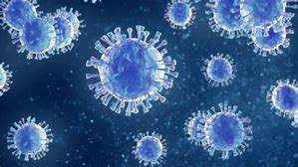
Figure 1: Corona virus

CHAPTER TWO

LITERATURE REVIEW

ENVIRONMENTAL HEALTH AND ECONOMIC SUSTAINABILITY

2.1 ENVIRONMENTAL HEALTH

2.1.1 INTRODUCTION

Environmental health is the branch of public health concerned with all aspects of the natural and built environment affecting human health. Environmental health is focused on the natural and built environments for the benefit of human health. The major sub disciplines of environmental health are: environmental science; environmental and occupational medicine, toxicology and epidemiology.
Other terms referring to or concerning environmental health are environmental public health, public health protection, and environmental health protection.

2.1.2 DEFINITION

Environmental health has been defined in a 1999 document by the World Health Organization (WHO) as: Those aspects of the human health and disease that are determined by factors in the environment. It also refers to the theory and practice of assessing and controlling factors in the environment that can potentially affect health.
Environmental health as used by the WHO Regional Office for Europe, includes both the direct pathological effects of chemicals, radiation and some biological agents, and the effects (often indirect) on health and wellbeing of the broad physical, psychological, social and cultural environment, which includes housing, urban development, land use and transport.
As of 2016 the WHO website on environmental health states "Environmental health addresses all the physical, chemical, and biological factors external to a person, and all the related factors impacting behaviours. It encompasses the assessment and control of those environmental factors that can potentially affect health. It is targeted towards preventing disease and creating health-supportive environments. This definition excludes behaviour not related to environment, as well as behaviour related to the social and cultural environment, as well as genetics. ."

2.1.3 DISCIPLINES

Five basic disciplines generally contribute to the field of environmental health: environmental epidemiology, toxicology, exposure science, environmental engineering, and environmental law. Each of these disciplines contributes different information to describe problems and solutions in environmental health, but there is some overlap among them.
- Environmental epidemiology studies the relationship between environmental exposures (including exposure to chemicals, radiation, microbiological agents, etc.) and human health. This discipline directly observes effects on human health rather than estimating effects from animal studies.
Figure 2: Environmental epidemiology

- Toxicology studies how environmental exposures lead to specific health outcomes, generally in animals, as a means to understand possible health outcomes in humans. Toxicology has the advantage of being able to conduct randomized controlled trials and other experimental studies because they can use animal subjects.

Figure 3: Toxicology

- Exposure science studies human exposure to environmental contaminants by both identifying and quantifying exposures. Exposure science can be used to support environmental epidemiology by better describing environmental exposures that may lead to a particular health outcome, identify common exposures whose health outcomes may be better understood through a toxicology study.

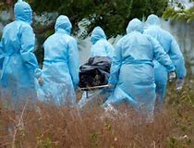
Figure 4: Exposure science

- Environmental engineering applies scientific and engineering principles for protection of human populations from the effects of adverse environmental factors; protection of environments from potentially deleterious effects of natural and human activities; and general improvement of environmental quality.
Figure 5: Environmental engineering

- Engineering law includes the network of treaties, statutes, regulations, common and customary laws addressing the effects of human activity on the natural environment.

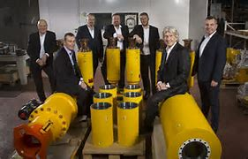
Figure 6: Engineering law

2.1.4 CONCERNS

Environmental health addresses all human-health-related aspects of the natural environment and the built environment. Environmental health concerns include:
- Air quality, including both ambient outdoor air and indoor air quality, which also comprises concerns about environmental tobacco smoke.
- Biosafety
- Disaster preparedness and response.
- Climate change and its effects on health.
- Environmental racism, wherein certain groups of people can be put at higher risk for environmental hazards, such as air, soil, and water pollution. This often happens due to marginalization, economic and political processes, and ultimately, racism. Environmental racism disproportionately affects different groups globally, however generally the most marginalized groups of any given region/nation.
- Food safety, including in agriculture, transportation, food processing, wholesale and retail distribution and sale.
- Hazardous materials management, including hazardous waste management, contaminated site remediation, the prevention of leaks from underground storage tanks and the prevention of hazardous materials releases to the environment and responses to emergency situations resulting from such releases.
- Housing, including substandard housing abatement and the inspection of jails and prisons.
- Childhood lead poisoning prevention.
- Land use planning, including smart growth.
- Liquid waste disposal, including city waste water treatment plants and on-site waste water disposal systems, such as septic tank systems and chemical toilets.
- Medical waste management and disposal.
- Noise pollution control.
- Occupational health and industrial hygiene.
- Radiological health, including exposure to ionizing radiation from X-rays or radioactive isotopes.
- Recreational water illness prevention, including from swimming pools, spas and ocean and freshwater bathing places.
- Safe drinking water.
- Solid waste management, including landfills, recycling facilities, composting and solid waste transfer stations.
- Toxic chemical exposure whether in consumer products, housing, workplaces, air, water or soil.
- Vector control, including the control of mosquitoes, rodents, flies, cockroaches and other animals that may transmit pathogens.
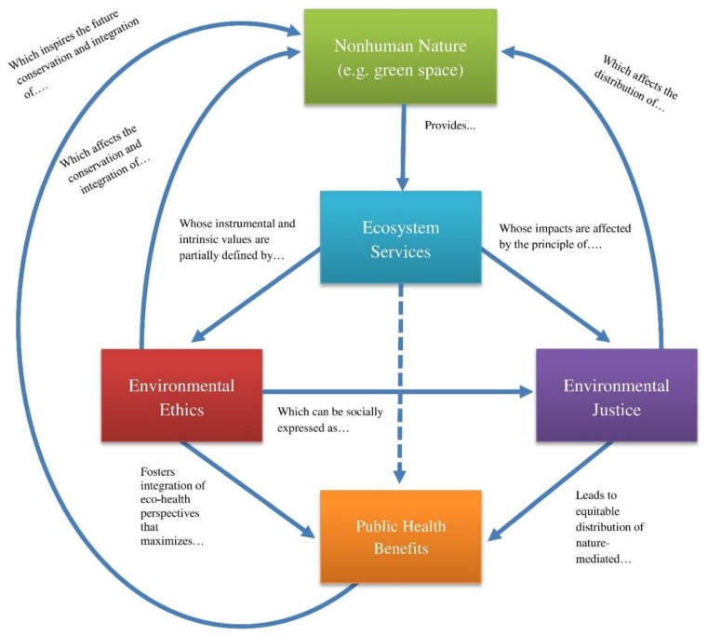
Figure 7: Environmental health

2.2 ECONOMIC SUSTAINABILITY

2.2.1 DEFINITION

The general definition of economic sustainability is the ability of an economy to support a defined level of economic production indefinitely.
Economic sustainability is the term used to identify various strategies that make it possible to use available resources to their best advantage. The idea is to promote the use of those resources in a way that is both efficient and responsible, and likely to provide long-term benefits. In the case of a business operation, it calls for using resources so that the business continues to function over a number of years, while consistently returning a profit.

2.2.2 INTRODUCTION

In most scenarios, the measure of economic sustainability is presented in monetary terms. The worth of assets and resources in dollar figures is common, as is identifying the amount of return generated by the efficient use of those resources. The idea is to aid in identifying areas of the operation in which resources are not being utilized in the most efficient manner, and take the steps to correct the situation. At the same time, the proposed changes to the operation are considered in terms of their overall effect on the production flow, making it possible to address any potential difficulties later in the process before the changes are actually implemented. Doing so means engaging in a strategy known as cross-sectoral coordination, which involves identifying what impact changes in one area of the operation will have on subsequent phases of the production process.
Figure 8: Money

2.2.3 ADVANTAGES

True sustainability encourages the responsible use of resources. This involves not only making sure that the business is making a profit, but that the operation is not creating environmental concerns that could cause harm to the balance of the local ecology. By being mindful of the impact of the operation on the local community, the business is able to choose raw materials that are more environmentally friendly and design a waste disposal strategy that does not cause damage. In the long run, attention to these types of details has the potential to increase the community’s investment in the continued operation of the business, and improve its chances for remaining a viable operation for a longer period of time.

2.2.4 RISKS

While the concept of economic sustainability is straightforward, there are potential obstacles that may be found in different companies. Resistance to change can often lead to a less than efficient use of available resources. A failure to track expenses and justify expenditures will also have adverse effects on the long-term stability of the company and limit the potential for sustainability. For this reason, companies sometimes work with outside consultants who can evaluate the business operation with relatively little bias and point out what needs to be done to improve the sustainability of the operation.

2.2.5 GOALS

The goal is to establish profitability over the long term. A profitable business is much more likely to remain stable and continue to operate from one year to the next. From this perspective, this strategy can be seen as a tool to make sure the business does have a future and continues to contribute to the financial welfare of the owners, the employees, and to the community where it is located.

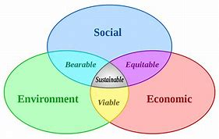
Figure 9: Economic sustainability

CHAPTER THREE

MEHTODOLOGY

ENGINEERING STRATEGIES

The basic strategies in the control of an outbreak are containment and mitigation. Containment may be undertaken in the early stages of the outbreak, including contact tracing and isolating infected individuals to stop the disease from spreading to the rest of the population, other public health interventions on infection control, and therapeutic countermeasures such as vaccinations which may be effective if available. When it becomes apparent that it is no longer possible to contain the spread of the disease, management will then move on to the mitigation stage, in which measures are taken to slow the spread of the disease and mitigate its effects on society and the healthcare system. In reality, containment and mitigation measures may be undertaken simultaneously.
Another strategy, suppression, requires more extreme long-term non-pharmaceutical interventions so as to reverse the pandemic by reducing the basic reproduction number to less than 1. The suppression strategy, which includes stringent population-wide social distancing, home isolation of cases, and household quarantine, was undertaken by China during the 2019–20 coronavirus pandemic where entire cities were placed under lockdown, but such strategy carries with it considerable social and economic costs.
Some of the engineering strategies employed in this current situation are:
- EPIDEMIOLOGY:
Several measures are commonly used to quantify mortality. These numbers vary by region and over time and are influenced by the volume of testing, healthcare system quality, treatment options, time since initial outbreak and population characteristics such as age, sex and overall health.
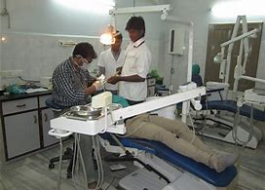
Figure 10: Epidemiology

- MANUFACTURING:
Due to capacity limitations in the standard supply chains, some digital manufacturers are printing healthcare material such as nasal swabs and ventilator parts.

- EXPERIMENTAL TESTING:
No medications are approved to treat the disease by the WHO although some are recommended by individual national medical authorities. Research into potential treatments started in January 2020, and several antiviral drugs are in clinical trials. Although new medications may take until 2021 to develop, several of the medications being tested are already approved for other uses or are already in advanced testing.

Figure 11: Experimental testing

- INFORMATION TECHNOLOGY:
In February 2020, China launched a mobile app to deal with the disease outbreak. Users are asked to enter their name and ID number. The app is able to detect 'close contact' using surveillance data and therefore a potential risk of infection. Every user can also check the status of three other users. If a potential risk is detected, the app not only recommends self-quarantine, it also alerts local health officials.

Big data analytics on cellphone data, facial recognition technology, mobile phone tracking and artificial intelligence are used to track infected people and people whom they contacted in South Korea, Taiwan and Singapore.

In March 2020, the Israeli government enabled security agencies to track mobile phone data of people supposed to have coronavirus. The measure was taken to enforce quarantine and protect those who may come into contact with infected citizens.

Also in March 2020, Deutsche Telekom shared aggregated phone location data with the German federal government agency, Robert Koch Institute, in order to research and prevent the spread of the virus.

Russia deployed facial recognition technology to detect quarantine breakers. Italian regional health commissioner Giulio Gallera said he has been informed by mobile phone operators that "40% of people are continuing to move around anyway".

German government conducted a 48 hours weekend hackathon with more than 42.000 participants. Also the president of Estonia, Kersti Kaljulaid, made a global call for creative solutions against the spread of coronavirus.
Figure 12: Information technology

CHAPTER FOUR

RESULTS

- GOOGLE, APPLE NEW CORONA VIRUS TRACKING SYSTEM:
Apple and Google have announced they are developing a new system to track the spread of the novel coronavirus, which will help users share data via Bluetooth Low Energy (BLE) transmissions, and other apps approved by health organizations.
The new tracking system will use short-range communications via Bluetooth to establish voluntary networks that trace recent contacts and archive extensive data on phones that have been in close proximity to one another, reports The Verge. Apps put out by public health authorities will also have full access to the data, and users who download the apps may report if they have been diagnosed with the COVID-19 illness. The new tracking system will also alert those who downloaded them to check if they've been in close contact with an infected person.

- INNOVATIVE FACE MASK FOR THE HEARING IMPAIRED:
The masks have a transparent section over the mouth for the hearing impaired to read lips. The masks also allow people to see the wearer's facial expressions, which is crucial when using Sign Language.

Figure 13: Innovative face mask

- MECHANICAL VENTILATION:
Most cases of COVID-19 are not severe enough to require mechanical ventilation (artificial assistance to support breathing), but a percentage of cases do. It has been recommended for the use of invasive mechanical ventilation because this technique limits the spread of aerosolised transmission vectors.

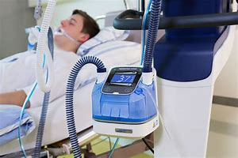
Figure 14: Mechanical ventilation

CHAPTER FIVE

CONCLUSION AND RECOMMENDATION

5.1 CONCLUSION
I strongly believe that the above mentioned strategies of engineering in handling the pandemic situation are effectively been carried out to help the victims as well as the rest of the world in taking preventive measures.
I also believe that the above mentioned results have also taking great effect in both sides of the world (victims and non-victims).

5.2 RECOMMENDATION

With respect to the current situation, I recommend the following:
- People should strictly adhere to the WHO instructions and guidance.
- People should follow and obey the country’s order and protocols.
- Governments in the country should take responsibility and provide for her citizens, especially those with little or no means of provision.
- People should use this medium to be creative and engage in one form of activity (legal) or the other from their various homes.
- Lastly, every person should engage in prayers and worships and to call upon their LORD(S) for help.

REFERENCE

- corono virus diseas 2019. (2020, april 10). Retrieved april 10, 2020, from wikipedia: https://en.wikipedia.org/wiki/Coronavirus_disease_2019#Other
- environmental health. (2020, april 8). Retrieved april 10, 2020, from wikipedia: https://en.wikipedia.org/wiki/Environmental_health
- industry: interesting engineering. (2020, april 4). Retrieved april 11, 2020, from interesting engineering: https://interestingengineering.com
- pandemic. (2020, april 11). Retrieved april 11, 2020, from wikipedia: https://en.m.wikipedia.org/wiki/Pandemic
- what is economic sustainability? (n.d.). Retrieved april 10, 2020, from wisegeek: https://www.wisegeek.com

