OPERATION, MAINTENANCE AND MANAGEMENT OF ENGINEERING EQUIPMENT FOR SUSTAINABLE DEVELOPMENT IN NIGERIA
BY
ATOLAGBE ABDULBASIT SULEIMAN
17/ENG03/011
A TERM PAPER SUBMITTED TO
COLLEGE OF ENGINEERING, AFE BABALOLA UNIVERSITY, ADO-EKITI, EKITI STATE.
FOR ENGINEERING LAW AND MANAGERIAL ECONOMICS (ENG 384)
IN PARTIAL FULFILMENT TO THE REQUIREMENTS FOR THE DEGREE OF BACHELOR OF ENGINEERING IN CIVIL ENGINEERING.

11th of APRIL, 2020

TABLE OF CONTENTS

TITLE PAGE………………………………………………..…………………………………1

TABLE OF CONTENTS………………………………………………………………………2

ABSTRACT…………………………………………………………………………………...3

- INTRODUCTION…………………………………………………….……………..…….5

- LITERATURE REVIEW……………………………………………………………….....7

- METHODOLOGY……………………………………………………………………….14

4.0 CHALLENGES…………………………………………………………………………..19

5.0 RECOMMENDATION……………………………………….………………………….20

6.0 CONCLUSION…………………………………………………………………………..21

7.0 REFERENCES…………………………………………………………………………...22

ABSTRACT

It is an undeniable fact that production of maintenance- free infrastructure is not feasible. The reality is that all the elements and components that make up an engineering infrastructure unavoidably, deteriorates with time due to inherent defects in design and construction, and the effects of environmental agents and users activities.

All engineering infrastructures are subject to aging, wear and tear in the performance of their functions and deterioration by exposure to outside operating environment. Hence, left to themselves, engineering infrastructures will eventually become inefficient, unreliable and fail. The issue then is how the existing infrastructure can be sustained to the extent that the functions they are designed to perform will not be compromised. To this end, this study will researched into sustainability strategies that can be adopted in engineering infrastructure maintenance. Data will be collected for purpose of extracting information on deployable strategies, including the use of Public engineering infrastructure in Southwestern part of Nigeria as case study. The study will later recommend strategies than can be adopted to aid this present generation provide solution to their environmental needs without compromise ability of future generation to meet their needs, which concept of sustainability has birthed.

Poor maintenance is known to be a significant factor militating against the achievements of enhanced productivity and full utilization of industrial facilities in developing countries like Nigerian(Sodiki, 2000). The ability of equipment, machineries or plants accurately and reliably to produce desired output could only be achieved through proper maintenance culture, which is significant to any nation’s economical development. This paper appraises the status of plant maintenance culture in Nigerian public and private sectors, to provide adequate information that will be of help towards achieving effective operations through an enhanced total capacity utilization of equipment, tools, machineries or plants, a tool for better economic development. Different public and private sectors were randomly selected within Ilorin metropolis. Two questionnaires were designed and oral interviews were also conducted within the staff of the selected organizations. The data collected were analysed manually and on computer using the Statistical Package for the Social Sciences(SPSS) software. The result shows a significant difference in the level of plants maintenance in the selected public and private sectors, in favour of private sectors. The research also revealed a general average machinery and equipment maintenance culture in Nigeria, which need to be improved on, to attain better and optimum plants operating condition required to satisfy expected needs of the nation at the minimum costs. This study recommended better working conditions for the skilled professionals; effective anti-corruption crusades at all levels; motivation towards enhanced local technological development for provision of good spare parts; comprehensive reforms to adopt systematic scheduling and standard maintenance policies in Nigeria among others.

- INTRODUCTION

Sustainability issue in recent times has dominated the arena of discussion in built environment. Billions of dollars worth of building investment are being initiated world over while little emphasis is placed on the aspect of maintenance of such infrastructure, this however could result into building an unsustainable buildings. In the tropic, careful consideration is often given to planning while proactive thought is not often accord the maintenance aspect, this however is common to the public utilities and infrastructure. Most sectors, unfortunately, are yet to give issue of sustainable design and building, an appropriate emphasis, buildings meant for human habitation are developed without much emphasis on design concept, space ergonomics, construction process, renewable material and post construction post occupancy requirement.

It is however pertinent at this juncture to appreciate the component of a sustainable building and infrastructure. Sustainable building are those that through their design, spatial orientation, choice of building components, construction and operational strategy, are highly efficient, also have low operating costs, environmentally friendly, and do not affect the health of their users and occupants negatively. Solomon, 2005). An infrastructure that contains structure and form that are not sustainable can be describe as high and this has become a phenomenon in the tropic, it is high time however that paradigm should shift from non sustainable development to sustainable one, through proactive strategy which this study aimed to achieve.

Equipment Asset Management (EAM) is a branch of reliability engineering that involves formulation of policies that guide the acquisition, operations and maintainability of equipment. Meeting the challenges of business of electricity supply includes having EAM that effectively manage equipment useful life and ensure reliability of supply. In this paper, the impact of EAM on electricity distribution reliability is evaluated using Load Point Reliability Indices. The impact on distribution efficiency and benefit is also discussed. Milsoft Utility Solution software is used to simulate the system reliability analysis that generates Load Point Reliability Indices such as Consumer Average Interruption Duration Index (CAIDI). The same analysis is repeated using improved equipment reliability data. Comparative analysis of the results shows that EAM policy such as Reliability Centered Asset Management (RCAM) results in improved network equipment failure rate. Improved failure rate in turn improves electricity supply reliability. EAM is also found to positively impact system efficiency and benefit as observed in the Distribution System Benefit and Efficiency analysis (DSBE). Analysis of a survey of maintenance of Nigeria electricity supply industry is also presented.

- LITERATURE REVIEW

2.1 PERSPECTIVES TO THE CONCEPT OF SUSTAINABILITY

There are existing views to the definition of sustainability concept; sustainable design/construction is one of such views. Sustainable infrastructure is viewed as the one that eliminates associated negative impact of infrastructures on user and environment. One of the schools of thought is the one that considers sustainability from the sustainable design/construction perspective, that, it is the design of and construction of infrastructure in a way that will enable the present generation meet their needs without compromising the prospect of future generation in meeting their needs.
Sustainable design/construction can also be described as the proper use of land, minimization of waste water, the use of less mechanical energy, understanding the site ecology, the application of eco-effective and recyclable materials among others. This can be generally described as producing an high performance infrastructure.

Another school of thought, viewed sustainable concept from the perspective of eliminating associated negative impact of infrastructure on users and environment, this school of thought emphasize maintaining infrastructure form and structure. (2) belong to this school of thought, that it is a design and construction practices that significantly reduce or eliminate the negative impact of building/infrastructures on the environment. It was established that this is achievable from the following six (6) key areas: Bioclimatic design indoor-environmental quality, construction of materials and resources, energy efficiency and renewable energy, and community design and connections; and sustainable design.
So also another school of thought believed that sustainable infrastructure should benefit society at large, improves standard of living (socially financially and economically), and secures the users health and safe for habitation.

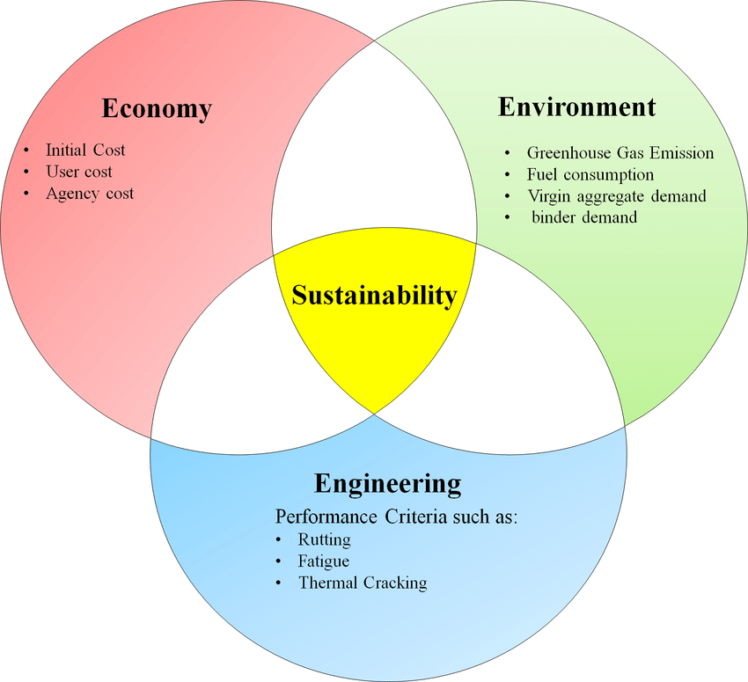
Fig1 : Venn Diagram Depicting Substainability In A Country.

  - INFRASTRUCTURE DETERIORATION PHENOMENA AND MAINTENANCE CONCEPT

Maintenance-free or self-sustaining infrastructure is highly desirable but not feasible. Infrastructures deteriorates with time due to wear and tear effect on the component, users and occupiers activity, inherent defects in design and construction and effects of environmental role in the deterioration of infrastructures’ component; hence left to themselves, facilities will eventually become inefficient, unreliable and fail opined that function change or function termination of the user, owner or manager is limited once the building’s acceptance threshold has been passed. If such building is sold the risk will then be transferred to the buyer, as did the original owner, it is at this stage that maintenance of such infrastructure is of great necessity, only repair or rehabilitation can bring such building back to the improved state or as-good-as-new state. When maintenance is ignored the effect is to aggravate the rate of infrastructures deterioration from year to year.

2.3 CRITICAL SUSTAINABILITY FACTORS IN ENGINEERING INFRASTRUCTURAL MAINTENANCE

Engineering infrastructures are required virtually at all facets of human endeavor, they are found at various stages of human economic and social economic life, buildings are common one around, it as well includes road, dam, equipment in building, production structures, drainage facilities, waste disposal and processing facilities, material production units, health facilities, transportation units, electricity outfits, and telecommunication systems. However, huge cost is always involved in infrastructures maintenance. (5), (6) identified three sets of factors which influence maintenance requirement and costs. These are: (i) Internal parameters pertaining to intrinsic characteristics of the building such as design and construction and the interdependence of building component and elements (ii) Usage and environmental effects which exert stress on the infrastructure and (iii) The effects of the previous users actions and owners response to maintenance need.

(i) Previous users action (Vandalism): Users action often constitute a great source for maintenance need in infrastructure maintenance. This could be described as vandalism, it has its roots in the social fabric of the community, and its often out of psychological disposition to cause damage, it is as well often calculated intention to express dissatisfaction to authority or society at large. Among the factors adduced as responsible for act of vandalism are wrong choice of materials, poor space layout, poor lighting arrangements and lack of security among others. Vandalism impairs the aesthetic of building, and reduces its life span and cost intensive.

(ii) Environmental stress effects on infrastructure: (Sick building Syndrome) Environmental agencies such as climatic conditions (rainfall, humility, temperature, wind groundwater conditions), chemical agents like chlorides and sulphates impact stress building and occupants. These stressors acts base on orientation of the structure and on external elements of the structure. The resultant effect of these stressors on the building is referred to as sick building syndrome.

(iii) Deficiency in design construction and interdependency of building components: The nature in which some elements in building were designed often hinders their maintainability. This may result from non-availability of replacement parts and components as in the case of many imported household items like lift, and air-conditioning (including Nigeria), in this kind of situation therefore, the most effective maintenance strategy should be one that minimizes the incidence of maintenance works through appropriate design. To be able to sustain a design or concept, it should be maintainable, and maintainability in the real sense of it is a measure of the ease of maintaining a building or its elements and components, which depends not only on the design and technical aspects but also on the availability of the building or components, when required for maintenance.

  - STRATEGIES FOR SUSTAINABLE ENGINEERING INFRASTRUCTURE

Constructing sustainable engineering infrastructure is approached in different ways with different priorities in different countries ranging from ecological impact on the environment, economic, social cultural consideration, density and demography of population, availability of land and water, energy production and supply, loss of natural habitat to lack of adequate facility to handling and resultant waste processing. So also strategies that could be adapted varies, however the some of the proactive strategy recommend could be any of the following or combination of more than one. Integrated project delivery system, re-engineering of construction process, environmental quality of construction, new construction concepts, assembly and disassembly approach, public
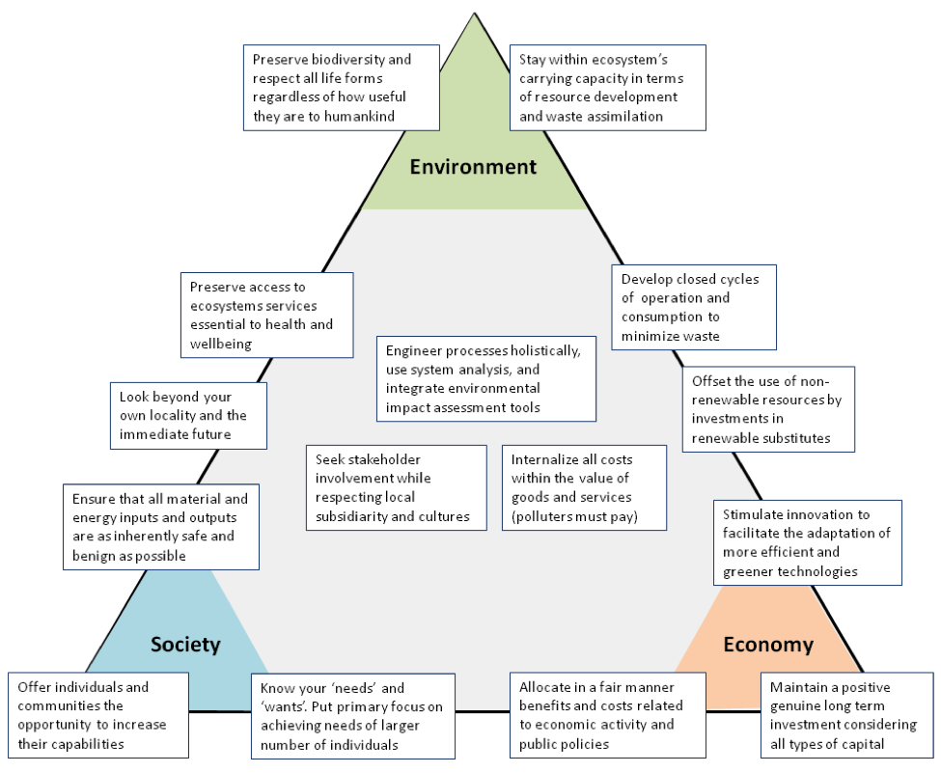
Fig 2: Economy – Society - Environment

awareness, setting of benchmark for regulation and best proactive, research and development, capacity building of construction sector, and energy conservation.

(a) Integrated approach in infrastructural design and construction: (I. A. I. D. C.) Because there is tendency for design process to increase in importance and complexity, there is therefore an urgent need for an integrated approach requiring among others co-engineering partnership between designers, engineers, and manufacturers. This will engender work cohesion in changing design information for an optimized alternative. This will enable adequate feedback for future design and improvement and as well information on best approach to maintain the existing infrastructure, so as to sustain them in from, structure and function.

(b) Process management (P.M): Management and Organization of key factors that comes to play in sustainability issue is as important as the concept itself. The subject must engage other issues not only technical aspect, but as well social, legal, economic and political matter. A structuring of the maintenance problem must be done in such a way that the complex interrelationship can be modeled for communication purpose. Also, a system of measuring progress must be put in place so that the extent of progress achieved can be appraised. A management framework must be developed which allows for planning, design, construction, monitoring and feedback on sustainability, as a key element in the development occupation and maintenance of infrastructures.

(c) Integrated project delivery system (I. P. D. S): An integrated delivery system is needed if the sustainability of engineering infrastructure will be realizable. Key actors involved are to be galvanized, from federal government, state government, and local government to designer, client, manufacturers and suppliers. Research has revealed that public infrastructures are poorly maintained, the federal government then should ensure the development of clear national sustainable policies and plans, local governments on the other hand holds key responsibility for land use, planning and implementation of sustainability policies as formulated by the federal government. Designers, builders and clients are responsible for reducing construction energy in building as well as non renewable resources. Thus builders, management and designers, are also to be responsible for increasing the recyclable material contents of building, waste generation and detoxification to produce an eco-friendly by-products.

(d) Re-engineering of the building and maintenance process: The penetration of new technology will lead to better output. New technology that involves better management of infrastructure development process through total quality managements and improved project coordination facilities as well as proactive maintenance system will be of immense value. This will help to large extent in having sustainable development.

(e) Improvement of environmental standard in construction and maintenance of engineering infrastructures: There should be a clear policy as regards standard obtainable in design, construction and maintenance of infrastructures. Paradigm should shift in the direction of “Green building Concepts.” According to (10), Green buildings are designed to meet certain objectives such as protecting occupant health, improving employee productivity, using energy, water and other resources more efficiently and reducing the overall impact to the environment. In this vein however, Green infrastructure is being advocated. It is high time that construction stakeholders shift focus to the direction of Green infrastructure. The infrastructure that will have less operating costs through increasing productivity and using less energy and water; improved public and occupant health due to improved indoor air quality and reduced environmental impacts.

(f) Introduction of new construction and maintenance concepts: The penetration of new technology and design concepts, construction and maintenance of infrastructure, will produce an economic and environmental valid construction products. Therefore, synergic approach in this respect, among designers, builders, and material manufacturers is needed to produce advanced products. The development and incorporation of subsystems however should not be cost intensive, the application should be flexible and environmentally compatible and sustainable. New concepts in maintenance should be introduced; introduction of Total Maintenance Operation Management (T. M. O. M.) is advocated. T. M. O. M. is a technique that involves appraising techniques used in maintenance of an item, with a view to establishing an optimized approach better in term of quality, and fair in term of cost and as well pliable in the aspect of environmentally friendly by-products.

(g) Incorporating eco-friendly construction materials: Studies reveals that people spent 80-85% of their time indoors, and most of the building materials often used in construction emits fumes and odour. The odour and emission from such are often poisonous, the effect can be carcinogenic or mutagenic, while other effects includes but not limited to the following: dizziness, memory loss, skin problem, respiratory tracts infection, migraine, headache, allergies of diverse kind, disturbance in biological functions and damage of cellular growth and genetics and destruction of ecosystem. Therefore eco-friendly materials are needed in construction work in order to sustain life and structure, that uses the construction products and bye products.

3.0 METHODOLOGY

This paper is purely a case study. Two (2) well designed questionnaires were administered at six (6) major economic sectors randomly selected within Ilorin metropolis as stated in Table 1, to elicit information on equipment, tools, machineries or plants maintenance culture in Nigerian from the technical staff in the various selected public and private sectors. Oral interviews were also conducted to ascertain the genuity of the information gathered.

3.1 ANALYSIS OF RESULTS

In gathering and data analysis the data obtained from the first questionnaire, the selected companies. Each question in the questionnaire was ranked into 2 or more options, which served as the basis for data analysis. The vital maintenance questions were referred to as variables(V). These variables range from V1 to V21 as appeared in the questionnaires. The result from the ranking (shown in Table 2) provided necessary data information from the selected organizations (sectors) for ease processing. The ranked data were processed on computer using SPSS software. The T-test for different between two correlated means shown in equation 1 was calculated to answer some of the research questions. The results were also analysed manually as presented in Tables 4 and 5. The manual analysis is found to be in line with the computer analysis.

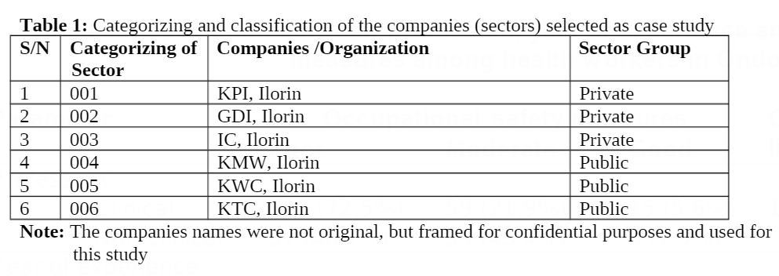

The difference is a result of variations: in the sectors’ mode of operations, aims and objectives, workers’ motivation, effective use of maintenance manual, types of maintenance embarked on, level and rate of maintenance, level of experts, types and complexity of machines, tools or plants and maintenance. The result also revealed that better maintenance activities take place in Nigeria private sectors than their public counterparts. The poor maintenance culture in public sector is attributed to very hard process in securing approval for procurements of spare parts, the poor attitude of workers in Nigeria towards the use and maintaining the public (government) properties, corruption, poor maintenance record keeping, and poor systematic scheduling of maintenance works, improper maintenance supervision, poor funding and poor maintenance management(Ademulegun, 2007). Poor attitude towards maintenance of government projects is a major problem of sustenance of such properties in Nigeria(NSE, 2003). Size, level of maintenance experts, adequate in-house maintenance specialists, adequate funding and proper supervision of works done by the outside specialists(contractors) are factors for better performance in private sectors. Tables 5 and 6 revealed proper maintenance supervision, adequate use of standard planned and preventive maintenance programs in private sectors.

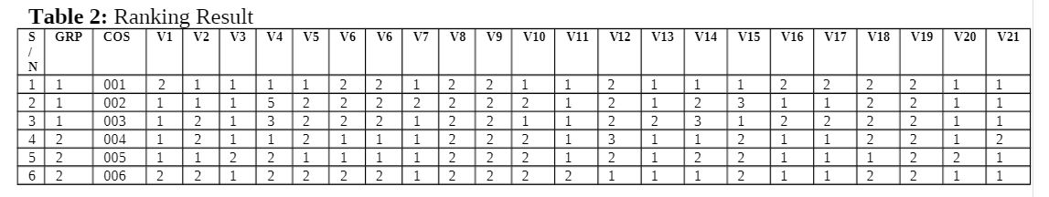

Personal interactions with the respondents during the interview revealed that type of maintenance mostly practiced in Nigerian public sectors is breakdown maintenance. That is, they do not embark on maintenance until when the plant is failed or totally shutdown. Though, the respondents of the second questionnaire disagreed with this practice(shown in Table 6). Meanwhile, further interactions with the selected public sectors’ executives revealed their uncared attitude to plant maintenance before failure, because of the belief that “no one works for government with stress”. This attitude was confirmed with their utterances that “the workers or the establishment losses nothing at the end of the idle period”, since the public sectors are usually funded by the government, without given a profit target. According to Table 3 & 5, the KTC, a public sector, performed averagely better in her maintenance culture (with the mean score of 33.0) than a public sector (KPI) that has a mean score of 32.0. The corporation better performance could be attributed to the facts that the company is self sustenance and tasked to generate fund internally to pay workers’ salaries and for her overall running. No subvention from the government quarters.

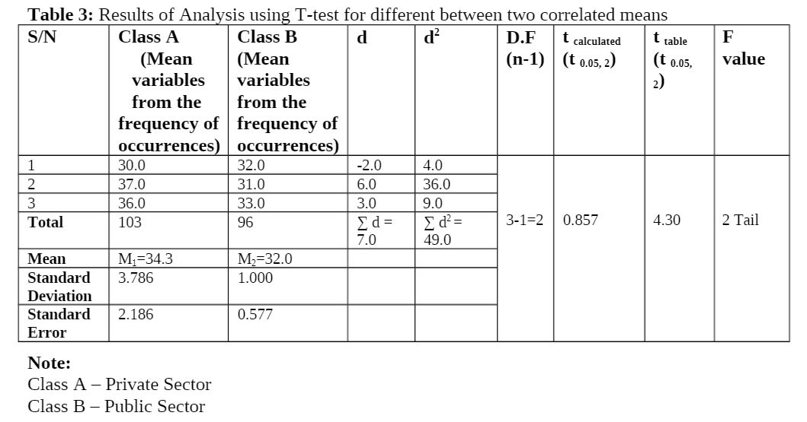

Nigerian sectors (public and private) in general need to improve on their maintenance cultures. The results from computer and manual analysis (Table 3 & 5) generally showed an average maintenance performance (i.e 50 – 61%). The view of the respondents during the oral interview (shown in Table 6) corroborates this result. This finding is also in line with the view of Nigeria Society of Engineers, NSE (2003) that maintenance is an issue so frequently overlooked in Nigeria. Sodiki (2000) also revealed that the problem of poor maintenance in Nigeria arises partly from political and cultural values and as a result of low level of awareness and technicality regarding maintenance matters. Political and cultural values have been hindering ese procurements of spare parts needed for adequate plant maintenance in Nigeria. The problem of low maintenances performance in Nigeria public and private sectors could also be attributed to low level of awareness regarding maintenance matters, unavailability of genuine parts and low level of technical (maintenance) expertas, poor record keeping, poor technical scheduling program, and unstable economic status, and unstable economic status, among others. Uhiars (2002) realized through his research findings that adequate trained manpower, spare parts and other maintenance materials are in short supply in Nigeria. This seriously hinders good and effective maintenance culture.
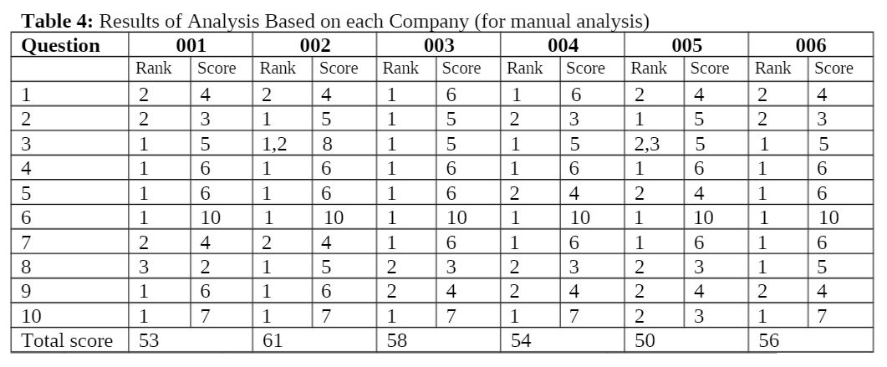

In Nigeria, the orientation of the private sectors executive towards profit making, through more production of goods and reduction in cost in another factor hindering good maintenance culture in their establishments. It is believed that maintenance do reduce their profits and consequently affect their achievements adversely. There is need to accept the maintenance function, as the aims of the organization may not initially conform to the main aim and objectives of production. At the longrun, proper maintenance culture will enhance the productivity and full capacity utuilization of industrial facilities. Priel (1974) identified sharp contrast between the ways in which work is done towards the goals of production and means through which objectives of maintenance is achieved.
This research revealed that the size or complexity of the machines, equipment or plants is one of the factors that determine the frequent or level of maintenance required. KPI, a private sector, has maintenance mean of 30.0 (Table 3) and 53% (Table 5), being the least performance.
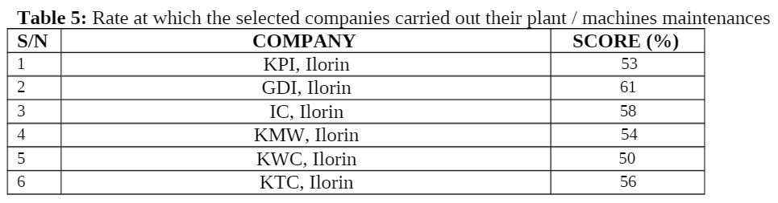

The small size and low rate at which the machines, equipment or plants are used in the company were given as contributing factors. The company has more idle times than production period, due to low production rate as result of scarcity of raw materials, unstable power supply etc. The machines, equipments or plants reliability or condition was as high as when they were just procured.

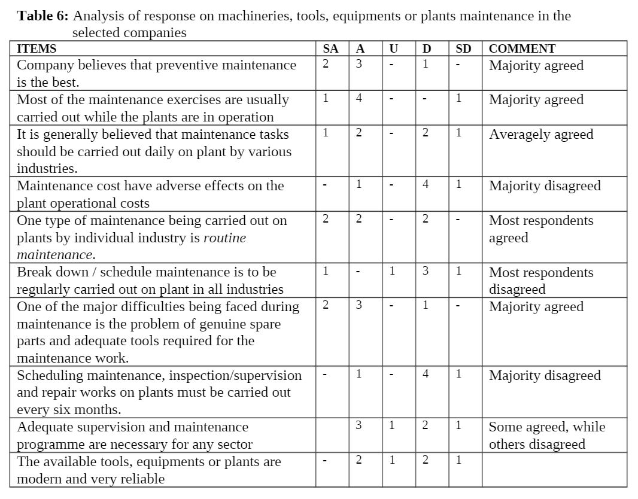

4.0 CHALLENGES

Maintenance not being treated seriously at the board level or even by local management;
lack of business culture in the maintenance process;
1. Lack of adequate management skills by maintenance technicians and even team leaders;
2. Isolation of the maintenance operation with little or no integration with the activities of
other departments;
3. Absence of adequate planned preventive maintenance methods;
4. Pre-occupation with introduction of advanced maintenance methods while relevant basic maintenance practices are not being implemented. Maintenance not being treated seriously at the board level or even by local management;
5. lack of business culture in the maintenance process;
6. Lack of adequate management skills by maintenance technicians and even team leaders;
7. Isolation of the maintenance operation with little or no integration with the activities of other departments;
8. Absence of adequate planned preventive maintenance methods;
9. Pre-occupation with introduction of advanced maintenance methods while relevant basic maintenance practices are not being implemented.
10. Lack of Maintenance Culture: Maintenance culture is lacked in developing countries
including Nigeria. Infrastructural facilities are left to decay after completion. It is shocking that
we spend huge sums of money building and developing infrastructures in Nigeria only for us to
look back after few years and find out that such beautiful infrastructures are decayed due to lack
of maintenance.

5.0 RECOMMENDATIONS

To proffer solution to the maintenance problems revealed by this paper, the following recommendations are made:
1. The Nigerian public and private sectors need to encourage the skilled professionals by provision of better working conditions, enhanced staff welfare etc as their services are signifgiacnt to achieve better plants maintenance.
2. Governments and different organizations need to encourage people towards good maintenance culture at all level.
3. Nigerians are to be orientated on importance of good maintenance culture to the society.
4. The public sectors need to be privatized. The privatization has to be since one.
5. Adequate funding of the public sector is required to cater for their maintenance problem.
6. There is need for development of good maintenance policies. This policies include (Ademulegun, 2007):
7. Maintaining proper record about the tols and equipment
8. Need for effective anti-corruption crusades at all levels
9. Sincere Re branding of Nigeria
10. Motivation towards local technological development for provision of good spare parts etc
11. Improvement on Nigeria political and cultural values.
12. Public sectors need comprehensive reforms to adopt systematic scheduling and maintenance works.
13. Need for adequate on-job training programs on maintenance know-how for technical staff to enhance their technological knowledge. Okoye(2003) suggested appropriate and adequate job training on maintenance know-how for Nigerian technical staff in both private and public sectors.

6.0 CONCLUSION

In conclusion, this study revealed that there is significant difference in the machinery and equipment maintenance cultures in Nigerian public and private economy sectors. The public sectors perform better in plants maintenance than the public sectors. The Nigerian cultures/attitudes towards machinery and equipment maintenance need to be improved, for better and optimum plants operating condition, such as efficiency, production capacity and product quality to satisfy expected Nigerian needs at minimum costs.

7.0 REFERENCES

Al-Hammad A. M. and Assaf, S. (1996). Assessment of Work Performance of Maintenance Contractors in Sandi Arabia. Journal of Management and Engineering. Pp 1-3
Apochi M. and Abdulhameed, A. (2008). ‘’Building for Environmental and Economic Sustainability’’. Technical Manual and User Guide. Pp 1-8
Balasubramanya M. C. and Sampath Kumar (2008) Green Building Technologies and Solutions to Global Warming. World Congress on Housing Kolkalta India pp 1-9
Gambataella, L. M and Moroni, M. (1991) ‘’Expert Systems Application to Building Pathology Diagnosis: Methodology’’ Proceeding of the Second European Conference on Application of Artificial Intelligence and Robotics to Building, Belgium. Pp 252-254. Solomon, N (2005)‘’The Pick of the Sustainable Crop’’, Architectural Record Pp 160.
Ghosh, S. K. (2008) ‘’Waste Water Recycling for Sustainable Development World’’ Congress on Housing. Kolkalta India pp 1-20
Hussaini, I. U. (2008) Landscaping for Energy Conservation: An Overview. Nigerian Journal of Construction Technology and Management. Pp 66-69
Iyagba, R. O. A (2005) ‘’The Menace of Sick Buildings: A Challenge to all for its Prevention and Treatment’’. An Inaugural Lecturer Delivered at University of Lagos. Nigeria.
Nadel, B. A. (2007) Windows and Sustainability: ‘’An Environmental Perspective’’. Architectural Record, pp 257-261
Olubodun, F.O. (2000): ‘’A factor approach to the analysis of components’ defects in housing stock’’. Structural Survey, 18(1), 46-57
Sanyal, D. (2008). A Search for Eco-Friendly Building Materials for Sustainable Urban Mass Housing. World Congress on Housing. Kolkalta India pp 1-15
Sour, L. H. and Yueng, G. C. S. (1993) Building Maintenance Technology. The Macmillan Press LTD. London.
Vijervaberg, G. (2000) ‘’Busing Maintenance Needs on Accommodation Policy’’: Building Research and Information. 28CD 18-25.
Winderlich N. O. (1991) ‘’Probabilistic Method for Maintenance’’: A SCE Journal of Engineering Mechanics. 117 9a), 2065-2066.

