ENGINEERING STRATEGIES FOR HANDLING COVID-19 FOR ENVIRONMENTAL HEALTH AND ECONOMIC SUSTAINABILITY
PREPARED BY
EGBOCHUKWU EBENEZER UZOCHIWARA
17/ENG01/008
A TERM PAPER SUMMITED
TO THE DEPARTMENT OF CHEMICAL ENGINEERING
AFE BABALOLA UNIVERSITY ADO-EKITI (ABUAD)
IN PARTIAL FULFILMENT
OF
ENG 384: ENGINEERING LAW AND MANAGERIAL ECONOMICS
DATE ISSUED: 30TH MARCH 2020
DATE OF SUBMISSION: 13TH APRIL 2020

ABSTRACT
This term paper gives a detailed account on the engineering strategies for handling covid-19 for environmental and economic sustainability. A new strain of coronavirus which originated in Wuhan, Hubei province, China, in late December 2019, has caused a cluster of cases of an acute respiratory disease, which is referred to as coronavirus disease 2019 (COVID-19). According to media reports, more than 200 countries and territories have been affected by COVID-19, because major outbreaks of it have occurred in the United States, central China, western Europe, and Iran. Coronaviruses are the subfamily of Orthocoronavirinae, in the family Coronaviridae, order Nidovirales, and realm Riboviria. They are enveloped viruses with a positive-sense single-stranded RNA genome and a nucleocapsid of helical symmetry. Entering into the field of engineering requires an engineering degree or an engineering degree with specialization. In general, chemical engineers work to design and develop chemical manufacturing equipment, processes and products. Coronavirus could be used as a weapon designed as other viruses existing. Hence, covid-19 has been seen to have severe effects on the environmental health and economic sustainability. Environmental health is the branch of public health concerned with all aspects of the natural and built environmental affecting human health, according to WHO, environmental health as it relates to health as all the physical, chemical, and biological factors external to a person and all the related behaviours, environmental health consists of preventing or controlling disease, injury, and disability related to the interactions between people and their environment. Economic sustainability refers to practices that support long-term economic growth without negatively impacting social, environmental, and cultural aspects of the community. Now the precept of handling is to simply control the virus so as not to out of hand but in this concept, we limit ourselves to the engineering strategies to handle the pandemic for environmental health and economic sustainability.
The effects of covid-19 on the environmental health has been seen to be drastically with respect to the elemental themes of environmental health, which includes: outdoor air quality, surface and ground water quality, toxic substances and hazardous wastes, homes and communities, infrastructure and surveillance, and global environmental health. The effects of covid-19 on the economic sustainability are seen on the financial system of a nation that displays only minor fluctuations in output growth and exhibits a consistently low inflation rate. Some of the engineering strategies given with case study for this issue are seen to be the use of artificial intelligence, the use of ventilators and mathematical modelling to handle this issue.
Furthermore, for the successful completion of the term paper, I was able acquire more knowledge in the engineering strategies for handling economic sustainability and environmental health due to the coronavirus.
Lastly, the term paper was totally successful because the set-out objectives were achieved after taking certain precautions and observations realized.

KEYWORDS
- Health
- Stability
- Economy
- Sustain
- Environment

TABLE OF CONTENTS
ABSTRACT ii
LIST OF FIGURES v
LIST OF TABLES vi
LIST OF ABBREVIATIONS vii
CHAPTER ONE 8
INTRODUCTION 8
CORONAVIRUS AND EXISTENCE 8
CORONAVIRUS AS A BIOLOGICAL WEAPON 10
HOW TO PROTECT YOURSELF 10
TERMINOLOGIES ASSOCIATED WITH CORONAVIRUS 11
CORONAVIRUS AS A PANDEMIC SITUATION 11
CORONAVIRUS AND ITS EFECTS CAUSED IN NIGERIA 12
WHO’S STRATEGIC OBJECTIVES FOR THIS RESPONSE ARE TO: 14
CHAPTER TWO 15
LITERATURE REVIEW OR THEORY 15
2.0 THE STRATEGIES FROM ENGINEERING FOR HANDLING THE COVID-19 SITUATION FOR ENVIRONMENTAL HEALTH AND ECONOMIC SUSTAINABILITY 15
2.1 CORONAVIRUS AFFECTING THE ENVIRONMENTAL HEALTH 15
2.1.1 UNDERSTANDING THE EFFECTS OF COVID-19 PRODUCED ON THE ENVIRONMENTAL HEALTH 16
2.1.2 CASE STUDIES OF SOME EXAMPLES OF THE EFFECTS OF CORNAVIRUS ON ENVIONMENTAL HEALTH 20
2.2 CRITICAL EXAMINATION OF THE EFFECT OF CORONAVIRUS ON THE ECONOMY SUSTAINABILITY 21
2.3 ENGINEERING STRATEGIES FOR HANDLING COVID-10 22
CHAPTER THREE 31
3.1 CASE STUDIES 31
3.1 CASE STUDIES ON THE EFFECTS OF CORNAVIRUS ON ENVIRONMENTAL HEALTH 31
CASE 1: CHINA 31
CASE 2: NIGERIA 33
CASE 4: ECONMIC SUSTAINANCE 33
3.1 CASE STUDY ON THE EFFECTS OF CORONAVIRUS ON ECONOMIC SUSTAINABILITY 34
CASE STUDIES OF THE ENGINEERING STRATEGIES OFFERING SOLUTIONS TO THE ENVIRONMENTAL HEALTH AND ECONOMIC SUSTAINABILITY 36
CASE 3: BODY PROTECTION 37
CASE 4: MONITORING THE PANDEMIC SITUATION AND ITS TRANSMISSIBILITY 38
CHAPTER FOUR 39
4.1 RESULT: CHINA AS CASE STUDY WITH RESPECT TO ENVIRONMENTAL HEALTH AND ECONMIC SUSTAINABILITY 39
4.2 ANALYSIS OF RESULT 41
DISCLOSURE OF THE ADEQUATE ENGINEERING STRATEGIES DEPLOYED BY CHINA USING THE COUNTRY AS CASE STUDY 41
ANOTHER CASE STUDY THAT IS CAPTIVATING IS THE RESPONSE GLOBALLY 43
STRATEGIC ENGINEERING STRATEGIES DEPLOYRATION ON CONTAINMENT 43
4.3 PRECAUTIONS: 45
4.4 OBSERVATIONS 45
CHAPTER FIVE 46
5.0 CONCULSION AND RECOMMENDATIONS 46
5.1 CONCLUSIONS 46
5.2 RECOMMENDATIONS 48
REFERENCES 52

LIST OF FIGURES
Figure 1: CORONAVIRUS 10
Figure 2: REUTERS/TEMILADE ADELAJA 12
Figure 3: Lagos: Can’t stop, won’t stop. 13
Figure 4: Worshippers attend a church service at the Living Faith Church, also known as the Winners’ Chapel just outside Lagos 14
Figure 5: The impact of coronavirus on stock markets since the start of the outbreak 21
Figure 6: Jobless claims hit new record as more than six million people files claims as coronavirus hits 22
Figure 7: Data from flight tracking service flight Radar 24 shows that the number of flights globally has taken a huge hit. 22
Figure 8: The goals of community mitigation: (1) delay outbreak peak; (2) reduce peak burden on healthcare, known as flattening the curve; and (3) diminish overall cases and health impact 23
Figure 9: Personal protective equipment 26
Figure 10: Artificial intelligence 29
Figure 11: Birth and Death rate in china from 1950 to 2015 31
Figure 12: China's industrial production falling 34
Figure 13: The value of Gold jumping back 35
Figure 14: Indication of car sales falling 35
Figure 15: oil price rallies 36
Figure 16: Figure 6: The goals of community mitigation: (1) delay outbreak peak; (2) reduce peak burden on healthcare, known as flattening the curve; and (3) diminish overall cases and health impact 36
Figure 17: Modelling and Simulation for the virus spread 38
Figure 18: Case fatality ratio (reported deaths among total cases) for COVID-19 in China over 40
Figure 19: DISTRIBUTION OF COVID-19 CASES AS OF FEBRUARY 2020 47
Figure 20: Conclusion aim of any engineering strategy 47
Figure 21: EXPOSURE RATE OUTSIDE CHINA 48

LIST OF TABLES
Table 1: CASE STUDY OF AN INTIAL VIRUS SHOWING ITS SEVERE IMPACT 45

LIST OF ABBREVIATIONS

WHO World Health Organization
FTSE Financial Times Stock Exchange
USA United states of America
NCDC Nigeria centre for disease control
IPC Infection prevention and control

CHAPTER ONE

INTRODUCTION

CORONAVIRUS AND EXISTENCE
A new strain of coronavirus which originated in Wuhan, Hubei province, China, in late December 2019, has caused a cluster of cases of an acute respiratory disease, which is referred to as coronavirus disease 2019 (COVID-19). According to media reports, more than 200 countries and territories have been affected by COVID-19, because major outbreaks of it have occurred in the United States, central China, western Europe, and Iran. On 11 March 2020, the World Health Organization characterized the spread of COVID-19 as a pandemic. As of 6 April 2020, the number of COVID-19 infected people reached 1.31 million, the death toll was 77,200 and the number of patients recovered was 276,189, maximum number of patients found in the U.S. 366,906.
Coronaviruses are the subfamily of Orthocoronavirinae, in the family Coronaviridae, order Nidovirales, and realm Riboviria. They are enveloped viruses with a positive-sense single-stranded RNA genome and a nucleocapsid of helical symmetry. The genome size of coronaviruses ranges from approximately 27 to 34 kilobases, the largest among known RNA viruses. The name coronavirus is derived from the Latin corona, meaning "crown" or "halo", which refers to the characteristic appearance reminiscent of a crown or a solar corona around the virions (virus particles) when viewed under two-dimensional transmission electron microscopy, due to the surface being covered in club-shaped protein spikes.
Coronaviruses (CoV) are a large family of viruses that cause illness ranging from the common cold to more severe diseases such as Middle East Respiratory Syndrome (MERS-CoV) and Severe Acute Respiratory Syndrome (SARS-CoV). A new strain of coronavirus (SARS-CoV-2) causes Coronavirus disease 2019, or COVID-19. COVID-19 was declared a pandemic by the WHO on 11 March 2020. Some coronaviruses are zoonotic, meaning they are transmitted between animals and people. Detailed investigations found that SARS-CoV was transmitted from civet cats to humans, and MERS-CoV from dromedary camels to humans. Several known coronaviruses are circulating in animals that have not yet infected humans. Common signs of infection include respiratory symptoms, fever, cough, shortness of breath, and breathing difficulties. In more severe cases, infection can cause pneumonia, severe acute respiratory syndrome, kidney failure and even death. Standard recommendations to prevent the spread of infection include regular hand washing, covering mouth and nose when coughing and sneezing, thoroughly cooking meat and eggs, and avoiding close contact with anyone showing symptoms of respiratory illness such as coughing and sneezing. The recommended distance from other people is 6 feet, a practice more commonly called social distancing.
Throughout history, there have been a number of pandemics of diseases such as smallpox and tuberculosis. One of the most devastating pandemics was the Black Death (also known as The Plague), which killed an estimated 75–200 million people in the 14th century. Other notable pandemics include the 1918 influenza pandemic (Spanish flu) and the 2009 flu pandemic (H1N1). Current pandemics include HIV/AIDS and the 2019–20 coronavirus pandemic.
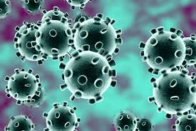
Figure 1: CORONAVIRUS

CORONAVIRUS AS A BIOLOGICAL WEAPON
Diseases considered for or known to be used as a weapon include anthrax, Ebola, Marburg virus, plague, cholera, typhus, Rocky Mountain spotted fever, tularemia, brucellosis, Q fever, machupo, Coccidioides mycosis, Glanders, Melioidosis, Shigella, Psittacosis, Japanese B encephalitis, Rift Valley fever, yellow fever, and smallpox, also including coronavirus if the cure or vaccine is found.

HOW TO PROTECT YOURSELF
To reduce the risk of spread of coronavirus, members of the public are advised to adhere to the following measures:
- Wash your hands regularly with soap under running water.
- Cover your mouth and nose properly with handkerchief or tissue paper when sneezing and/or coughing. You may also cough into your elbow if a handkerchief is not available.
- Avoid close contact with anyone showing symptoms of respiratory illness such as coughing and sneezing.
- Avoid self-medication, report to the nearest health facility when you experience any of the above-mentioned symptoms.
- Healthcare workers are always advised to observe standard infection prevention and control measures when attending to patients and take a travel history.
As the situation is evolving, this advisory will be updated as more information becomes available.

TERMINOLOGIES ASSOCIATED WITH CORONAVIRUS
- A pandemic (from Greek πᾶν, pan, 'all' and δῆμος, demos, 'people') is an epidemic of disease that has spread across a large region, for instance multiple continents, or worldwide. A widespread endemic disease with a stable number of infected people is not a pandemic. Widespread endemic diseases with a stable number of infected people such as recurrences of seasonal flu are generally excluded as they occur simultaneously in large regions of the globe rather than being spread worldwide.
- Epidemic: This a widespread occurrence of an infectious disease in a community at a particular time.

CORONAVIRUS AS A PANDEMIC SITUATION
A pandemic is an epidemic occurring on a scale that crosses international boundaries, usually affecting people on a worldwide scale Pandemics can also occur in important agricultural organisms (livestock, crop plants, fish, tree species) or in other organisms. A disease or condition is not a pandemic merely because it is widespread or kills many people; it must also be infectious. For instance, cancer is responsible for many deaths but is not considered a pandemic because the disease is neither infectious nor contagious.
The World Health Organization (WHO) previously applied a six-stage classification to describe the process by which a novel influenza virus moves from the first few infections in humans through to a pandemic. This starts with the virus mostly infecting animals, with a few cases where animals infect people, then moves through the stage where the virus begins to spread directly between people and ends with a pandemic when infections from the new virus have spread worldwide. In February 2020, a WHO spokesperson clarified that "there is no official category [for a pandemic]".
In a virtual press conference in May 2009 on the influenza pandemic, Dr. Keiji Fukuda, Assistant Director-General ad interim for Health Security and Environment, WHO said "An easy way to think about pandemic ... is to say: a pandemic is a global outbreak. Then you might ask yourself: 'What is a global outbreak'? Global outbreak means that we see both spread of the agent ... and then we see disease activities in addition to the spread of the virus."

CORONAVIRUS AND ITS EFECTS CAUSED IN NIGERIA
As part of attempts to limit the spread of Covid-19, governments have instituted lock-down measures and banned public gatherings. Lagos, Africa’s largest city with 21 million people, is attempting to do the same. With 11 confirmed cases, by far the most in Nigeria, the state government has asked schools to shut down and banned public gatherings of more than 50 people, particularly religious congregations.
In the event of more cases, tougher measures will likely follow. Given Lagos’ standing as Nigeria’s economic nerve centre, the threat of a highly contagious viral outbreak in a state where 20 million people are squeezed into land mass that’s about the size of Indianapolis (population: 870,000), is grim.
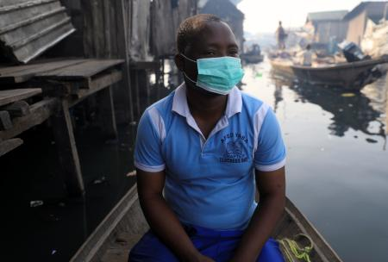
But shutting down Lagos on any scale will likely be an uphill task for the government,the city is defined by non-stop activity and a hustle and bustle spirit that perennially draws thousands of Nigerians from other states in search of better economic opportunities. it’s a city of ingenuity and chutzpah which most people need to be able to survive in an overwhelmed urban system. this means Lagos is often defined by lawlessness as people seek solutions for their daily life.
Figure 2: REUTERS/TEMILADE ADELAJA
Beyond cultural and behavioural nuances, the government will also be up against the might of religion—Nigeria’s Christian population is the largest in Africa and is projected to double by 2060. Lagos itself is home to some of the country’s most well-attended mega-churches with hundreds of branches that welcome millions in congregation every Sunday.
As such, attempting to enforce a ban on religious gatherings likely puts the state government at odds with powerful religious leaders whose co-operation is fundamental given their influence. Yet, there are already signs of potential conflict between the government and influential clergymen: the Christian Association of Nigeria (CAN) says a ban on religious gatherings is not necessary. “We believe we will never get to the point of having to ban all services and churches will be grounded,” CAN’s Lagos chairman has said. These issues will also apply to Lagos’ vast Muslim population (Nigeria has the fifth largest Muslim population globally) when it comes to attending large mosques for customary prayer services on Friday.
Figure 4: Worshippers attend a church service at the Living Faith Church, also known as the Winners’ Chapel just outside Lagos
One-way governments across the globe have ensured that lockdowns are effective has been to assuage the effects of lost income on citizens with social benefits like suspending particular taxes and bills as well as offering cash payments. But even those measures are unlikely to work in Lagos.
Inefficient data capturing methods and agencies mean the Lagos government does not really know how many people live in its sprawling city as its suburbs keep growing out into neighbouring states.
And there’s also the practical matter of being able to afford such palliative measures for 21 million people as recent events suggest otherwise: after a tragic gas explosion in the Lagos suburb of Abule Ado last week, the state government launched a relief fund asking citizens to donate to pay off medical bills and relocation costs of those affected.

WHO’S STRATEGIC OBJECTIVES FOR THIS RESPONSE ARE TO:
• Limit human-to-human transmission including reducing secondary infections among close contacts and health care workers, preventing transmission amplification events, and preventing further international spread from China*;
• Identify, isolate and care for patients early, including providing optimized care for infected patients;
• Identify and reduce transmission from the animal source;
• Address crucial unknowns regarding clinical severity, extent of transmission and infection, treatment options, and accelerate the development of diagnostics, therapeutics and vaccines;
• Communicate critical risk and event information to all communities and counter misinformation;
• Minimize social and economic impact through multisectoral partnerships

AGENCIES USED ISSUED FOR THE FIGHT OF CORONAVIRUS
- WHO- WORLD HEALTH ORGANISATION
- NCDC-NIGERIA CENTER FOR DISEASE CONTROL
- IPC- INFECTION PREVENTION AND CONTROL
- TECH GIANTS

CHAPTER TWO

LITERATURE REVIEW OR THEORY

2.0 THE STRATEGIES FROM ENGINEERING FOR HANDLING THE COVID-19 SITUATION FOR ENVIRONMENTAL HEALTH AND ECONOMIC SUSTAINABILITY

2.1 CORONAVIRUS AFFECTING THE ENVIRONMENTAL HEALTH
Environmental health is the branch of public health concerned with all aspects of the natural and built environment affecting human health. Environmental health is focused on the natural and built environments for the benefit of human health.
Humans interact with the environment constantly. These interactions affect quality of life, years of healthy life lived, and health disparities. The World Health Organization (WHO) defines environment, as it relates to health, as “all the physical, chemical, and biological factors external to a person, and all the related behaviors.” Environmental health consists of preventing or controlling disease, injury, and disability related to the interactions between people and their environment.
The highlights of the elements of environmental health includes;
- Outdoor air quality
- Surface and ground water quality
- Toxic substances and hazardous wastes
- Homes and communities
- Infrastructure and surveillance
- Global environmental health
Maintaining a healthy environment is central to increasing quality of life and years of healthy life. Globally, 23% of all deaths and 26% of deaths among children under age 5 are due to preventable environmental factors. Environmental factors are diverse and far reaching. They include:
- Exposure to hazardous substances in the air, water, soil, and food
- Natural and technological disasters
- Climate change
- Occupational hazards
- The built environment
Poor environmental quality has its greatest impact on people whose health status is already at risk. Therefore, environmental health must address the societal and environmental factors that increase the likelihood of exposure and disease.

2.1.1 UNDERSTANDING THE EFFECTS OF COVID-19 PRODUCED ON THE ENVIRONMENTAL HEALTH
In understanding the effects or how the environmental health is affected by the coronavirus outbreak, one needs to examine the effects produced on the 6 themes of the Environmental Health topic area draw attention to elements of the environment and their linkages to health.
- Outdoor Air Quality:
Poor air quality is linked to premature death, cancer, and long-term damage to respiratory and cardiovascular systems. Decreasing air pollution is an important step in creating a healthy environment, as a result of the outbreak of the coronavirus there has been an improvement in the air quality.
A drop-in air pollution was first observed by NASA in China’s Hubei province, where the coronavirus outbreak began in December. The Chinese government on January 23 put Wuhan and other cities on lockdown to contain the virus, leading to a standstill for normal life. “This is the first time I have seen such a dramatic drop-off over such a wide area for a specific event,” Fei Liu, an air quality researcher at NASA’s Goddard space flight centre, told the Guardian.
Also, in Madrid this week, Spain’s Directorate General for Traffic registered a 14 percent drop in rush-hour traffic, El País reported. The European Commission last year referred the Spanish capital to court for failing to meet EU limits on air pollution designed to protect people’s health. Marshall Burke, a researcher at Stanford University, calculated the improvements in air quality recorded in China may have saved the lives of 4,000 children under 5 years old and 73,000 adults over 70.
Even more conservative estimates would put the number of lives saved at roughly 20 times the number of deaths from the virus directly. “It seems clearly incorrect and foolhardy to conclude that pandemics are good for health ... But the calculation is perhaps a useful reminder of the often-hidden health consequences of the status quo,” Burke wrote in a blog post.
- Surface and Ground Water
Surface and ground water quality concerns apply to both drinking water and recreational waters. Contamination by infectious agents or chemicals can cause mild to severe illness. Protecting water sources and minimizing exposure to contaminated water sources are important parts of environmental health.
The coronavirus spreads majorly through fluids and landing on surfaces, thereby, creating an unprotected environment for people to live in and also, in result causes or forces the people of the environmental health to live in an isolation.
- Toxic Substances and Hazardous Wastes
The health effects of toxic substances and hazardous wastes are not yet fully understood. Research to better understand how these exposures may impact health is ongoing. Meanwhile, efforts to reduce exposures continue. Reducing exposure to toxic substances and hazardous wastes is fundamental to environmental health. Due to the pandemic situation at hand, countries such as Italy, America, Spain and Nigeria have initiated a lockdown policy and in result affects greatly the exposure to toxic substances and mountains of waste such as;
- Coffee chain Starbucks decided to stop accepting reusable cups from its customers — only serving drinks in disposable single-use cups that are not yet recyclable in a bid to prevent the spread of the virus.
- Coronavirus initiating warnings towards eating pre-packed foods, for example at work functions- despite an effort by the European food safety authority to reassure people that, so far, there is ‘no evidence that food is a likely source or route of transmission of the virus’.
- The drowning under medical waste produced by hospitals including face masks and single-use tissues. The volume of medical waste is reported to have quadrupled to more than 200 tons a day in cities such as Wuhan and countries such as; Italy and America, England and Italy because of the Single-use medical items that have been in contact with infected patients must be burned to prevent further contamination that could occur during recycling.
- Homes and Communities
People spend most of their time at home, work, or school. Some of these environments may expose people to:
- Indoor air pollution
B. Inadequate heating and sanitation
C. Structural problems
D. Electrical and fire hazards
E. Lead-based paint hazards
These hazards can impact health and safety. Maintaining healthy homes and communities is essential to environmental health. The outbreak of Coronavirus results in most of these hazards such as the greenhouse gas emission reduced due to the Slowing economic activity which also drives down emissions — if only temporarily. As countries order the closedown of schools, shops and factories, emissions are expected to fall. The last time carbon emissions fell was during the economic crisis in 2008-2009. But as the economy picked up, so did demand for coal and other fossil fuels — especially in China, the world’s largest emitter. A study by specialist outlet Carbon Brief found that in China, carbon dioxide emissions have fallen by around 25 percent as a result of COVID-19. Another factor that could dampen emissions growth is lower oil demand. The International Energy Agency said that global oil demand is expected to decline this year “as the impact of the new coronavirus spreads around the world, constricting travel and broader economic activity.” The pandemic affects energy markets more broadly, but oil markets are most severely hit by “dealing a heavy blow to demand for transport fuels,” especially in China, the world’s largest energy consumer, said IEA Executive Director Fatih Birol. “While the repercussions of the virus are spreading to other parts of the world, what happens in China will have major implications for global energy and oil markets.”
“Obviously there are almost certainly going to be further impacts on emissions,” of Carbon Brief. However, an assessment for Europe would come in “the situation is fast moving and even in Italy the restrictions have only started very recently.” But as more people choose to stay at home, demand for home entertainment could soar, driving up energy use. Germany’s Deutsche Commercial Internet Exchange interconnection platform, or De-Cix, reported a record throughput of data: More than 9.1 terabits of data per second were transmitted Tuesday evening, according to De-Cix.
“Never before has so much data been exchanged at peak times at an Internet Exchange,” the Frankfurt-based company said in a press release. De-Cix added that the rise in internet traffic can be explained by both more people streaming videos as well as by an increase in searches for new information about the coronavirus
- Infrastructure and Surveillance
Preventing exposure to environmental hazards relies on many partners, including state and local health departments. Personnel, surveillance systems, and education are important resources for investigating and responding to disease, monitoring for hazards, and educating the public. Additional methods and greater capacity to measure and respond to environmental hazards are needed.
- Global Environmental Health
Water quality is an important global challenge. Diseases can be reduced by improving water quality and sanitation and increasing access to adequate water and sanitation facilities. The coronavirus outbreak has affected the global environmental health by creating a medium of awareness through the need for sanitation, because coronavirus can also pollute water and if this is productive, it would be disastrous one has people with the virus would increase largely and in response increasing the death rate.

2.1.2 CASE STUDIES OF SOME EXAMPLES OF THE EFFECTS OF CORNAVIRUS ON ENVIONMENTAL HEALTH

CLIMATE IS NO THE CRISIS
With the virus consuming everybody’s attention, the climate issue has been crowded off the agenda. The European Parliament opted to forgo a debate on the EU’s new Climate Law after the plenary session was shortened to minimize people’s exposure. Parliament President David Sassoli then quarantined himself for two weeks.
“Meetings are being canceled but important decisions should not be delayed,” said Anton Lazarus of the European Environmental Bureau. “The corona crisis cannot be allowed to slow down action to tackle climate and ecological crises.”
Swedish climate activist Greta Thunberg on Wednesday urged her followers via Instagram to shift the ongoing Fridays for Future protests into cyberspace.
When it comes to coronavirus, “We can’t solve a crisis without treating it as a crisis and we must unite behind experts and science,” she wrote. “This of course goes for all crises.”
Kalina Oroschakoff, Joshua Posaner, Saim Saeed, Louise Guillot, Laurenz Gehrke and Aitor Hernández-Morales contributed reporting.

QUARANTINE IN RESPONSE TO AVOIDANCE OF SPREAD OF THE PANDEMIC
The President of the republic of Nigeria, His Excellency Muhammadu Buhari initiated regulations that would regulate the Coronavirus situation declaring the pandemic as a “dangerous infectious disease.” A statement from the presidency noted that the president had signed the regulations “in exercise of the powers conferred on him by Sections 2, 3 and 4 of the Quarantine Act (CAP Q2 LFN 2004), and all other powers enabling him in that behalf.” A spokesman, said the regulations, effective March 30, 2020, “also gave legal backing to the various measures outlined in the President’s National Broadcast on March 29, 2020, such as Lockdown in Lagos, FCT and Ogun State as a measure to containing the spread of the pandemic in the country”. The government’s chief lawyer, Attorney General Abubakar Malami, dismissed a reported legal challenge on the propriety of Buhari’s lockdown orders of March 29. He said the quarantine act empowered the president to restrict movement when a “dangerous disease” breaks out.
C. HEALTH DISPARITY
Health disparity refers to a higher burden of illness, injury, disability, or mortality experienced by one group relative to another. There has been an increase health disparity experienced by the environment as a result of the outbreak of coronavirus.

2.2 CRITICAL EXAMINATION OF THE EFFECT OF CORONAVIRUS ON THE ECONOMY SUSTAINABILITY
The coronavirus outbreak which originated in china has infected more than 550,000 people. Its spread has left businesses around the world countries costs. The effects of the coronavirus give a big shift in the stock market where shares in companies are bought and sold, this affects many investments plan to be in pensions or in an individual savings accounts (ISAs). This has never been seen by DOW and the FTSE recently since their biggest one in 1987. Economic stability describes the financial system of a nation that displays only minor fluctuations in output growth and exhibits a consistently low inflation rate, this stability is usually seen as a desirable state for a developed country that is often encouraged by the policies and actions of its central bank.
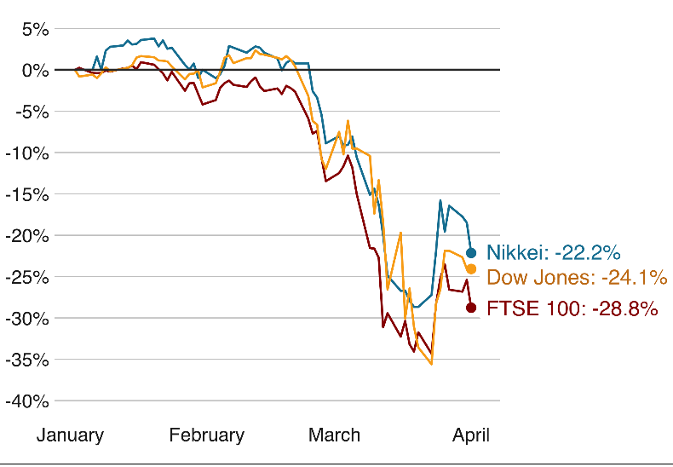
This in effects develops fear in investors that spread of coronavirus will destroy economic growth and that government action may not be enough to stop the decline. In response, central banks in many countries have slashed the interest rates which in theory making borrowing cheaper and encourage spending to boost the economy. Another of this coronavirus is on the global market being able to recover some grounds after the US senate passed a $2 trillion coronavirus aid bill to help workers and business. This coronavirus aid had also been warned by analyst to may be volatile until the pandemic is contained.
Figure 5: The impact of coronavirus on stock markets since the start of the outbreak
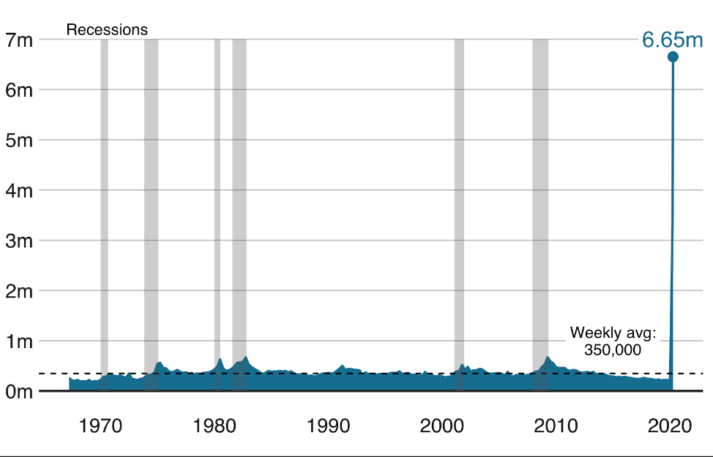
Another effect produced by the pandemic is the issue of joblessness, the number of unemployment hitting a record highly and signaling an end to a decade of expansion to one of world’s largest economies.
Figure 6: Jobless claims hit new record as more than six million people files claims as coronavirus hits
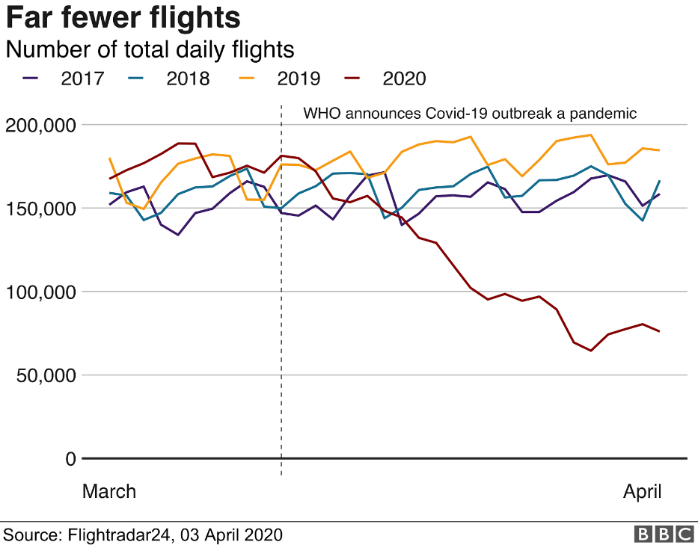
As a result of the governmental travel restrictions in effects to the coronavirus crisis, the travel industry as been badly damaged with airlines cuttings flights and tourists cancelling business trips and holidays.
Figure 7: Data from flight tracking service flight Radar 24 shows that the number of flights globally has taken a huge hit.
Other effects of the pandemic crisis on the economic stability includes countries and world capitals being put under a strict lockdown resulting form the a total halt to major industrial production chains and finally the economy growth has be said to be a halve growth to 1.5% in 2020 as factories suspend their activities and workers stay at home so as to contain the virus due to the intensive outbreak making the economic stability to fluctuate in a dropping direction for the output growth.

2.3 ENGINEERING STRATEGIES FOR HANDLING COVID-19
This includes the strategies from the engineering field which affects the environmental health and economic stability resulting from the engineering strategies deployed which are:

ADAPTATION TO THE BASIC PRINCIPLE GIVEN OFF BY THE WORLD HEALTH ORGANISATION USED IN HANDLING A PANDEMIC:
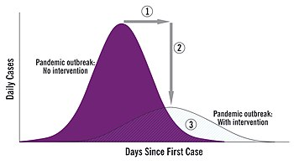
In this strategy involves the principle deployed by the world health organization to handle a pandemic could as be used as principle (strategy) by the engineering field to handle this pandemic firstly. This simply involves ‘management of the pandemic itself’. The basic strategies in the control of an outbreak are containment and mitigation. Containment may be undertaken in the early stages of the outbreak, including contact tracing and isolating infected individuals to stop the disease from spreading to the rest of the population, other public health interventions on infection control, and therapeutic countermeasures such as vaccinations which may be effective if available. When it becomes apparent that it is no longer possible to contain the spread of the disease, management will then move on to the mitigation stage, in which measures are taken to slow the spread of the disease and mitigate its effects on society and the healthcare system. In reality, containment and mitigation measures may be undertaken simultaneously.
Figure 8: The goals of community mitigation: (1) delay outbreak peak; (2) reduce peak burden on healthcare, known as flattening the curve; and (3) diminish overall cases and health impact
A key part of managing an infectious disease outbreak is trying to decrease the epidemic peak, known as "flattening the epidemic curve". This helps decrease the risk of health services being overwhelmed, and provides more time for a vaccine and treatment to be developed. Non-pharmaceutical interventions may be taken to manage the outbreak. In a flu pandemic, these actions may include: personal preventive measures such as hand hygiene, wearing face-masks, and self-quarantine; community measures aimed at social distancing such as closing schools and cancelling mass gatherings; community engagement to encourage acceptance and participation in such interventions; and environmental measures such as cleaning of surfaces.
Another strategy, under managing outbreak so as to handle the pandemic is suppression, requires more extreme long-term non-pharmaceutical interventions so as to reverse the pandemic by reducing the basic reproduction number to less than 1. The suppression strategy, which includes stringent population-wide social distancing, home isolation of cases, and household quarantine, was undertaken by China during the 2019–20 coronavirus pandemic where entire cities were placed under lockdown, but such strategy carries with it considerable social and economic costs.

DEPLOYRATION OF OPTIMIZED SUPPLY OF P.P.E
Personal protective equipment (PPE) is protective clothing, helmets, goggles, or other garments or equipment designed to protect the wearer's body from injury or infection. The hazards addressed by protective equipment include physical, electrical, heat, chemicals, biohazards, and airborne particulate matter. Protective equipment may be worn for job-related occupational safety and health purposes, as well as for sports and other recreational activities. "Protective clothing" is applied to traditional categories of clothing, and "protective gear" applies to items such as pads, guards, shields, or masks, and others. PPE suits can be similar in appearance to a cleanroom suit.
The purpose of personal protective equipment is to reduce employee exposure to hazards when engineering controls and administrative controls are not feasible or effective to reduce these risks to acceptable levels. PPE is needed when there are hazards present. PPE has the serious limitation that it does not eliminate the hazard at the source and may result in employees being exposed to the hazard if the equipment fails.
Any item of PPE imposes a barrier between the wearer/user and the working environment. This can create additional strains on the wearer; impair their ability to carry out their work and create significant levels of discomfort. Any of these can discourage wearers from using PPE correctly, therefore placing them at risk of injury, ill-health or, under extreme circumstances, death. Good ergonomic design can help to minimize these barriers and can therefore help to ensure safe and healthy working conditions through the correct use of PPE.
Practices of occupational safety and health can use hazard controls and interventions to mitigate workplace hazards, which pose a threat to the safety and quality of life of workers. The hierarchy of hazard controls provides a policy framework which ranks the types of hazard controls in terms of absolute risk reduction. At the top of the hierarchy are elimination and substitution, which remove the hazard entirely or replace the hazard with a safer alternative. If elimination or substitution measures cannot apply, engineering controls and administrative controls, which seek to design safer mechanisms and coach safer human behavior, are implemented. Personal protective equipment ranks last on the hierarchy of controls, as the workers are regularly exposed to the hazard, with a barrier of protection. The hierarchy of controls is important in acknowledging that, while personal protective equipment has tremendous utility, it is not the desired mechanism of control in terms of worker safety. The outbreak could be handled by using some of the types of the personal protective equipment which includes:

RESIPIRATORS (AIR-PURIFYING RESPIRATORS)
Respirators serve to protect the user from breathing in contaminants in the air, thus preserving the health of one's respiratory tract. There are two main types of respirators. One type of respirator functions by filtering out chemicals and gases, or airborne particles, from the air breathed by the user. The filtration may be either passive or active (powered). Gas masks and particulate respirators are examples of this type of respirator. A second type of respirator protects users by providing clean, respirable air from another source. This type includes airline respirators and self-contained breathing apparatus (SCBA). In work environments, respirators are relied upon when adequate ventilation is not available or other engineering control systems are not feasible or inadequate.
This is of great use because coronavirus is spherical and are of 120-160nm diameter of, with an envelope bearing of 20 long plug shaped projections that collectively resemble a grown or the solar corona. The ssRNA+ genome is coiled inside a helical nucleocapsid of 9-11nm diameter, at 27-32kb, coronavirus genomes are the largest among RNA viruses, they are non-segmented, five inches capped and three inches polyadenylated. This means that a respirator or a nose mask pores can prevent the coronavirus from penetrating into the nose and in response the COVID-19 situation is handled. Recall that coronavirus is a disease that affects the respiratory system.

SKIN PROTECTION
Since coronavirus as could be contracted through the fluid of an infected person on surfaces, even when an infected person sneezes or sweats, therefore skin protection such as hand gloves can be used to also handle the pandemic since it does not have a pore space for the virus to pass through. Occupational skin diseases such as contact dermatitis, skin cancers, and other skin injuries and infections are the second-most common type of occupational disease and can be very costly. Skin hazards, which lead to occupational skin disease, can be classified into four groups.
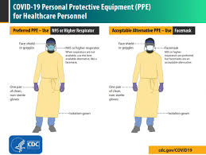
Any form of PPE that acts as a barrier between the skin and the agent of exposure can be considered skin protection. Because much work is done with the hands, gloves are an essential item in providing skin protection. Some examples of gloves commonly used as PPE include rubber gloves, cut-resistant gloves, chainsaw gloves and heat-resistant gloves. For sports and other recreational activities, many different gloves are used for protection.
Figure 9: Personal protective equipment

EYE AND HEARING PROTECTIVE
In this type of protective the major senses of the body are being protected as they covered so as to not allow form of virus penetration into the body of any kind.

HANDLING BY PRESENTATION OF A SAFE VACCINE DEVELOPED
This research, teaching and bio-pharmaceutical industrial consists consulting in the field of bio-design and optimization for bio-pharmaceutical product process development, both fundamental and applied research. In this way one can handle the case of the pandemic. In this research for the vaccine, chemical engineers are partner up with scientist and micro-biologist to find or fight for vaccine.

ESTABLISHMENT OF A PORTFOLIO FOR CONVID-19 CANDITATES AND ALSO PROVISION OF TECHNOLOGY TRANSMISION:
This becomes a strategy as to handle the covid-19 case through the provision of the technology transformation for Hepatitis B surface antigen vaccine to prevent Hepatitis B virus infection which in effects reduces the rate at which the coronavirus spread. Also, the establishment of a portfolio of covid-19 candidates through four R and B programs, in partnership with invio for funding- these promising nucleic acid technologies that deliver genes into the body to retool human cells to produce an immune response.

ENGINEERS STRATEGISING WITH THE JANSSEN PHARMACEUTICAL COMPANY FOR ANT-VIRAL THERAPIES:
This strategy would handle the pandemic situation greatly as in relieving the effects of the infection in the short term, which also offers Advac and Per.C6 technologies so that a vaccine can be produced to provide immunity. Those use bioreactors of suspended human cells to produce viral vectors that would contain the antigen of covid-19. When these are injected into the body, they safely mimic the virus, priming the immune system, so it’s ready to fight the real covid-19 virus if the person later becomes infected.

LARGE SCALE VACCINE PRODUCTION
This is another strategy in the engineering field to handle covid-19 case using chemical engineers to develop, produce, design and provide the ability to rapidly upscale production of the vaccines which includes the design of lager plant, tower, column with bigger operation techniques (such as the techniques used to manufacture the Janssens’ Ebola Vaccine) to produce more quantified, qualified and efficient vaccines to be distributed.

PROCESS IMPORVEMENT
In this strategy to handle covid-19, chemical engineers with experience develops new manufacturing plants tasked with short-term developments expected to help improve future responses to outbreaks which points to semi-continuous and continuous manufacturing processes being developed by the likes of Pall and Univercells.
On what individual process engineers could do, it is noted that the high margins on pharmaceuticals, along with regulations that effectively prevent manufacturers from changing process design have stalled the sorts of operational improvements that process engineers typically carry out in other sectors.
“By the time process engineers have got involved the process is fixed. So, when you say ‘Let’s not do batch tangential flow filtration’ or ‘Let’s not do a batch chromatography – let’s make it continuous because that’s what the kit is designed for’ it’s always too late.”
Some opportunities admit the fact of not being taken to improve operations, though notes that regulators are showing more flexibility with operating companies. And in turn, operating companies are taking on board systems thinking approaches that help drive operational improvements.
“Things are developing. As the world gets more focused on environmental forces it’s going to drive those changes.”
“the big influence process engineers can make in vaccines production is from within the equipment suppliers because they are developing the equipment and thinking how it’s joined up.”
Whereas manufacturers in the past would have to go to one company for filtration and another for reactors and so on, suppliers are now offering integrated solutions.
“Process engineers can help with that integration of equipment supply. We will then have cheaper capital cost of facilities, cheaper operational costs, and less supplier interfaces.”
“Process engineering in this field is still relatively young compared to standard small molecules, oil and gas. It’s a very interesting and challenging area for process engineers.”

THE MATHEMATICAL MODELLING FOR CORONAVIRUS AS A FIRST-HAND STRATEGY
Mathematical model is description of a system using mathematical concepts and language. The process of developing the mathematical model is termed mathematical modelling. A model may help to explain a system and to study the effects of different components, and to make predictions about behaviour. In the quest for a mathematical model to estimate the transmissibility and the dynamic of transmission of the virus, the elements of the model must contain governing equations, supplementary sub-models, Assumptions and constraints. There are several researches focusing on mathematical modelling, these researches focused on calculating the basic reproduction number (R0) by using the serial intervals and intrinsic growth rate, or using ordinary differential equations and Markov Chain Monte Carlo methods. However, the bat origin and the transmission route form the seafood market to people were not considered in the published models.
This strategy develops a Bats-Hosts-Reservoir-People (BHRP) transmission network model for simulating the potential transmission from the infection source (probably be bats) to the human infection. Since the Bats-Hosts-Reservoir network is hard to explore clearly and public concerns were focusing on the transmission from Seafood Wholesale (reservoir) to people, the model is simplified as Reservoir-People (RP) transmission network model, and R0 was calculated based on the RP model to assess the transmissibility of the SARS-CoV-2.
This involves Simulation methods and statistical analysis such as Berkeley Madonna 8.3.18 employed for the curve fitting. The fourth-order Runge–Kutta method, with tolerance set at
0.001, was used to perform curve fitting. While the curve fitting is in progress, Berkeley Madonna displays the root mean square deviation between the data and best run so far. The coefficient of determination (R2) was employed to assess the goodness-of-fit. SPSS 13.0 was employed to calculate the R² with the help of all this simulation and modelling the coronavirus can be handled.

THE USE OF ARTIFICIAL INTELLIGENCE TO FIGHT COVID-19
Artificial intelligence (AI) are the machines which are programmed and designed in such a way that they act and think like a human. The introduction of AI brings an idea of the error-free world and slowly introduce in all the sector that reduce human effort and give an accurate and faster result.
Coronavirus could be tackled using Artificial intelligence through playing a part in each stage of the covid-19 pandemic, from predicting the spread of the novel coronavirus to powering robots that can replace humans in the hospital wards.
Figure 10: Artificial intelligence
In the pursue of handling covid-19, the artificial intelligence could play a role of an immediate application of processing large amounts of data to find treatments, reducing the spread, and treating ill patients. In these roles to be played by the AI, it is important for basis of where we are on the pandemic cycle. For example, using the artificial intelligence, the Canadian health surveillance startup Blue Dot being among the first in the world to accurately identify the spread of covid-19 and its risk according to CNBC. In late, December, the startup’s AI software discovered a cluster of unusual pneumonia cases in Wuhan, China and predicted where the virus might go next, but imagine the number of lives that would have been saved if the virus spread was mitigated and the global response was triggered sooner. Another thing AI can do to handle the pandemic is to help the researchers scour through the data to find potential treatments. The artificial intelligence (AI) uses a natural language processing to analyze tens of thousands of scientific research papers at an unprecedented pace.
The use of AI limits the human interaction since the stay-at-home order is one-way AI can help fight the pandemic such as people being able to order groceries without stepping foot inside a store. Also, robots replacing clinicians in hospitals, help disinfect rooms, provide telehealth services and process and analyze covid-19 test samples. For example, the fist patient diagnosed with covid-19 in Everett-Wash was treated with a robot as said by the province regional medical centre. The AI raises privacy and ethics concerns amid pandemic despite the AI’s positive role in fighting the pandemic, the privacy and ethical questions raised can not be overlooked with respect to the stay at home order, using the location data from smartphones to help track, but there would still be long term arising implications such as deploying robots to take hospital wards which in view helps reduces spread but also displaces staff because job losses resulting from automation is already at the forefront of many discussions.

THE USE OF VENTILATORS
Ventilators are machines that provides mechanical ventilation by moving breathable air into and out of the lungs, to deliver breathable to a patient who is physically unable to breathe or breathing insufficiently. The use of ventilators recognized the engineering field to be a major important strategy in fighting coronavirus since the virus is a disease that attacks the respiratory system severely, therefore not allowing the patients to breath in properly. The ventilator could serve as an important machine for the patients to take in air.

DONATIONS
Another important strategy for engineers is donations, as important as any discovery is the financial aspect that would fund the research so much important, therefore engineers should not only deposit their knowledge but also funds or money.

POLICIES
A strategy which is inevitable should be offer by the engineers to the government to be treated as serious as possible so as to prevent spread of the virus.

CHAPTER THREE
3.0 METHODOLOGY

3.1 CASE STUDIES

3.1 CASE STUDIES ON THE EFFECTS OF CORNAVIRUS ON ENVIRONMENTAL HEALTH

CASE 1: CHINA
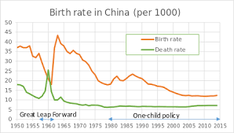
Population: In the past 15 years China has experienced numerous public health crises caused by diseases outbreak including severe Acute Respiratory Syndromes (SARS) in 2003 and influenza- a virus subtype H7N9 in 2013. These epidemics such as SARS and H7N9 have caused huge negative impacts on the population health and the economy, but this case coronavirus which has become a pandemic bringing a threatened national and even international security. The effects of the covid-19 on China’s environmental health can be seen through the increase in the death rate causing reduction in population. This year the death rate would reduce more than usual of any other year, as shown below:
Figure 11: Birth and Death rate in china from 1950 to 2015
The SARS outbreak infected thousands of people, causing widespread serious illness across a large population and many deaths. According to WHO, 648 of the 8082 probable cases of SARS in mainland China and Hong Kong died initial after the release. Worldwide, in just 3 months, there were more than 8000 infected individuals, with over 700 deaths (almost 9% of infected cases). The psychological impact of SARS was also very serious. The distress was more prominent among the groups of nurses who were working with patients with SARS. Studies show that the SARS outbreak also fostered negative impacts on people’s mental health, as mentioned by two hospital doctors: These SARS cases caused extreme emotional sadness. Psychologically it is entirely possible that an event destroyed a person. They needed psychological counselling. As SARS cases live in the hospital, people won’t be able to see their family, and feared the treatment, developing a mental disorder.
In the case of identifying the effects of environmental health in china caused by the pandemic, the elements are also examined:
The outdoor air quality: As a result of the lockdown in response to coronavirus, the air quality as been seen to have been free from industrial air pollution, providing cleaner air in the environment.
Surface and ground water quality: China as a case study is viewed that their surface and ground water quality reduced due to the disease that could is transmitted through fluids.
Toxic substances and hazardous wastes: the environmental health had also been helped by the pandemic, since companies can’t be able to produce goods over there, toxic substances such as waste resulting from end product has been reduced greatly.
Homes and communities: These include Indoor air pollution, Inadequate heating and sanitation, Structural problems, Electrical and fire hazards, and Lead-based paint hazards of china which is seen to have increased exponentially, but has the air pollution as reduced by 25 percent in China the homes and communities as increased by that same proportion reduced of the outside pollution.
Infrastructure and surveillance: Coronavirus in China as brought the surveillance and infrastructure in china to a big pause. Preventing exposure to environmental hazards relies on many partners, including state and local health departments. Personnel, surveillance systems, and education are important resources for investigating and responding to disease, monitoring for hazards, and educating the public, therefore bringing another method of putting the environmental hazard to pause.
Global Environmental Health: Coronavirus in china as brought simply a global health disorder such like the Water quality being an important global challenge, The coronavirus outbreak has affected the global environmental health by creating a medium of awareness through the need for sanitation, because coronavirus can also pollute water and if this is productive, it would be disastrous one has people with the virus would increase largely and in response increasing the death rate in china.

CASE 2: NIGERIA
In Nigeria, the pandemic has been declared has a dangerous disease by our president, meaning it has the potential of bring harm to the body of environmental health as seen in our death rate and health dispersity increasing. In result to the presidential speech,the government’s chief lawyer, Attorney General Abubakar Malami, dismissed a reported legal challenge on the propriety of Buhari’s lockdown orders of March 29. He said the quarantine act empowered the president to restrict movement when a “dangerous disease” breaks out.

CASE 3: INDIA
In India, it is seen through their environmental health, their air quality as been spotted to be cleaner and more visible since lockdown due to the pandemic. This increase in the visible air in the air quality was seen to be as a result of the decrease in the use of fossil fuels burning which is a 2.5micronones smaller than the cubic of a human hair, this fossil fuel also do causes bad respiratory system but due to the decrease in it the environmental health is now in a good condition for them in India.

CASE 4: ECONMIC SUSTAINANCE
The economic sustainability of various companies as been sited to be unstable, businesses such as Football clubs are now losing their funds to run the club gradually as they stay more lockdown at home. The president of united state-Donald Trump also had a say on the economy sustainability saying that it is better to heal firstly (and on this having a 49% to 48% win).

3.1 CASE STUDY ON THE EFFECTS OF CORONAVIRUS ON ECONOMIC SUSTAINABILITY
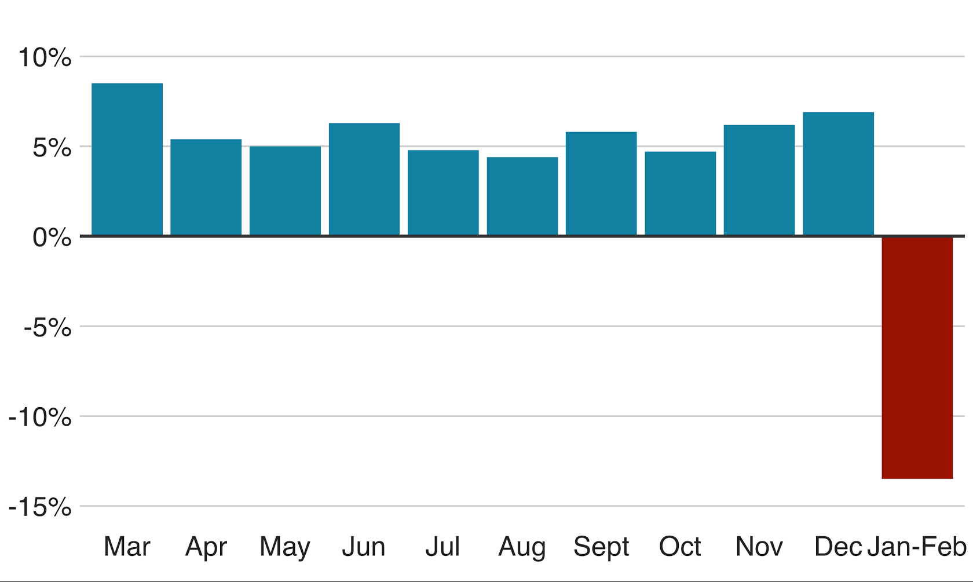
A major case study of this effect can be seen from where the virus was found in, which is in China, Wuhan city. In china, where the coronavirus first appeared, industrial production, sales and investment all fell into the first two month of the year, compared with the same period in 2019. China makes up a third of manufacturing globally and is the world’s largest exporter of goods. The pandemic had affected their economy severely in sense of their production, for example, their industrial production fell by 13.5% in the first two months of the year as shown below:
Figure 12: China's industrial production falling
Another example of the case study of how the coronavirus has affected China’s economy is on their car sales, due to the restrictions that has affected the supply chains of the big companies such as the industrial equipment manufacturer JCB and carmaker Nissan, shops and car dealerships have all reported a fall in the demand, also an indication was made that china’s car demand dropped by 86%in February. Forcing more carmakers such as Telsa or Geely to now sell cars online as customers stay away from showrooms, this fall in the car sales in China are shown below:
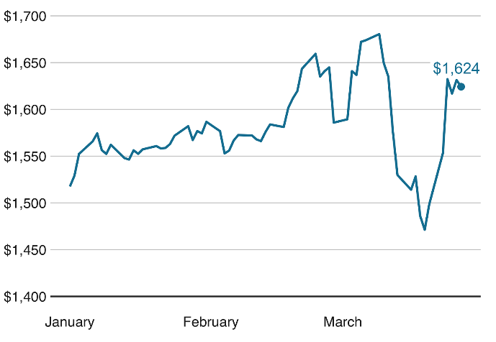
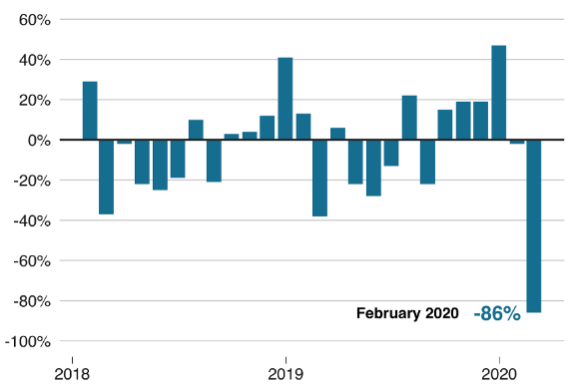
Another case study in effect to economy stability is the issue of Gold investment, in a time of crisis, investors often choose less risky investments. Since Gold is traditionally considered a ‘safe haven’ for investment in times of uncertainty, the price of gold tumbled briefly in march, as investors were fearful about a global recession.
Figure 13: The value of Gold jumping back
Figure 14: Indication of car sales falling

Another case study is the oil price being affected by a row between Opec, the group of oil producers, and Russia, this is also seen in Nigeria, Italy, America, Dubai and other countries. Coronavirus has driven the price down further as shown below:
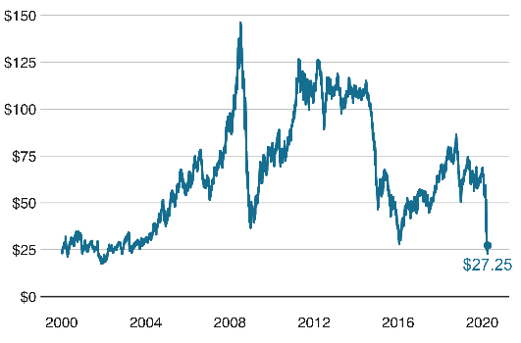
Figure 15: oil price rallies

CASE STUDIES OF THE ENGINEERING STRATEGIES OFFERING SOLUTIONS TO THE ENVIRONMENTAL HEALTH AND ECONOMIC SUSTAINABILITY

CASE 1:
The initial strategy is to initiate the deployed principle given by the world health organization for managing Pandemic situations. A good example of this principle deployed is in Nigeria in initiating the lockdown, following the principle stage by stage in order to achieve a good goal of eradicating the disease. This stage involves containment, mitigation, suppression etc.
Figure 16: Figure 6: The goals of community mitigation: (1) delay outbreak peak; (2) reduce peak burden on healthcare, known as flattening the curve; and (3) diminish overall cases and health impact

CASE 2:
Another case study deployed as an engineering strategy is in artificial intelligence, taking Italy has a case study where their environmental health is in a hazardous state, where movement is completely shut down due to high case value found in their country. In this country where the doctors work non-stop, robots sourced from AI could be used efficiently to a very great advantage. For example, using the artificial intelligence, the Canadian health surveillance startup Blue Dot being among the first in the world to accurately identify the spread of covid-19 and its risk according to CNBC. In late, December, the startup’s AI software discovered a cluster of unusual pneumonia cases in Wuhan, China and predicted where the virus might go next, but imagine the number of lives that would have been saved if the virus spread was mitigated and the global response was triggered sooner. Another thing AI can do to handle the pandemic is to help the researchers scour through the data to find potential treatments. The artificial intelligence (AI) uses a natural language processing to analyze tens of thousands of scientific research papers at an unprecedented pace.

CASE 3: BODY PROTECTION
The case seen from body protection failure was initially seen from Italy due to their citizens inability to comply with the simply the protection. This case could be solved from one of the strategies offered by engineering which is the use of personal protective equipment.

CASE 4: MONITORING THE PANDEMIC SITUATION AND ITS TRANSMISSIBILITY
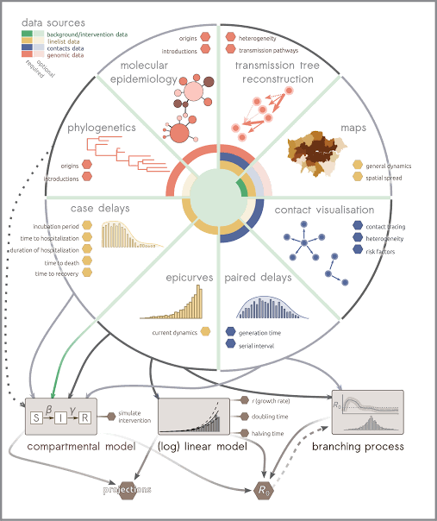
In this case, countries such as Nigeria quietly employed the use mathematical modelling for the coronavirus, this modelling is an engineering strategy which involves adequate simulation in monitoring the virus spread. This strategy develops a mathematical model to estimate transmissibility and dynamic transmission of the virus.
Figure 17: Modelling and Simulation for the virus spread

CHAPTER FOUR
4.0 RESULT AND ANALYSIS (DISCUSSION) OF RESULT

4.1 RESULT: CHINA AS CASE STUDY WITH RESPECT TO ENVIRONMENTAL HEALTH AND ECONMIC SUSTAINABILITY
All discoveries, research and teaching seen in china about the virus includes;
Symptoms of COVID-19 are non-specific and the disease presentation can range from no symptoms (asymptomatic) to severe pneumonia and death. As of 20 February 2020, and based on 55924 laboratory confirmed cases, typical signs and symptoms include: fever (87.9%), dry cough (67.7%), fatigue (38.1%), sputum production (33.4%), shortness of breath (18.6%), sore throat (13.9%), headache (13.6%), myalgia or arthralgia (14.8%), chills (11.4%), nausea or vomiting (5.0%), nasal congestion (4.8%), diarrhea (3.7%), and hemoptysis (0.9%), and conjunctival congestion (0.8%). People with COVID-19 generally develop signs and symptoms, including mild respiratory symptoms and fever, on an average of 5-6 days after infection (mean incubation period 5-6 days, range 1-14 days). Most people infected with COVID-19 virus have mild disease and recover. Approximately 80% of laboratory confirmed patients have had mild to moderate disease, which includes non-pneumonia and pneumonia cases, 13.8% have severe disease (dyspnea, respiratory frequency ≥30/minute, blood oxygen saturation ≤93%, PaO2/FiO2 ratio <300, and/or lung infiltrates >50% of the lung field within 24-48 hours) and 6.1% are critical (respiratory failure, septic shock, and/or multiple organ dysfunction/failure). Asymptomatic infection has been reported, but the majority of the relatively rare cases who are asymptomatic on the date of identification/report went on to develop disease. The proportion of truly asymptomatic infections is unclear but appears to be relatively rare and does not appear to be a major driver of transmission. Individuals at highest risk for severe disease and death include people aged over 60 years and those with underlying conditions such as hypertension, diabetes, cardiovascular disease, chronic respiratory disease and cancer. Disease in children appears to be relatively rare and mild with approximately 2.4% of the total reported cases reported amongst individuals aged under 19 years. A very small proportion of those aged under 19 years have developed severe (2.5%) or critical disease (0.2%). based on 55924 laboratory confirmed cases, typical signs and symptoms include: fever
(87.9%), dry cough (67.7%), fatigue (38.1%), sputum production (33.4%), shortness of breath
(18.6%), sore throat (13.9%), headache (13.6%), myalgia or arthralgia (14.8%), chills (11.4%),
nausea or vomiting (5.0%), nasal congestion (4.8%), diarrhea (3.7%), and hemoptysis (0.9%),
and conjunctival congestion (0.8%).
People with COVID-19 generally develop signs and symptoms, including mild respiratory
symptoms and fever, on an average of 5-6 days after infection (mean incubation period 5-6
days, range 1-14 days). Most people infected with COVID-19 virus have mild disease and recover. Approximately 80% of laboratory confirmed patients have had mild to moderate disease, which includes non-pneumonia and pneumonia cases, 13.8% have severe disease (dyspnea, respiratory frequency ≥30/minute, blood oxygen saturation ≤93%, PaO2/FiO2 ratio <300, and/or lung infiltrates >50% of the lung field within 24-48 hours) and 6.1% are critical (respiratory failure, septic shock, and/or multiple organ dysfunction/failure). Asymptomatic infection has been reported, but the majority of the relatively rare cases who are asymptomatic on the date of identification/report went on to develop disease. The proportion of truly asymptomatic infections is unclear but appears to be relatively rare and does not appear to be a major driver of transmission. Individuals at highest risk for severe disease and death include people aged over 60 years and those with underlying conditions such as hypertension, diabetes, cardiovascular disease, chronic respiratory disease and cancer. Disease in children appears to be relatively rare and mild with approximately 2.4% of the total reported cases reported amongst individuals aged under 19 years. A very small proportion of those aged under 19 years have developed severe (2.5%) or critical disease (0.2%).
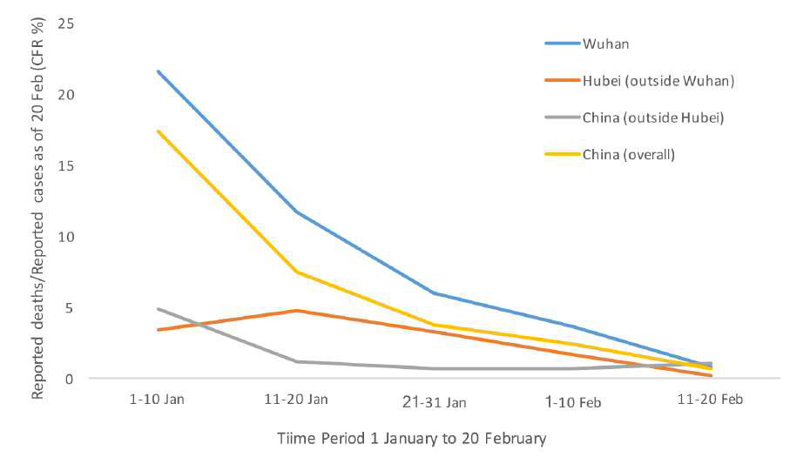
Figure 18: Case fatality ratio (reported deaths among total cases) for COVID-19 in China over

4.2 ANALYSIS OF RESULT

DISCLOSURE OF THE ADEQUATE ENGINEERING STRATEGIES DEPLOYED BY CHINA USING THE COUNTRY AS CASE STUDY
The analysis of result using China as a major case study deploying engineering strategies to make life easier (which is the preferential aim of an engineer), it was seen that in trying to sustain their economy and also have a stable environmental health, china deployed a stage-like principle;
- Stage 1:
During the early stage of the outbreak, the main strategy focused on preventing the exportation of cases from Wuhan and other priority areas of Hubei Province, and preventing the importation of cases by other provinces; the overall aim was to control the source of infection, block transmission and prevent further spread. The response mechanism was initiated with multi-sectoral involvement in joint prevention and control measures. Wet markets were closed, and efforts were made to identify the zoonotic source. Information on the epidemic was notified to WHO on 3 January, and whole genome sequences of the COVID-19 virus were shared with WHO on 10 January. Protocols for COVID-19 diagnosis and treatment, surveillance, epidemiological investigation, management of close contacts, and laboratory testing were formulated, and relevant surveillance activities and epidemiological investigations conducted. Diagnostic testing kits were developed, and wildlife and live poultry markets were placed under strict supervision and control measures.

- Stage 2:
In this stage of the outbreak, the main strategy was to reduce the intensity of the epidemic and to slow down the increase in cases. In Wuhan and other priority areas of Hubei Province, the focus was on actively treating patients, reducing deaths, and preventing exportations. In other provinces, the focus was on preventing importations, curbing the spread of the disease and implementing joint prevention and control measures. Nationally, wildlife markets were closed and wildlife captive-breeding facilities were cordoned off. On 20 January, COVID-19 was included in the notifiable report of Class B infectious diseases and border health quarantine infectious diseases, with temperature checks, health care declarations, and quarantine against COVID-19 instituted at transportation depots in accordance with the law. On 23 January, Wuhan implemented strict traffic restrictions. The protocols for diagnosis, treatment and epidemic prevention and control were improved; case isolation and treatment were strengthened. Measures were taken to ensure that all cases were treated, and close contacts were isolated and put under medical observation. Other measures implemented included the extension of the Spring Festival holiday, traffic controls, and the control of transportation capacity to reduce the movement of people; mass gathering activities were also cancelled. Information about the epidemic and prevention and control measures was regularly released. Public risk communications and health education were strengthened; allocation of medical supplies was coordinated, new hospitals were built, reserve beds were used and relevant premises were repurposed to ensure that all cases could be treated; efforts were made to maintain a stable supply of commodities and their prices to ensure the smooth operation of society.

- Stage 3
The third stage of the outbreak focused on reducing clusters of cases, thoroughly controlling the epidemic, and striking a balance between epidemic prevention and control, sustainable economic and social development, the unified command, standardized guidance, and scientific evidence-based policy implementation. For Wuhan and other priority areas of Hubei Province, the focus was on patient treatment and the interruption of transmission, with an emphasis on concrete steps to fully implement relevant measures for the testing, admitting and treating of all patients. A risk-based prevention and control approach was adopted with differentiated prevention and control measures for different regions of the country and provinces. Relevant measures were strengthened in the areas of epidemiological investigation, case management and epidemic prevention in high-risk public places. New technologies were applied such as the use of big data and artificial intelligence (AI) to strengthen contact tracing and the management of priority populations. Relevant health insurance policies were promulgated on "health insurance payment, off-site settlement, and financial compensation". All provinces provided support to Wuhan and priority areas in Hubei Province in an effort to quickly curb the spread of the disease and provide timely clinical treatment. Pre-school preparation was improved, and work resumed in phases and batches. Health and welfare services were provided to returning workers in a targeted and ‘one-stop’ manner. Normal social operations are being restored in a stepwise fashion; knowledge about disease prevention is being popularized to improve public health literacy and skills; and a comprehensive program of emergency scientific research is being carried out to develop diagnostics, therapeutics and vaccines, delineate the spectrum of the disease, and identify the source of the virus.

ANOTHER CASE STUDY THAT IS CAPTIVATING IS THE RESPONSE GLOBALLY
The COVID-19 virus is a new pathogen that is highly contagious, can spread quickly, and must be considered capable of causing enormous health, economic and societal impacts in any setting. It is not SARS and it is not influenza. Building scenarios and strategies only on the basis of well-known pathogens risks failing to exploit all possible measures to slow transmission of the COVID-19 virus, reduce disease and save lives. COVID-19 is not SARS and it is not influenza. It is a new virus with its own characteristics. For example, COVID-19 transmission in children appears to be limited compared with influenza, while the clinical picture differs from SARS. Such differences, while based on limited data, may be playing a role in the apparent efficacy of rigorously applied non-pharmaceutical, public health measures to interrupt chains of human-to human transmission in a range of settings in China. The COVID-19 virus is unique among human coronaviruses in its combination of high transmissibility, substantial fatal outcomes in some high-risk groups, and ability to cause huge societal and economic disruption. For planning purposes, it must be assumed that the global population is susceptible to this virus. As the animal origin of the COVID-19 virus is unknown at present, the risk of reintroduction into previously infected areas must be constantly considered. The novel nature, and our continuously evolving understanding, of this coronavirus demands a tremendous agility in our capacity to rapidly adapt and change our readiness and response planning as has been done continually in China. This is an extraordinary feat for a country of 1.4 billion people.

STRATEGIC ENGINEERING STRATEGIES DEPLOYRATION ON CONTAINMENT
China’s uncompromising and rigorous use of non-pharmaceutical measures to contain transmission of the COVID-19 virus in multiple settings provides vital lessons for the global response. This rather unique and unprecedented public health response in China reversed the escalating cases in both Hubei, where there has been widespread community transmission, and in the importation provinces, where family clusters appear to have driven the outbreak. Although the timing of the outbreak in China has been relatively similar across the country, transmission chains were established in a wide diversity of settings, from megacities in the north and south of the country, to remote communities. However, the rapid adaptation and tailoring of China’s strategy demonstrated that containment can be adapted and successfully operationalized in a wide range of settings. China’s experience strongly supports the efficacy and effectiveness of anchoring COVID-19 readiness and rapid response plans in a thorough assessment of local risks and of utilizing a differentiated risk-based containment strategy to manage the outbreak in areas with no cases vs. sporadic cases vs. clusters of cases vs. community-level transmission. Such a strategy is essential for ensuring a sustainable approach while minimizing the socio-economic impact.

Table 1: CASE STUDY OF AN INTIAL VIRUS SHOWING ITS SEVERE IMPACT
CATEGORIES | SARS | H7N9
Health effects | (i) In 2003 in China: 5327 cases, 349 deaths; mortality  rate 6.6%  (ii) By 11 July 2003, the virus had spread to 29 countries and regions, with a cumulative number of confirmed cases of 8096 people, 774 people deaths and an average death rate of 9.6%. | (i) In 2013 in China: 135 cases, 45 deaths; mortality rate 33.6%  (ii) By December 3, 2013, a total of 148 cases of H7N9  avian influenza was confirmed on the Chinese  mainland, Taiwan and Hong Kong area, where 48 died,  with a case fatality rate of 32.43%
Social impacts | Panic, criticized  (i)Information was “doctored” and delayed.  (ii) Rumors and social chaos  (iii)Food, salt and Banlangen (Radix Isatidis) were sold out  (iv) Flights were cancelled  (v) Schools were closed  (vi) large mass-gathering events cancelled | Social stability, praised  (i) Reliable information, promptly released  (ii) No social chaos  (iii) The management of the problem satisfied both the Chinese and international community.
Economic impacts | (i)The global macroeconomic impact of SARS was estimated at USD 30–100 billion or around USD 3–10 million per case  (ii) Caused losses of USD 12.3-28.4 billion and an estimated decrease of 1% in GDP in China | (i) China’s poultry industry suffered a loss of more than  40 billion RMB  (ii) There was little economic impact in the global community

4.3 PRECAUTIONS:
It should be ensured that in all prevention analyzed by the world health organization should be put in place and take seriously.
Key epidemic indicators that inform evidence-based control strategy decision making
and adjustments
- Effectiveness of infection prevention and control (IPC) measures in various health
care settings.
- Effectiveness of entry and exit screening
- Effectiveness of the public health control measures and their socio-economic impact
o Restriction of movement
o Social distancing
o School and workplace closures
o Wearing mask in general public
o Mandatory quarantine
o Voluntary quarantine with active surveillance

4.4 OBSERVATIONS
Observations such as samples should be first rendered in a pilot scale before advancing down to the larger scale.
During the course of the research it was observed that Transmission on dynamics was seen below:
    - Modes of Transmission:
o Role of aerosol transmission in non-health care settings
o Role of fecal-oral transmission
- Viral shedding in various periods of the clinical course in different biological samples
(i.e. upper and lower respiratory tract, saliva, faeces, urine)
o Before symptom onset and among asymptomatic cases
o During the symptomatic period
o After the symptomatic period / during clinical recovery

CHAPTER FIVE

CONCULSION AND RECOMMENDATIONS

5.1 CONCLUSIONS
The outbreaks of SARS represented serious public health emergency crisis events in China, and both had significant impacts on health, society, and the economy. The virus had not been reported in human beings previously. They both can lead to severe disease, characterized by high fever, severe respiratory symptoms, and death, and there are still no specific antiviral drugs and vaccines for them. SARS coronavirus is thought to be an animal virus arising from an as-yet-unknown animal reservoir (perhaps bats) that spread to other animals (civet cats) and then to the first infected humans in Wuhan city, China in 2019.the animal reservoir is poultry. Worldwide, people of all ages had little protective immunity and coronavirus presents a global epidemic threat. China’s emergency management of the epidemics is difficult, despite the suppression done as an engineering strategy, SARS has the fact of increasing the mortality rate, control efforts for SARS. An effective and efficient emergency response can reduce avoidable mortality and morbidity and reduce the economic, social, and security impacts of all public health emergencies including disease outbreaks. The effectiveness of emergency preparedness and responses is highly dependent on the quality and amount of information that is available at any given time, and quality communication and coordination among partners is crucial. Information sharing and communication are considered key tools for the coordination of prevention and management of infectious diseases.
The engineering strategies providing in this context work could extremely eradicate the spread of coronavirus and these strategies includes; adaption to the principle for handling pandemic provided by the world health organization, provision of technology transformation, the use of artificial intelligence, establishment of a portfolio of covid-19 candidates through R and B programs and the use of mathematical modelling in this situation can completely sustain the environmental health and bring about a sustainable economy.
In conclusion, the aim of handling anything is to maintain it so as not to to go out of control,now likewise the coronavirus is handled so as not go out of hand, meaning controlling it by subjecting it through subjection of various strategy but in this case of this context we examine the subjection of engineering strategy to control the virus simply, such as Countries such as Italy using drones to monitor the people’s lockdown. The president of America, Donald Trump on Saturday 11th, 2020 says Economy is not the issue but health is the major thing right time, indicating that activity to bring the economy to sustainance could be brought to a pause.
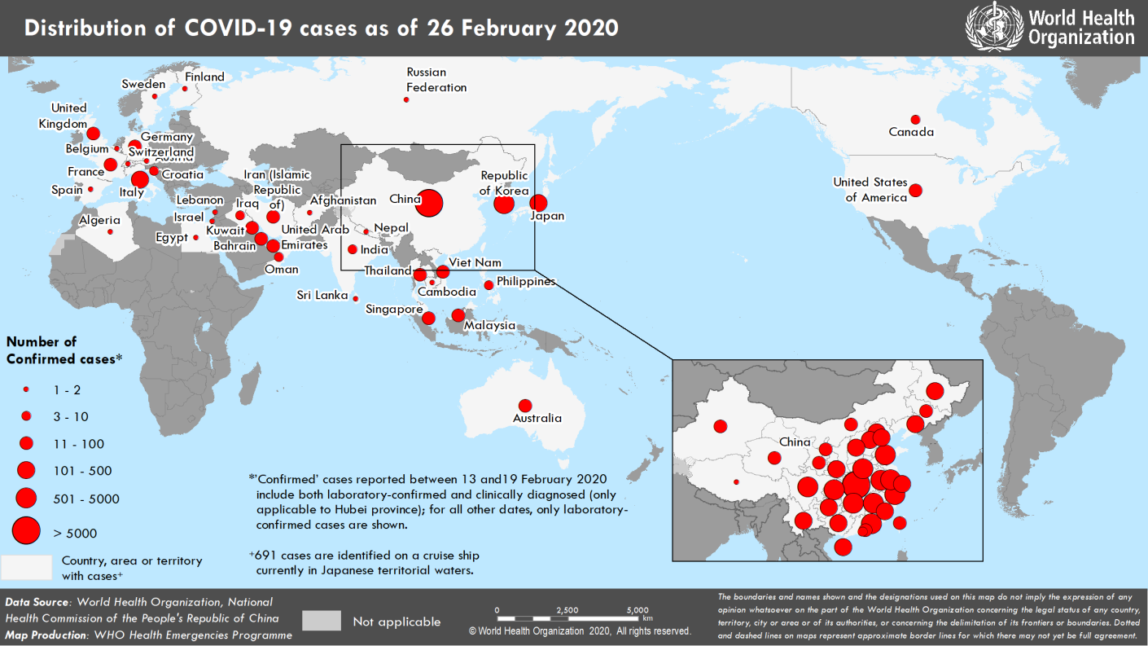
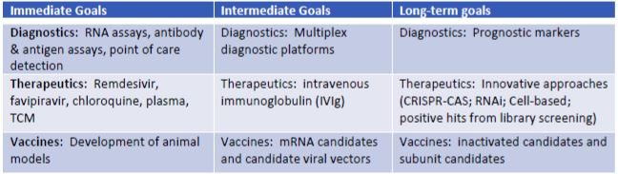
Figure 19: DISTRIBUTION OF COVID-19 CASES AS OF FEBRUARY 2020
Figure 20: Conclusion aim of any engineering strategy
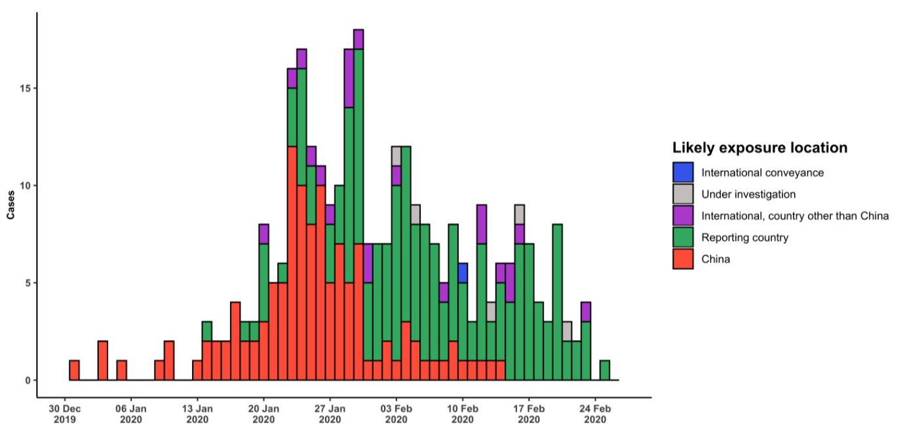
Figure 21: EXPOSURE RATE OUTSIDE CHINA

5.2 RECOMMENDATIONS
During the course of the research, I took notes of some things which may be of great interest such as the difficulties faced on lockdown from the spread of coronavirus are a sufficient justification for ending the pandemic. Government should as a matter of urgency, make stringent laws, provide basic amenities of living to a livable extent for the people and take drastic action against defaulters not just by payment of fines. Fines for defaulting companies should be so exorbitant so as to deter them. Furthermore, the environmental health and sustainable economy could be saved severely through the use of the engineering strategies. Environmentalists, scientist, engineers, microbiologist, chemist and doctors should continue in their quest to end this pandemic.
In view of this, I write to propose some recommendations which should be considered during the course of water resource management research and they are as follows;
  - The use of artificial intelligence to analyze data and limit the communication between human to human.
  - The Nigerian government could help minimize the impact of COVID-19 on the most vulnerable businesses and citizens by providing incentives and safety nets to the most affected: Through targeted tax incentives, social transfers, and regulatory support.
  - The lockdown strategy with social distancing should be taking seriously.
  - Expansion of the laboratories used in research work
  - In Nigeria, governmental agencies are always relying on the knowledge of the white men, which quite good in some ways, but not allowing our own practitioners to perform, not funding them and giving them an opportunity to prove their worth is a bad thing. Therefore, Nigerian practitioners should be offered the privilege with basic amenities to source the research program or work. For example, in Nigeria there a many microbiologist who could also partake in the sourcing for the cure of the virus but due to lack of government intervention in funding or financing they can’t undergo what mend to do.
  - An appropriate level of emergency management protocols, depending on the assessed risk in each area and recognizing the real risk of new cases and clusters of COVID-19 as economic activity resumes, movement restrictions are lifted, and schools reopen;
  - Carefully monitor the phased lifting of the current restrictions on movement and public gatherings, beginning with the return of workers and migrant labor, followed by the eventual reopening of schools and lifting other measures;
  - Further strengthen the readiness of emergency management mechanisms, public health institutions (e.g. CDCs), medical facilities, and community engagement mechanisms to ensure sustained capacity to immediately launch containment activities in response to any resurgence in cases;
  - Prioritize research that rapidly informs response and risk management decisions, particularly household and health care facility studies, age-stratified seroepidemiologic surveys and rigorous investigation of the animal-human interface; establish a centralized research program to fast-track the most promising rapid diagnostics and serologic assays, the testing of potential antivirals and vaccine candidates, and Chinese engagement in selected multi-country trials; and
  - As the country with the greatest knowledge on COVID-19, further enhance the systematic and real-time sharing of epidemiologic data, clinical results and experience to inform the global response.
  - Recognize that true solidarity and collaboration is essential between nations to tackle the common threat that COVID-19 represents and operationalize this principle;
  - Rapidly share information as required under the International Health Regulations (IHR) including detailed information about imported cases to facilitate contact tracing and inform containment measures that span countries;
  - Recognize the rapidly changing risk profile of COVID-19 affected countries and continually monitor outbreak trends and control capacities to reassess any ‘additional health measures’ that significantly interfere with international travel and trade.
  - Efforts should be made to consistently evaluate existing and future diagnostic tests for detection of COVID-19 using a harmonized set of standards for laboratory tests and a biorepository that can be used for evaluating these tests.
  - Consider the establishment of a centralized research program in China to oversee that portfolio and ensure the most promising research (vaccines, treatments, pathogenesis) are adequately supported and studied first; program staff dedicated to the clinical research would work at the clinical research site(s) to decrease the research workload of the clinicians at the site
  - Consider including one or more sites within China in the ongoing and future multicenter, international trials; Chinese investigators should be actively engaged in international trials
  - Continue to develop additional animal models, making every effort to ensure these mimic human infection and virus transmission as closely as possible
  - Conduct studies to determine which of the commonly used forms of PPE are most effective in controlling the spread of COVID-19.
  - Continue to perform whole genome analysis of COVID-19 viruses isolated from different times and places, to evaluate virus evolution.
  - Conduct pathogenesis studies using biopsy/post-mortem specimens of COVID-19 patients or infected animal models.
  - Evaluate available nucleic acid PCR diagnostics
  - Rapidly develop and evaluate rapid/point-of-care diagnostics and serologic assays
  - Conduct further study to interpret the result of positive COVID-19 RNA detection in feces in patients recovering from COVID-19
  - Enhance international cooperation, especially in terms of biosafety and information sharing for increased understanding of the COVID-19 virus and traceability of the virus.
  - Consider monitoring proinflammatory cytokines via multiplex assays to predict the development of “cytokine storm”.
  - Ensure processes are in place for infection prevention among the most vulnerable, including the elderly
  - Ensure readiness to provide clinical care and to meet IPC needs, including:
- anticipated respiratory support requirements (e.g. pulse oximeters, oxygen, and invasive support where appropriate)
b. national guidelines for clinical care and IPC, revised for COVID-19, enhanced uptake of influenza and pneumococcal vaccine according to national guidelines
c. nationally standardized trainings for disease understanding and PPE use for HCWs
d. community engagement, rapid response teams, laboratory testing e. PPE and Medication stockpiles, treatment protocols including designated facilities, patient transportation, early identification protocols; triage, temperature screening, holding bays (triage, including pulse oximetry).
  - Reassess risk and capacities based on different stages of the outbreak; approve different measures during the different phases of the response; assess different stages of the response; reach a balance between response and social development
  - Initiate a timely scientific evidence based, efficient and flexible joint multi-sectoral mechanism, which is driven by strong government leadership.

REFERENCES
[1.] F. Chen, S. Cao, J. Xin, and X. Luo, “Ten years after SARS: where was the virus
from?” Journal of Thoracic Disease, vol. 5, Suppl 2, p. S163, 2013.
[2.] W. Tong, “Construction of the, Prevention-Active, Public Health Emergency
Management Mode Reflection on Response to SARS and A/H1N1 Incidents,” Journal
of University of Electronic Science and Technology of China (Social Sciences
Edition), vol.15, no. 1, 2013.
[3.] E. Wish nick, “Dilemmas of securitization and health risk management in the People’s
Republic of China: The cases of SARS and avian influenza,” Health Policy and
Planning, vol. 25, no. 6, pp. 454–466, 2010.
[4.] Smith, “Responding to global infectious disease outbreaks: lessons from SARS on the
role of risk perception, communication and management,” Social science & medicine,
vol. 63, no. 12, pp. 3113–3123, 2006.
[5.] L. Mackellar, “Pandemic influenza: A review,” Population and Development Review,
vol. 33, no. 3, pp. 429–451, 2007.
[6.] L. Du, B. Luo, J. Wang, B. Pan, J. Chen, and J. Liu, “Study on Social Burden of ASRS
in Guangzhou,” Chinese Journal of Public Health Management, vol. 22, no. 4, pp.
274–276, 2006.
[7.] Zhang, “The impact of SARS on China’s economy should not be underestimated,”
Journal of Guizhou University (Social Science), vol. 21, no. 4, pp. 48–50, 2003.
[8.] B. Zeng, R. W. Carter, and T. De Lacy, “Short-term perturbations and tourism effects:
The case of SARS in China,” Current Issues in Tourism, vol. 8, no. 4, pp. 306–322,
2005.
[9.] S. Liu, J. Sun, J. Cai et al., “Epidemiological, clinical and viral characteristics of fatal
cases of human avian influenza (H7N9) virus in Zhejiang Province, China,” Infection,
vol. 67, no. 6, pp. 595–605, 2013.
[10.] X. Huo, L.-L. Chen, L. Hong et al., “Economic burden and its associated factors of
hospitalized patients infected with A (H7N9) virus: A retrospective study in Eastern
China, 2013- 2014,” Infectious Diseases of Poverty, vol. 5, no. 1, article no. 79.

