Name: OKIKE CHUKYAMEAH

MATRIC NO: 17/ENG02/065

DEPARTMENT: COMPUTER ENGINEERING

LEVEL: 300LV

Table of Contents
History of covid-19 3
How it spreads 4
Occupational hazards associated with covid-19 5
Development of engineering equipment’s to support health workers against COVID-19 5
Conclusion 8

THE ASSESSMENT OF OCCUPATIONAL HAZARDS AND
DEVELOPMENT OF ENGINEERING EQUIPMENT TO SUPPORT
HEALTH WORKERS AGAINST COVID-19.
The covid-19 pandemic is a virus that has gotten the whole world scared, but first and foremost what is Covid-19?

History of covid-19
The Covid-19 virus is an unknown strain of the novel corona virus family, the covid-19 virus is highly transmittable and is caused by severe acute respiratory syndrome coronavirus 2 also known as SARs-CoV-2, it first emerged in Wuhan, china and has spread remarkably to almost every continent in the world. Genomic analysis has revealed that SARs-CoV-2 is phylogenetically related to severe acute syndrome like bat viruses, thus indicating that bats could as well be the primary reservoir. The intermediate source of origin and transfer to humans is not known, however, the rapid human to human transfer has been confirmed widely. There is no clinically approved antiviral drug or vaccine available to be used against COVID-19. However, few broad-spectrum antiviral drugs have been evaluated against COVID-19 in clinical trials, resulted in clinical recovery.
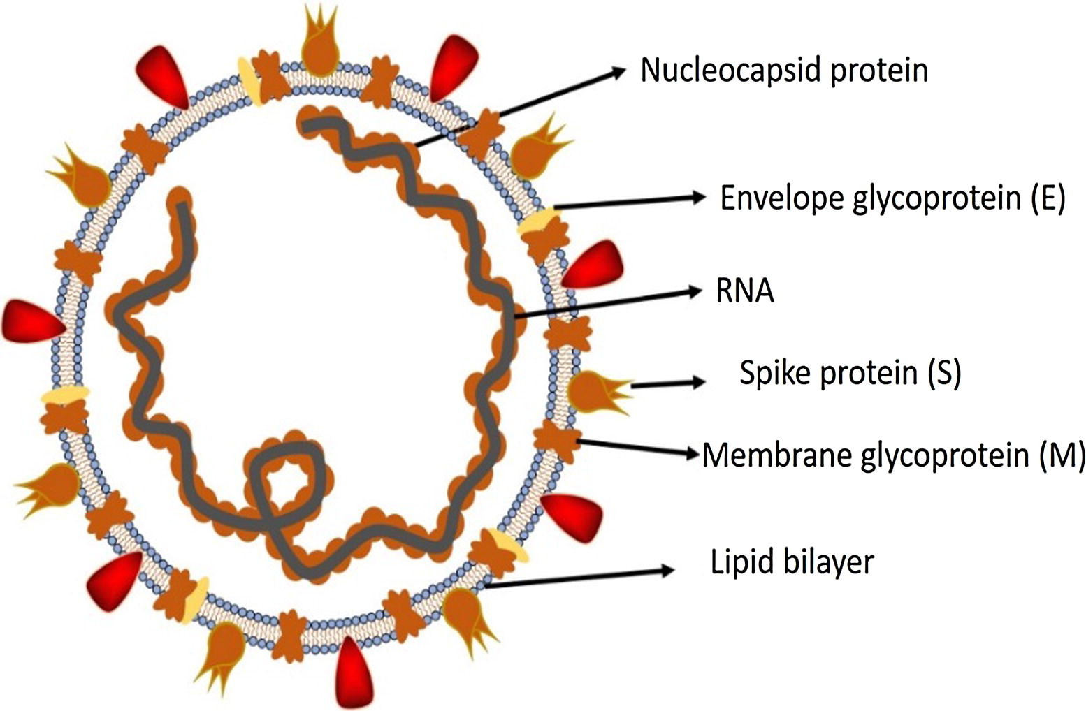

How it spreads
Coronavirus disease spreads primarily through contact with an infected person when they cough or sneeze. It also spreads when a person touches a surface or object that has the virus on it, then touches their eyes, nose, or mouth. And symptoms include:
- cough
- fever
- tiredness
- difficulty breathing (severe cases)
People may be sick with the virus for 1 to 14 days before developing symptoms. The most common symptoms of coronavirus disease (COVID-19) are fever, tiredness, and dry cough. Most people (about 80%) recover from the disease without needing special treatment.
More rarely, the disease can be serious and even fatal. Older people, and people with other medical conditions (such as asthma, diabetes, or heart disease), may be more vulnerable to becoming severely ill. So far then preventing is as follows
- STAY home as much as you can
- Keep safe distance
- WASH hands often
- COVER your cough
- SICK? Call ahead

Currently all affected countries are in lock down and nations are looking to every citizen to help in their own way in fighting the covid-19 virus, THIS IS WHERE MY PRESENTATION LEADS US, HOW CAN COMPUTER ENGINEERS HELP IN THIS STATE OF EMERGENCY.
A major underlying factor affecting the effective management of the covid-19 is the fear it brings to the community; people fear being isolated which is understandable as human beings if not anything are social creatures and the thought of one or a loved one being taken away with no assurance that he might ever see their family is disheartening to say the least and thus people then refuse to report any strange symptoms they find of the covid-19.

Occupational hazards associated with covid-19
The virus outbreak is in no small way affecting the various occupation I the world. Humans are forced to retreat at their homes and stay indoors at the expense of their career and that in turn might pose a threat to one’s economy.
- Health worker: no doubt these worker cant go on a break because they are the most essential occupation and while they are essential it puts them at a risk off getting infected with the covid-19 virus and they could lose their lives the risk and stake is so high that with every infected person they encounter during their work they themselves stand a chance of losing their lives .
A total of 81% of the global workforce of 3.3 billion people have had their workplace fully or partly closed. And Nearly 200 million people could end up out of work.

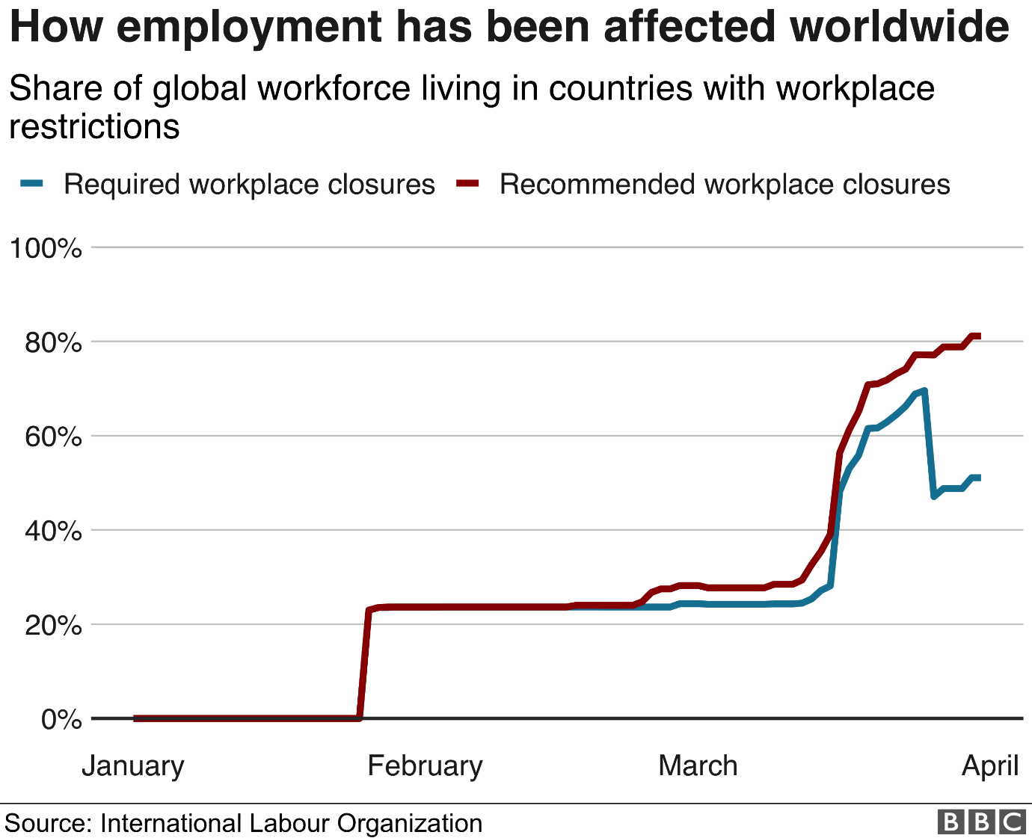

The outbreak is expected to wipe out 6.7% of working hours across the world during the second quarter of 2020.
That is the equivalent of 195 million full-time workers losing their jobs.
The worst-hit region is predicted to be the Arab states, with an 8.1% decline in working hours (five million full-time workers).
The ILO says it is "the most severe crisis" since World War Two.
It adds that the eventual increase in global unemployment during the course of 2020 will depend largely on two factors:
- How quickly the world economy recovers in the second half of the year
- How effectively policy measures will boost the demand for labour
There is a high risk that the end-of-year worldwide unemployment figure will be much higher than an initial ILO (internal labour organization) projection of 25 million people.

Development of engineering equipment’s to support health workers against COVID-19
During an outbreak there are always risk associated with the control of the outbreak, most often than not these risks pose a greater threat to the medical practitioners. They are tasked with the preservation of human live and thus they must treat those who are infected, and this can sometimes lead to them getting infected. But there are ways which computer engineering can help a to reduce those risk.
- By the creation of safety AI’s one can help limit the risk taken by doctors and surgeon as these AI’s can monitor patients’ vitals and alert the doctors of any abnormalities detected.
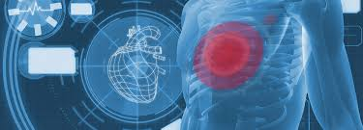
- Using high-tech scanners and VR (virtual reality) doctors will be able to replicate Data from the scanners and view it without having to be present at the scene. This will enable patients and doctors to effectively communicate and access live feed of the patient.
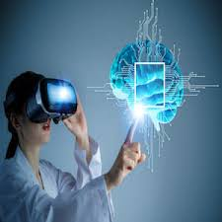
using VR, the doctor can see a holographic projection of the patient’s brain, and this technology can be used to further bridge the gap between the victims of the covid-19 while the victims remain in lockdown.
- Creating high tech containment facilities these patients can effectively be kept in proper isolation thus reducing the risk of it spreading, these patients can be monitored within closed walls and effectively the health workers will be safer and protected from the virus.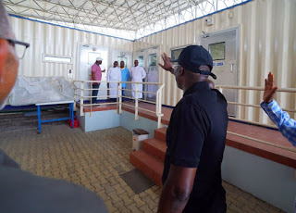
- Creation of software that can be specifically used to detect the virus, or rather disturbances in the human system, as we all know there are devices that are capable of detecting the heart rate and blood pressure of humans, and these are readily available to the public for purchase, by implementing software that can use a mobile phones built-in sensors, or create a device and an specially detect the deadly virus and make is consumer available, can drastically decrease fear and uncertainness of the public towards having the virus, and they can easily forward the results of the test to their personal or Nearest Public Doctor.
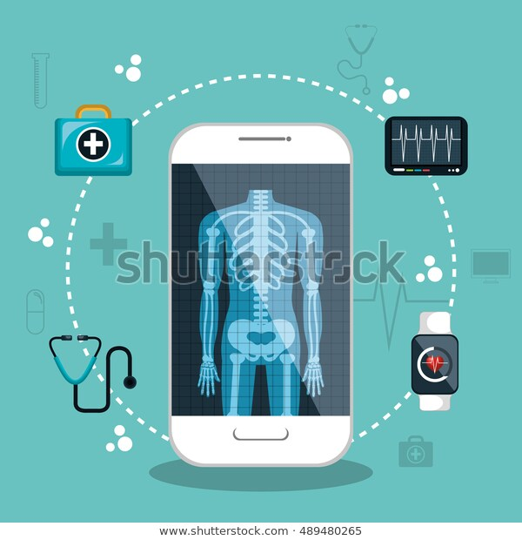

Conclusion
In a time, such as this we need the help of everyone to ensure our survival and saves from what the epidemic we are facing. Covid-19 has proved to be more resilient than has first been suspected and now we need the help of humanity to effectively put an end to it.

