TERM PAPER ON THE INPUT OF CIVIL AND ENVIROMENTAL ENGINEERING STRATEGIES FOR HANDLING COVID-19 FOR ENVIROMENTAL HEALTH AND ECONOMIC SUSTAINABILITY

BY

Emenyonu clinton

17/ENG03/021

SUBMITTED TO

ENGR. DR. OYEBODE

AFE BABALOLA UNIVERSITY, ADO-EKITI, EKITI STATE.

IN PARTIAL COMPLETION OF THE CONTINUOUS ASSESSMENT (C.A) FOR THE ENGINEERING LAW AND MANAGERIAL ECONOMICS (ENG 384) COURSE.

April 13th, 2020

CERTIFICATION

This project is to certify that the work was carried out by EMENYONU CLINTON. of the Department of civil/ environmental Engineering with Matric number 17/Eng03/021 in partial completion of the continuous assessment (C.A) of the Engineering Law and Managerial Economics (ENG384) course under the supervision of Engr. Oyebode, Afe Babalola University, Ado Ekiti. Nigeria during the 2019/20 academic session.

Engr. Oyebode
Lecturer-in-Charge

DEDICATION

This presentation is dedicated to me, family and my lecturers who have imparted the knowledge of this course on me.

ACKNOWLEDGEMENT

My gratitude and appreciation goes to God almighty who saw me through this period of time with his grace and kindness, Engr. Dr. Oyebode, the lecturer in charge of the ENG 384 course.

ABSTRACT
For development to be sustainable, it should be able to meet the needs of the present without compromising the ability of future generations to meet their own needs. Generally, development is considered unsustainable when insufficient attention is paid to the economic, environmental and social consequences. A prerequisite for development is growth and that is directly related to production or output of a country.

INTRODUCTION

Who is an environmental engineer

Environmental engineering is a professional engineering discipline that takes from broad scientific topics like chemistry, biology, ecology, geology, hydraulics, hydrology, microbiology, and mathematics to create solutions that will protect and also improve the health of living organisms and improve the quality of the environment. Environmental engineering is a sub-discipline of civil engineering, chemical engineering and mechanical engineering.

COMPONENTS OF SUSTAINABLE DEVELOPMENT

Economic Sustainability As mentioned earlier, the need for growth is paramount in achieving economic development and therefore economic sustainability. It should also be noted that poverty is a very significant barrier to growth and Bangladesh is no stranger to it. Poverty therefore, is the foremost major obstacle for Bangladesh to overcome in her bid to attain sustainable development. With the aid of the poverty trap cycle diagram shown below, it can be seen how low economic growth can have harmful knock-on effects, which hampers development

ENGINEERING: ITS IMPORTANCE AND BENEFITS

Engineering is a profession that opens doors to many careers. Engineering takes responsibilities for the safety of people and environment. Engineering offers a rewarding and lucrative career. Engineers’ prestige in the society is their creativity, innovation, passion, ability to focus and always inquisitive and curious to finding solutions to problems. A career in engineering affords the opportunity to make a difference, afford them job security and trying out new technology. Engineering as a profession always seek optional solutions to problems, makes judgments’ and provide explanations to their choices. Good communication is an important way of learning, which helps engineers move from being a novice to experts and allow them gain new professional knowledge and abilities. Engineering and technology may not be the easiest area of study, but they are subjects that continue to be in demand and because they are challenging, those studying them stands out from crowd as they will also find enjoyment and satisfaction throughout their career.

ENVIROMENTAL STABILITY

Assessing the economic impact of COVID-19
What are the channels of economic impact we can expect from COVID-19? (See the figure below for a summary.)
Beyond the human tragedy, there is a direct economic impact from lives lost in an outbreak. Families and loved ones lose that income and their in-kind contributions to household income such as childcare. Of note, the distribution of COVID-19 fatalities skews old, which means many of those most likely to die are no longer working and are less likely to be the primary provider for their families. (Keep in mind, though, that in many low- and middle-income countries, individuals work until a later age.) Though less likely to pass away from COVID-19, many working age adults still fall ill and their families will feel the financial burden as they miss work for days or weeks.

What should we do to minimize COVID-19’s economic impact? Recommendations from the IMF
What actions can policymakers and donors take to lessen the economic impacts of the COVID-19 pandemic for low- and middle-income countries? Here are three actions beyond the stimulus and liquidity recommendations from the International Monetary Fund:
- Contain the pandemic. , “To assuage market reactions to the outbreak, you have to present a viable plan to defeat *the outbreak*.” As long as the outbreak is actively spreading, many aversion behaviors may well be rational and wise. Containing the disease is the first step to mitigating not only the health impacts but also the economic impacts.
- Strengthen the safety net. The most vulnerable households are those most likely to be affected economically. Low-wage workers are often those most likely to lose their jobs if they miss work due to an extended illness. They are often the least able to work remotely to avoid contracting the virus. And they are the least likely to have savings to survive an economic downturn. Making sure there is an economic safety net—cash transfers, sick leave, subsidized health coverage—in place helps the most vulnerable survive and provides support to enterprises that serve those populations.
- Measure the impact. Systematic data on which populations are experiencing the greatest hardships and which industries are failing is essential to providing assistance. During the Ebola epidemic of 2014-2015, —building on the sample frames from existing surveys—to gather just-in-time information on the impacts of both ill health and aversion behavior on households and enterprises across the countries., monitoring the economic situation and providing support to households in need can mitigate the most urgent needs.

WHAT IS COVID 19

Anatomy of COVID-19
A virus isn’t a cell, isn’t even considered ALIVE. It’s a nucleic acid (DNA or RNA) wrapped in a coat of proteins, some attached to sugars (glycoproteins).
Many familiar viral pathogens – those that cause cold, flu, hemorrhagic fevers like Ebola, rabies, dengue, and yellow fever – are RNA VIRUSES notorious for mutating rapidly and unable to correct errors.
The “body” of COVID-19 is basically a genome enveloped in glycoproteins, with a smear of fat and bearing the crown of spikes that inspired the name “coronavirus.”

Practice Essentials
Coronavirus disease 2019 (COVID-19) is defined as illness caused by a novel coronavirus now called severe acute respiratory syndrome coronavirus 2 (SARS-CoV-2; formerly called 2019-nCoV), which was first identified amid an outbreak of respiratory illness cases in Wuhan City, Hubei Province, China. ^{[1]} It was initially reported to the WHO on December 31, 2019. On January 30, 2020, the WHO declared the COVID-19 outbreak a global health emergency. ^{[2, 3]} On March 11, 2020, the WHO declared COVID-19 a global pandemic, its first such designation since declaring H1N1 influenza a pandemic in 2009. ^{[4]}
Illness caused by SARS-CoV-2 was recently termed COVID-19 by the WHO, the new acronym derived from "coronavirus disease 2019. " The name was chosen to avoid stigmatizing the virus's origins in terms of populations, geography, or animal associations

Basic protective measures against the new coronavirus
Stay aware of the latest information on the COVID-19 outbreak, available on the WHO website and through your national and local public health authority. Most people who become infected experience mild illness and recover, but it can be more severe for others. Take care of your health and protect others by doing the following:

Wash your hands frequently
Regularly and thoroughly clean your hands with an alcohol-based hand rub or wash them with soap and water.
Why? Washing your hands with soap and water or using alcohol-based hand rub kills viruses that may be on your hands.

Maintain social distancing
Maintain at least 1 metre (3 feet) distance between yourself and anyone who is coughing or sneezing.
Why? When someone coughs or sneezes they spray small liquid droplets from their nose or mouth which may contain virus. If you are too close, you can breathe in the droplets, including the COVID-19 virus if the person coughing has the disease.

Avoid touching eyes, nose and mouth
Why? Hands touch many surfaces and can pick up viruses. Once contaminated, hands can transfer the virus to your eyes, nose or mouth. From there, the virus can enter your body and can make you sick.

Practice respiratory hygiene
Make sure you, and the people around you, follow good respiratory hygiene. This means covering your mouth and nose with your bent elbow or tissue when you cough or sneeze. Then dispose of the used tissue immediately.
Why? Droplets spread virus. By following good respiratory hygiene you protect the people around you from viruses such as cold, flu and COVID-19.

If you have fever, cough and difficulty breathing, seek medical care early
Stay home if you feel unwell. If you have a fever, cough and difficulty breathing, seek medical attention and call in advance. Follow the directions of your local health authority.
Why? National and local authorities will have the most up to date information on the situation in your area. Calling in advance will allow your health care provider to quickly direct you to the right health facility. This will also protect you and help prevent spread of viruses and other infections.

Stay informed and follow advice given by your healthcare provider
Stay informed on the latest developments about COVID-19. Follow advice given by your healthcare provider, your national and local public health authority or your employer on how to protect yourself and others from COVID-19.
Why? National and local authorities will have the most up to date information on whether COVID-19 is spreading in your area. They are best placed to advise on what people in your area should be doing to protect themselves.

Protection measures for persons who are in or have recently visited (past 14 days) areas where COVID-19 is spreading
- Follow the guidance outlined above.
- Stay at home if you begin to feel unwell, even with mild symptoms such as headache and slight runny nose, until you recover. Why? Avoiding contact with others and visits to medical facilities will allow these facilities to operate more effectively and help protect you and others from possible COVID-19 and other viruses.
- If you develop fever, cough and difficulty breathing, seek medical advice promptly as this may be due to a respiratory infection or other serious condition. Call in advance and tell your provider of any recent travel or contact with travelers. Why? Calling in advance will allow your health care provider to quickly direct you to the right health facility. This will also help to prevent possible spread of COVID-19 and other viruses.

Environmental Engineers Identify Factors Affecting COVID-19 Transmission

Environmental engineers and other researchers are working to pinpoint the environmental factors that could affect the transmission of the coronavirus disease 2019 (COVID-19), in an effort to minimize dangerous environments and stem the spread.
The behaviors of viruses and how they react to various environments is highly variable, according to researchers at Stanford University. Some viruses can be transmitted through water and others are airborne, for example¹. While the primary method of transmission for most enveloped viruses is via close contact with infected individuals, understanding the exact ways that COVID-19 can be transmitted is essential to slowing the spread and preventing more infections.¹
Infections with severe acute respiratory syndrome coronavirus (SARS-CoV-2; the virus that causes COVID-19) are believed to be mainly spread via person-to-person contact and via exposure to droplets produced by sneezing or coughing, but the researchers noted that indirect routes may also be possible. Indirect transmission occurs when enveloped viruses are released into the environment by the host and continue to live on surfaces, in the air, or in water long enough to infect another host.¹
“This potential role of the environment in the spread of COVID-19 highlights the multitude of applied research needs that must be addressed to effectively control outbreaks and pandemics as novel enveloped viruses emerge,” the researchers said in viewpoint published in Environmental Science and Technology¹.
In addition to understanding how large of a role indirect transmission plays in the COVID-19 pandemic, the researchers added that various environmental conditions can influence how long the virus survives on various surfaces. Those conditions can include relative humidity, fomite material, and air temperature, and understanding these variations could help ensure properly cleaned surfaces and environments in which the virus is less likely to spread.¹
The spread of COVID-19 via fecal contamination of water may be of particular concern. According to Alexandria Boehm, PhD, a Stanford professor and researcher on the project, increasing evidence has shown that the SARS-CoV-2 viruses, or at least their genomes, are excretes in feces, making fecal exposure a possible route of transmission.²
“It’s unlikely this could be a major transmission route, but a person could potentially be exposed by interacting with water contaminated with untreated fecal matter,” Boehm said in a statement from Stanford.²
Other research has shown that viruses similar to the SARS-CoV-2 viruses are susceptible to water treatment systems, but analyzing and pinpointing the exact risks could be vital during the COVID-19 pandemic, especially in regions of the world with less developed water treatment systems.²
Finally, the authors said there are many opportunities for collaboration between environmental scientists, environmental engineers, and health researchers during the rush to find more definitive answers on COVID-19 and its transmission. Krista Wigginton, MS, PhD, another researcher at Stanford, said that while COVID-19 is the major focus at the moment, taking a broader approach to many viruses could ensure a better understanding of their various environmental factors.²
“We tend to study viruses very intensely when there is an outbreak, but the results from one virus aren’t easy to extrapolate to other viruses that emerge 5 years later,” Wigginton said in the statement.²
Wigginton explained that while environmental engineers are analyzing pathogens outside of the host, virologists are studying what happens within the host cells, and public health researchers are trying to understand how the virus circulates within communities. Combining all of these viewpoints is going to be necessary to discover more about COVID-19.²
DIAGRAMS OF COVID-19 VIRUS AND SAFETY MATERIALS TO PREVENT ITS SPREAD IN THE ENVIROMENT

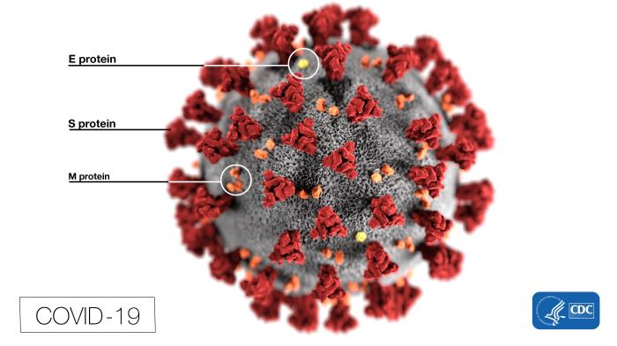
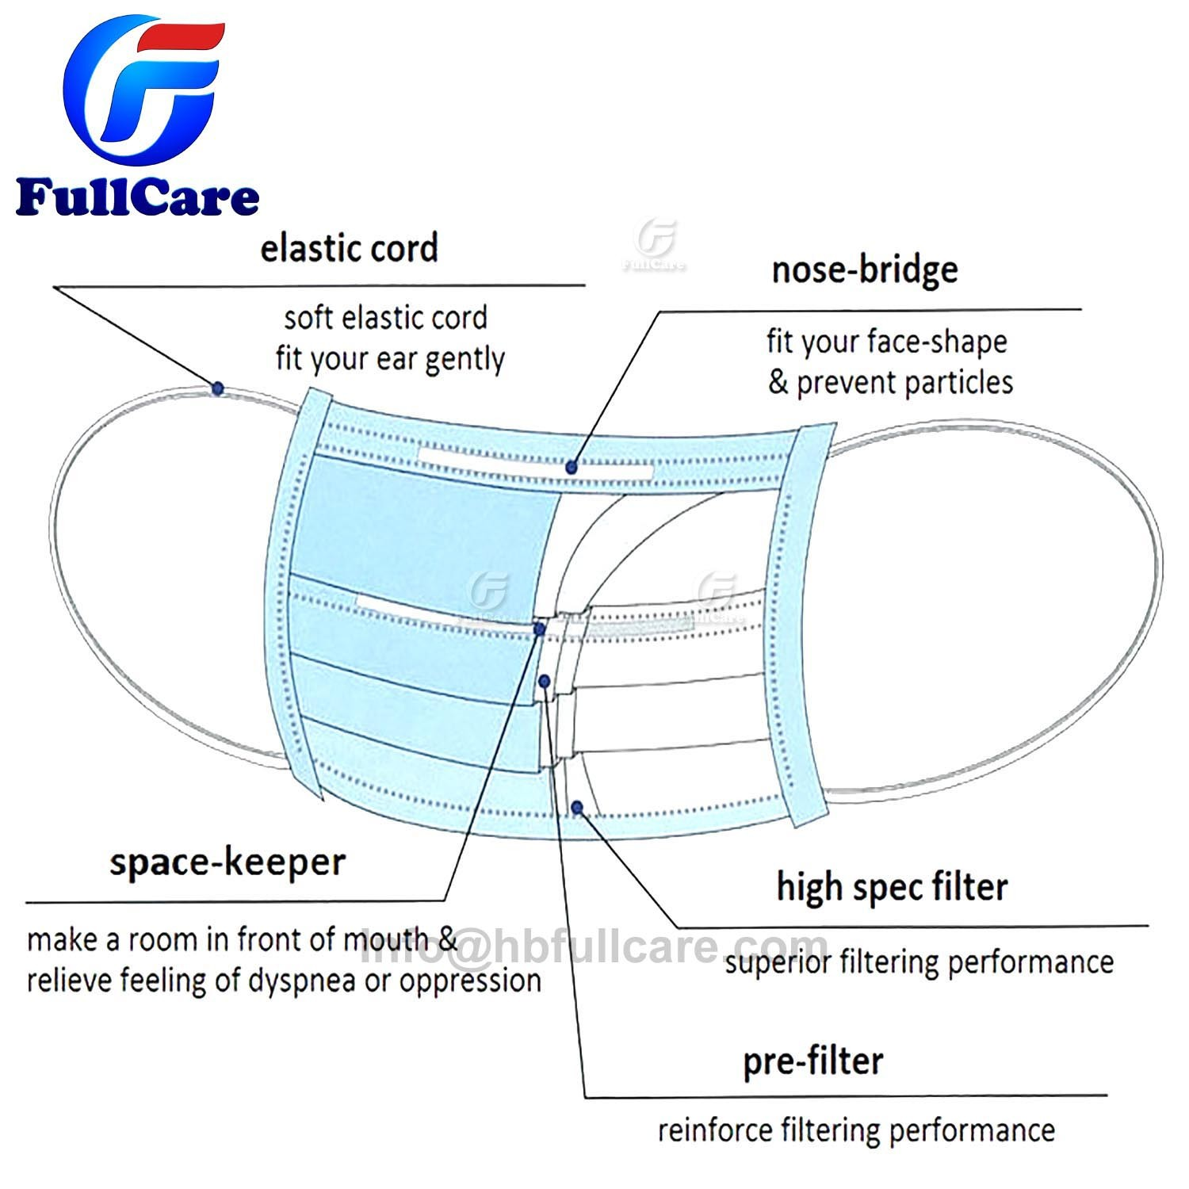

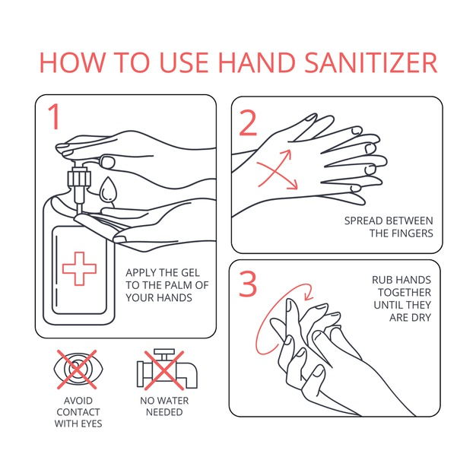

REFERENCES

Wigginton K, Boehm A. Environmental Engineers and Scientists Have Important Roles to Play in Stemming Outbreaks and Pandemics Caused by Enveloped Viruses. Environmental Science and Technology; March 24, 2020. https://pubs.acs.org/doi/10.1021/acs.est.0c01476#. Accessed March 30, 2020.
- Jordan R. Environmental engineers at Stanford discuss how to identify factors affecting COVID-19 transmission. Stanford News; March 26, 2020.https://news.stanford.edu/2020/03/26/understanding-spread-covid-19/. Accessed March 30, 2020.

