IDU-EMEKA CHIDERA HENRY

17/ENG02/034

SUBMITTED TO
ENGR. DR.OYEBODE

AFE BABALOLA UNIVERSITY, ADO-EKITI, EKITI STATE.

IN PARTIAL COMPLETION OF THE CONTINUOUS ASSESSMENT (C.A) FOR THE ENGINEERING LAW AND MANAGERIAL ECONOMICS (ENG 384) COURSE.
April 12, 2020

ASSIGNMENT
Briefly discuss the following intellectual property protection methods.
1 Patent
Patent example
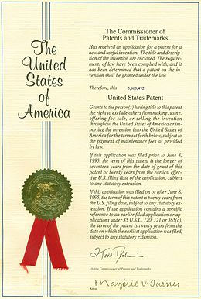
A patent is a form of intellectual property that gives the owner the legal right to exclude others from making, using, selling and importing an invention for a limited period of years, in exchange for publishing an enabling public disclosure of the invention. In most countries patent rights fall under civil law and the patent holder needs to sue someone infringing the patent in order to enforce his or her rights. In some industries patents are an essential form of competitive advantage; in others they are irrelevant.
The word patent originates from the Latin patere, which means "to lay open" (i.e., to make available for public inspection). It is a shortened version of the term letters patent, which was an open document or instrument issued by a monarch or government granting exclusive rights to a person, predating the modern patent system. Similar grants included land patents, which were land grants by early state governments in the USA, and printing patents, a precursor of modern copyright.
In modern usage, the term patent usually refers to the right granted to anyone who invents something new, useful and non-obvious. Some other types of intellectual property rights are also called patents in some jurisdictions: industrial design rights are called design patents in the US, plant breeders' rights are sometimes called plant patents, and utility models and Gebrauchsmuster are sometimes called petty patents or innovation patents.

2 Copyright

Copyright is the exclusive right given to the creator of a creative work to reproduce the work, usually for a limited time. The creative work may be in a literary, artistic, educational, or musical form. Copyright is intended to protect the original expression of an idea in the form of a creative work, but not the idea itself. A copyright is subject to limitations based on public interest considerations, such as the fair use doctrine in the United States. Some jurisdictions require "fixing" copyrighted works in a tangible form. It is often shared among multiple authors, each of whom holds a set of rights to use or license the work, and who are commonly referred to as rights holders. These rights frequently include reproduction, control over derivative works, distribution, public performance, and moral rights such as attribution.
Copyrights can be granted by public law and are in that case considered "territorial rights". This means that copyrights granted by the law of a certain state, do not extend beyond the territory of that specific jurisdiction. Copyrights of this type vary by country; many countries, and sometimes a large group of countries, have made agreements with other countries on procedures applicable when works "cross" national borders or national rights are inconsistent.
Typically, the public law duration of a copyright expires 50 to 100 years after the creator dies, depending on the jurisdiction. Some countries require certain copyright formalities to establishing copyright, others recognize copyright in any completed work, without formal registration.
While copyright law is not all-encompassing, other laws, such as patent and trademark laws, may impose additional sanctions. Although copyrights, trademarks, and patents are frequently used interchangeably, they offer different forms of protection for intellectual property.

3. Trademark
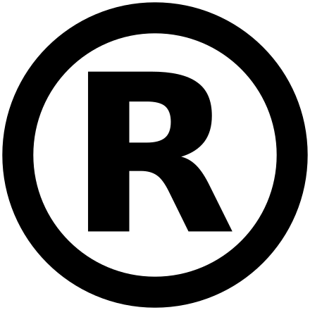
Registered trademark symbol
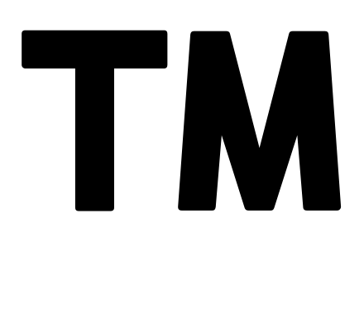
Trademark symbol
A trademark (also written trade mark or trade-mark) is a type of intellectual property consisting of a recognizable sign, design, or expression which identifies products or services of a particular source from those of others, although trademarks used to identify services are usually called service marks. The trademark owner can be an individual, business organization, or any legal entity. A trademark may be located on a package, a label, a voucher, or on the product itself. For the sake of corporate identity, trademarks are often displayed on company buildings. It is legally recognized as a type of intellectual property.
The first legislative act concerning trademarks was passed in 1266 under the reign of Henry III, requiring all bakers to use a distinctive mark for the bread they sold. The first modern trademark laws emerged in the late 19th century. In France the first comprehensive trademark system in the world was passed into law in 1857. The Trade Marks Act 1938 of the United Kingdom changed the system, permitting registration based on "intent-to-use”, creating an examination based process, and creating an application publication system. The 1938 Act, which served as a model for similar legislation elsewhere, contained other novel concepts such as "associated trademarks", a consent to use system, a defensive mark system, and non claiming right system.
The symbols ™ (the trademark symbol) and ® (the registered trademark symbol) can be used to indicate trademarks; the latter is only for use by the owner of a trademark that has been registered.
A trademark identifies the brand owner of a particular product or service. Trademarks can be used by others under licensing agreements; for example, Bullyland obtained a license to produce Smurf figurines; the Lego Group purchased a license from Lucasfilm in order to be allowed to launch Lego Star Wars; TT Toys Toys is a manufacturer of licensed ride-on replica cars for children. The unauthorized usage of trademarks by producing and trading counterfeit consumer goods is known as brand piracy.
The owner of a trademark may pursue legal action against trademark infringement. Most countries require formal registration of a trademark as a precondition for pursuing this type of action. The United States, Canada and other countries also recognize common law trademark rights, which means action can be taken to protect an unregistered trademark if it is in use. Still, common law trademarks offer to the holder, in general, less legal protection than registered trademarks.

4. Trade secret
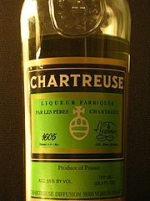
Green Chartreuse liqueur protected by confidential information of the ingredients

Trade secrets are a type of intellectual property that comprise formulas, practices, processes, designs, instruments, patterns, or compilations of information that have inherent economic value because they are not generally known or readily ascertainable by others, and which the owner takes reasonable measures to keep secret. In some jurisdictions, such secrets are referred to as confidential information.
The precise language by which a trade secret is defined varies by jurisdiction, as do the particular types of information that are subject to trade secret protection. Three factors are common to all such definitions:
A trade secret is information that
- is not generally known to the public;
- confers economic benefit on its holder because the information is not publicly known; and
- where the holder makes reasonable efforts to maintain its secrecy.
In international law, these three factors define a trade secret under article 39 of the Agreement on Trade-Related Aspects of Intellectual Property Rights, commonly referred to as the TRIPS Agreement.
Similarly, in the United States Economic Espionage Act of 1996, "A trade secret, as defined under 18 U.S.C. § 1839(3)(A),(B) (1996), has three parts: (1) information; (2) reasonable measures taken to protect the information; and (3) which derives independent economic value from not being publicly known."
Trade secrets are an important, but invisible component of a company's intellectual property (IP). Their contribution to a company's value, measured as its market capitalization, can be major. Being invisible, that contribution is hard to measure. Patents are a visible contribution, but delayed, and unsuitable for internal innovations. Having an internal scoreboard provides insight into the cost of risks of employees leaving to serve or start competing ventures.

