LAWAL TESLIM
18/ENG06/038
MECHANICAL ENGINEERING

A WEB BASED HEALITHCARE MANAGEMENT SYSTEM
Software development life cycle processes
- Requirement analysis
- Planning
- Designing
- System development
- Testing
- Deployment
REQUIREMENT ANALYSIS
The concept for LMR system is a web based health care management system. For effective COVID19 healthcare, a network system monitoring someone’s vital signs and evaluating one’s health condition is highly desirable. The purpose of this study is to design and implement a prototype based health care management system
PLANNING
In system design, we adopted a platform-independent web based system for easy use. Then we considered security and privacy because of the personal data handled via the Internet.
Hardware requirements list is often accompanied by a hardware compatibility list (HCL), especially in case of operating systems. An HCL lists tested, compatibility and sometimes incompatible hardware devices for a particular operating system or application. The following sub-sections discuss the various aspects of hardware requirements. These include, Intel dual Core, i3 as the processor of the Os, Internet connection for the health center, clinical thermometer.
Software Requirements deal with defining software resource requirements and prerequisites that need to be installed on a computer to provide optimal functioning of an application. Design A well- defined algorithm for a web-based COVID19 Healthcare Management System STEP1: Start
2: Body status to the virus=0
3: Add the COVID19 symptoms in the system
4: Put the software involved
5: Create a questionnaire
6: Collect qualitative data
7: Analyze Data
8: Body Status positive to the virus
9: Else
10: Body Status negative to the virus
11: Display feedback
12: Stop
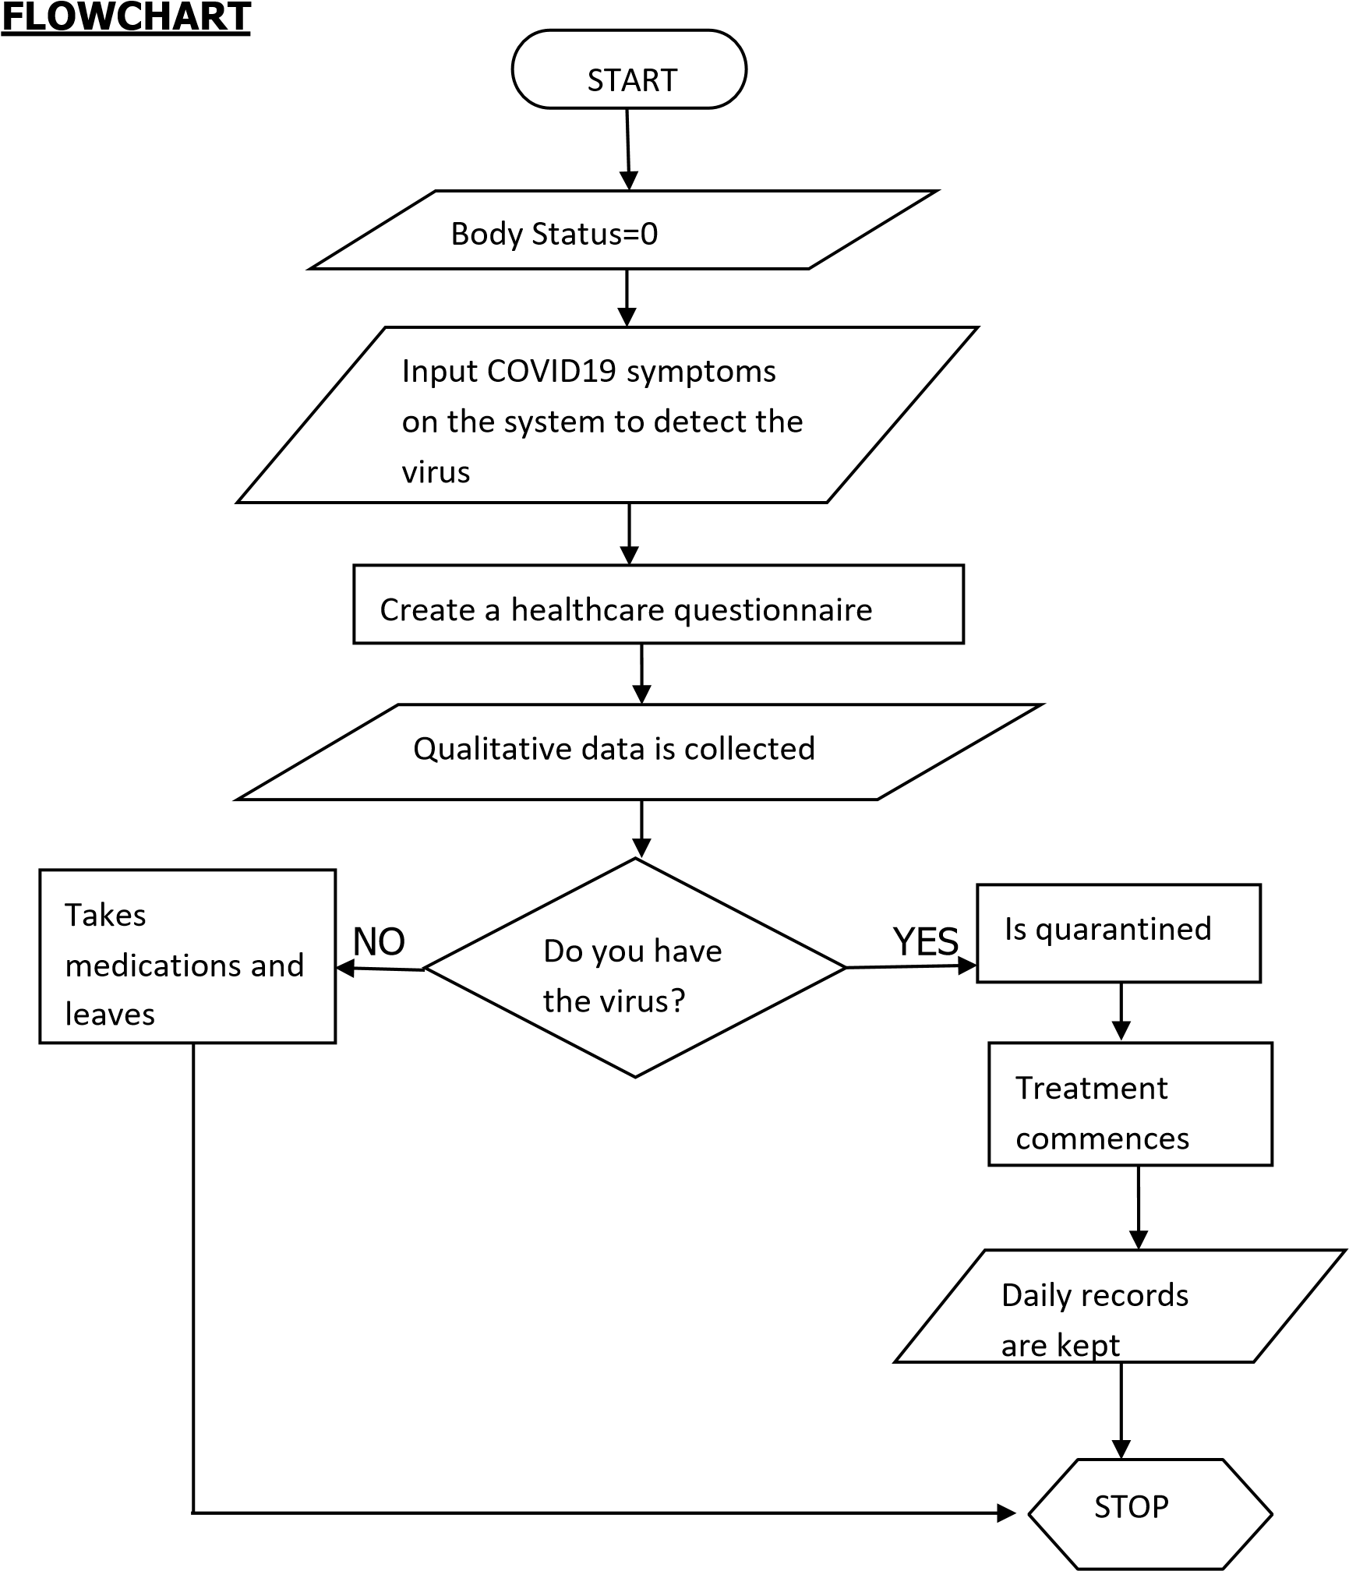

System development

The data viewer function provided graphs of physiological data, which are body temperature, blood pressure, pulse wave (PW), and electrocardiograph (ECG), measured by the vital sensing system.
Testing
The COVID19 Healthcare web apps need to be fool-proof, which is why testing the apps and their functionalities become so important. Right from testing the security and compliances to the workability and the integration of the app, testing can also be done with different operating systems, internet connections and hardware.

Deployment
This application is being released to detect, display the rate of virus, store, transmit and access data through the web together and its updated when necessary based on the health center feedback
TOP- DOWN DESIGN APPROACH OF THE APPLICATION

Web based Healthcare application

Web server

Database

server

Application

Server

Create questionnaire

Data Analyst

Feedback

Function

Data Viewer

Function

JavaScript

,

HTML

documents

