4

NAME: SANNI ABDULRAHMAN O.
MATRIC NO: 17/ENG03/050
COURSE: ENGINEERING LAW (ENG384)
TOPIC: DESIGN OF INNOVATIVE AND AUTOMATED RESPIRATORY BUILDINGS FOR PATIENTS AND HEALTH WORKERS AGAINST CORONAVIRUS DISEASE OUTBREAK

Coronavirus disease (COVID-19) is an infectious disease caused by a new virus.
The disease causes respiratory illness (like the flu) with symptoms such as a cough, fever, and in more severe cases, difficulty breathing. You can protect yourself by washing your hands frequently, avoiding touching your face, and avoiding close contact (1 meter or 3 feet) with people who are unwell.
Recent attention in health care has been on the actual architectural design of a hospital facility, including its technology and equipment, and its effect on patient safety. To address the problems of errors in health care and serious safety issues, fundamental changes of health care processes, culture, and the physical environment are necessary and need to be aligned, so that the caregivers and the resources that support them are set up for enabling safe care. The facility design of the hospital, with its equipment and technology, has not historically considered the impact on the quality and safety of patients, yet billions of dollars are and will be invested annually in health care facilities. This provides a unique opportunity to use current and emerging evidence to improve the physical environment in which doctors and other caregivers work, and thus improve both doctors and patient outcomes.

The following below are required in the design of an innovative respiratory building

- Patient-centeredness, including
  - using variable-acuity rooms and single-bed rooms
  - ensuring sufficient space to accommodate family members
  - enabling access to health care information
  - having clearly marked signs to navigate the hospital
- Safety, including
  - applying the design and improving the availability of assistive devices to avert patient falls
  - using ventilation and filtration systems to control and prevent the spread of infections
  - using surfaces that can be easily decontaminated
  - facilitating hand washing with the availability of sinks and alcohol hand rubs
  - preventing patient and provider injury
  - addressing the sensitivities associated with the interdependencies of care, including work spaces and work processes
- Effectiveness, including
  - use of lighting to enable visual performance
  - use of natural lighting
  - controlling the effects of noise
- Efficiency, including
  - standardizing room layout, location of supplies and medical equipment
  - minimizing potential safety threats and improving patient satisfaction by minimizing patient transfers with variable-acuity rooms
- Timeliness, by
  - ensuring rapid response to patient needs
  - eliminating inefficiencies in the processes of care delivery
  - facilitating the clinical work of nurses
- Equity, by
  - ensuring the size, layout, and functions of the structure meet the diverse care needs of patients

Below is an example of a floor plan for an innovated respiratory building for healthworkers against coronavirus
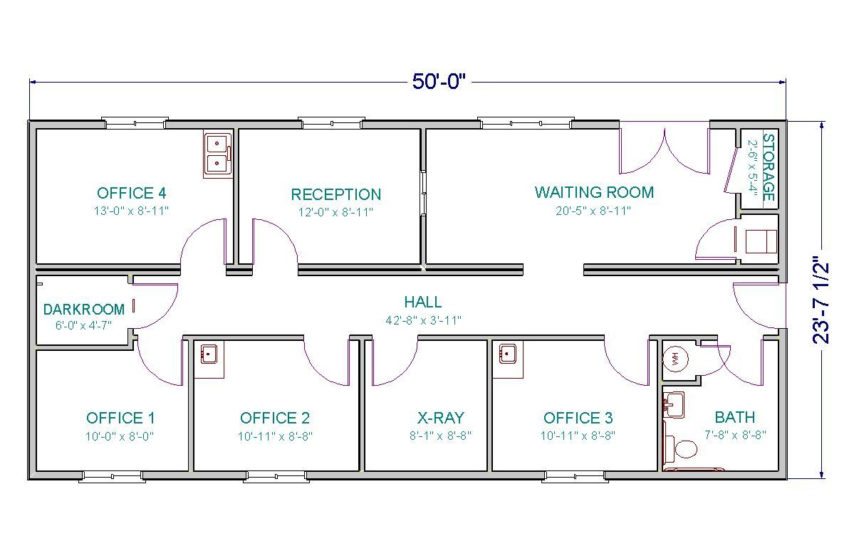

In the floor plan it shows the various locations of offices and on the lower level Is an empty big room full of beds where coronavirus patients are taken to and treated.
It will also have a room where recovering patients would be moved to in order not to come in contact with the disease again
It will also consist of Bar-coding, unit doses at point of service, electronic medical records, and physician order entry are critical elements for medication error reduction. Private rooms with alcoves that include medical records allow nurses to concentrate on one patient and document those efforts, before moving on to the next patient.
Operating room suites were standardized, using proper lighting and cable access to digital images and photographs of the surgery site if required.
Locating the bathroom at the head of the bed with railings to the stool and shower, and utilizing bathroom lights that automatically turn on when anyone enters the bathroom are essential in a place like to avoid patients and health workers to be in contact with objects because the virus can be spread from objects.
We also have to consider suicidal patients, to avoid that, there are many things patients can use to hang themselves, such as bathroom curtain rods, showerheads, television brackets, or lights. But if you decide to use breakaway shower curtain rods and minimize other hanging risks by choosing lights and brackets that met the design needs of the room but would be less likely to be used for a suicide attempt. To minimize jumping, windows cannot be opened, and they are triple-paned, making them much harder to break through. If a suicide-risk patient is identified, that patient is transferred to the mental health unit, but increased visibility to the patient room helps staff keep a closer watch, which helps minimize the risk of suicides and cameras would be kept in the patients’ room and at the mental ward.

Scalability, adaptability, flexibility
Many design and construction concepts can be applied to achieve a scalable (e.g., the ability to expand or remodel easily) or adaptable (e.g., the ability to adapt space for different or evolving services) health care facility.
All rooms should have higher-than-normal ceilings to allow changes to be incorporated in the future. Space around the bed is sized so procedures (e.g., colonoscopies) could be performed in the room in the future.
Noise reduction
Noise interferes with communication, creates distractions, affects cognitive performance and concentration, and contributes to stress and fatigue.
Some patients might be affected by noise, Noise cancellation headphones should be distributed for all patients or a wall, a small barrier should be done after each bed but it doesn’t reach the roof in order to reduce the noise
Ventilation
Ventilation moves outdoor air into a building or a room, and distributes the air within the building or room. The general purpose of ventilation in buildings is to provide healthy air for breathing by both diluting the pollutants originating in the building and removing the pollutants from it

Building ventilation has three basic elements:
- ventilation rate — the amount of outdoor air that is provided into the space, and the quality of the outdoor air;
- airflow direction — the overall airflow direction in a building, which should be from clean zones to dirty zones; and
- air distribution or airflow pattern — the external air should be delivered to each part of the space in an efficient manner and the airborne pollutants generated in each part of the space should also be removed in an efficient manner.

Assessing ventilation performance Ventilation performance in buildings can be evaluated from the following four aspects, corresponding to the three basic elements of ventilation discussed above.
• Does the system provide sufficient ventilation rate as required?
• Is the overall airflow direction in a building from clean to dirty zones (e.g. isolation rooms or areas of containment, such as a laboratory)?
• How efficient is the system in delivering the outdoor air to each location in the room?
• How efficient is the system in removing the airborne pollutants from each location in the room?
Two overall performance indices are often used. The air exchange efficiency indicates how efficiently the fresh air is being distributed in the room, while the ventilation effectiveness indicates how efficiently the airborne pollutant is being removed from the room. Engineers define the local mean age of air as the average time that the air takes to arrive at the point it first enters the room, and the room mean age of air as the average of the age of air at all points in the room (Etheridge & Sandberg, 1996). The age of air can be measured using tracer gas techniques (Etheridge & Sandberg, 1996). The air exchange efficiency can be calculated from the air change per hour and the room mean age of air (Etheridge & Sandberg, 1996). For piston-type ventilation, the air exchange efficiency is 100%, while for fully mixing ventilation the air exchange efficiency is 50%. The air exchange efficiency for displacement ventilation is somewhere in between, but for short-circuiting the air exchange efficiency is less than 50%

The use of outdoor air for natural ventilation, combined with natural cooling techniques and the use of daylight, have been essential elements of architecture since ancient times and up to the first part of the 20th century (ASHRAE, 2007b). Classical architecture with H, L, T or U-shaped floor plans was used, together with open courts, limited plan depth and maximum windows sizes, to exploit natural ventilation and daylight. In recent times, natural ventilation has been largely replaced by mechanical ventilation systems in high- and middle-income countries. At first, full mechanical heating, ventilation and air-conditioning systems appeared to be able to solve all the practical problems of natural ventilation for year-round control of indoor environmental conditions. However, mechanical ventilation also requires careful design, strict equipment maintenance, adoption of rigorous standards, and design guidelines that take into consideration all aspects of indoor environmental quality and energy efficiency (ASHRAE, 2007b). The same is also true for high-tech natural ventilation. Natural ventilation is not without its problems, particularly for facilities in countries where winters are cold. More work is needed to design low-cost and reliable ventilation systems for rooms that encourage rather than prevent the flow of air and yet allow internal temperature control. It follows that natural and mechanical ventilation systems can, in practice, be equally effective for infection control. However, natural ventilation only works when natural forces are available, for example, winds or breezes, and when inlet and exhaust apertures are kept open. On the other hand, the difficulties involved in properly installing and maintaining a mechanical ventilation system may lead to a high concentration of infectious droplet nuclei and ultimately result in an increased risk of disease transmission. In existing health-care facilities with natural ventilation, this system should be maximized where possible, before considering other ventilation systems. However, this depends on climatic conditions being favourable for its use.

The design of proper, general ventilation systems can play an important role in preventing the spread of infections. Patients with infectious diseases that spread easily through air (e.g. chickenpox, measles, covid-19, tuberculosis) should be placed in airborne precaution rooms. However, there is often a delay between admission of these patients to the health-care facility, and the diagnosis of their infectious disease. Disease transmission to other patients or staff can occur while these patients are waiting in common areas (e.g. waiting room, emergency departments). Paying more attention to ventilation requirements in these common, non-isolation spaces could lead to significant infection-control benefits. However, the strategies for disease control and prevention involve the assessment of threats and resources, and then applying appropriate administrative controls, environmental and other engineering controls, and PPE, in conjunction with using a suitable ventilation system.

Principal architectural styles in the hospital
Many of the buildings that form the current hospital date from its inauguration in 1875, and exhibit the characteristics of Spanish colonial architecture. These include high ceilings (generally 4.2 m or higher), large windows, and skylights for light and ventilation. The general medical and surgical wards — large ‘Nightingale’ wards of 40 beds — are situated around a central garden where patients and staff can relax outside. The building housing the infectious diseases and respiratory wards, named Santa Rosa after the patron saint of Lima, is a two-storey building with high ceilings, large windows and balconies for TB patients to take the air. Part of the ground floor has been converted into mechanically ventilated negative-pressure isolation rooms for TB-HIV patients. Substantial additions were made to the hospital in 1971 using modern building design and construction. These additions include the emergency department, paediatric and surgical departments, and laboratory and X-ray services. These buildings generally have small windows and low ceilings (approximately 2.9 m high).

There are three methods that may be used to ventilate a building: natural, mechanical and hybrid (mixed-mode) ventilation.

What is natural ventilation?
Natural forces (e.g. winds and thermal buoyancy force due to indoor and outdoor air density differences) drive outdoor air through purpose-built, building envelope openings. Purpose-built openings include windows, doors, solar chimneys, wind towers and trickle ventilators. This natural ventilation of buildings depends on climate, building design and human behaviour.
What is mechanical ventilation?
Mechanical fans drive mechanical ventilation. Fans can either be installed directly in windows or walls, or installed in air ducts for supplying air into, or exhausting air from, a room. The type of mechanical ventilation used depends on climate. For example, in warm and humid climates, infiltration may need to be minimized or prevented to reduce interstitial condensation (which occurs when warm, moist air from inside a building penetrates a wall, roof or floor and meets a cold surface). In these cases, a positive pressure mechanical ventilation system is often used. Conversely, in cold climates, exfiltration needs to be prevented to reduce interstitial condensation, and negative pressure ventilation is used. For a room with locally generated pollutants, such as a bathroom, toilet or kitchen, the negative pressure system is often used.
In a positive pressure system, the room is in positive pressure and the room air is leaked out through envelope leakages or other openings. In a negative pressure system, the room is in negative pressure, and the room air is compensated by “sucking” air from outside. A balanced mechanical ventilation system refers to the system where air supplies and exhausts have been tested and adjusted to meet design specifications. The room pressure may be maintained at either slightly positive or negative pressure, which is achieved by using slightly unequal supply or exhaust ventilation rates. For example, a slight negative room pressure is achieved by exhausting 10% more air than the supply in a cold climate to minimize the possibility of interstitial condensation. In an airborne precaution room for infection control, a minimum negative pressure of 2.5 Pa is often maintained relative to the corridor (CDC, 2003).
What is hybrid or mixed-mode ventilation?
Hybrid (mixed-mode) ventilation relies on natural driving forces to provide the desired (design) flow rate. It uses mechanical ventilation when the natural ventilation flow rate is too low (Heiselberg & Bjørn, 2002). When natural ventilation alone is not suitable, exhaust fans (with adequate pre-testing and planning) can be installed to increase ventilation rates in rooms housing patients with airborne infection. However, this simple type of hybrid (mixed-mode) ventilation needs to be used with care. The fans should be installed where room air can be exhausted directly to the outdoor environment through either a wall or the roof. The size and number of exhaust fans depends on the targeted ventilation rate, and must be measured and tested before use. Problems associated with the use of exhaust fans include installation difficulties (especially for large fans), noise (particularly from high-power fans), increased or decreased temperature in the room and the requirement for non-stop electricity supply. If the environment in the room causes thermal discomfort spot cooling or heating systems and ceiling fans may be added. Another possibility is the installation of whirlybirds (whirligigs or wind turbines) that do not require electricity and provide a roof-exhaust system increasing airflow in a building.

CONCLUSION
In the next few years, hospital leaders will be involved in new hospital construction projects to meet the changing marketplace demands associated with the growing demand of an aging population. Many clinicians, architects, and hospital administrators believe that the hospital built environment can benefit the satisfaction of health care providers as well as patient satisfaction and outcomes. There is some evidence that the built environment may influence patient and family perceptions of the quality of and satisfaction with care received during a hospitalization. There is also some evidence that nurse satisfaction with the built environment was related to general well-being and job satisfaction, two factors that are critical because of their impact on patient care.

