DESIGN OF INNOVATIVE AND AUTOMATED RESPIRATORY BUILDINGS FOR PATIENTS AND HEATH WORKERS AGAINST CORONAVIRUS DISEASE OUTBREAK

Prepared by BASSEY SAVIOUR JOSEPH
16/ENG05/015

Submitted to Department of Mechanical/Mechatronics Engineering, Afe-Babalola University in partial fulfilment of the requirements of ENG 384: Engineering law and Managerial Economics

11th April 2020

Certification
This is to certify that this report under mechatronics engineering education in Nigeria was written and typed by Bassey Saviour with matric number 16/eng05/015 in the department of mechanical and mechatronics engineering, college of engineering, Afe Babalola university, Ado-Ekiti(Abuad), Ekiti state.

Dedication
I am dedicating this report to God Almighty in Heaven for His grace in completing this report, also my family, most especially, my wonderful parents, Engr Joseph Bassey and Mrs. Emily Bassey for their love, prayers and support, confident and boldness.

Acknowledgment
Firstly, I would like to appreciate God Almighty for giving me this opportunity to improve my knowledge in my respected course and field mechatronics engineering.
My profound gratitude goes to the college of engineering, Provost of the college of Engineering and the Head of Department, Mechanical & Mechatronics Engineering, I want to thank specially the members of the academic and lecturers of the engineering law and managerial economics
Finally, I would also like to say a big thank you to my parents, Mr & Mrs Bassey.

Abstract
This article is based on the mechatronics engineering in Nigeria. The challenges backed by this specific course or study as people may term it as. The whole concept is to encourage the government and students to focus on developing more time into the technological age which is termed as mechatronics. From the point of views of the report we can classify mechatronics as a field of engineering ruling the world in technology like drones for security purposes, automation for reduction in human work.

Table of content

Cover page i
Certification ii
Dedication iii
Acknowledgement iv
Abstract v
Table of content vi
Introduction 1
- MERS-COV (Middle East Respiratory Syndrome)
- SARS-COV (Severe Acute Respiratory Syndrome)
- 2019-nCOV (2019 Novel Coronavirus)
Engineering innovation and automated respiratory towards patients
- Air
- Human contact
- Surfaces
Means of aiding the health workers against the fight of coronavirus
Items/devices needed for the innovative design
- Motor
- Air pump
- Hose
- Vacuum
- Motor trays
- Air filter
Objective

Conclusion

Reference

INTRODUCTION
Lets start by defining coronavirus,
Coronavirus is a type of common virus that infects humans typically leading to an upper respiratory infection. The virus spread through the air by coughing and sneezing, close personal contact touching an objector surface contaminated with the virus. Seven different types of human coronavirus have been identified most people will be infected with at least one type of coronavirus in their life time.

Examples of human coronavirus:
- MERS-COV (Middle East Respiratory Syndrome)
- SARS-COV (Severe Acute Respiratory Syndrome)
- 2019-nCOV (2019 Novel Coronavirus)

- MERS-COV: it’s a specie of coronavirus which infects humans, bats and camels. The infecting virus is an enveloped, positive-sense, single stranded RNA virus which enters its host cell by binding the DPP4 receptor. These species is a member of the genus Beta coronavirus and Subgenus Merbecovirus
- SARS-COV: it’s a viral respiratory illness caused by a coronavirus known as severe acute respiratory syndrome. The first ever reported case was in Asia in Feburary 2003
- 2019-nCOV: much is not known about the recent virus except it was discovered in 2019 December and it’s a new strain that has not been previously identified in humans. The known factor of the virus is that it attacks the respiratory organs and weakens them which could lead to fatal incident such as death or reduction in life span.

Engineering innovation and automated respiratory towards patients
As engineers, we develop ideas and machines that benefit human lives. Currently we can say engineers worldwide are bringing up ideas on how to deal with the pandemic.
Engineers initiative is to first identify the means of how the virus is been passed and eliminate it then identify the main places the virus attacks in the human body which are the respiratory organs of the human body.
With this initiative identified
Engineers now know the virus is passed through this three(3) ways;
- Air
- Human contact
- Surfaces
Now we look for ways to eliminate the way the virus is passed from patients to health workers as engineers.
Means of aiding the health workers against the fight of coronavirus
Innovative idea an engineer could do is to build a machine which could aid the infected patient to breathe clean filtered air through their nostrils and a vacuum to suck up the virus from the internal body leading to an empty air space in the body for about 3 seconds before clean filtered air is pumped into the body through the nostril
Items/devices needed for the innovative design
- Motor
- Air pump
- Hose
- Vacuum
- Motor trays
- Air filter

- Motor: this rotates in the machine and activates the air pumps by pushing on them to pump the filtered air to the individuals nostrils.
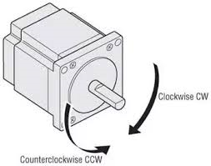
- Air pumps: these are rubber bags filled with air which are pushed on by the motors to pump air into the nostrils of the infected individual.
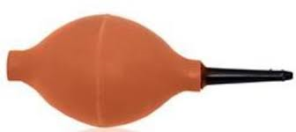
- Hose: this are pipes that allow passage of air to the nostrils of the individual.
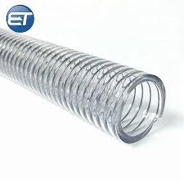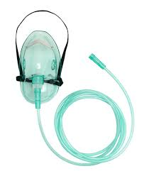
- Vacuum: these would be placed in the machine to suck up the virus from the infected individual through the mouth
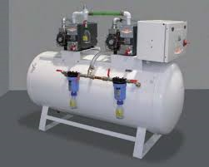

- Conveyor belt: This mechanical machine be used as a medium of transporting food and table water to the infected individuals to avoid the spread of the virus to health workers
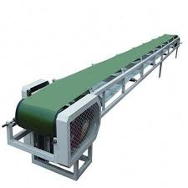
- Air filters: this components are placed in the air pumps in other to filter the air that is been pumped into the infected individual for successful breathing
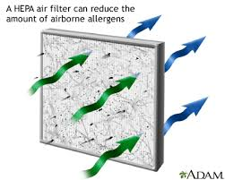

OBJECTIVE
The objective of the innovated design is to aid tackle the spread of the Covid-19 and to help in fighting the virus within the infected patients. The basic concept of the design could be seen above with their functions. The air pump are rubber like in other for the rotating motor to rotate and compress the air pumps to produce air which is passes through the air filter which would filtrate the air to clean the air in other to avoid allergies from the air pumped to the infected individual. Once the air has been filtered it passes through the hose connected to the face mask which is them inhaled by the infected individual. As seen by the design we have improved the ways ventilators operate and eliminating manpower in the situation to avoid the spread of the virus. The use of the vacuum from the listed apparatus above is to help in the suction of the virus from the internal organs of the infected individual. The conveyor belts can be used to transport food from the room door to the patient in other to avoid exposure to the virus.
With the basic idea of the design to combat the pandemic facing the earth currently we have been able to reduce manpower and eliminate the spread of the virus from the infected individual to the health workers within the hospital.

CONCLUSION
In conclusion, as engineers during this pandemic we have to create innovative ways to help the health workers in the combat against the virus and spread. The possible best ways to combat the virus is to think of more productive ways to eliminate spread and increase the ways to help the already infected people.

