NAME: UKPAI CHINEYE SHALOM
MATRIC NO: 17/ENG01/028
DEPARTMENT: CHEMICAL ENGINEERING
COURSE CODE/TITLE: ENG 312 (PROCESS INSTRUMENTATION) ASSIGNMENT

1a) Instrumentation is a collective term for measuring instruments that are used for indicating, measuring and recording physical quantities. The term has its origins in the art and science of scientific instrument-making.
Instrumentation can refer to devices as simple as direct-reading thermometers, or as complex as multi-sensor components of industrial control systems. Today, instruments can be found in laboratories, refineries, factories and vehicles, as well as in everyday household use (e.g., smoke detectors and thermostats)
1b) Chromatography is a separation process involving two phases, one stationary and the other mobile. Typically, the stationary phase is a porous solid (e.g., glass, silica, or alumina) that is packed into a glass or metal tube or that constitutes the walls of an open-tube capillary. The mobile phase flows through the packed bed or column. The sample to be separated is injected at the beginning of the column and is transported through the system by the mobile phase. In their travel through the column, the different substances distribute themselves according to their relative affinity for the two phases.
Mobile phase
Chromatography usually is divided into two categories depending on the type of mobile phase that is used. If the mobile phase is a liquid, the technique is liquid chromatography; if it is a gas, the technique is gas chromatography. In a simple liquid chromatographic apparatus the stationary phase is held in place either in a column or on a plane (such as a plate of glass, metal, or plastic or a sheet of paper). In the case of a column, the lower end is loosely plugged, often with glass wool or a sintered glass disk. Prior to the separation, the column is filled with the mobile phase to a level that is slightly above the level of the stationary phase. The mixture to be separated is added to the top of the column and is allowed to drain onto the stationary phase.
Stationary phase
In gas chromatography the stationary phase is contained in a column. The column generally is a coiled metallic or glass tube. An injector near the entrance to the column is used to add the analyte. The mobile phase gas usually is contained in a high pressure gas cylinder that is attached by metallic tubing to the injector and the column. A detector, placed at the exit from the column, responds to the separated components of the analyte.
1c) Moisture is an unwanted contaminant that exists in industrial gases and the atmosphere, and is able to penetrate virtually any surface including such metals as copper, bronze and carbon steel. Therefore, it is important to first accurately measure the moisture content in order to subsequently control or remove the unwanted moisture.
Without measuring moisture, it can lead to the following consequences;
• Penetrate virtually any surface
• Render test results useless
• Result in poor product quality
• Cause corrosion in tubing
• Lead to ice formation at low temperature
• Cause premature wear and equipment failure
• React with other chemicals and gases, etc.
So therefore it is important to measure moisture to avoid the following consequences listed above.
Ways of measuring moisture include;
There are four core methods. They include the use of heat, chemicals, electrical properties and electrro- magnetic phenomena.

2a) A process variable, process value or process parameter is the current measured value of a particular part of a process which is being monitored or controlled. An example of this would be the temperature of a furnace. The current temperature is called the process variable, while the desired temperature is known as the set-point. The set point is usually abbreviated to SP, and the process value is usually abbreviated to PV.
1. Process control instrumentation ensures consistency: Measurements are one of the most important parts in a processing plant. Using the proper process control instrumentation to remodel and rework your internal operations allows your machines to reduce variability and run to the best of their abilities. Additionally, it keeps ones employees well-rested, level-headed and, most importantly, excited to come to work every day. By simple eliminating unnecessary machinery, or even physical labor, there will be more time and space for your business to grow.
2. It reduces labor costs: One of the biggest benefits of the process control industry is automated efficiency. In fact, it’s possible that after you implement your process control instrumentation and rework your operations, you’ll see less of a need for your existing machine or human labor. There will be more income to go around, which means an increase in general performance.
3. Process control instrumentation improves quality: Process control systems are central to maintaining product quality. Using proper instrumentation, control systems maintain the proper ratio of ingredients, regulate temperatures and monitor outputs. Without this standard of control, products would vary and quality would be impaired.
4. There’s opportunity for additional business: By shifting focus to cost-effective and objective-reaching technologies, you’ll increase your ability to take on more work. Furthermore, you and your business will grow into the best version of yourselves, which means your clients will see their hopes come to fruition, too.
2b) A Magnetic flow meter is a transducer that measures fluid flow by the voltage induced across the liquid by its flow through a magnetic field. Some applications of magnetic flow meter are listed below;
Magnetic flow meters can be highly effective for applications involving corrosive conditions and for measuring the flow rate of corrosive materials, such as abrasives or slurries.
They are also commonly employed in measuring paper stock or pulp.
They can also be used to measure low flow rates and pipe networks with relatively short inside diameters.
Magnetic flow meters can be used to measure flow rates for combustible or explosive liquids, often under hazardous conditions.
2c) i) A sphygmomanometer is a device that measures blood pressure. It composes of an inflatable rubber cuff, which is wrapped around the arm. A measuring device indicates the cuff’s pressure. A bulb inflates the cuff and a valve releases pressure. A stethoscope is used to listen to arterial blood flow sounds. As the heart beats, blood forced through the arteries cause a rise in pressure, called systolic pressure, followed by a decrease in pressure as the heart’s ventricles prepare for another beat. This low pressure is called the diastolic pressure.
The sphygmomanometer cuff is inflated to well above expected systolic pressure. As the valve is opened, cuff pressure (slowly) decreases. When the cuff’s pressure equals the arterial systolic pressure, blood begins to flow past the cuff, creating blood flow turbulence and audible sounds. Using a stethoscope, these sounds are heard and the cuff’s pressure is recorded. The blood flow sounds will continue until the cuff’s pressure falls below the arterial diastolic pressure. The pressure when the blood flow sounds stop indicates the diastolic pressure.

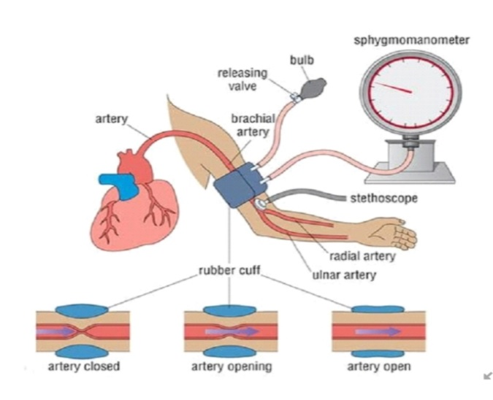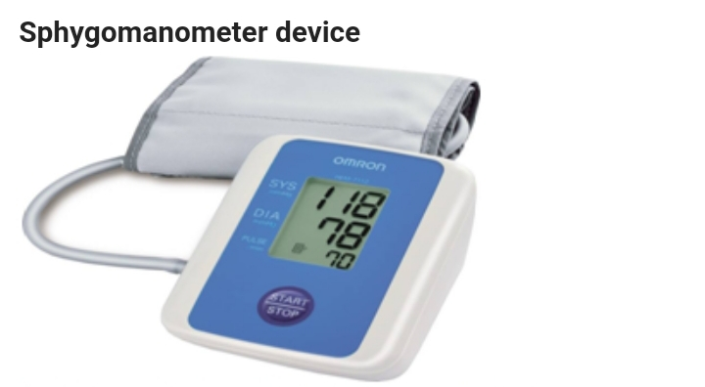

ii) A barometer is an instrument for measuring atmospheric pressure. Two kinds of barometers are in common use, a mercury barometer and an aneroid barometer. The first makes use of a long narrow glass tube filled with mercury supported in a container of mercury, and the second makes use of an elastic disk whose size changes as a result of air pressure.
Mercury barometers
The principle of the mercury barometer was discovered by the Italian physicist Evangelista Torricelli in about 1643. That principle can be illustrated as follows: a long glass tube is sealed at one end and then filled with liquid mercury metal. The filled tube is then turned upside down and inserted into a bowl of mercury, called a cistern, when this happens, a small amount of mercury runs out of the tube into the cistern, leaving a vacuum at the top of the tube. Vacuums, by nature, exert very little or no pressure on their surrounding environment.
As atmospheric pressure pushes down on the surface of the mercury in the cistern, that mercury in turn pushes up with an equal pressure on the mercury in the glass tube. The height of the mercury in the tube, therefore, reflects the total pressure exerted by the surrounding atmosphere. Under normal circumstances, the column of mercury in the glass tube stands at a height of about 30 inches (76 centimetres) when measured at sea level.
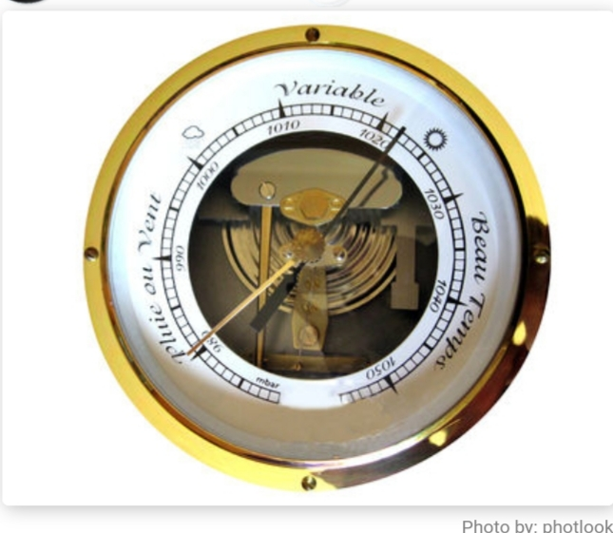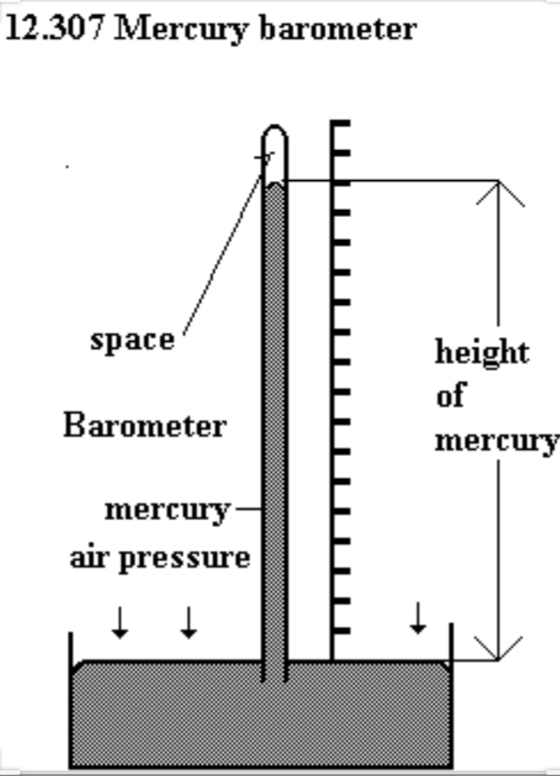

iii) A diaphragm pressure gauge is a device that uses a diaphragm with a known pressure to measure pressure in a fluid.
It has many different uses, such as monitoring the pressure of a canister of gas, measuring atmospheric pressure, or recording the strength of the vacuum in a vacuum pump.
The diaphragm pressure gauge consists of a circular membrane, made from sheet metal of precise dimensions, which can either be flat or corrugated. It diaphragm is mechanically connected to the transmission mechanism, which will amplify the small deflections of the diaphragm, and transfer them to the pointer.
The process pressure is applied to the lower side of the diaphragm, while the upper side is at atmospheric pressure. The differential pressure arising across the diaphragm lifts up the diaphragm and puts the pointer in motion. The deflection of the diaphragm is very small (+/- 1 mm), making it necessary to use a high-ratio multiplying movement, to rotate the pointer along the full length of the scale. The actuation of such a high-ratio transmission mechanism is possible, because diaphragm deflection is able to generate large forces.
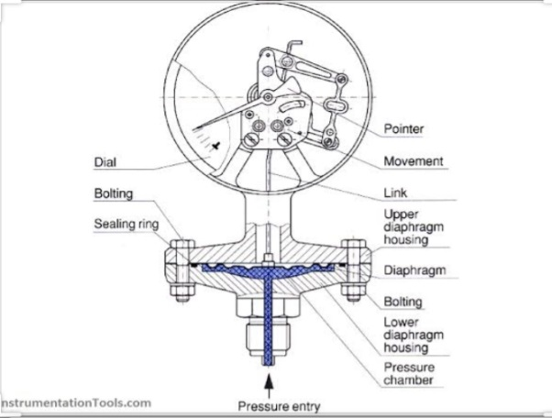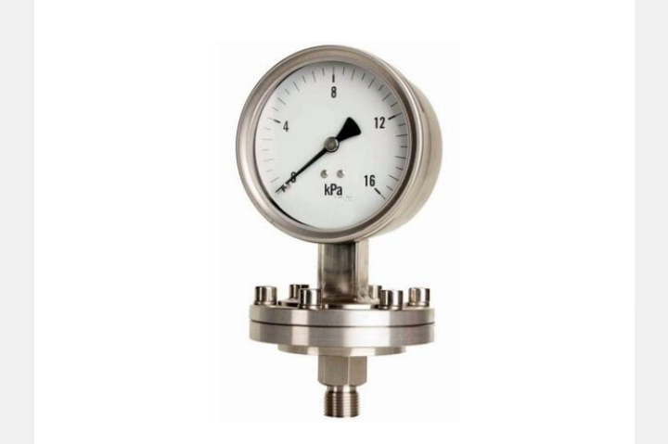

REFERENCES
https://www.instrumentationtools.com
https://wwww.blog.wika.com
https://www.instrumentationforum.com
https://www.omega.com
https://en.m.wikipedia.org

