NAME: SAMPSON SOPHIA
MATRIC NUMBER:19/ENG08/009
DEPARTMENT: BIOMEDICAL ENGINEERING
COURSE CODE: ENG 224
COURSE TITLE: STRUCTURED COMPUTER PROGRAMMING(ALGORITHM)

ASSIGNMENT: Covid-19 has caused a serious pandemic across the world, with serious impacts been felt in all areas of humanities. As a young engineer working with a multi-national health company, you are saddle with a huge responsibility of designing web-based application that can detect, display, rate (degree of infection), store, transmit data obtained wirelessly and access the data via the web together with other features which the board of directors allow you to come up with.
- Design the application following the software development cycle.
- Critically discuss the hardware and software features.
- Support your answer with a flowchart and an algorithm.
- Draw the Top-down or Bottom-up design approach of the application.

Note: Bonus mark will be awarded for clarity and uniqueness.

1.DESIGN THE APPLICATION FOLLOWING THE SOFTWARE DEVELOPMENT CYCLE
WHAT IS SOFTWARE DEVELOPMENT
Software development is the process of specifying, designing, conceiving, programming, documenting, testing and bug fixing involved in creating and maintaining applications, frameworks, or other software components. It is also a process of writing and maintaining the source code, but in a broader sense, it includes all that is involved between the conception of the desired software through to the final manifestation of the software, sometimes in a planned and structured process.
WHAT IS SOFTWARE DEVELOPMENT CYCLE
Software Development Life Cycle is a process that produces software with the highest quality and lowest cost in the shortest time possible. SDLC provides a well-structured flow of phases that help an organization to quickly produce high-quality software which is well-tested and ready for production use.
SDC is a framework that is used to structure, plan and control the process of developing information systems. This can also be regarded as the step to step process involved in software development. The following processes below are known as the software development cycle of process:
1. Conceptualization.
2. Specification and planning.
3. Design.
4. Implementation, Documenting and Coding.
5.Testing and Debugging.
6. Deployment and Maintenance.

1. Identification of need or Requirement Analysis (Conceptualization) ; This is best known as identifying the current problems. And what are the current problems? This phase is the main focus of the project which is a web-based application that tests, detects, stores, compares statistics and transmits information on Covid-19. It also helps in checking the degree of which it spread at a given area or region and how it can be managed. Meetings are held in order to determine the requirements of the software just like; Who is going to use the system? How will they use the system? What data should be input into the system? What data should be the output of the system? .

2.Planning: In this stage of the SDLC, the team determines the cost and resources required for implementing the analyzed requirements. It also details the risks involved and provides sub-plans for softening those risks. In other words, the team should determine the feasibility of the project and how they can implement the project successfully with the lowest risk in mind. The modus of the program are:
i. Testing
ii. Detection
iii. Display rate of infection
iv. Store data received
v. Transmit data received
The application is designed to create awareness concerning the virus.
3. Design: Once the analysis is complete, the step of designing takes over, which is basically building the architecture of the project. These steps help remove possible flaws by setting a standard and attempting to stick to it.
ALGORITHM
1. START
2. REGISTER PATIENTS
3. PERFORM CHECK-UP
4. IF TEMPERATURE >=37
5. PRINT POSITIVE
DISPLAY RATE OF INFECTION
ELSE
PRINT NEGATIVE
6. STORE DATA ON SERVER
7. TRANSMIT TO WEB
8. STOP

4. Implementation, development and coding: Implementation is the part of the process where engineers actually program to code for the software. The actual task of developing the software starts here with data recording going on in the background. Once the software is developed, the stage of implementation comes in where the product goes through a study to see if its functioning properly. The program is written in high level language including the necessary features.
5. Testing and Debugging: The testing stage accesses the software to test if there are any errors or documents bugs. In this stage, we test for defects and deficiencies. We fix those issues until the product meets the original specifications. A dry run is carried out to know the state of the program and bugs are removed. In short, we want to verify if the code meets the defined requirements.
6. Deployment and Maintenance: The program is released to al health organizations worldwide. It is updated based on new discoveries about Covid-19.

2. CRITICALLY DISCUSS THE HARDWARE AND SOFTWARE FEATURES
The program has both hardware and software features
HARDWARE FEATURES
1. DETECTION
REAL TEMPERATURE: is a temperature monitoring program design for computers. It can measure the temperature of individual with processor to great accuracy.
HW MONITOR: is a complete monitoring program for the computer; it detects all sensors of hardware component and tell us the temperature.

2.DISPLAY
MONITOR: it is the most type of hardware known, it displays information about to processes and received.
GRAPHICS CARD: is responsible for rendering an image to the monitor, it does this by converting data into a signal your monitor can understand.

3.RATE
PULSE SENSOR: is a simple sensor used in hospital. It finds the rate of heartbeat within fraction of seconds

4.STORING
HARD DISK DRIVE: can be found in almost all desktops and laptops. It stores all files for operating system. It uses magnetic storage to record data.

5.TRANSMITTING DATA
ROUTER
LINER DRIVER

SOFTWARE DEVICES
PAS: Patient Administration System.
OTMS: Operating Theatre Management System.
LIMS: Laboratory Information Management System.
BMS: Booking Management System.
AMS: Appointment Management System.
HCS: Hospital Costing System.

The process begins with the patient getting to any test station to test for Covid-19. The patient then registers to the computer systems. After which then put through a series of tests to confirm if infection has occurred. If positive the system will detect and determine the degree of infection. Thereafter the results are stored and transmitted through signals to the web.

3. SUPPORT YOUR ANSWER WITH A FLOWCHART AND AN ALGORITHM

ALGORITHM

STEP 1: Start
STEP 2: Register Patient
STEP 3: Take Temperature
STEP 4: If Temperature>=37
STEP 5: Check for Covid-19 Symptoms
Cough
Fever
Breathlessness
STEP 6: Print positive
Display rate of infection
Else
Print negative
STEP 7: Store data on server
STEP 8: Transmit to web
STEP 9: Stop

FLOWCHART

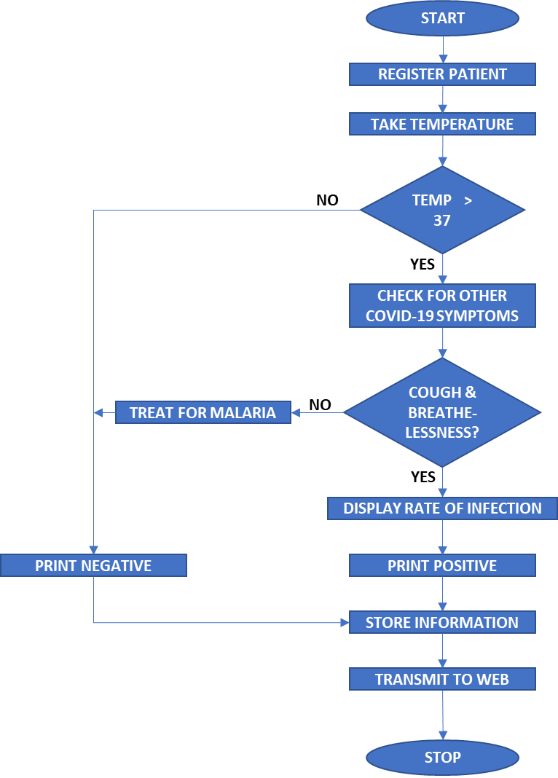

4.

Covid-19 TOP TO BOTTOM

APPLICATION

HARDWARE SOFTWARE

Clinical Computer Input&
Database Fever GUI
Equipment Equipment Output
Software Detection Devices
& Servers

