ENGINEERING LAW AND HAZARD ASSESSMENT OF HEALTH WORKERS FOR ENHANCED OCCUPATIONAL SAFETY IN NIGERIA
BY
17/ENG02/048
NNABUGWU CHIDUBEM.A.
A TERM PAPER SUBMITTED TO
COLLEGE OF ENGINEERING, AFE BABALOLA UNIVERSITY, ADO-EKITI, EKITI STATE.
FOR ENGINEERING LAW AND MANAGERIAL ECONOMICS (ENG 384)
IN PARTIAL FULFILMENT TO THE REQUIREMENTS FOR THE DEGREE OF BACHELOR OF ENGINEERING IN COMPUTER ENGINEERING.

11th of APRIL, 2020
TABLE OF CONTENTS

TITLE PAGE………………………………………………..…………………………………1

TABLE OF CONTENTS………………………………………………………………………2

ABSTRACT…………………………………………………………………………………...3

- INTRODUCTION…………………………………………………….……………..…….5

2.0 LITERATURE REVIEW……………………………………………………………….....7

3.0 CHALLENGES…………………………………………………………………………..14

4.0 RECOMMENDATION……………………………………….………………………….15

5.0 CONCLUSION…………………………………………………………………………..16

6.0 REFERENCES…………………………………………………………………………...17

ABSTRACT
This study provides an overview of the main OSH risks faced by emergency responders
during disease outbreaks and other emergencies, such as natural disasters, chemical incidents,
radiological emergencies and emergencies involving conflicts. The intent is to assist organizations and workplaces to better prepare and respond to these events. This paper, which is particularly focused on needs in low-resource settings, provides technical guidance on good
practices and procedures in establishing systems that can: 1) reduce occupational exposures,
injury, illness and death among response workers; 2) decrease stress and reduce fears; and 3)
promote the health and well-being of health-care and other response workers. The study cover managerial and technical tools and strategies for managing OSH in emergency situations. These tools include an OSH management systems approach for use in emergencies, an incident command system (ICS), OSH controls and standard precautions and their application during emergencies.
The manual is intended for experts and officials in emergency response organizations who are
responsible for workers’ OSH. This information is particularly important in countries with high
risk of emergencies – such as those with high transmission of highly infectious agents (e.g.
cholera, yellow fever, viral haemorrhagic fevers) and/or natural disasters, and chemical and
radiological incidents. The key target audience includes personnel from agencies and organiza-
tions responsible for implementing the International Health Regulations (IHR) within a country, government agencies in the health and labour sectors, international organizations, nongovernmental organizations (NGOs), humanitarian and charitable bodies, faith-based organizations, hospitals and health-care facilities, public and private companies, security forces, employers and trade unions.
Occupational Safety and Health (OSH) does not only seek to secure the safety and health of persons at work but consequentially stimulates productivity in the business of the enterprise. It is, therefore, necessary that the National Occupational Safety and Health System be visibly identified and coordinated for effective management, and one of the means of achieving that is through the development of a National Occupational
Safety and Health Profile.
The current leadership of this nation is very much interested in the protection of the labour force and the revitalization of the economy for improved wellbeing of the generality of the people. This is why at this time, the Federal Ministry of Labour and Employment in collaboration with the International Labour Organization (ILO) took the step to develop a baseline National Occupational Safety and Health Profile to stimulate effective management of safety and health at work in Nigeria
The systems approach to Occupational Safety and Health has been widely proven to be an effective strategy for achieving the sustainable safety and health management, leading to the development of a preventative OSH culture and continuous improvement of the work environment. The International Labour Organization’s Convention 187 on Promotional Framework on Occupational Safety and Health provides the guidelines towards achieving these objectives. A National Occupational Safety and Health Profile, as the starting point, brings about the identification of the relevant elements of the national OSH system, their specific roles, capacities and achievements for effective synergy towards a sustainable national OSH prevention programme.
This Profile provides the framework for the strengthening of the National Occupational Safety and Health System by identifying the institutional framework, programmes and activities to facilitate systematic assessment and review of the progress and impact of Occupational Safety and Health efforts in the nation. It constitutes an inventory of all the tools and resources available for implementing and managing Occupational Safety and Health in Nigeria, to assist in data and information acquisition for record and planning purposes,setting national priorities for action and promotion of participatory OSH, as desired in the National Policy.

- INTRODUCTION

Occupational health is a course that deals with the study of the health problems employees’ face in their work environment and how those health problems are managed to protect the health status of employee and their family. It exposes the different sources through which the employees are affected. The processes of detecting the health problems are similar to investigative processes obtainable in established health institutions. The unit examines the historical development of occupational health; the role of health team members and the efforts of international organizations to ensure that safety measures are provided and workers get their compensation from employers. The unit looks at the historical development of OH in both developed and developing countries including Nigeria. It also looks at the contributions made by International Labour Organisation (ILO) and the World Health Organisation (WHO) in the protection of health and safety of people at work settings. Healthcare workforce is one of the largest work forces in the world constituting over 12% of the working population in the whole world. Nigeria has one of the largest pools of healthcare personnel in Africa and they make up about one third of the total workforce in Nigeria. Health workers perform their duties in an increasing hazardous work environment and occupational settings. Personnel in this workforce are responsible for providing quality health care services, even though their work places (hospitals, clinics and laboratories) are increasingly unsafe.
It was reported that healthcare workers (HCWs) encounter different hazards due to their activities. This includes but not limited to sharp related injuries, direct infections, stress, assault from patients and their relatives, allergies, back pain, and other musculoskeletal injuries. In spite of the numerous hazards in their unsafe workplaces, healthcare occupational settings continue to be neglected by governments, management and regulators. Occupational health hazards put HCWs at risk of increased morbidity and mortality. Loss of skilled health personnel will adversely affect healthcare services which are already suboptimal in developing countries such as Nigeria. The multiplying effects of occupational injuries and diseases among health workers include economic loss, physical loss and psychological disorders such as stress and depression. These have an overall negative impact on the workers, their families and the nation at large.
Identifying factors relating to occupational hazards among HCWs is essential in formulating occupational health safety policy and system that will improve the productivity and overall wellbeing of HCWs. This study assessed the level of awareness of occupational health safety, identified common hazards among health workers and determined association between profession, year of experience and level of awareness of occupational health hazards among these health workers in two government hospitals in Ondo, South west Nigeria.

2.0 LITERATURE REVIEW
The federal government is working with stakeholders to structure medical and life insurance for health workers involved in the war against COVID-19 in Nigeria. The Secretary to the Government of the Federation (SGF), Boss Mustapha, said this at the Presidential Taskforce briefing on COVID-19 in Abuja on Friday. Healthcare workers are vulnerable to COVID-19 virus as they are first responders to patients. Some health workers working at isolation centres across affected states have expressed their dissatisfaction over lack of necessary insurance and other welfare policies.
Nigeria has recorded 210 cases of COVID-19, out of which 20 people have been discharged after recovering from the virus, while four have died. It is, however, uncertain if health workers are among the recorded cases as their identities are not disclosed officially. Only persons who test positive or their associates are allowed to disclose such identities.
Following the complaint by the health workers and their unions, Mr Mustapha said the insurance for health workers is being planned considering the danger they are exposed to during this COVID-19 pandemic. “In recognition of the danger to which our frontline health workers are exposed to, government is working with other stakeholders to structure medical and life insurance cover for their protection. “I, therefore, wish to assure them of our commitment and urge them to put in their utmost best as they battle to save us from this ravaging disease,” Mr Mustapha said.
In his remarks, the Minister of Health, Osagie Ehanire, commended the health workers for their efforts so far. ”I must at this juncture commend our frontline health workers who are doing a great job in case identification and management. ”As we prepare strategies to contain COVID-19 outbreak, we must not lose sight of other health challenges in our country. ”Routine healthcare service must continue in all hospitals. Only a wing of tertiary centers need to be put to use for infected patients control. ”It is important that we do not drop the ball and lose gains made in many areas of healthcare, including maternal and child health and immunization,” he said.

2.1 COMPANIES TAKING THE INITIATIVE
Binah.ai
Either remotely or on-premises, Binah.ai's video-based app removes the need for wearables and provides vital signs measurements such as heart rate, heart rate variability, mental stress, oxygen saturation, respiration rate and more - all with medical-grade accuracy. Binah.ai’s app countless use cases span over a wide range of fields such as telemedicine, remote patient monitoring, primary care, preventive medicine, nursing homes, and life insurance. With their series of non-invasive, video-based health and wellness monitoring solutions, Binah.ai gives an unparalleled advantage in health analytics as its technology transforms any device equipped with a simple camera into a medical-grade healthcare gadget.
ContinUse Biometrics
This Tel Aviv-based startup is reimagining global health monitoring. CU-BX® has developed a contact-free sensing platform that provides highly accurate physiological measurements within a multitude of environments. Backed by extensive clinical data, CU-BX® proprietary optic-based sensors monitor key biometric parameters such as respiratory rate, heart rate variability, and breathing patterns with medical-grade accuracy. Proprietary sensors are embedded throughout the environment into electronic devices or vehicles, and seamlessly monitor vital signs of any known person who is in range. Cu-Bx™ requires no ongoing intervention, so a person’s daily routines are unaffected and adherence issues are non-existent.
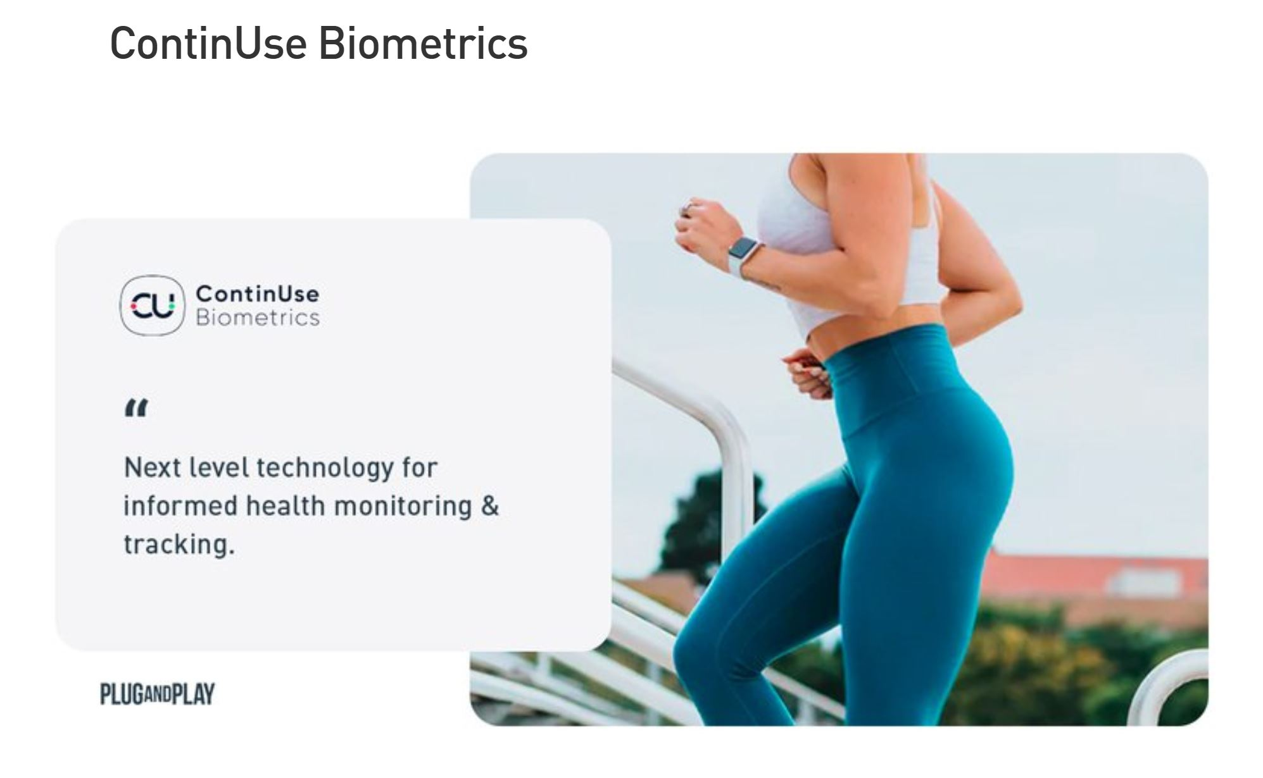
Fig 1.0: ContinUse Biometrics
Since the sensors do not require physical touch to provide accurate measurement, CU-BX® sensing solutions are intrinsically hygienic, providing additional protection against the spread of infection and disease. When confronting novel viral outbreaks, it is paramount that medical providers, institutions and organizations have the optimal tools to quickly and efficiently manage the situation. In the case of COVID-19, proximity to infected persons greatly amplifies the likelihood of contagion. Passive or contact-free means to flag symptomatic patients may thus allow greater control of viral spread. A HIPPA and GDPR compliant health cloud maintains all records and enables meaningful analytics which further supports the development of insights and potentially new preventative measures in the future.
Wireless Medical Devices
HealthBeatsHealthBeats is a globally operating remote vitals monitoring platform designed to bring healthcare to home. HealthBeats provides users with medical devices to self-monitor themselves on a regular basis and to have their results transmitted in real time to care providers for proactive care management. HealthBeats is the global distributor of iHealth Labs' full range of regulatory approved medical devices.
Currently, HealthBeats is exploring how its platform can be made available for the broader population and support the further spread of COVID-19. Their hope is to streamline data collection and automate some of the processes to increase speed and efficiency in response to the COVID-19 pandemic. For individuals with a quarantine order or those required to stay at home, HealthBeats allows the immediate implementation of automated vital signs tracking, such tracking temperature and blood oxygen/heart rate twice a day with alerts sent out in real-time for any missed or threshold readings.
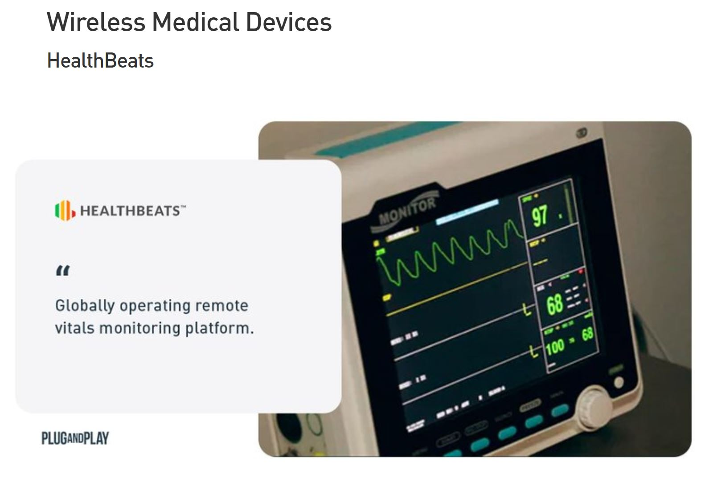
Fig 2.0: HealthBeats
Detecting Pathogens
The new coronavirus SARS-CoV-2 appears to be fairly easily spread. But the good news is that it's not among the most transmissible diseases out there. The new coronavirus spreads mostly through person-to-person contact within a 6-foot (1.8 meters) radius, according to the Centers for Disease Control and Prevention (CDC). People with COVID-19, which is the disease caused by the coronavirus, spread viral particles through coughing and sneezing. The particles can land in the mouths or noses of those nearby. Solutions that detect airborne pathogens may help us identify risk in social determinants.

Koniku
Koniku claims that the most advanced piece of technology on the planet is wetware. They merge biological neurons with silicon technology complete with odor sensing, classification, and real biological learning. With its contactless odor surveillance system, it has found applicability within airport security. The company has been working with the Airbus Group to develop a technology capable of sniffing explosives in the air without the need to touch, or search passengers. That means the passenger can walk from the curbside to aircraft without any visible security. Koniku demonstrated the detection of TATP in the air at two parts per billion or 0.1 nanograms in under 10 seconds, in lab conditions and on the field. Koniku fuse living cells or brain cells with silicon to achieve this result and virtually achieve the same accuracy as a dog's nose.
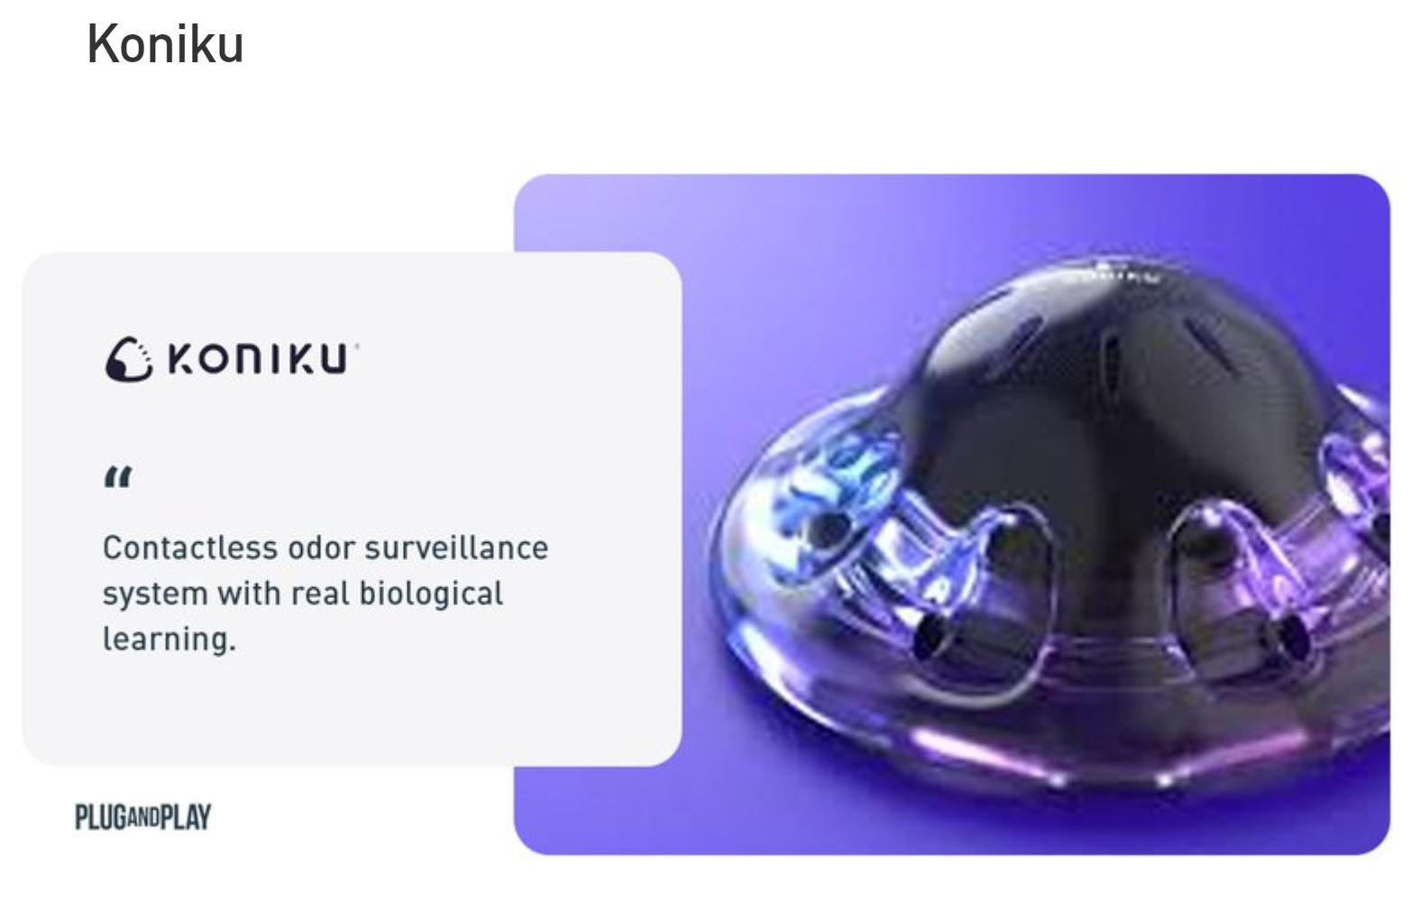
Fig 3.0: Koniku
Nuwave Sensors
NuWave Sensors develops a range of smart air quality sensors designed to continuously monitor airborne contaminants in industrial and commercial environments, where the stability of air quality is essential, and rapid diagnosis of contamination events is crucial.
Their clients include healthcare facilities, manufacturing, food processing, and clean room environments, as well as research and environmental monitoring.
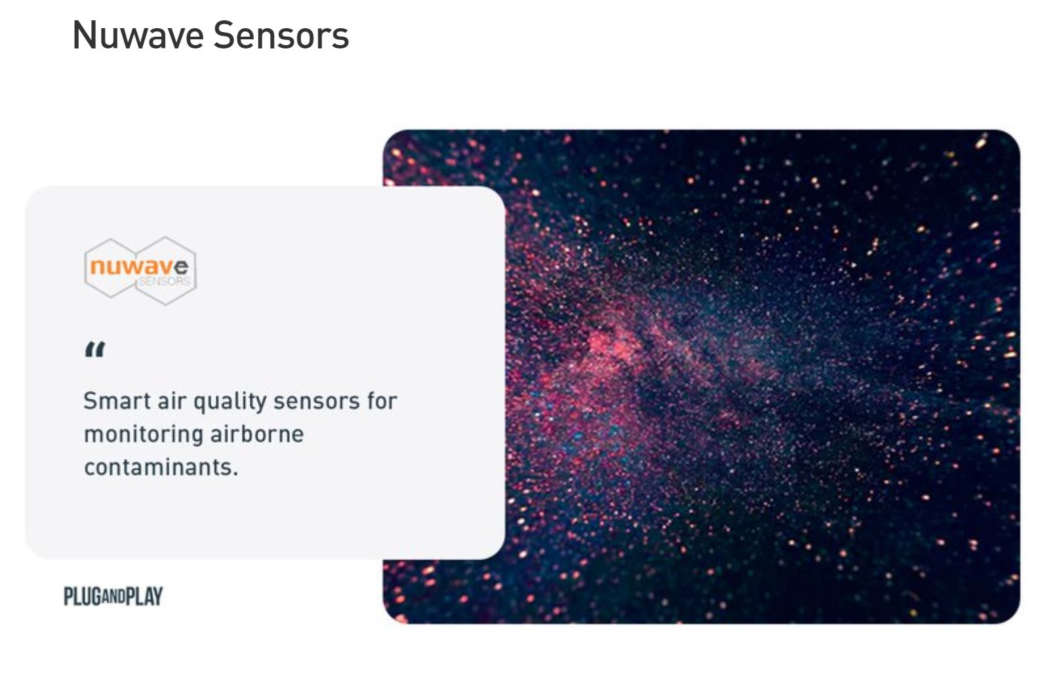
Fig 4.0: Nuwave Sensors
Health worker rights include that employers and managers in health facilities:
• assume overall responsibility to ensure that all necessary preventive and protective measures are taken to minimize occupational safety and health risks;
• provide information, instruction and training on occupational safety and health, including;
o Refresher training on infection prevention and control (IPC); and
o Use, putting on, taking off and disposal of personal protective equipment (PPE);
• provide adequate IPC and PPE supplies (masks, gloves, goggles, gowns, hand sanitizer, soap and water, cleaning supplies) in sufficient quantity to healthcare or other staff caring for suspected or confirmed
Including implementation of occupational safety and health management systems to identify hazards and assess risks to health and safety; infection prevention and control (IPC) measures; zero-tolerance policies towards workplace violence and harassment.
COVID-19 patients, such that workers do not incur expenses for occupational safety and health
requirements;
• familiarize personnel with technical updates on COVID-19 and provide appropriate tools to assess, triage,
test and treat patients and to share infection prevention and control information with patients and the public;
• as needed, provide with appropriate security measures for personal safety;
• provide a blame-free environment for workers to report on incidents, such as exposures to blood or bodily fluids from the respiratory system or to cases of violence, and to adopt measures for immediate followup, including support to victims;
• advise workers on self-assessment, symptom reporting and staying home when ill;
• maintain appropriate working hours with breaks;
• consult with health workers on occupational safety and health aspects of their work and notify the labour inspectorate of cases of occupational diseases;
• not be required to return to a work situation where there is continuing or serious danger to life or health, until the employer has taken any necessary remedial action;
• allow workers to exercise the right to remove themselves from a work situation that they have reasonable justification to believe presents an imminent and serious danger to their life or health. When a health worker exercises this right, they shall be protected from any undue consequences;
• honour the right to compensation, rehabilitation and curative services if infected with COVID-19 following exposure in the workplace. This would be considered occupational exposure and resulting illness would be considered an occupational disease,
• provide access to mental health and counselling resources; and
• enable co-operation between management and workers and/or their representatives.

3.0 CHALLENGES
1. This unprecedented situation is sending shockwaves through the world of work. To soften the blow, governments were most likely to opt for the five policies below, according to the ITUC:
Provision of free health care - 50% of countries
Employment protection for those self-isolating - 34% of countries
Tax relief for businesses - 31% of countries
Paid sick leave for a period of self-isolation - 29% of countries
Bailout funds for business or sectors - 29% of countries
2. A lack of access to healthcare and paid sick leave are among the concerns.
3. Job losses are set to exceed predictions of 25 million worldwide.
4. Only 21% of countries are providing sick leave for all or some workers. The countries polled represent a swathe of the world's most powerful economies, including 28 out of 36 OECD countries and fifteen G20 countries.
5. there are many businesses who have simply taken an opportunity to lay off staff. In some cases, they are taking government support and still laying off staff, where the factories and retail outlets and services are shutting down, people often have far too little sick pay, if any at all. Wage and job guarantees are lacking. The International Labor Organization (ILO) says we could lose up to 25 million jobs worldwide – and depending on the timeframe, it could be worse than that.
6. It's a challenge now to manage, a global office of people in their own homes. The technology we have now really does play up the opportunities, but it also highlights the costs and potential risks of people being atomized from their place of work.
7. And for people with young children, this is an incredibly difficult time. Balancing work and family is a whole new realm of challenges. So from a personal point of view and from an economic point of view, this is nothing short of potentially disastrous for people's livelihoods and indeed for stable economies.

4.0 RECOMMENDATIONS
Health workers should:
1. Follow established occupational safety and health procedures, avoid exposing others to health and safety risks and participate in employer-provided occupational safety and health training;
2. Use provided protocols to assess, triage and treat patients;
3. Treat patients with respect, compassion and dignity;
4. Maintain patient confidentiality;
5. Swiftly follow established public health reporting procedures of suspect and confirmed cases;
6. Provide or reinforce accurate infection prevention and control and public health information, including to concerned people who have neither symptoms nor risk;
7. Put on, use, take off and dispose of personal protective equipment properly;
8. Self-monitor for signs of illness and self-isolate or report illness to managers, if it occurs;
9. Advise management if they are experiencing signs of undue stress or mental health challenges that require support interventions; and
10. Report to their immediate supervisor any situation which they have reasonable justification to believe presents an imminent and serious danger to life or health.

5.0 CONCLUSION
According to the World Health Organisation (WHO), coronaviruses are a family of viruses that cause illnesses ranging from the common cold to more severe diseases such as severe acute respiratory syndrome (SARS) and the Middle East respiratory syndrome (MERS). These viruses were originally transmitted from animals to people. SARS, for instance, was transmitted from civet cats to humans while MERS moved to humans from a type of camel. Several known coronaviruses are circulating in animals that have not yet infected humans.
This study showed that majority of the government health workers had high occupational hazard risk, poor compliance to occupational safety measures despite high awareness of OHS. Clinical health workers and health workers with more than 10 years experience had better awareness of OHS.

8.0 REFERENCES
Andersen LL, Clausen T, Mortensen OS, Burr H, Holtermann A. A prospective cohort study on musculoskeletal risk factors for long-term sickness absence among healthcare workers in eldercare. International Archives of Occupational and Environmental Health. 2012;85(6):615–622.
Goniewicz M, Włoszczak-Szubzda A, Niemcewicz M, Witt M, Marciniak- Niemcewicz A, Jarosz MJ. Injuries caused by sharp instruments among healthcare workers international and Polish perspectives. Annals of Agricultural and Environmental Medicine. 2012;19(3):523–527.
Lipscomb J, Rosenstock L. Healthcare workers: Protecting those who protect our health. Infection Control and Hospital Epidemiology. 1997;18(6):397–399.
Manyele SV, Ngonyani HAM, Eliakimu E. The status of occupational safety among health service providers in hospitals in Tanzania. Tanzania Journal of Health Research. 2008;10(3):159-165.
Moore Jr RM, Kaczmarek RG. Occupational hazards to health care workers: Diverse, ill-defined and not fully appreciated. American Journal of Infection Control. 1990;18(5):316–327.
Ndejjo R, Musinguzi G, Yu X, Buregyeya E, Musoke D, Wang JS, Halage AA, Whalen C, Bazeyo W, Williams P, Ssempebwa J. Occupational health hazards among healthcare workers in Kampala, Uganda. J Environ Public Health. 2015;2015:913741. DOI:10.1155/2015/913741
Nsubuga FM, Jaakkola MS, Needle stick injuries among nurses in sub-Saharan Africa. Tropical Medicine and International Health. 2005;10(8):773-781.
Stonerock T. Professional Burnout. Recent Developments in Theory and Research, London and New York; 2004.
Triolo PK. Occupational health hazards of hospital staff nurses. Part II: Physical, chemical and biological stressors. AAOHN Journal. 1989;37(7):274–279.

