Mbam Oguzie
17/ENG05/021
Mechatronics
Eng 384

1 A patent is a form of intellectual property that gives the owner the legal right to exclude others from making, using, selling and importing an invention for a limited period of years, in exchange for publishing an enabling public disclosure of the invention. In most countries patent rights fall under civil law and the patent holder needs to sue someone infringing the patent in order to enforce his or her rights. In some industries patents are an essential form of competitive advantage; in others they are irrelevant.
The procedure for granting patents, requirements placed on the patentee, and the extent of the exclusive rights vary widely between countries according to national laws and international agreements. Typically, however, a patent application must include one or more claims that define the invention. A patent may include many claims, each of which defines a specific property right. These claims must meet relevant patentabilityrequirements, such as novelty, usefulness, and non-obviousness.
Under the World Trade Organization's (WTO) TRIPS Agreement, patents should be available in WTO member states for any invention, in all fields of technology, provided they are new, involve an inventive step, and are capable of industrial application. Nevertheless, there are variations on what is patentable subject matter from country to country, also among WTO member states. TRIPS also provides that the term of protection available should be a minimum of twenty years.

2 Copyright is the exclusive right given to the creator of a creative work to reproduce the work, usually for a limited time. The creative work may be in a literary, artistic, educational, or musical form. Copyright is intended to protect the original expression of an idea in the form of a creative work, but not the idea itself. A copyright is subject to limitations based on public interest considerations, such as the fair use doctrine in the United States. Some jurisdictions require "fixing" copyrighted works in a tangible form. It is often shared among multiple authors, each of whom holds a set of rights to use or license the work, and who are commonly referred to as rights holders.[citation needed] These rights frequently include reproduction, control over derivative works, distribution, public performance, and moral rights such as attribution.
Copyrights can be granted by public law and are in that case considered "territorial rights". This means that copyrights granted by the law of a certain state, do not extend beyond the territory of that specific jurisdiction. Copyrights of this type vary by country; many countries, and sometimes a large group of countries, have made agreements with other countries on procedures applicable when works "cross" national borders or national rights are inconsistent.
Typically, the public law duration of a copyrightexpires 50 to 100 years after the creator dies, depending on the jurisdiction. Some countries require certain copyright formalities to establishing copyright, others recognize copyright in any completed work, without formal registration.

3 Trademark symbols
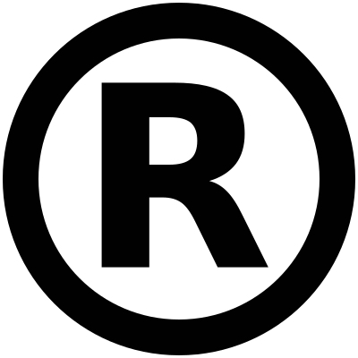

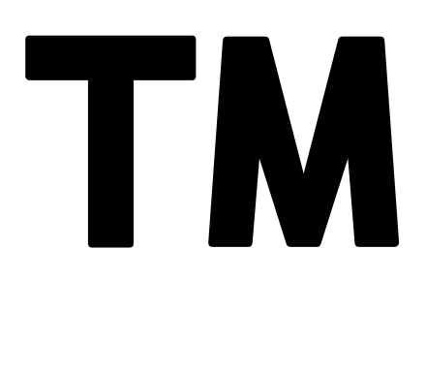
A trademark (also written trade mark or trade-mark) is a type of intellectual property consisting of a recognizable sign, design, or expression which identifies products or services of a particular source from those of others, although trademarks used to identify services are usually called service marks. The trademark owner can be an individual, business organization, or any legal entity. A trademark may be located on a package, a label, a voucher, or on the product itself. For the sake of corporate identity, trademarks are often displayed on company buildings. It is legally recognized as a type of intellectual property.
The first legislative act concerning trademarks was passed in 1266 under the reign of Henry III, requiring all bakers to use a distinctive mark for the bread they sold. The first modern trademark laws emerged in the late 19th century. In France the first comprehensive trademark system in the world was passed into law in 1857. The Trade Marks Act 1938of the United Kingdom changed the system, permitting registration based on "intent-to-use”, creating an examination based process, and creating an application publication system. The 1938 Act, which served as a model for similar legislation elsewhere, contained other novel concepts such as "associated trademarks", a consent to use system, a defensive mark system, and non claiming right system.
The symbols ™ (the trademark symbol) and ® (the registered trademark symbol) can be used to indicate trademarks; the latter is only for use by the owner of a trademark that has been registered.
usage of trademark

A trademark identifies the brand owner of a particular product or service. Trademarks can be used by others under licensing agreements; for example, Bullyland obtained a license to produce Smurf figurines; the Lego Group purchased a license from Lucasfilm in order to be allowed to launch Lego Star Wars; TT Toys Toys is a manufacturer of licensed ride-on replica cars for children.[6] The unauthorized usage of trademarks by producing and trading counterfeit consumer goods is known as brand piracy.
The owner of a trademark may pursue legal action against trademark infringement. Most countries require formal registration of a trademark as a precondition for pursuing this type of action. The United States, Canada and other countries also recognize common law trademark rights, which means action can be taken to protect an unregistered trademark if it is in use. Still, common law trademarks offer to the holder, in general, less legal protection than registered trademarks.

4 Trade secrets are a type of intellectual property that comprise formulas, practices, processes, designs, instruments, patterns, or compilations of information that have inherent economic value because they are not generally known or readily ascertainable by others, and which the owner takes reasonable measures to keep secret.[1] In some jurisdictions, such secrets are referred to as confidential information.

The precise language by which a trade secret is defined varies by jurisdiction, as do the particular types of information that are subject to trade secret protection. Three factors are common to all such definitions:
A trade secret is information that
- is not generally known to the public;
- confers economic benefit on its holder because-the information is not publicly known; and
- where the holder makes reasonable efforts to maintain its secrecy.

