NAME:INEGBEDION ANDREW ODIGIE

DEPT:ELECT/ELECT

MATRIC:17/ENG04/033

Engineering maths assignment 3

a)

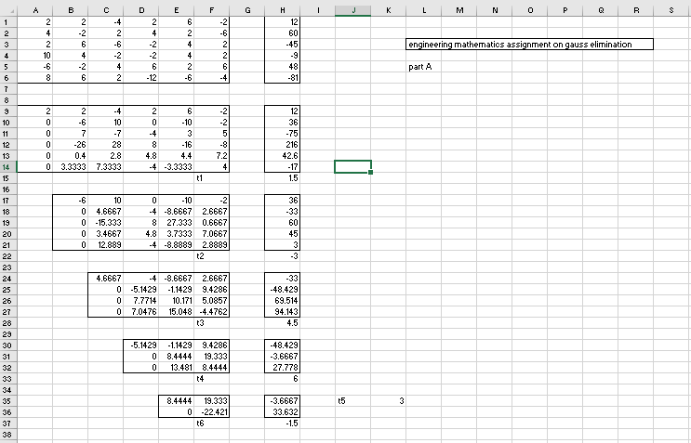

b)

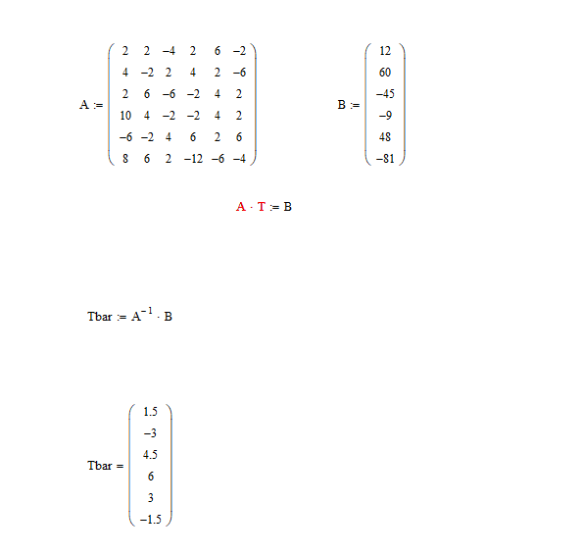

c) 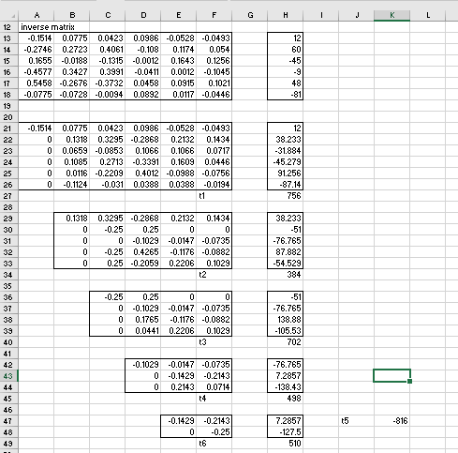

d) 