A TERM PAPER ON ENGINEERING LAW AND MANAGERIAL ECONOMICS FOR INFRASTRUCTURAL DEVELOPMENT IN NIGERIA: CHALLENGES AND WAY FORWARD
PREPARED BY
IBRAHIM ABDUL-HAMID
17/ENG 06/040
SUBMITTED TO
ENGR. OYEBODE
CIVIL ENGINEERING DEPARTMENT,
COLLEGE OF ENGINEERING,
AFE BABALOLA UNIVERSITY, ADO-EKITI,
EKITI STATE, NIGERIA.
IN PARTIAL FULFILMENT OF ENG384: ENGINEERING LAW AND MANAGERIAL ECONOMICS
13TH APRIL 2020

ACKNOWLEDGEMENT
First and foremost, I appreciate God, the giver of life, for enabling me to write this term paper.

ABSTRACT
Infrastructure development is the basis of measuring the performance of democratic leaders and it is the foundation of good democratic governance. Infrastructure is the medium, the tools and techniques of a project or programme or strategy. Demand for infrastructural development is higher and resources used in provision of infrastructure are limited. Ethnic-interest agitation and lobbying are common things in democratic governance. The military era in Nigeria was for the most part of the economic boom and only succeeded in widening the gap in infrastructure demand and provision. Most infrastructures are now decayed and need repair or replacement. Government is the system that organizes and sensitizes the people of an area in other for all to have an acceptable community. Government have the power to put in place all measures that it deems fit will make an environment conducive for living for everybody. Infrastructure development in democratic governance involves identifying the right project, carrying out feasibility and viability studies and carrying out physical development of the project. The challenges are numerous and include finance, technology for development, maintenance and design. The challenges also include international requirements of project to be sustainably developed. Projects must meet the carbon emission standard set by international organizations, communities must be bio-diversified and emit as little greenhouse gases (GHGs) as possible, natural environment must be preserved and so on. The challenges are many but any serious government can overcome them as a result of incessant research and development in infrastructure development worldwide.

LIST OF FIGURES
Fig 1. Flooded street in Lagos
Fig 2. Vendors displaying goods for sale while contesting for space with public transport vehicles

INTRODUCTION
Infrastructure is the basic physical and organisational structures needed for the operation of a society like industries, buildings, roads, bridges, health services, governance and so on. It is the enterprise or the products, services and facilities necessary for an economy to function (Sulivan and Sheffrin, 2003). Infrastructure can be described generally as the set of interconnected structural elements that provide framework supporting an entire structure of development. It is the means of achieving an objective or set of objectives and also includes the objectives. It is an important term for judging a country, region or state’s and individual’s developments/status.
The term typically refers to the technical structures that support a society, such as roads, water supply, sewers, electrical national grids, telecommunications, and so forth, and can be defined as "the physical components of interrelated systems providing commodities and services essential to enable, sustain, or enhance societal living conditions" (Fulmer, 2009).
Viewed functionally, infrastructure facilitates the production of goods and services, and also the distribution of finished products to end-users (markets), as well as basic social services such as schools and hospitals; for example, roads enable the transport of raw materials to a factory (American Heritage Dictionary, 2009). In military parlance, the term refers to the buildings and permanent installations necessary for the support, redeployment, and operation of military forces (Department of Defense Dictionary, 2005).
The word infrastructure has been used in English since at least 1927 according to Online Etymology Dictionary (2012), originally meaning "The installations that form the basis for any operation or system ". Infrastructure in developing countries connotes roads and transport infrastructures. The advent of telecommunication infrastructure in Nigeria brought infrastructure to the front seat as the products and services necessary for the performance of an entity.
There are two types of infrastructure, “Hard and Soft" infrastructure. Hard refers to the large physical networks necessary for the functioning of a modern industrial nation, whereas "soft" infrastructure refers to all the institutions which are required to maintain the economic, health, and cultural and social standards of a country, such as the financial system, the education system, the health system, the governance system, and judiciary system, as well as security (Kumar, 2005).

THE NATURE OF INFRASTRUCTURES IN THIRD WORLD COUNTRIES SUCH AS NIGERIA
Nigeria remains at the centre of Sub Saharan Africa’s growth story. With a population of over 177 million and an estimated GDP of over US$587 billion in 2015, the country has abundant natural resources including one of the largest natural gas and crude oil reserves in Africa, over 300,000 square kilometres of arable land, and signiﬁcant deposits of largely untapped minerals. Strong demographic growth with an improving age mix, increased technological innovation, and fast urbanisation also continue to shape the future of Nigeria. 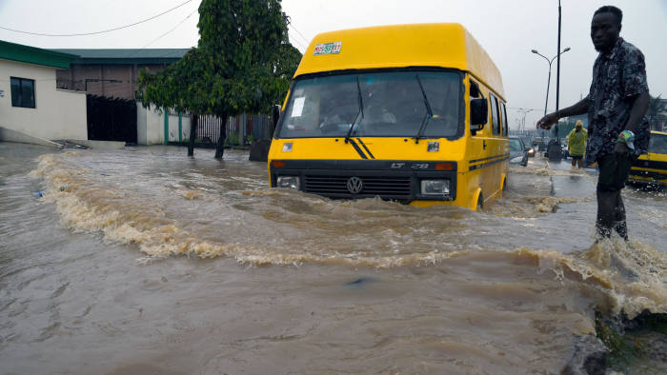 Fig 1: flooded street in Lagos
The Infrastructural report of Nigeria just like any third world country is nothing to write home about. The housing situation is in a sorry state both quantitatively and qualitatively (Agbola, 1998; Ajanlekoko, 2001; Nubi, 2000; Onibokun, 1996 Oyedele, 2006). Most infrastructures are now decayed and need repair, rehabilitation or replacement. Government is the system that plans, organizes, controls and supervises the people who are live in an area in other for all to have a conducive environment for living and a sense of belonging. Governments have the power to put in place all measures that will make an environment beneficial for living for everybody.
Infrastructure development in democratic governance is more challenging because of the accessibility of people to government and involves identifying the right project, carrying out feasibility and viability studies and embarking out physical development of the project. The challenges are numerous and include finance, technology for development, maintenance and design. The challenges also include quality requirements of projects to meet international standard and to be sustainably developed. Projects must meet the carbon emission standard set by international organizations like International Standard Organisation. 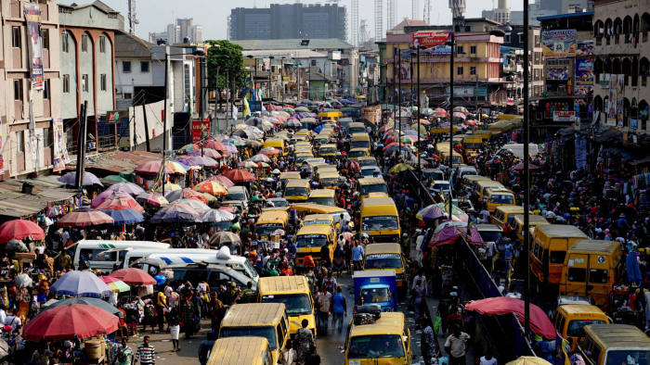
Fig 2: Vendors displaying goods for sale while contesting for space with public transport vehicles

Tradesmen and other technical human resources needed for infrastructural development are scarce because of lack of training and motivation. As a result, many professionals, tradesmen and senior managers are moving to other countries for ‘greener pastures’. Because of fast money, most youths that should have learnt a trade are now “commercial bicycle riders”.
The numerous challenges have not been tackled as they should. Nigeria's lack of basic infrastructure to facilitate sustainable development and trade – both regionally and globally – and to ensure competitiveness is already known by all. In particular, for the large number of local governments, especially the rural ones, the dwellers produce have no access to markets and are not stored, hampered by weak transport and energy infrastructure.
As a country who largely depends on imported goods(for goods ranging from rice, ﬁsh, and wheat to reﬁned oil and gas products), the huge decline in government revenues has created signiﬁcant pressure is being placed on Nigeria’s currency due to a huge decline:the high dependence on oil revenues, and the limited investments in infrastructure when there was a boom in oil prices. This makes diversiﬁcation of the economy a top priority in being able to build value-adding processing / manufacturing industries that can compete globally and supply the domestic market with essential products.

THE BENEFITS OF INFRASTRUCTURE IN NATIONAL DEVELOPMENT
The African Development Bank (ADB) has made infrastructure development a cornerstone in its development agenda with regional member countries. The Bank recognizes that lack of adequate social and economic infrastructure is one of the key constraints to short and medium term poverty reduction in Africa, and has thus been a major force in private and public sector infrastructure development through the provision of financial and technical resources. At the same time, the Bank recognises the increasing importance of governance for infrastructure development and has made good governance an imperative in its lending and non-lending operations.
There have been considerable changes in the delivery of national infrastructure services across Africa. While Nigeria has improved its telecommunication infrastructural situation, it has not improved in other areas like health, education, airport infrastructures, electricity, housing and transportation. However, performance in terms of infrastructure service delivery and quality continue to vary across countries. Infrastructure is the medium of production of goods and services and forms the national asset of any nation.
Infrastructure can help solve four problems: social; health and environment; development; and, economics. A region's infrastructure network, broadly speaking, is the very socio-economic climate created by the institutions that serve as conduits of trade and investment. Some of these institutions are public, others private. In either case, their roles in the context of integration are transformative, helping to change resources into outputs or to enhance trade by removing barriers. Therefore, an improvement in regional infrastructure is one of the key factors affecting the long-term economic growth of a region.
The linkages between infrastructure and economic growth are multiple and complex. Not only does infrastructure affect production and consumption directly, it also creates many direct and indirect externalities. It also involves large flows of expenditure, thereby creating additional employment. Studies have shown that infrastructure can have a significant impact on output, income, employment, international trade, and quality of life. Infrastructure development can reduce stress and promote good health. It will also reduce crime level.
Infrastructure has always played a key role in integrating economies within a region. A well developed and efficient infrastructure is essential for a region's economic development and growth. In a dynamic concept, infrastructure is seen as a regional public good that moves factors of production within and across countries, thus helping the region attain higher productivity and growth.

THE CHALLENGES OF INFRASTRUCTURE DEVELOPMENT IN NIGERIA
The challenges of infrastructure development in Nigeria are:
- Lack of Visionary Leaders: Visionary leaders are the builders of a new dawn, working with imagination, insight, and boldness. They present a challenge that calls forth the best in people and brings them together around a shared sense of purpose. Visionary leaders are change agents. Nigeria contains few change agents and therefore lacks the needed infrastructure to develop the nation.
- Demand and supply: Due to poor performances of most past leaders in the area of infrastructure provision, the desire for infrastructure development overwhelms the provision. With a land mass of 9,110,000 square kilometers of land and over 150,000 million people, Nigeria has a total road network of 193,200KM. This comprises of 34,123KM federal roads, 30,500KM state roads and 129,577 KM local government roads. Unfortunately, over 70% of the federal roads are in bad state of repair. In the area of housing, Nigeria requires about 17 million housing units and 60 trillion naira in order to meet its housing needs.
- PESTLES Analysis: The challenges of infrastructural development in Nigeria can be discussed under PESTLES Analysis. Challenges infrastructural development can be: political, economic, social, technology, legal, environmental and safety. Political environment has to do with the political stability, policy formulation and politics of the project environment both within and without. Economic environment deals with issues like interest rate, inflation, currency exchange rate, price fluctuation etc. Social environment has to do with workforce diversity including cultural difference, age difference etc. Technology environment deals with the machineries which are used for the execution of projects. Physical environmental issues like site topography, geology and climatology is also essential. Safety issues have to do with health and safety and security of resources on site, that is, human, material and financial.
While some countries have been able to implement individual projects to alleviate those difficulties, Nigeria does not have common strategic targets for infrastructure development. Good governance is crucial for ensuring the effective and efficient provision of infrastructure. This is largely because, firstly, good governance means that resource allocations will reflect national developmental priorities and thus respond to societal demands.
- Procurement Method: The procurement methods being adopted are prone to criticisms. The Public Finance Initiatives, especially the Concession Method and Public/Private Partnership (PPP) are questionable and seems to mortgage others who are not part of the arrangement to the scheme’s future. The 105-kilometre Lagos-Ibadan Expressway which, under the PPP scheme, the federal government did concession to Bi-Courtney Consortium in 2009 for N89.53 billion for 25 years is not the best arrangement possible and has not change the situation of the road.
- Corruption: Corruption does not only raise the price of infrastructure, it can also reduce the quality of, and economic returns from, infrastructure investment. The corruption in Nigeria is very high and unbearable for effective infrastructural development. The Bureau of Public Procurement (BPP), the Independent Corrupt Practices Commission (ICPC) and Economic and Financial Crimes Commission (EFCC) have not been able to eradicate corruption in the country. The BPP has saved the country a whopping sum of N216.6 billion during the 2010 Appropriation year from its review of contract processes before the issuance of Certificate of No Objection.

WAYS TO AID INFRASTRUCTURAL DEVELOPMENT IN NIGERIA
- Better project planning
Robust and diligent project planning is usually perceived by project sponsors to be an expensive undertaking. However, the shortcuts sometimes taken by sponsors consistently results in very expensive project failures, as well as improperly structured or poorly executed capital projects. These have signiﬁcant unfavourable implications for the sponsors, investors, and ﬁnanciers of such projects, and the infrastructure sector track record in Nigeria as a whole. In developing projects and ensuring that the right results are achieved, it is necessary that the project sponsor be more deliberate about the business case development and project appraisal process. The sponsor should also ensure the necessary feasibility, traﬃc, environmental, legal/regulatory and other relevant studies are carried out to support the business case for investment. While ensuring that the objectives of infrastructure projects are clearly articulated and communicated among the key stakeholders, attention should be given to risk identiﬁcation, allocation, and management. It is extremely important that relevant risks are allocated to the stakeholder that is best positioned to handle them, especially when dealing with Public Private Partnerships (PPPs). The importance of technical expertise cannot be overemphasized at this stage. Adequate project preparation goes a long way to build credibility and demonstrate bankability for a project, and enables the project attract the right “partners” and investors, many who continue to show interest in the Nigerian market but are unable to ﬁnd properly developed / structured, i.e. bankable, projects to invest in.
- Stronger technical partnerships and commitment to knowledge transfer
Infrastructure projects typically require a broad mix of diverse skills and competencies for successful delivery. The level of competence required for successful and timely execution of these projects is usually built over several years of successful project design, development, and delivery. Unfortunately, Nigeria is challenged on this front as there is a lack of skilled manpower and only a limited number of infrastructure projects have been successfully delivered in the country over the last ﬁve decades. Nigeria must therefore forge stronger relationships between local sponsors and foreign technical partners that have signiﬁcant experience successfully delivering infrastructure projects in other countries. This is necessary for credible infrastructure development, and the subsequent management and maintenance of the infrastructure assets after delivery. Sponsors must ensure that the interests of their technical partners are aligned with theirs, and the arrangement must deliberately create opportunities for local capacity building by pairing local talent with international expertise right from the start of the project for necessary skills and knowledge transfer.
- Mobilising the “right” equity for infrastructure projects
Many project sponsors sometimes underestimate the quantum of equity required for infrastructure projects and look for ways to seek short-term returns or save on project developments costs. This usually ends up being detrimental to project viability, quality of delivered assets and project completion timeline. It is important for sponsors to understand the long-term nature of infrastructure projects and also seek to work with other co-investors with similar interests as it relates to risk, investment horizon and expected returns. Private equity and infrastructure funds play an important role in providing ﬁnancing for projects at different stages, and are always looking to partner with credible and experienced local sponsors to develop projects. The technical expertise and track record of the sponsors are extremely important factors for these ﬁnancial investors, in addition to the sponsors’ deep understanding of the local environment. Other sources of equity that need to be tapped into include pension and insurance funds, subject to regulation by their respective regulatory bodies. For example, pension funds in Nigeria are allowed to invest in infrastructure projects through infrastructure bonds and infrastructure funds, and the project shall not be less than N5 billion in total with limits of 15% and 10% set for infrastructure bonds and infrastructure funds4 respectively.
- Innovative funding arrangements
The Nigerian economy is dominated by short-term ﬁnancing of three to ﬁve years terms, traditionally provided by domestic commercial banks. However, a limited number of deals in the market have been funded with seven to ten year loan tenors usually with participation from international banks and development ﬁnance institutions, and in some cases with risk guarantees from multilateral organisations like the World Bank. One of the major issues faced by foreign investors and ﬁnanciers include the exchange rate risk for dollar-denominated transactions, where revenues of the project / investee companies are in Naira, as well as the limited hedging options / instruments to mitigate this risk.

CONCLUSION
The challenges of infrastructure development in Nigeria are many. The demand surpasses the supply and finance that will stimulate rapid provision is not there. Due to wide gap between provision and needs, the leadership classes are in arrears in all sectors. Governments do not set the priority right in infrastructure development. Projects are supposed to meet objectives, but in most cases, projects embarked upon are white elephant projects.

RECOMMENDATIONS
Good governance will be the only antidote that can bridge the wide gap. Secondly, good governance promotes accountability, reduces corruption and therefore minimises resource wastage through inefficiency. And finally, good governance ensures stability (economic and political) and reduces the level of risk associated with large and lumpy infrastructure investments. This in turn facilitates the mobilisation of both public and private sector financing resources that are critical for infrastructure development.

REFERENCES
- TS01C - Construction Economics and Management I, 6119
Olufemi Adedamola Oyedele The Challenges of Infrastructure Development in Democratic Governance
- Nigeria March 28 2016 Infrastructure development in Nigeria: Better late than never

