A
TERM PAPER
ON
ENGINEERING STRATEGIES
FOR
HANDLING COVID-19
FOR ENVIRONMENTAL HEALTH AND ECONOMIC SUSTINABILITY
PREPARED BY
TANARAMI WUWUORITSELA ADRIEL
17/ENG05/038
SUBMITTED TO
THE DEPARTMENT OF MECHANICAL AND MECHATRONICS ENGINEERING,
COLLEGE OF ENGINEERING,
AFE BABALOLA UNIVERSITY, ADO-EKITI, EKITI STATE, NIGERIA
IN PARTIAL FULFILMENT OF ENG 384: ENGINEERING LAW AND MANAGERIAL ECONOMICS

APRIL

ABSTRACT
Coronaviruses are a large family virus that are known to cause illness ranging from the common cold to more severe illnesses such as Middle east or Severe acute respiratory syndrome.
A novel coronavirus (COVID-19) was identified in 2019 in Wuhan, Hubei province china has spread to many countries worldwide. This is a new strand of coronavirus that has not been previously identified in humans.
This term paper is on the engineering strategies for handling COVID-19 for environmental health and economic sustainability.
Efforts have been made to develop vaccines against human coronavirus (Covid) infections such as MERS (Middle east Respiratory Syndrome) and SARS (Severe acute Respiratory Syndrome) in the past decades. However, to date, no licensed antiviral treatment or vaccine exists for MERS and SARS. Most of the efforts for developing Covid vaccines and drugs target the spike glycoprotein or S protein, the major inducer of neutralizing antibodies. Although a few candidates have shown efficacy in in vitro studies, not many have progressed to randomized animal or human trials, hence may have limited use to counter COVID-19 infection.

TABLE OF CONTENTS
- Abstract …………………………………………………………………….. 4
- Introduction ………………………………………………………………… 5
- Literature Review …………………………………………………………... 7
- Challenges and Prospects …………………………………………………. 14
- Conclusion and Recommenation ………………………………………….. 15
- References ……………………………………………………………….... 16

TABLE OF FIGURES
- Fig 1 ……………………………………………………………………….. 7
- Fig 2 ……………………………………………………………………….. 9
- Fig 3 ……………………………………………………………………….. 9
- Fig 4 ……………………………………………………………………… 10
- Fig 5 ……………………………………………………………………… 10
- Fig 6 ……………………………………………………………………… 11
INTRODUCTION
Coronaviruses (CoVs) are positive-sense, single-stranded RNA viruses of the family Coronaviridae (subfamily Coronavirinae ) that infect a wide host range to produce diseases ranging from common cold to severe/fatal illnesses. Coronavirus disease (COVID-19) is an infectious disease caused by a new virus.
The disease causes respiratory illness (like the flu) with symptoms such as a cough, fever, and in more severe cases, difficulty breathing. You can protect yourself by washing your hands frequently, avoiding touching your face, and avoiding close contact (1 meter or 3 feet) with people who are unwell.
Coronavirus disease spreads primarily through contact with an infected person when they cough or sneeze. It also spreads when a person touches a surface or object that has the virus on it, then touches their eyes, nose, or mouth.

Symptoms
People may be sick with the virus for 1 to 14 days before developing symptoms. The most common symptoms of coronavirus disease (COVID-19) are fever, tiredness, and dry cough. Most people (about 80%) recover from the disease without needing special treatment.
More rarely, the disease can be serious and even fatal. Older people, and people with other medical conditions (such as asthma, diabetes, or heart disease), may be more vulnerable to becoming severely ill.
People may experience:
· cough
· fever
· tiredness
· difficulty breathing (severe cases)

The basic and current prevention methods are;
1 STAY home as much as you can
2 KEEP a safe distance
3 WASH hands often
4 COVER your cough
5 SICK? Call ahead

There’s currently no vaccine to prevent coronavirus disease (COVID-19).
You can protect yourself and help prevent spreading the virus to others if you:
Do
· Wash your hands regularly for 20 seconds, with soap and water or alcohol-based hand rub
· Cover your nose and mouth with a disposable tissue or flexed elbow when you cough or sneeze
· Avoid close contact (1 meter or 3 feet) with people who are unwell
· Stay home and self-isolate from others in the household if you feel unwell
Don't
· Touch your eyes, nose, or mouth if your hands are not clean

LITERATURE REVIEW
The present scenario of COVID-19 warrants the need for implementing robust preventive and control measures due to the potential for infections. We need to rely exclusively on preventive measures since considerable time is required before efforts to develop a new vaccine or antiviral agent becomes fruitful.
The current statistics of the corona virus pandemic is at almost two million confirmed cases and over a hundred thousand of people dead and about four hundred thousand of people recovered.

CORONA VIRUS
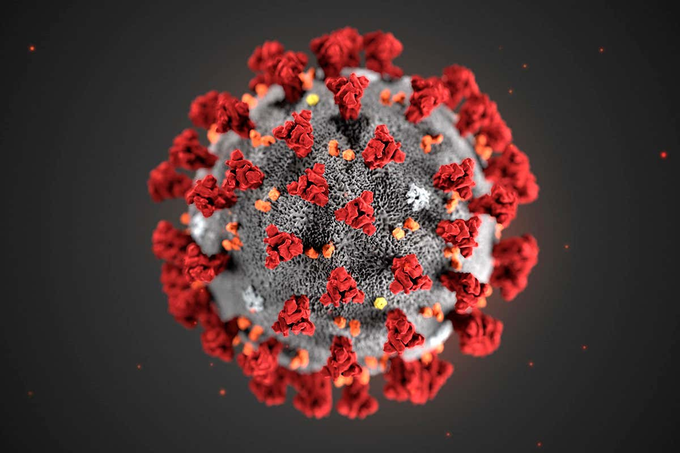
Fig 1: Corona
Coronavirus (CoVs) is a positive-sense, single-stranded RNA viruses of the family Coronaviridae (subfamily Coronavirinae ) that infect a wide host range to produce diseases ranging from common cold to severe diseases. The novel virus was initially named “2019-nCoV” which was changed to “SARS-CoV-2” by the Coronavirus Study Group (CSG) of International Committee on Taxonomy of Viruses (ICTV) and its commomly called COVID-19, since it was found to be the sister virus of severe acute respiratory syndrome coronavirus (SARS-CoV). The ongoing coronavirus threat that emerged in China has rapidly spread to other countries and has been declared as a global health emergency by the World Health Organization (WHO).
Many nations are diverting their best efforts for the implementation of appropriate preventive and control strategies. Neither vaccines nor direct-acting antiviral drugs are available for the treatment of human and animal coronavirus infections.
Many efforts have been directed to develop vaccines against human CoV infections in recent decades, but a limiting factor is the degree of cross-protection rendered by these vaccines due to their extensive sequence diversity. Various vaccines, immunotherapeutic, and drug options have been explored during the recent threats of Zika, Ebola, and Nipah viruses as well as against previous CoVs including SARS- and MERS-CoVs. These valuable options can be exploited for their potency, efficacy, and safety along with expediting other ongoing research so as to discover valuable modalities for tackling the emerging COVID-19, but as yet there is no effective vaccine or therapeutic, for which intense efforts are ongoing.
Most of the therapeutic options that are available for managing COVID-19 are based on previous experiences in treating SARS- and MERS-CoV. A major reason for the lack of approved and commercially available vaccines or therapeutic agents against these CoVs might be the relative lack of interest among the pharmaceutical companies. These are outbreak scenarios: the demand for drugs or vaccines lasts only for a period while the outbreak lasts. The number of affected people will also be a small proportion of the global drug and vaccine market. So by the time a new drug or vaccine is developed, there might not be any patients for clinical trials and also no meaningful market for newly discovered drugs. According to WHO guidelines, infected patients will receive supportive care including oxygen therapy, fluid therapy, and antibiotics for treating secondary bacterial infections. The WHO also recommends the isolation of patients suspected or confirmed for COVID-19. The major therapeutic drugs that might be effective in managing COVID-19 include remdesivir, lopinavir/ritonavir alone or in combination with interferon-β, convalescent plasma, and mAbs. Nevertheless, before utilizing these drugs for COVID-19 pneumonia patients, clinical efficacy, and safety studies should be conducted.

The current equipment use to protect the spread of corona virus are;
- Nose mask
For protecting the mouth and nose.
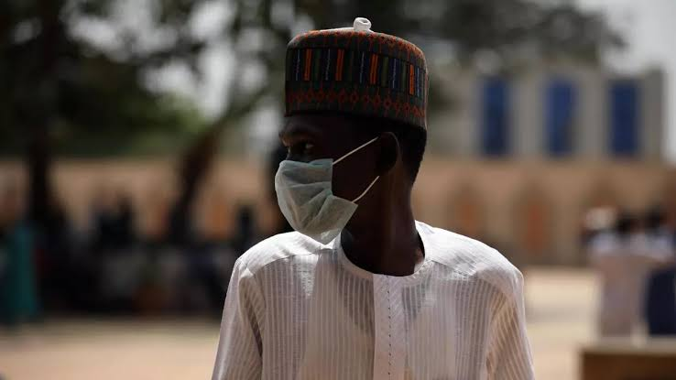
Fig 2: Nose mask
- Sanitizer
It is a liquid use to decrease infectious agents on the hands.
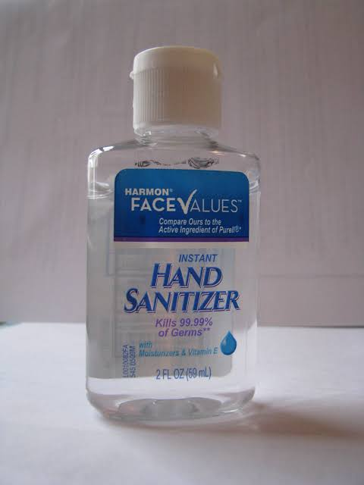
Fig 3: sanitizer
- Ventilators
A ventilator is a machine that provides mechanical ventilation by moving breathable air into and out of the lungs, to deliver breaths to a patient who is physically unable to breathe, or breathing insufficiently. Modern ventilators are computerized microprocessor-controlled machines, but patients can also be ventilated with a simple, hand-operated bag valve mask. Ventilators are chiefly used in intensive-care medicine, home care, and emergency medicine (as standalone units) and in anesthesiology (as a component of an anesthesia machine).

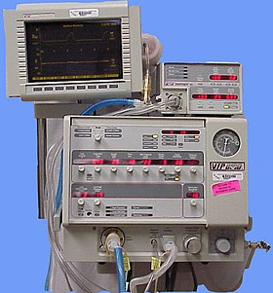
Fig 4: ventilator
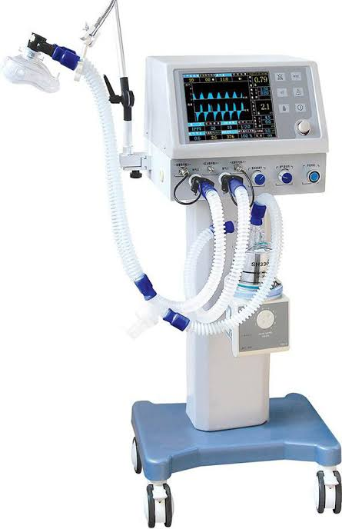 Fig 5: Ventilator
Clearly, the infections need to be contained and allowed to trickle out in a controlled flow in order for the whole system to be managed safely into a less critical state.
When we look at countries that have relatively done well in tackling the virus, there are signs of (computer) engineering at work. No country has however been able to deploy engineering solutions in a way that also helps day-to-day life continue in some safe way.
WHAT COULD ENGINEERS DO?
- Focus on the mass production and distribution of on-street hand sanitizer, or gloves treated with new, safe anti-viral coating.
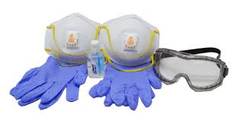Fig 6: Protective equipment
- Use and installation of doors that does not require grabbing the handle or indeed pressing lift buttons or with the used of sensors.
- Mass production of medical equipment like ventilators.
- Design better protective infrastructure to help shop workers facing customers at tills.
- What about designing new personal trolley handles from home?
- Create new kinds of easy to make and deploy protective face gear for the elderly and vulnerable.
As the Coronavirus COVID-19 continues to spread across the country, hospitals and clinics will need to find ways to support an increase in patients who test positive for the virus.
Engineers are working with multiple hospitals across the country to help them create these isolation areas as quickly and efficiently as possible. One key area of focus is understanding how to best utilize or modify existing infrastructure before moving to new or temporary structures.
Some of the ways we can make use of existing structures are;
- Turning an Entire Wing into an Isolation Area
Traditionally, most hospitals will already have a limited number of negative pressure Airborne Infection Isolation Rooms (AIIR) within the facility, but most likely will not have a sufficient quantity to accommodate the increased demand placed on the facility to accommodate COVID-19 patients. In an effort to help clients increase the number of AIIR patient rooms available, we have been able to develop a viable solution for designing negative pressure zones within existing facilities without any additional exhaust equipment by utilizing existing HVAC systems which already serve an entire wing or floor, and rebalancing the existing system serving the area. We are currently consulting with medical centers in Wisconsin and California who are looking into using this kind of strategy. The big advantage is that this plan keeps your isolated patients closer to all hospital technology, staff, and specialists. However, the ability to execute this type of strategy is also very dependent on the facilities occupancy, as well as the capabilities, layout, and type of their existing mechanical systems.

- Leveraging Underutilized Spaces
Many ancillary services may be slow or postponing elective services during this crisis. For example, a hospital outpatient department or an off-site ambulatory surgery center, may have rescheduled all of its cases for the next few weeks. These types of facilities can be utilized by rebalancing the air of a surgical area, or for the entire facility. Additionally, smaller hospitals that are not able to use an entire wing might look into utilizing HEPA negative air machines to convert special care units, or other rooms in the facility to negative pressure.
Moving forward, hospitals will need to have a more comprehensive plan for surge isolation scenarios. We hope this information is helpful to anyone working through options in these difficult times. Please feel free to reach out if you would like any additional details on these strategies, or to share additional ideas that are being used in your local communities.

- Companies, governments, and groups have employed policies and technologies for remote monitoring, meetings, measurements, learning, and controls to promote social distancing needed to slow the spread and not overload healthcare facilities. No one wants to hear that their ill or elderly loved ones were on the wrong end of a triage decision where healthcare is beyond capacity. So every single person can all do our part to change the infection rate.
Economically speaking, engineers can help by,
- Developing websites for small businesses.
- Creating an app that could analyze the symptoms that you’re having to know if you have been infected.
- Helping universities to create online classes for lectures.

CHALLENGES AND PROSPECTS
Some challenges engineers might face during this time are;
- Transportation of medical supplies.
- Poor quality of some equipment due to mass production.
- Lack of willing personnel.
- There’s still a lot we don’t know about the viruses.

PROSPECTS
Researchers are searching for effective and suitable vaccine candidates and therapeutics for controlling the deadly COVID-19. There are no effective vaccines or specific antiviral drugs for COVID-19. Hence, we have to rely exclusively on enforcing strict preventive and control measures that minimize the risk of possible disease transmission. Results obtained from the recently conducted in vitro study against COVID-19 are promising since the drugs remdesivir and chloroquine were found to be highly effective in controlling the infection. Direct clinical trials can be conducted among the patients infected with COVID-19 since these drugs are being used for treating other diseases and have well-established safety profiles, making the further evaluation of these drugs much easier. S protein is considered a key viral antigen for developing CoV vaccines, as shown in several preclinical studies. Although research is in progress to improve prevention, treatment, and control of COVID-19, the documented clinical data on different therapeutic approaches for CoVs are scarce. Further research should be directed toward the study of SARS-CoV-2 in suitable animal models for analyzing replication, transmission, and pathogenesis.

CONCLUSION
There are no effective vaccines or specific antiviral drugs for COVID-19. Hence, we have to rely exclusively on enforcing strict preventive and control measures that minimize the risk of possible disease transmission.
We all need to think again about how technologies and science-based critical thinking can spread compassion and wisdom more quickly than hysteria and misinformation. So kindly stay safe during this pandemic.

REFERENCES
1.htttps://rtmec.com/strategies-for-creating-isolation-areas-within-your-existing-hospital-infrastructure/
2. Wikipedia.org
3. https://www.tandfonline.com/doi/full/10.1080/21645515.2020.1735227
4. https://www.fastcompany.com/90486994

