NAME: OJIJI AMOROBAN CATHERINE
MATRIC NO. : 18/ENG01/015
DEPT.: CHEMICAL ENGINEERING

SOFTWARE DEVELOPMENT PROCESSES
In developing an application, there are various steps that are to be taken. They are to be implemented and broadened in developing a software application, these steps include:
- Conceptualization
- Specification
- Design
- Implementation
- Testing and Debugging
- Release and Update

CONCEPTUALIZATION
Software conceptualization provides the basis for your project. All applications evolve from ideas in the minds of designers and programmers to become a reality as we go through the design process, adhering to project milestones and conducting our quality assurance tests all along the way.
In this case since the wed based application to be created is related to the COVID-19,to avoid exaggeration of suspected number of ceases it is most reasonable that the application should contain information about the disease, contact to and of well knowledgeable personnel; doctors, nurses etc., series of steps to detect the symptoms, a distribution chart showing the most affected places with the most afflicted people along side with the rate of transmission. To obviously control access and enable feedback, the application would allow storage and transmission of data to and by contacted personnel along side with a password application.

SPECIFICATION
A software requirements specification (SRS) is a detailed description of a software system to be developed with its functional and non-functional requirements. The SRS is developed based the agreement between customer and contractors,which deals with the relationship between software and hardware components. In this case;
FUNCTIONAL REQUIREMENT/ SOFTWARE FEATURES
TITLE: User Interface
DESC: This would show the interaction between the user and the web portal. An example is shown below;

LOGIN
PROFILE
MENU

SIDE PANEL
REPORT
DATA EXPORT

DASHBOARD

This dashboard can be created using software such as
- Visual basic
- Java script
- C+ ETC.
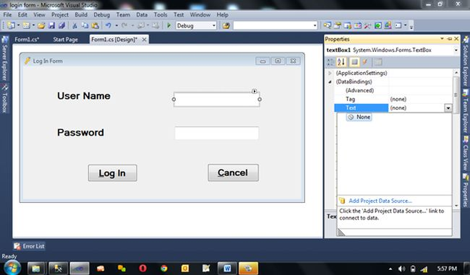

TITLE: Access the web portal
DESC: A user should be able to access the web portal. The access would not be
restricted to registered users. Someone who is not registered would also be able to read
the relevant eHealth information provided by the web portal.
TITLE : Security
DESC: The system shall protect the data and services from unauthorized access. The
system shall also provide authentication and secure transaction. System should provide
highest possible security mechanism in order to protect critical information. System
should run privately over public network (For this Secured tunneling mechanism should
be used). System should restrict all the non-member of the project to get access to the
system. The system shall provide a mechanism of user authentication to unambiguously
identify a user.

TITLE: Constantly update and notify the government health/eHealth policy
DESC : The web portal should always be up-to-date in regard to the government’s
policy. It should should notify the users about the new policy and rules made by the
authority.

TITLE: User Registration
DESC: A user, as specified in earlier section must be able to register their credentials.
They should provide their basic information about themselves for eg. name, address,
email, phone number. They should also identify themselves the kind of users (mentioned
under user characteristics) they are.

TITLE: User Login
DESC: Given that a user is registered, the user should be able to log into the web portal.
The system should keep and maintain the user login information .
TITLE: Data Entry
DESC: User should be able to fill in the necessary health information. Some of the key data that should be entered by the user themselves include;
---- Type of User
----Name
----Age
----Sex
----COVID-19 symptoms
----Location
----Prescription
----Diseases suffered (health history)

HARDWARE FEATURES
Mobile Requirements
Nowadays handheld devices are one of the best tool for raw data entry. With the help of
mobile devices patient’s and other related medical data can be entered on the go. The web
portals can be accessed through various smartphone platforms like;
i) IOS
ii)Android
iii) Blackberry

Server Requirements
The server hardware specification depends on the amount of data to be processed and the
number of users accessing the server database. The specification of server usually
increases with increase in the number of end users. However, a general estimate for a
5000+ user server is given below;

NO of user: 5000+
Processor: Dual Hexacore Xeon L5640 ( or better)
Memory: 32GB+
Hardware: 15k SAS2drives RAID10

TITLE : Security
DESC: The system shall protect the data and services from unauthorized access. The
system shall also provide authentication and secure transaction. System should provide
highest possible security mechanism in order to protect critical information. System
should run privately over public network (For this Secured tunneling mechanism should
be used). System should restrict all the non-member of the project to get access to the
system. The system shall provide a mechanism of user authentication to unambiguously
identify a user.

TITLE: Sensor
DESC: A finger print based means by which temperature, blood pressure, heart beat/pulse rate can be measured by implementing a software, much like the one used on a treadmill.

DESIGN
Software design is the process of envisioning and defining software solutions to one or more sets of problems. Software design is divided into;
- Algorithm
- Flowchart

For this web based application for COVID-19; the portal would allow both users and knowledgeable personnel access the portal but at different access points. It would allow for new users to register and regular users to login (after inputting security password),the user is then redirected to the page homepage which would show information about the hospital and website and also health tips. Regular users, having their information already saved on the data base would be allowed to edit and update, but new users wouldn’t. For new users they’d be required to fill in health details alongside with their location (which would reflect the rate and degree of transmission in that area) and questioners concerning COVID-19 (i.e. the symptoms), if they match they’d be further directed to a page where the temperature, blood pressure and heart beat/pulse rate would be measured, If they don’t they would be redirected to health tips . If they match the set standards for a COVID-19 patient, they’d be directed to the qualified personnel’s where the qualified personnel could be contacted . In cases where it seems minor they are redirected to book an appointment, but in serious cases they’re advised to visit the visit a nearby hospital immediately.

ALGORITHM
FOR PATIENT
- START
- DISPLAY REGISTRATION
- DISPLAY NEW PATIENT
-IF New Patient== TRUE
DISPLAY CREATE ID
-ELSE IF
DISPLAY LOGIN
-IF CREATE ID==TRUE
ENTER INFORMATION
- ELSE IF
DISPLAY LOGIN
- IF ENTER INFORMATION IS RECOGNISED
DISPLAY CREATE UNIQUE PATIENT USERNAME AND PASSWORD
- ELSE IF
DISPLAY LOGIN
- IF CREATE UNIQUE PATIENT USERNAME AND PASSWORD
PRINT ‘ENTERED TO DATABASE’
- ELSE IF
DISPLAY LOGIN
- END IF

- DISPLAY LOGIN
- READ USERNAME AND PASSWORD
- IF PASSWORD= TRUE
DISPLAY HOMEPAGE
- ELSE IF
DISPLAY LOGIN
- END IF
- DISPLAY HOMEPAGE
- DISPLAY HEALTHTIPS
- DISPLAY HEALTHCARE INFORMATION
- DISPLAY DATABASEDISPLAY
- IF DATABASEDISPLAY.VISIBLE==TRUE
DISPLAY EDIT
-FOR IF EDIT IS RECOGNISED
DISPLAY QUESTIONNIARE
-ELSE
PRINT ‘WRONG DATABSEDISPLAY,PLEASE REFILL’
- END FOR IF
- ELSE IF
DISPLAY FILL DATABASE
- IF FILL DATABASE==TRUE
DISPLAY PICK LOCATION
- ELSE IF
PRINT ‘WRONG INPUT,PLEASE REFILL’
- IF PICK LOCATION IS RECOGNISED
DISPLAY QUESTIONIARE
- ELSE IF
DISPLAY ‘PICK LOCATION’
- END IF

- DISPAY QUESTIONIARE
- IF QUESTIONIARE =TRUE
DISPLAY SENSOR READINGS
- ELSE IF
DISPLAY HEALTH TIPS

- DISPLAY SENSOR READINGS
- DISPLAY TEMPERATURE READINGS
- IF SENSOR READS TEMPERATURE ABOVE 38 OR BELOW 35 DEEGREES
DISPLAY BLOOD PRESSURE READINGS
- ELSE IF
- DISPLAY CONTINUE WITH READINGS
-FOR IF CONTINUE WITH READINGS==TRUE
DISPLAY BLOOD PRESSURE READINGS
-ELSE
DISPLAY HEALTHTIPS
-END FOR IF
- IF BLOOD PRESSURE READINGS READ ABOVE 135/85 OR BELOW 110/72
DISPLAY HEART / PULSE RATE READINGS
- ELSE IF
DISPLAY CONTINUE WITH READINGS
-FOR IF CONTINUE WITH READINGS==TRUE
DISPLAY HEART/PULSE RATE
-ELSE
DISPLAY HEALTH TIPS
-END FOR IF
- IF HEART/PULSE RATE IS ABOVE 86 OR BELOW 78BEATS/MIN
DISPLAY CONTACT DOCTOR
- END IF

- DISPLAY CONTACT DOCTOR
- DISPLAY PHONE NUMBER AND EMAIL ADRESS LINK
- DISPLAY CASE SEVERITY
- IF DISPLAY MAJOR==TRUE
PRINT ‘VISIT HOSPITAL NOW’
- ELSE IF
DISPLAY BOOK APPOINTMENT
- IF BOOK APPOINTMENT ==OK
DISPLAY APPOINTMENT
-FOR IF APPOINTMENT==TRUE
DISPLAY EMAIL ADRESS LINK
-ELSE
DISPLAY HOMEPAGE
END FOR IF
- ELSE IF
DISPLAY HOMEPAGE
END

FOR DOCTOR
  - START
  - DISPLAY LOGIN
  - READ USERNAME AND PASSWORD
- IF PASSWORD= TRUE
DISPLAY HOMEPAGE REVIEW
- ELSE IF
DISPLAY LOGIN
- END IF
  - DISPLAY DATABASE SYSTEM
  - DISPLAY APPOINTMENTS
  - END

FLOWCHART
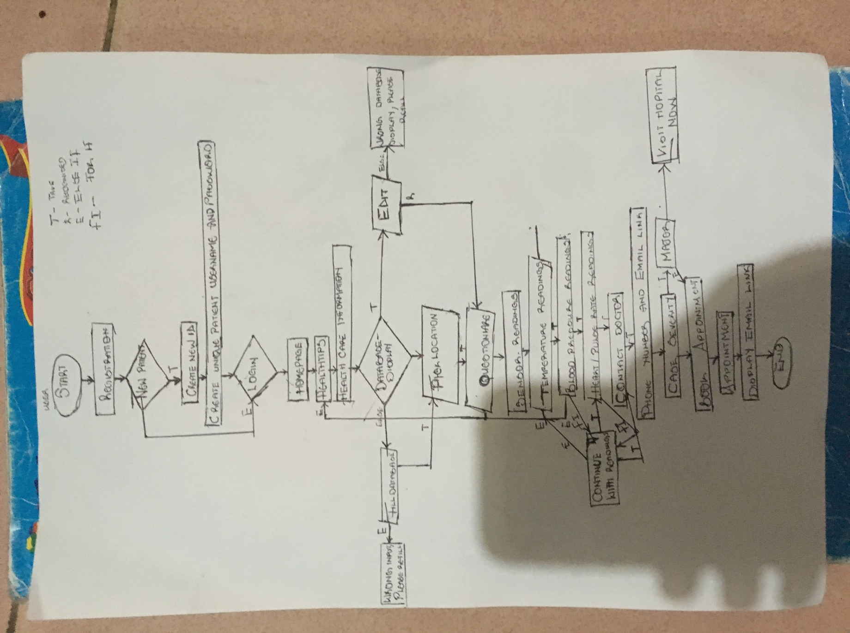
IMPLEMENTATION
Implementation is the part of the process where software engineers actually program the code for the project.
This can simply be done by trying it out on a real life situation. One of the unique requirements of healthcare solutions is the security of Protected Health Information (PHI). Special considerations must be made to ensure that patients’ health information is protected from intentional or unintentional access by individuals that are not authorized to access this data, including members of the development team during the development process. Securing PHI is an essential element of any delivered healthcare solution, so it’s critical to get this step right.
When it comes to securing PHI, a number of processes need to be added or modified to your Agile software development process to protect patient data and to protect the development team from intentional or unintentional exposure to patient data. To do this, your development team should:
- Obfuscate the data: If you need to use patient data during product development, obfuscate the private health information. A superior approach to obfuscating the data is to not use ‘real’ data for software development and testing purposes. Our teams often will build and use a repository of fictional patient test data.
- Create non-functional user stories for PHI requirements: The security requirements for protecting PHI must be captured in user stories so the team can implement those requirements in the product.

TESTING AND DEBUGGING
Testing has to do with running or applying the program to see if it works, Debugging is testing for syntax and logic errors for bugs in the program and then removed. This would be done by more than one person to check for correctness.

RELASE AND UPDATE
The web based software application is then released , and alongside with the questioners for the COVID-19 there would be questions for users on what they’d like to improve. It would be sent as a feedback and if proven right, recognised as an update.

