AFE BABALOLA UNIVERSITY ADO-EKITI (ABUAD)

A TERM PAPER
ON
ENGINEERING STRATEGIES FOR HANDLING COVID-19 FOR ENVIRONMENTAL HEALTH AND ECONOMIC STABILITY

PREPARED BY

OGOMUEGBUNAM FAVOUR CHIDI
17 / ENG01 / 021

SUBMITTED TO

ENGR. OYEBODE OLUWADARE JOSHUA

DEPARTMENT OF CIVIL ENGINEERING
COLLEGE OF ENGINEERING

DATE: 13TH APRIL,2020

ABSTRACT
Engineers have an obligation to deliver, using a systematic and workable technique for problem understanding through deductive analysis; and, various techniques for figuring out effective solutions to real life challenges. This paper aims to present a review on the engineering strategies for handling covid-19 for the development of environmental health and economic sustainability.
Chemical engineering deals with the application of chemistry and other natural sciences to manufacturing processes. It focuses on using the safest and most efficient ways to make products. Chemical engineering may be applied to any product that involves chemicals or chemical reactions, including food, medicine, and cosmetics. A chemical engineer is an engineer who focuses on making industrial and consumer products through chemical methods. Chemical engineers help plan the composition of the product itself, as well as the overall manufacturing processes and industrial equipment.
Sustainable development is considered a key concept and solution in creating a promising and prosperous future for human societies. Nevertheless, there are some predicted and unpredicted problems that epidemic diseases are real and complex problems. Hence, in this research work, a serious challenge in the sustainable development process was investigated using the classification of confirmed cases of COVID-19 (new version of Coronavirus) as one of the epidemic diseases. Hence, binary classification modelling was used by the group method of data handling (GMDH) type of neural network as one of the artificial intelligence methods. For this purpose, the Hubei province in China was selected as a case study to construct the proposed model, and some important factors, namely maximum, minimum, and average daily temperature, the density of a city, relative humidity, and wind speed, were considered as the input dataset, and the number of confirmed cases was selected as the output dataset for 30 days. The proposed binary classification model provides higher performance capacity in predicting the confirmed cases. In addition, regression analysis has been done and the trend of confirmed cases compared with the fluctuations of daily weather parameters (wind, humidity, and average temperature). The results demonstrated that the relative humidity and maximum daily temperature had the highest impact on the confirmed cases. The relative humidity in the main case study, with an average of 77.9%, affected positively, and maximum daily temperature, with an average of 15.4 °C, affected negatively, the confirmed cases.
in this paper I, have discussed the critical role of engineers in the development of environmental health and economic stability against covid-19. I also discussed on the medium of how the virus is spread and how to protect one self with use of proper PPE both for workers and students.

TABLE OF CONTENTS
- ABSTRACT
- TABLE OF CONTENTS
CHAPTERS
- LITERATURE REVIEW
- INTRODUCTION
- METHODOLOGY
- CONCLUSION
RECOMMENDATIONS AND REFERENCES

LITERATURE OVERVIEW
Chemical engineering deals with the application of chemistry and other natural sciences to manufacturing processes. It focuses on using the safest and most efficient ways to make products. Chemical engineering may be applied to any product that involves chemicals or chemical reactions, including food, medicine, and cosmetics. A chemical engineer is an engineer who focuses on making industrial and consumer products through chemical methods. Chemical engineers help plan the composition of the product itself, as well as the overall manufacturing processes and industrial equipment.

ENVIRONMENTAL HEALTH AND SAFETY POLICY
Top management should set in place procedures to define, document, and endorse a formal EHS policy for an organization. The policy should clearly outline the roles and expectations for the organization, faculty, EHS personnel, and individual employees or students. It should be developed in communication with laboratory personnel to ensure that all major concerns are adequately addressed.
The EHS policy should state intent to
- prevent or mitigate both human and economic losses arising from accidents, adverse occupational exposures, and environmental events;
- build EHS considerations into all phases of the operations, including laboratory discovery and development environments;
- achieve and maintain compliance with laws and regulations; and
- continually improve EHS performance.
The EHS policy and policy statement should be reviewed, revalidated, and where necessary, revised by top management as often as necessary. It should be communicated and made readily accessible to all employees and made available to relevant interested parties, as appropriate.

MANAGEMENT COMMITMENT
Management commitment to EHS performance is widely recognized as one of the elements most critical to EHS program success and to the development of a strong culture of safety within an organization. Therefore, the management system document establishes management commitment with a formal statement of intent, which defines examples of how performance goals are supported. Examples of how this commitment is supported include the following:
- Establish methods to use energy more efficiently, reduce waste, and prevent accidents.
- Comply with laws, regulations, and organizational requirements applicable to their operations.
- Improve EHS performance continually.
- Conduct periodic assessments to verify and validate EHS performance.

PLANNING
Planning is an integral part of all elements of the management system and to be effective involves the design and development of suitable processes and organizational structure to manage EHS aspects and their associated risk control systems proportionately to the needs, hazards, and risks of the organization. Planning is equally important to deal with health risks that might only become apparent after a long latency period. It also establishes objectives that define the criteria for judging success or failure of the management system. Objectives are identified on the basis of either the results of the initial status review, subsequent periodic reviews, or other available data.
Various sources of information are used to identify applicable EHS aspects and to assess the risk associated with each. Examples include, but are not limited to, information obtained from the following:
- hazard/exposure assessment,
- risk assessment,
- inspections,
- permits,
- event investigations (injury and illness investigations, environmental incident investigations, root-cause analysis, trend analysis),
- internal audits and/or external agency audits,
- fire and building codes,
- employee feedback concerning unsafe work conditions or situations,
- emerging issues,
- corporate/institution goals, and
- emergency management.
Once applicable EHS aspects are identified, a risk-based evaluation is performed to determine the potential impact and adequacy of existing control measures. If additional controls or corrective actions are needed to reduce risks to acceptable levels, they are integrated into business planning. Categorizing each item in this manner allows gaps that are identified to be prioritized and incorporated, based on level of importance and available resources.
Care should be taken when developing and disseminating new controls and corrective actions. If requirements are perceived by laboratory personnel as unnecessarily onerous, there is potential for lower compliance within the organization and a loss of credibility on the part of EHS personnel. While understanding that some individuals will never be convinced of the need for new controls, it is important to provide clear, supported justifications for changes to existing protocols to encourage adoption of the new policies and procedures.

IMPLEMENTATION
The design of management arrangements should reflect the organization's business needs and the nature of their risks. However, there should be appropriate activity across all elements of the model (policy; planning; implementation; performance measurement, audits, and change management; and management review).
Specifically the organization should make arrangements to cover the following key areas:
- overall plans and objectives, including employees and resources, for the organization to implement its policy;
- operational plans to implement arrangements to control the risks identified;
- contingency plans for foreseeable emergencies and to mitigate their effects (e.g., prevention, preparedness, and response procedures);
- plans covering the management of change of either a permanent or a temporary nature (e.g., associated with new processes or plant working procedures, production fluctuations, legal requirements, and organizational and staffing changes);
- plans covering interactions with other interested parties (e.g., control, selection, and management of contractors; liaison with emergency services; visitor control);
- performance measures, audits, and status reviews;
- corrective action implementation;
- plans for assisting recovery and return to work of any staff member who is injured or becomes ill through work activities;
- communication networks to management, employees, and the public;
- clear performance and measurement criteria defining what is to be done, who is responsible, when it is to be done, and the desired outcome;
- education and training requirements associated with EHS;
- document control system; and
- contractors should have written safety plans and qualified staff whose qualifications are thoroughly reviewed before a contract is awarded. All contractor personnel should be required to comply with the sponsoring organization's safety policies and plans.
Though it is the responsibility of each individual researcher to ensure that work is performed in a prudent and safe manner, achieving a safe laboratory environment is a cooperative endeavor between management, EHS personnel, and laboratory personnel. Regulations, policies, and plans will never cover every contingency, and it is important for these different groups to communicate with each other to ensure that new situations can be handled appropriately. One way to ensure that the needs of all groups are being met is by creating safety committees consisting of representatives from each part of an organization. In this forum, safety concerns can be raised, information can be distributed to affected parties, and a rough sense of the efficacy of policies and programs can be gained.

PERFORMANCE MEASUREMENT AND CHANGE MANAGEMENT
The primary purpose of measuring EHS performance is to judge the implementation and effectiveness of the processes established for controlling risk. Performance measurement provides information on the progress and current status of the arrangements (strategies, processes, and activities) used by an organization to control risks to EHS. Measurement information includes data to judge the management system by
- gathering information on how the system operates in practice,
- identifying areas where corrective action is necessary, and
- providing a basis for continual improvement.
All of the components of the EHS management system should be adequately inspected, evaluated, maintained, and monitored to ensure continued effective operation. Risk assessment and risk control should be reviewed in the light of modifications or technological developments. Results of evaluation activities are used as part of the planning process and management review, to improve performance and correct deficiencies over time.
Periodic audits that enable a deeper and more critical appraisal of all of the elements of the EHS management system (see Figure 2.1) should be scheduled and should reflect the nature of the organization's hazards and risks. To maximize benefits, competent persons independent of the area or activity should conduct the audits. The use of external, impartial auditors should be considered to assist in evaluation of the EHS management system. When performing these reviews, it is important that the organization have a plan for following up on the results of the audit to ensure that problems are addressed and that recognition is given where it is deserved.
The concept of change management in the laboratory environment varies markedly from methods typically prescribed, for example, in manufacturing operations. By its very nature, the business of conducting experiments is constantly changing. Therefore, it is a part of everyday activities to evaluate modifications and/or technological developments in experimental and scale-up processes. As such, a number of standard practices are used to identify appropriate handling practices, containment methods, and required procedures for conducting laboratory work in a safe manner. Several examples of these practices include
- identification of molecules as particularly hazardous substances (PHSs),² which specifies certain handling and containment requirements and the use of personal protective equipment (PPE);
- approval and training for new radioisotope users;
- completion of biosafety risk assessments for the use of infectious agents; and
- Material Safety Data Sheet (MSDS) review of chemicals being used

MANAGEMENT REVIEW OF EHS MANAGEMENT SYSTEM
Top management should review the organization's EHS management system at regular intervals to ensure its continuing suitability, adequacy, and effectiveness. This review includes assessing opportunities for improvement and the need for changes in the management system, including the EHS policy and objectives. The results of the management review should be documented.
Among other information, a management review should include the following:
- results of EHS management system audits,
- results from any external audits,
- communications from interested parties,
- extent to which objectives have been met,
- status of corrective and preventive actions,
- follow-up actions from previous management reviews, and
- recommendations for improvement based on changing circumstances.
The outputs from management review should include any decisions and actions related to possible change to EHS policy, objectives, and other elements of the management system, consistent with the commitment to continual improvement.
The management system review ensures a regular process that evaluates the EHS management system in order to identify deficiencies and modify them. Systemic gaps, evidence that targets are not being met, or compliance issues that are discovered during compliance or risk assessments indicate a possible need for revision to the management system or its implementation.

EMPLOYEE SAFETY TRAINING PROGRAM
Newly hired employees or students working in a laboratory should be required to attend basic safety training prior to their first day. Additional training should be provided to laboratory personnel as they advance in their laboratory duties or when they are required to handle a chemical or use equipment for the first time.
Safety training should be viewed as a vital component of the laboratory safety program within the organization. The organization should provide ongoing safety activities that serve to promote a culture of safety in the workplace that will begin when the person begins work and will continue for the length of their tenure. Personnel should be encouraged to suggest or request training if they feel it would be beneficial. The training should be recorded and related documents maintained in accordance with organizational requirements.
Training sessions may be provided in-house by professional trainers or may be provided via online training courses. Hands-on, scenario-based training should be incorporated whenever possible. Safety training topics that may prove to be helpful to laboratory personnel include
- use of CHPs and MSDSs,
- chemical segregation,
- PPE,
- safety showers and eyewash units,
- first aid and cardiopulmonary resuscitation,
- chemical management,
- gas cylinder use,
- fire extinguisher training,
- laser safety, and
- emergency procedures.

INTRODUCTION
Many people are interested in an organization's approach to laboratory environmental health and safety (EHS) management including laboratory personnel; customers, clients, and students (if applicable); suppliers; the community; shareholders; contractors; insurers; and regulatory agencies. More and more organizations attach the same importance to high standards in EHS management as they do to other key aspects of their activities. High standards demand a structured approach to the identification of hazards and the evaluation and control of work-related risks.
A comprehensive legal framework already exists for laboratory EHS management. This framework requires organizations to manage their activities in order to anticipate and prevent circumstances that might result in occupational injury, ill health, or adverse environmental impact.
Much remains unknown about how SARS-CoV-2, the virus that causes COVID-19, spreads through the environment. A major reason for this is that the behaviors and traits of viruses are highly variable – some spread more easily through water, others through air; some are wrapped in layers of fatty molecules that help them avoid their host’s immune system, while others are “naked. This makes it urgent for environmental engineers and scientists to collaborate on pinpointing viral and environmental characteristics that affect transmission via surfaces, the air and fecal matter, according to Alexandria Boehm, a Stanford professor of civil and environmental engineering, and Krista Wigginton, the Shimizu Visiting Professor in Stanford’s department of civil and environmental engineering
The concept of sustainable development as a new concept, process, and undeniable fact has emerged in the policies of major governments, and plays a key role in the development of human societies. Sustainable development is, generally, a combination of the three social, economic, and environmental goals in which political goals are involved. In fact, sustainable development is the advancement of the quality of all aspects of life of today’s generation without creating negative impacts on the lives of future generations. While it may seem easy to create sustainability in theory, the process of sustainable development faces many unforeseen problems and obstacles that slow down the process. One of the anticipated problems is the emergence of epidemic diseases that not only have a negative impact on the economy but also cause social problems, both of which are fundamental to sustainable development. Although this is a temporary and transient problem, it has the potential to disrupt the process, which can have years of adverse effects. The COVID-19 (a new version of Coronavirus) is one of the newest and most serious challenges facing governments, and there has not been much research into this problem. Although the understanding of COVID-19 is limited, interim guidance on laboratory biosafety was introduced by the World Health Organization (WHO). Kampf et al. investigated the persistence of coronaviruses on inanimate surfaces and ways to deal with it. They found that the period of persistence is nine days for coronaviruses, and some disinfectants, such as 62%–71% ethanol, 0.5% hydrogen peroxide, or 0.1% sodium hypochlorite can be very efficient in dealing with this virus. Lai et al. have evaluated the outbreak of COVID-19 and its challenges. Based on their results, they made some recommendations for the prevention of more outbreaks of the virus. In another study, the role of inanimate surfaces in the outbreak of coronaviruses is investigated by Kampf. Based on the obtained results, he provided some recommendations about the impact of surface disinfection to prevent further viral spread. Telles has conducted an overview of the behaviours of viruses. Some datasets were investigated, and the obtained results show that dynamic mathematical modelling was essential to predict behaviours of viruses. The role of media coverage on the public was evaluated by Wen et al. Their obtained results indicated that misleading and biased media coverage could have a negative impact on individuals’ mental health. Chen et al. carried out an investigation for predicting the number of confirmed cases of COVID-19. They evaluated the trend of transmission and recovery rates based upon time, and a mathematical model was proposed. The obtained results show that the proposed model had a suitable performance to predict the confirmed cases. In another study, the trend of the COVID-19 outbreak was estimated in China by Li and Feng. Their results show that rapid and dynamic strategies can be useful to diminish and constrain the current crisis. Chinazzi et al. evaluated the effect of travel constraints to reduce the COVID-19 outbreak. The obtained results indicated that travel restrictions are highly effective in reducing the spread of this new coronavirus.
It is worth mentioning that the impact of temperature on virus spread and survival show different results. There have been some investigations on the effects of environmental parameters on epidemic diseases, too. The flu virus spreads quickly in cold and dry conditions, while it is completely inactive at temperatures above 30 °C. However, the epidemic of one type of coronavirus, MERS-CoV, was between April and August, which meant that the virus spread quickly in warm temperature, low wind speed, low relative humidity, and high ultraviolet index.
A review of previous studies shows that very few researchers have addressed the challenges of the COVID-19 (new version of Coronavirus) in the sustainable development process and, also, unpredictable problems and complexity of the issues require the use of highly capable approaches like artificial intelligence methods to understanding these types of issues. Hence, due to the importance of the subject, the present study investigated the feasibility of artificial intelligence in the classification of confirmed cases of COVID-19, which is a severe challenge in the sustainable development process, and it is an imperative task. In addition, statistical analysis was carried out, and the obtained results were discussed. It is worth mentioning that this type of analysis has not been used in previous research.

METHODOLOGY
Humanity cannot continue to consume finite resources and generate waste at current rates. The challenge of living within the limits of planet Earth without compromising future development must be solved. This requires a paradigm-shift in lifestyles, both in terms of behavioural and practical changes. How will this be achieved? What role will technology play? And how can chemical engineering make a difference? As well as contributing to solutions, chemical engineers must make the case for greater and more proactive action to counter the impact of ever-increasing resource demand.

METHOD OF STUDY
Two approaches were used in the current study, as follows:
- The possible correlations among the trends of confirmed cases in different case studies were investigated, and then a binary classification model was constructed to predict and classify using the group method of data handling (GMDH) algorithm based upon some critical factors; maximum, minimum, and average temperature, the density of a city, relative humidity, and wind speed were considered as the input dataset and the number of confirmed cases was selected as the output dataset for 30 days.
- Regression analysis was used, and a trend of the confirmed cases of COVID-19 analysed in the five provinces with the highest confirmed cases, including Hubei, Guangdong, Henan, Zhejiang, and Hunan, and the daily fluctuations of confirmed cases were compared with fluctuations of weather parameters.

CONDITIONS OF ANALYSIS
- The environmental and urban parameters in the analysis included density, sex ratio, average age, elevation, maximum, minimum, and average temperature, relative humidity, and wind.
- For daily analysis of the possible trend between confirmed cases of COVID-19 and environmental factors, the data of Hubei province was used.
- The climate data is based on the stations situated in the capital of the provinces or regions because the population is generally higher in these areas.
- The analysis period was from 28 January 2020 to 26 February 2020 (30 days).
- The analysis of the possible correlations about trends of confirmed cases in different case studies was based on the average values in one month.

CASE STUDY
To carry out the analysis of correlation among environmental factors and confirmed cases of COVID-19, a set of data, including 42 provinces in China, Japan, South Korea, and Italy, were used. The selected case studies can be seen in Table 1 and are based on the most confirmed cases of COVID-19 and available data, as shown in Figure 1. It is worth mentioning that the quarantine on travel in and out of Wuhan and the suspension of flights, trains, public buses, and the metro system began on 23 January 2020 and also on 24 January 2020 in 15 cities in Hubei [19,20]. The estimated incubation period of COVID-19 is about 2–14 days [20].
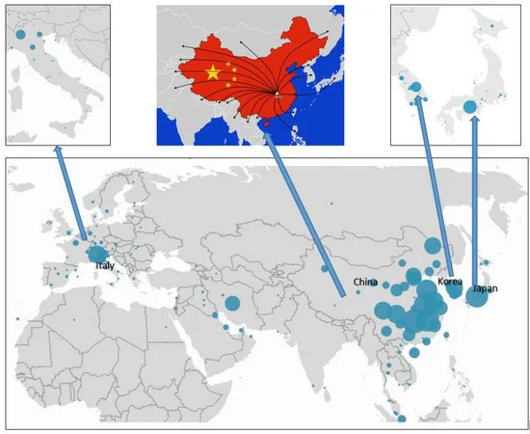
Figure 1. The locations of the case studies [39].
Table 1. The selected case studies.
GROUP METHOD OF DATA HANDLING (GMDH)
Artificial Intelligence includes a wide range of methods and algorithms that work based on machine intelligence and has many applications in various fields of science [40], including fuzzy logic theory and application [41,42,43,44,45,46], artificial intelligence techniques and sociology [47,48,49], risk assessment and hazard identification [50,51], machine learning [52,53,54,55,56,57], and meta-heuristic algorithms and clustering techniques [58,59,60,61,62]. The group method of data handling (GMDH) type of neural network is one of these algorithms that was proposed by Ivakhnenko [63]. GMDH is a self-organization algorithm that has been used successfully for pattern recognition, optimization of complex systems modelling, and prediction problems, and it is also called the polynomial of the Ivakhnenko equation [63,64]. This algorithm can predict the value of from an approximate function ( ), for each input vector (X), which is shown in Equation (1). The basic form of a relation between input and output data can be declared as a discrete type of the Volterra functional series, referred to as the Kolmogorov–Gabor polynomial. Equation (2) shows the underlying neural network map, which is also called the polynomial of Ivakhnenko [65,66].
y∧ = f∧(xi1 , xi2 , xi3 , ……… xim ) (1)
i=(1,2,3,……, m)
y = a + ∑i=1mbi xi + ∑i=1m∑j=1mcij xi xj + ∑i=1m∑j=1m∑k=1mdijk xi xj xk + ∑i=1m∑j=1m∑k=1m∑l=1meijkl xi xj xk xl (2)
where Y is the output, m is the number of data, and X₁, X₂, X₃… X_{m} is the input variables vector. In many cases, the quadratic and bivariate form of this polynomial is used as Equation (3).
yˆ = G (xi , xj) =a0 + a1 xi + a2 xj+ a3 xixj+ a4 x2i+ a5 x2j (3)
Figure 2 shows a schematic of input and output variables of the GMDH algorithm, where X= (X₁, X₂, X₃, …. X_{m}) is the input dataset and Y= (y₁, y₂, y₃,…. y_{n}) is the output dataset. In this algorithm, the input dataset is imported to the initial layer and then, after evaluation and optimization, the output is considered as a new input for the next layer. This process is continued and stopped if the algorithm reaches a better answer from layer (n+1) in comparison with layer (n). As mentioned before, to deal with unpredicted and uncertain problems, the GMDH algorithm can be applied as a powerful tool. Hence, a binary classification analysis was done by the GMDH algorithm in the present study [67,68,69].
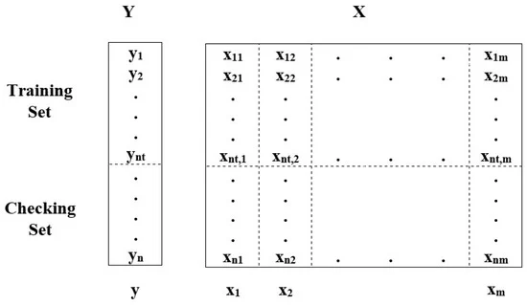
Figure 2. Schematic of input and output variables of the group method of data handling (GMDH) algorithm.

RESULTS
Binary Classification Modelling Using GMDH
Before binary classification modeling using the Gmdh algorithm, a regression analysis was conducted among the total data set (See Table A1 in Appendix A) for 42 case studies in four countries, including China, Japan, South Korea, and Italy. This analysis shows that there is a low correlation coefficient (R²); hence, it can be concluded that we should evaluate case by case for binary classification modeling, and Hubei province in China was selected as a case study for this part of the analysis.
Initially, evaluating the parametric correlation of each independent input dataset is necessary for carrying out reliable modeling [70,71,72,73]. Hence, before modeling, a correlation analysis was conducted using Pearson’s correlation coefficient among the dataset for five independent input data, including maximum, minimum, and average temperature, relative humidity, and wind speed. Furthermore, it should be noted that independent input data, including the density of the city, is not considered for evaluating the parametric correlation because the value of this parameter is constant. The mathematical relations of Pearson’s method can be expressed in Equations (4)–(7) [74].
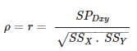 (4)
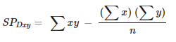 (5)
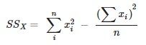 (6)
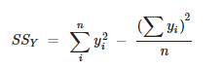 (7)
where is the Pearson’s correlation coefficient for two independent parameters that are shown with X and Y, and is the covariance between them. The standard deviation of X and Y are indicated with and. Table 2 shows the results of the correlation coefficient analysis for five independent input data. According to the previous studies, when, the correlation coefficient is strong, hence the obtained results show that independent input data were correctly selected. Although there is a correlation coefficient of 0.83 between the maximum and average temperatures, it can be accepted because this value is very insignificant.
Table 2. The correlation coefficient between five environmental factors.
Secondly, determining the control parameters of the algorithm is an important task because it plays a key role in the fast convergence of the algorithm. There are no specific relations about most of these parameters, and they are determined based upon previous studies, experts, and trial and error. Hence, the selection pressure is dimensionless and has an impact on the sensitivity of the modeling error [75]. It is selected as 0.6 based upon the most recent studies. However, the maximum number of layers and the maximum number of neurons in a layer are considered based upon expert opinions and trial and error [76]. For this purpose, a range of values was determined for the maximum number of layers equal to 5, 10, and 15, and also another range of values was considered including 5, 10, 15, 20, and 30. It is worth mentioning that the confusion matrix is used as the measure of accuracy to evaluate the performances of the binary classification model by the GMDH algorithm. The basic form of a confusion matrix is shown in Figure 3, and Equations (8) and (9) indicate the mathematical relations of accuracy and error.
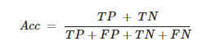 (8)
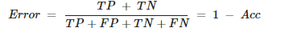 (9)
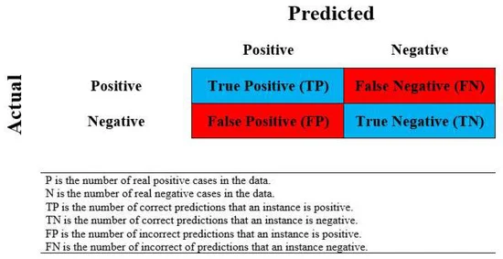
Figure 3. Schematic of the confusion matrix.
According to the maximum number of layers and the maximum number of neurons in a layer, in total, 20 models were constructed. The six notable factors, namely the maximum, minimum, and average temperature, the density of cities, relative humidity, and wind speed were considered as the input dataset and the number of confirmed cases was chosen as the output dataset for 30 days. It should be noted that the two classes (label) are assigned and considered for the number of confirmed cases, and this means that, for the number of confirmed cases under 850, people were given label “0” and, for the number of confirmed cases above 850, people were given label “1”. In addition, there is the information of Wuhan city for 30 days as the number of cases studies; for modeling, 75% of cases were considered as training cases and the rest were considered as testing cases [77]. The obtained results of the accuracy of the training and testing models are shown in Table 3.
Table 3. The accuracy of the GMDH algorithm to classify days based upon confirmed cases.
After modeling, a simple ranking was conducted for determining the best model based on the study of Zorlu et al. [78]. The results of this ranking have been shown in Table 4.
Table 4. The Ranking of binary classification models.
The obtained results from Table 4 indicate that the 3rd model has highly acceptable degrees of accuracy and robustness. Figure 4, Figure 5 and Figure 6 demonstrate the results of the confusion matrix for training, test, and total data set, respectively.
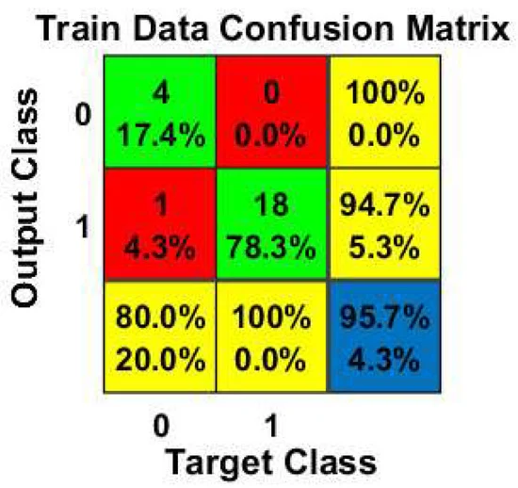
Figure 4. The obtained results of the training confusion matrix.
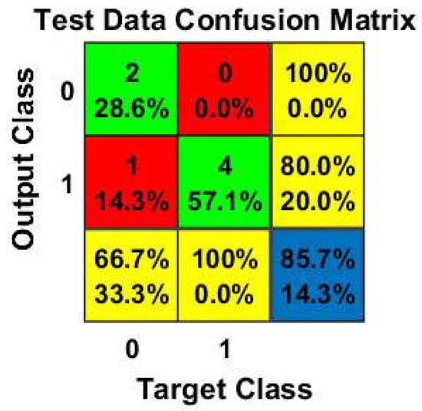
Figure 5. The obtained results of the test confusion matrix.
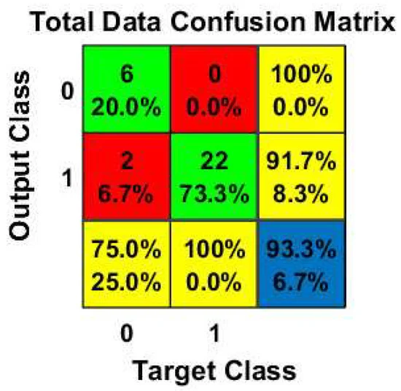
Figure 6. The obtained results of the total confusion matrix.
According to Figure 4, the proposed model could predict four cases with label “0” correctly with 100% accuracy and also, from 19 cases, it could correctly predict 18 cases with label “1”, and only 1 case was wrongly estimated with label “1” in label “0”. Generally, this model had a 95.7% accuracy for train data. For test data based upon Figure 5, the proposed model correctly estimated two confirmed cases with label “0”. It could also correctly predict four cases with label “1” with 80% accuracy, and the accuracy of test data was 85.7% in total. Consequently, it can be concluded that, according to Figure 6, the third model (the proposed model) had the suitable performance capacity in predicting and classifying the confirmed cases of COVID-19 for all data.

REGRESSION ANALYSIS
The impact of weather parameters and confirmed cases was analyzed with the multi linear regression (MLR) technique. The analysis is based on the weather data of Wuhan, as presented in Table A2 (See Appendix B). In this regard, the regression calculations between weather parameters and confirmed cases have been done for data from 28-Jan to 26-Feb and from 5-Feb to 26-Feb. For this purpose, maximum, minimum, and average daily temperature, relative humidity, and wind speed were considered equal to “A”, ”B”, ”C”, ”D”, and ”E”, respectively, and the number of confirmed cases was considered as “Y”. Equations (10) and (11) demonstrate two relations for data from 28-Jan to 26-Feb and from 5-Feb to 26-Feb, respectively.
Y=−148.13−107.7A−72.7B+52.6C+35.9D+51.3E (10)
Y=642.9−127.6A−84.2B+43.1C+31.6D+61E (11)
The result shows the R² in the first case is equal to 0.44, and in the second case, 0.65, which shows an increase. In addition, according to the results of collinearity diagnostics of the regression analysis from Equation (11), the obtained results show that relative humidity, maximum daily temperature, average daily temperature, wind speed, and the minimum daily temperature had the highest to the lowest share in the expression of changes of output (confirmed cases), respectively. Since the data in the second case started from 5-Feb, which is about 14 days after the Wuhan lockdown on 23-Jan, it seems that the rate of confirmed cases from 5-Feb might be affected more by the environmental factors.

The Correlations Among The Trends Of Confirmed Cases And Weather Parameters
The correlations among the trends of confirmed cases in Hubei and weather parameters are presented in Figure 7, Figure 8 and Figure 9. It is clear from Figure 7 that the confirmed rate increased from 28-Jan to 5-Feb, which is about 14 days after the start of quarantine, and then decreased with some fluctuations. According to the comparisons, it seems there are some correlations between the fluctuation of weather data (wind, humidity, and average temperature) and the confirmed cases.
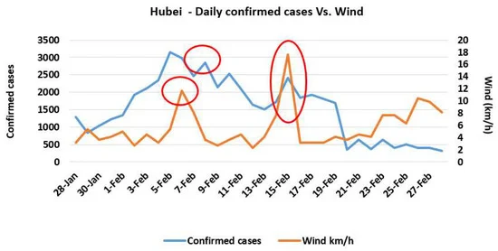
Figure 7. Daily Confirmed cases of COVID-19 in Hubei and wind speed.
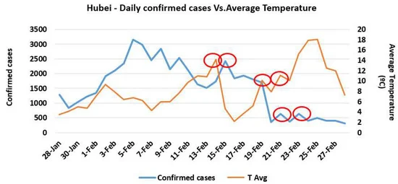
Figure 8. Daily Confirmed cases of COVID-19 in Hubei and average temperature.
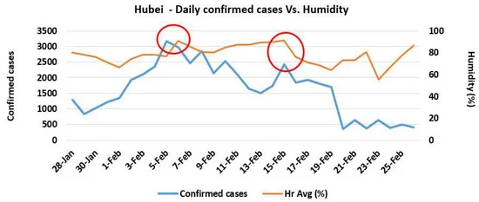
Figure 9. Daily Confirmed cases of COVID-19 in Hubei and Humidity.
The daily fluctuations of confirmed cases with fluctuations of weather parameters in four case studies in China are presented in Figure 10, Figure 11, Figure 12 and Figure 13. The same trend in the province of Hubei exists in the other four provinces, and the rate increased until 4-Feb and decreased with some fluctuations.
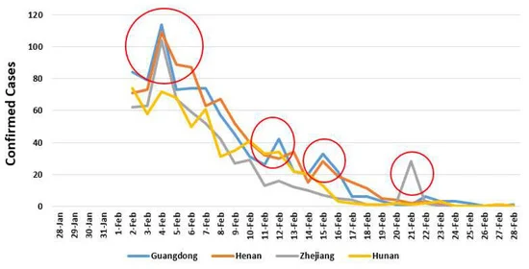
Figure 10. Confirmed daily cases in Guangdong, Henan, Zhejiang, and Henan.
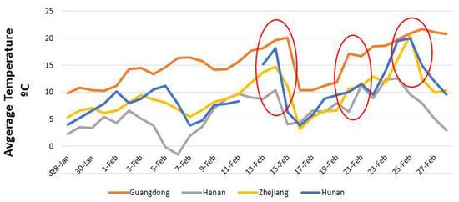
Figure 11. The average daily temperature in four case studies.
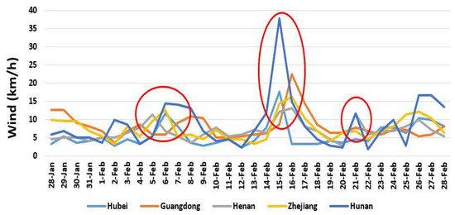
Figure 12. The average daily wind speed in five case studies.
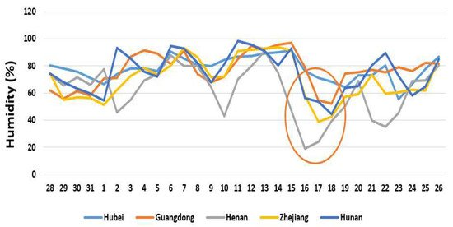
Figure 13. The average daily humidity in five case studies.
DISCUSSSION OF RESULT
According to the regression analysis, no correlation was found among the different case studies in four countries, which might be because of the policy and type of restrictions in different countries in confronting the issue. Therefore, the prediction for the trend could be case by case and based on the countries policy.
The GMDH algorithm had an appropriate performance to predict and classify, with reliable accuracies equal to 95.7% and 85.7% for the training and testing datasets, respectively. It should be noted that the proposed model and its obtained results are unique and should not be used to evaluate directly in other cities. The GMDH algorithm showed reliable result in the selected case study. Hence, the problem of collecting data and incomplete data could affect the analysis in case studies facing insufficient data, and the use of other artificial intelligence method algorithms like the naive bayes classifier can be useful. In addition, other qualitative and quantitative factors may be significant, such as policies of governments, accessibility of health and hygiene facilities, education level, and food culture.
The comparisons between the result of regression analysis for 42 case studies in four countries that show a low correlation coefficient (R²), and the binary classification modeling using GMDH that show high accuracy in Wuhan, demonstrate some unknown pattern between climate factors and confirmed cases of COVID-19. The analysis confirmed that GMDH could be an appropriate technique in predicting and classifying the confirmed cases of COVID-19, and for checking the possible pattern of the dataset. However, the impact of daily temperature, wind, and humidity might occur in the upcoming days, not the same day, and it could be the reason for the low correlation coefficient in the regression analysis.
The daily analysis in the main case study, Hubei, and other four case studies in China show the positive impact of quarantine in decreasing the number of confirmed cases. In fact, after about 14 days, which is equal to 5-Feb, the increasing trend of positive samples stopped. Moreover, the regression calculations between weather parameters and confirmed cases for data from 28-Jan to 26-Feb and from 5-Feb to 26-Feb show an increase and, therefore, it seems that the rate of confirmed cases from 5-Feb might be affected more by the environmental factors.
The comparisons among the trends of confirmed cases and daily weather parameters (wind, humidity, and average temperature) show similar fluctuations that could approve the role of weather parameters on the epidemic rate of COVID-19.
The results of the research are in good agreement with similar studies about the impact of environmental parameters on epidemic diseases, such as the quicker spread of flu virus in cold and dry conditions by Lowen et al., 2007 and Price et al., 2019 or the faster increase of MERS-CoV in warm temperature, low wind speed, low relative humidity, and high ultraviolet index by Altamimi and Ahmed, 2019.

CONTROL AND PREVENTION OF COVID-19
Measures for protecting workers from exposure to, and infection with, SARS-CoV-2, the virus that causes Coronavirus Disease 2019 (COVID-19), depend on the type of work being performed and exposure risk, including potential for interaction with people with suspected or confirmed COVID-19 and contamination of the work environment. Employers should adapt infection control strategies based on a thorough hazard assessment, using appropriate combinations of engineering and administrative controls, safe work practices, and personal protective equipment (PPE) to prevent worker exposures. Some OSHA standards that apply to preventing occupational exposure to SARS-CoV-2 also require employers to train workers on elements of infection prevention, including PPE.
OSHA has developed this interim guidance to help prevent worker exposure to SARS-CoV-2. The general guidance below applies to all U.S. workers and employers. Depending on where their operations fall in OSHA's exposure risk pyramid (Spanish), workers and employers should also consult additional, specific guidance for those at increased risk of exposure in the course of their job duties broken down by exposure risk level.
General Guidance for All Workers and Employers
For all workers, regardless of specific exposure risks, it is always a good practice to:
- Frequently wash your hands with soap and water for at least 20 seconds. When soap and running water are unavailable, use an alcohol-based hand rub with at least 60% alcohol. Always wash hands that are visibly soiled.
- Avoid touching your eyes, nose, or mouth with unwashed hands.
- Practice good respiratory etiquette, including covering coughs and sneezes.
- Avoid close contact with people who are sick.
- Stay home if sick.
- Recognize personal risk factors. According to U.S. Centers for Disease Control and Prevention (CDC), certain people, including older adults and those with underlying conditions such as heart or lung disease or diabetes, are at higher risk for developing more serious complications from COVID-19.
IDENTIFY AND ISOLATE SUSPECTED CASES
- In workplaces where exposure to COVID-19 may occur, prompt identification and isolation of potentially infectious individuals is a critical first step in protecting workers, visitors, and others at the work site.
- Wherever feasible, immediately isolate individuals suspected of having COVID-19. For example, move potentially infectious individuals to isolation rooms. On an aircraft, if possible and without compromising aviation safety, move potentially infectious individuals to seats away from passengers and crew. In other work sites, move potentially infectious individuals to a location away from workers, customers, and other visitors and with a closed door, if possible.
- Take steps to limit the spread of the individual's infectious respiratory secretions, including by providing them a facemask and asking them to wear it, if they can tolerate doing so. Note: A surgical mask on a patient or other sick person should not be confused with PPE for a worker; the surgical mask acts to contain potentially infectious respiratory secretions at the source (i.e., the person's nose and mouth).
- After isolation, the next steps depend on the type of workplace. For example:
- In most types of workplaces (i.e., those outside of healthcare):
Isolated individuals should leave the work site as soon as possible. Depending on the severity of the isolated individual's illness, he or she might be able to return home or seek medical care on his or her own, but some individuals may need emergency medical services.
- In healthcare workplaces:
- If possible, isolate patients suspected of having COVID-19 separately from those with confirmed cases of the virus to prevent further transmission, including in screening, triage, or healthcare facilities.
- Restrict the number of personnel entering isolation areas, including the room of a patient with suspected or confirmed COVID-19.
- Protect workers in close contact* with the sick person by using additional engineering and administrative controls, safe work practices, and PPE.
- Sick workers should leave the work site as soon as possible. Depending on the severity of the isolated worker's illness, he or she might be able to return home or seek medical care on his or her own, but some individuals may need emergency medical services.
ENVIRONMENTAL CLEANING AND DECONTAMINATION
When people touch a surface or object contaminated with SARS-CoV-2, the virus that causes COVID-19, and then touch their own eyes, noses, or mouths, they may expose themselves to the virus.
Early information from the CDC, the National Institutes of Health, and other study partners suggests that SARS-CoV-2 can survive on certain types of surfaces, such as plastic and stainless steel, for 2-3 days. However, because the transmissibility of SARS-CoV-2 from contaminated environmental surfaces and objects is still not fully understood, employers should carefully evaluate whether or not work areas occupied by people suspected to have the virus may have been contaminated and whether or not they need to be decontaminated in response.
The CDC provides instructions for environmental cleaning and disinfection for various types of workplaces, including:
- Healthcare facilities, as part of CDC healthcare infection control recommendations
- Post mortem care facilities, such as autopsy suites
- Laboratories
- Other, non-healthcare facilities
Employers operating workplaces during the COVID-19 pandemic should continue routine cleaning and other housekeeping practices in any facilities that remain open to workers or others. Employers who need to clean and disinfect environments potentially contaminated with SARS-CoV-2 should use EPA-registered disinfectants with label claims to be effective against SARS-CoV-2. Routine cleaning and disinfection procedures (e.g., using cleaners and water to pre-clean surfaces before applying an EPA-registered disinfectant to frequently touched surfaces or objects for appropriate contact times as indicated on the product's label) are appropriate for SARS-CoV-2, including in patient care areas in healthcare settings in which aerosol-generating procedures are performed.
Workers who conduct cleaning tasks must be protected from exposure to hazardous chemicals used in these tasks. In these cases, the PPE (29 CFR 1910 Subpart I) and Hazard Communication (29 CFR 1910.1200) standards may apply, and workers may need appropriate PPE to prevent exposure to the chemicals. If workers need respirators, they must be used in the context of a comprehensive respiratory protection program that meets the requirements of OSHA's Respiratory Protection standard (29 CFR 1910.134) and includes medical exams, fit testing, and training.
Cleaning chemicals' Safety Data Sheets and other manufacturer instructions can provide additional guidance about what PPE workers need to use the chemicals safely.
PERSONAL PROTECTIVE EQUIPMENT CONSIDERATIONS
The interim guidance for specific worker groups and their employers includes recommended PPE ensembles for various types of activities that workers will perform. In general:
- PPE should be selected based on the results of an employer's hazard assessment and workers specific job duties.
- When disposable gloves are used, workers should typically use a single pair of nitrile exam gloves. Change gloves if they become torn or visibly contaminated with blood or body fluids.
- When eye protection is needed, use goggles or face shields. Personal eyeglasses are not considered adequate eye protection.
- If workers need respirators, they must be used in the context of a comprehensive respiratory protection program that meets the requirements of OSHA's Respiratory Protection standard (29 CFR 1910.134) and includes medical exams, fit testing, and training.
- Surgical masks are not respirators and do not provide the same level of protection to workers as properly-fitted respirators.
- If there are shortages of PPE items, such as respirators or gowns, they should be prioritized for high-hazard activities.
- Workers need respiratory protection when performing or while present for aerosol-generating procedures, including cardiopulmonary resuscitation (CPR) and intubation.
- Workers must be protected against exposure to human blood, body fluids, other potentially infectious materials, and hazardous chemicals, and contaminated environmental surfaces.
- CDC provides strategies for optimizing the supply of PPE, including guidance on extended use and limited reuse of N95 filtering facepiece respirators (FFRs) and methods for decontaminating and reusing disposable filtering facepiece respirators during crises.
- These guidelines are intended for use in healthcare but may help employers in other sectors optimize their PPE supplies, as well.
- After removing PPE, always wash hands with soap and water for at least 20 seconds, if available. Ensure that hand hygiene facilities (e.g., sink or alcohol-based hand rub) are readily available at the point of use (e.g., at or adjacent to the PPE removal area).
- Employers should establish, and ensure workers follow, standard operating procedures for cleaning (including laundering) PPE and items such as uniforms or laboratory coats intended to function as PPE, as well as for maintaining, storing, and disposing of PPE. When PPE is contaminated with human blood, body fluids, or other potentially infectious materials, employers must follow applicable requirements of the Bloodborne Pathogens standard (29 CFR 1910.1030) with respect to laundering. OSHA’s Enforcement Procedures for the Occupational Exposure to Bloodborne Pathogens (CPL 02-02-069) provide additional information.

IMPLEMENTING ADMINISTRATIVE CONTROLS
All healthcare facilities in Nigeria must ensure that they have an IPC programme, with their healthcare workers correctly trained on basic IPC procedures and able to implement standard precautions as well as droplet and contact precautions. All facilities must provide the supplies, equipment, information leaflets and posters needed to assist healthcare workers and visitors adhere to IPC requirements.
The Health facility management team must:
• Restrict healthcare workers from entering the rooms of COVID-19 patients if they are not involved in direct care.
• Consider bundling activities to minimize the number of times a room is entered (e.g., check vital signs during medication administration or have food delivered by healthcare workers while they are performing other care) and plan which activities will be performed at the bedside.
• Visitors will not be allowed but if this is not possible, restrict the number of visitors to areas where COVID-19 patients are being isolated; restrict the amount of time visitors are allowed to spend in the area; and provide clear instructions about how to put on and remove PPE and perform hand hygiene to ensure visitors avoid self-contamination
• Train and Educate Healthcare Workers
- Provide HCW with job- or task-specific education and training on preventing transmission of COVID-19.
- Ensure that HCW are educated, trained, and practice the appropriate use of PPE prior to caring for a patient. They should also ensure prevention of contamination of clothing, skin and environment during the process healthcare delivery
➢ Monitor and ensure Management of ill and Exposed Healthcare Personnel and i. Inform NCDC of all healthcare worker infection
➢ Provide appropriate isolation rooms
➢ Provide physical barriers or partitions to guide patients through triage areas
➢ Provide adequate quantities as well as appropriate supplies for prevention of disease transmission e.g. Medical masks, certified N95masks, gloves, hand hygiene, respiratory hygiene and waste disposal materials etc.
➢ Report all suspect and confirmed cases in healthcare facilities to the State Epidemiologist or DSNO and NCDC.

Use of Engineering and Environmental controls
The following engineering controls should be put in place
• Provide isolation rooms that are well ventilated (wide open windows that open to the outside, away from other wards with doors closed and preferably with an ante-room. Rooms should provide air flow of at least 160 L/s per patient with at least 12 air exchanges per hour and controlled direction of air flow (air flow should be away from the healthcare worker towards the patient to the outside through the open window. Air should not flow from the patients room into the hallway or other rooms/wards.
• Provide physical barriers or partitions to guide patients through triage areas,
• Provide closed suctioning systems for airway suctioning for intubated patients.

ENVIRONMENTAL INFECTION CONTROL
➢ Dedicated medical equipment should be used for patient care.
➢ All non-dedicated, non-disposable medical equipment used for patient care should be cleaned and disinfected appropriately.
➢ Ensure that environmental cleaning and disinfection procedures are followed consistently and correctly. Infection Prevention and Control recommendations during Health Care when COVID-19 infection is suspected 9
➢ There should be no sweeping of either holding areas or isolation units, wet cleaning is the rule of thumb.
➢ Routine cleaning with detergent and water and disinfection procedures (use of cleaning agent and water to clean surfaces prior to use of 0.05% Chlorine solution to clean frequently touched surfaces and floors) are appropriate for COVID-19 in healthcare settings, including those patient-care areas in which aerosol-generating procedures are performed.

CONCLUSION
Protecting and creating healthy environments is a critical component of sustainable development. Environmental health can be integrated into sustainable development by:
- Improving environmental quality for the poorest populations with the greatest burden of environmental diseases, by reducing exposures to air pollution in homes and villages from biomass burning, and providing clean water and sanitation
- Identifying efforts to address environmental problems that can also provide health benefits. For example, creating environments that encourage biking and walking for transportation reduces greenhouse gas and toxic air pollution emissions (environmental benefit) and increases physical activity (health benefit).
- Recognizing that some policies, practices, and technologies designed to promote sustainability and economic development may have unintended adverse environmental health effects, and attempting to prevent or mitigate these before they are implemented.

In the above study, a serious challenge of sustainable development was investigated using the GMDH algorithm and regression analysis. According to the results, the GMDH algorithm has an appropriate performance to predict and classify the parameters of a case study affected by COVID-19, and the accuracies based on Wuhan datasets were equal to 95.7% and 85.7% for training and testing, respectively. No correlation was found among the different case study datasets in four countries, which might be due to different policies and types of restrictions in each country and means that the prediction of the trend could be made case by case. The results of collinearity diagnostics of the regression analysis demonstrated that the relative humidity and maximum daily temperature and average temperature had the highest share in the expression of changes of output (confirmed cases), respectively. The relative humidity (in the case study with an average of 77.9%) affected positively, and maximum daily temperature (in the case study with an average of 15.4 °C) affected negatively, the confirmed cases. The study shows the positive impact of quarantine in decreasing the number of confirmed cases, which was effective after about 14 days, alongside the impact of environmental factors in confirmed cases of COVID-19 and the role of regression analysis and binary classification by using artificial intelligence in the investigations.
Finally, since the analysis shows the impact of the weather parameters on confirmed cases of COVID-19, the development of a prediction model with more datasets is suggested for future studies

REFERENCES
https://www.ncbi.nlm.nih.gov/books/NBK55873/
https://www.niehs.nih.gov/health/topics/population/global/index.cfm
https://www.mdpi.com/2071-1050/12/6/2427/htm
https://www.chemengonline.com/sustainability-snapshot-making-practical-progress/
https://www.osha.gov/SLTC/covid-19/controlprevention.html
https://ncdc.gov.ng/themes/common/docs/protocols/172_1583044210.pdf
https://news.stanford.edu/2020/03/26/understanding-spread-covid-19/

